Security Incident Detection and Response Management System
Final Project – Sprint I Report
EECE 435L

Maya Zeaiter
Services 1–3: Users and Identity, Asset Management, Incident Management
Zeinab Harb
Services 4–6: Threat Intelligence, Security Audit Logging, Security Reports
Omar Obeid
Services 7–9: Vulnerability Management, Notifications and Alerts, Security Playbooks

Date of submission: 20 October 2026
Repository: https://github.com/mayazeaiter37/Maya_Zeaiter-Zeinab_Harb-Omar_Obeid

Table of Contents
3. Introduction (Omar Obeid) 4
Project overview 4
Objectives 4
4. System Architecture (Omar Obeid) 5
Description of each service 6
Communication between services 6
5. Implementation Details 7
5.1 Services 1–3 (Maya Zeaiter) 7
5.2 Services 4–6 (Zeinab Harb) 56
5.3 Services 7–9 (Omar Obeid) 100
6. Database Design 159
6.1 Tables of Services 1–3 (Maya Zeaiter) 159
6.2 Tables of Services 4–6 (Zeinab Harb) 160
6.3 Tables of Services 7–9 (Omar Obeid) 161
7. Error Handling and Validation 166
7.1 Services 1–3 (Maya Zeaiter) 166
7.2 Services 4–6 (Zeinab Harb) 166
7.3 Services 7–9 (Omar Obeid) 167
8. API Documentation (Maya Zeaiter, Zeinab Harb, Omar Obeid) 168
Response format 168
Service 1: Users and Identity Management (Maya Zeaiter) 168
Service 2: Asset Management (Maya Zeaiter) 169
Service 3: Incident Management (Maya Zeaiter) 170
Service 4: Threat Intelligence (Zeinab Harb) 170
Service 5: Security Audit Logging (Zeinab Harb) 171
Service 6: Security Reports (Zeinab Harb) 172
Service 7: Vulnerability Management (Omar Obeid) 173
Service 8: Notification and Alert Management (Omar Obeid) 174
Service 9: Security Playbook and Response Automation (Omar Obeid) 175
9. Authentication and Authorization 177
9.1 Authentication mechanism and roles (Maya Zeaiter) 177
9.2 Access control rules – Services 4–6 (Zeinab Harb) 177
9.3 Access control rules – Services 7–9 (Omar Obeid) 178
10. GitHub and Version Control (Maya Zeaiter, Zeinab Harb, Omar Obeid) 180
11. References and AI usage 183
11.1 Services 1–3 (Maya Zeaiter) 183
11.2 Services 4–6 (Zeinab Harb) 183
11.3 Services 7–9 (Omar Obeid) 184

Team member responsible for each section
Section | Responsible team member(s)
1. Title Page, 2. Table of Contents | Omar Obeid
3. Introduction | Omar Obeid
4. System Architecture | Omar Obeid (diagram); each member for their own services
5. Implementation Details | 5.1 Maya Zeaiter · 5.2 Zeinab Harb · 5.3 Omar Obeid
6. Database Design | Schema diagram: Omar Obeid · tables: each member for their own tables
7. Error Handling and Validation | Maya Zeaiter · Zeinab Harb · Omar Obeid (own services)
8. API Documentation | Each member for their own APIs (README), compiled by Omar Obeid
9. Authentication and Authorization | Maya Zeaiter (mechanism) · Zeinab Harb · Omar Obeid (access rules)
10. GitHub and Version Control | All members (each pushed their own work)
11. References and AI usage | All members (team AI statement) · each member for their own work

3. Introduction (Omar Obeid)

Project overview
Organisations face a continuous stream of cybersecurity events: phishing emails, malware infections, suspicious logins, vulnerable software and indicators of compromise shared by threat-intelligence feeds. When these events are tracked in e-mails and spreadsheets, incidents are lost, nobody knows who is responsible, and auditors cannot reconstruct what happened.
This project is the backend of a Security Incident Detection and Response Management System: a REST API that centralises users and roles, organisational assets, security incidents and their investigation, threat indicators, an append-only security audit log, security reports, vulnerability (CVE) tracking, notifications and alerts, and standardised incident-response playbooks.
Scope of Sprint I: the complete backend (no user interface): nine services exposed as JSON REST APIs, a shared SQLite database, token authentication with role-based access control for four roles (Security Administrator, Security Analyst, Regular User, Auditor), input validation, consistent error handling, audit logging of every data change and permission violation, automated tests, a Postman collection per member and API documentation.

Objectives
- Give each security event an owner and a controlled lifecycle (incidents, vulnerabilities, response actions only move forward through their allowed statuses).
- Enforce least privilege: every endpoint checks the caller's role, and record-level rules (own data only, assigned analyst only) are enforced and logged.
- Keep an accountable, tamper-resistant audit trail of all activity.
- Provide decision support through reports, threat indicators, CVSS-based vulnerability tracking, alerts and step-by-step response playbooks.
- Build the system as a team of three, each member owning three services, with their own commits in one shared GitHub repository.

4. System Architecture (Omar Obeid)
The system is a single Flask application (app.py) backed by one SQLite database (security_system.db, created from schema.sql). Each of the nine services is a Flask Blueprint in its own module and is registered in app.py. All services share three modules:
- common.py: the response format {status, message, developer, data}, the ApiError exception, signed bearer tokens, the require_roles(...) RBAC decorator, deny() for record-level rules, write_log() for audit records and set_developer() so every response names the student who built that service.
- validators.py: reusable input validation (required/unknown fields, types, enums, email, password strength, IP addresses, domains, hashes, CVE identifiers, CVSS scores, dates).
- models.py: dataclass entities and the repository layer. BaseRepository implements parameterised CRUD and search; one subclass per table adds its specific queries (inheritance and polymorphism, e.g. LogRepository.update() refuses to modify audit logs).
Request flow: client → route in a blueprint → require_roles (authentication, then role check, violations logged) → validation → repository (parameterised SQL) → write_log() → JSON response. Any ApiError or database constraint error is converted by global handlers in app.py into the same error format.
Figure 1: System architecture: clients, the Flask application with the nine service blueprints, the shared layer and the SQLite database (Omar Obeid)

Description of each service
# | Service | Responsibility | Developer
1 | Users and Identity Management | Registration, login, tokens, roles, account status | Maya Zeaiter
2 | Asset Management | Servers, workstations, databases, applications, network and cloud assets | Maya Zeaiter
3 | Incident Management | Incident lifecycle, assignment to analysts, investigation notes | Maya Zeaiter
4 | Threat Intelligence | Indicators of compromise (IPs, domains, hashes, signatures) | Zeinab Harb
5 | Security Audit Logging | Append-only audit trail, search, logs by user | Zeinab Harb
6 | Security Reports | Summary, incident, asset, threat, vulnerability and activity reports | Zeinab Harb
7 | Vulnerability Management | CVE records on assets, CVSS/severity, remediation lifecycle | Omar Obeid
8 | Notification and Alert Management | Per-user alerts, read tracking, search | Omar Obeid
9 | Security Playbook and Response Automation | Response playbooks with ordered, assigned, tracked actions | Omar Obeid

Communication between services
All services run in the same process and communicate through shared modules and the shared database:
- Audit logging: every service calls write_log() for data changes and require_roles/deny() log every unauthorized attempt into the logs table owned by the Security Audit Logging Service.
- Notifications: the Incident Management Service creates Incident Assignment notifications; the Vulnerability Management Service sends Vulnerability Alert notifications for High/Critical findings to the asset owner; the Playbook Service notifies users assigned to a response action (through send_notification() of the Notification Service).
- Reports: the Security Reports Service reads the tables of the other services (users, assets, incidents, threats, logs, vulnerabilities) with read-only aggregate SQL.
- References: incidents and vulnerabilities reference assets, playbooks reuse the incident categories of Service 3, and all ownership/assignment fields reference users, enforced by foreign keys.

5. Implementation Details

5.1 Services 1–3 (Maya Zeaiter)

Architecture of my services
The backend is a Flask application. Each service is a Flask Blueprint (users_service.py, assets_service.py, incidents_service.py) registered in app.py. The services share:
- Entity classes (User, Asset, Incident, InvestigationNote), which are Python dataclasses. Each has a to_dict() method; User.to_dict() hides the password hash. Incident encapsulates the lifecycle rules in next_status() and can_transition_to().
- Repositories (BaseRepository, with subclasses UserRepository, AssetRepository, IncidentRepository and NoteRepository). They demonstrate inheritance: the base class implements generic get_by_id, get_all, insert, update, delete and search, and each subclass only sets its table and primary key and adds specific queries such as get_by_username_or_email or for_incident.
- common.py, which holds the response format, the ApiError exception, token handling, the require_roles decorator and write_log(). write_log() inserts into the shared logs table used by the Security Audit Logging Service.

Service 1: Users and Identity Management (Maya Zeaiter)
Responsibility: manages accounts, authentication, roles and account status.
How duplicate usernames are handled. The database declares username and email as UNIQUE. Before inserting, the API also checks (case-insensitively) whether the username or email already exists. If it does, it returns 409 Conflict with the message Username 'x' is already taken, so no second row is ever created.
Authentication mechanism.
- At registration, the password is hashed with Werkzeug's generate_password_hash (PBKDF2-SHA256 with a random salt). Only the hash is stored in users.password_hash, never the plain-text password.
- At login, the user is looked up by username or email, and check_password_hash compares the submitted password with the stored hash.
- If the account is not Active, login is refused with 403, which blocks inactive and suspended users.
- On success, the server returns a signed token (itsdangerous URLSafeTimedSerializer, signed with the app's SECRET_KEY). The token contains the user id and role and expires after 8 hours.
- Every protected request sends Authorization: Bearer <token>. The server verifies the signature and expiry, then reloads the user from the database, so a deleted or suspended user loses access immediately.
- Every successful and failed login is written to the audit log (LOGIN_SUCCESS / LOGIN_FAILED).
How permissions are checked (e.g. for Delete User). Each route is decorated with @require_roles(...), which lists the roles allowed to call it (DELETE /users/{id} allows only Security Administrator). The decorator does three things:
- It authenticates the token (401 if the token is missing or invalid).
- It compares the user's role with the allowed list. If the role is not allowed, it writes an UNAUTHORIZED_ACCESS log with severity Warning and returns 403.
- Only if both checks pass does it run the route.
Record-level rules are enforced inside the route. For example, a Regular User may only update or view their own account, and these violations are logged the same way.
Data structure returned by GET /users. The response is {status, message, developer, data: {count, users: [...]}}. Each user has user_id, full_name, username, email, department, role, account_status, created_date, last_login_date. The password hash is never returned.
GET /users/{username} responses. An existing user returns 200 with the user object. A non-existing user returns 404 with {"status":"error","message":"User 'ghost_user' not found"}.

Service 2: Asset Management (Maya Zeaiter)
Responsibility: manages organizational assets (servers, workstations, databases, applications, network devices and cloud resources).
How asset criticality is stored. criticality_level is a TEXT column with a CHECK (criticality_level IN ('Low','Medium','High','Critical')) constraint. The API validates the value first and returns a clear 400; the CHECK constraint is a second safety net at the database level. Asset type and status are stored the same way.
Authorization for delete. Only Security Administrator is listed in @require_roles for DELETE /assets/{id}. An analyst or auditor gets 403, and the attempt is recorded in the logs. Deleting an asset sets incidents.asset_id to NULL, so incident history is kept.
Response format of GET /assets. data: {count, assets: [...]}. Each asset includes its details, criticality_level and current status. GET /assets/{id} additionally returns the owner and the related_incidents (the Users→Assets and Assets→Incidents relationships).
How search works. Query parameters are mapped to a whitelist of columns. name, ip and department use a case-insensitive partial match (LIKE %value%). type, criticality and status must match exactly and are validated against the allowed values. When several parameters are given, they are combined with AND. Values are passed as SQL parameters (?), never concatenated into the query, so the injection attempt name=' OR '1'='1 returns 0 results.

Service 3: Incident Management (Maya Zeaiter)
Responsibility: manages the full incident lifecycle, assignment to analysts and investigation notes.
Why each severity level was selected (adapt this to the incidents you create):
- Critical: data exfiltration from the customer database, which stores sensitive data and requires immediate response.
- High: repeated suspicious logins on the customer database, which affect an important system.
- Medium: a phishing email to a single employee, which needs investigation but has no confirmed compromise.
- Low: browser pop-ups on one workstation, a minor event with limited impact.
Implemented workflow. Incident.STATUS_FLOW = [Open, Under Investigation, Mitigated, Resolved, Closed]. An incident may only move to the next status in the list. Skipping a step (e.g. Open → Closed) or going backwards returns 400 with the allowed flow. Additional rules:
- the incident must be assigned to an analyst before it can become Under Investigation;
- only the assigned analyst (or an admin) can change the status;
- only an admin can close an incident;
- reaching Resolved sets resolution_date;
- every transition is written to the audit log.
Assignment validation. The API checks that the incident exists and is not Closed, and that the target user exists, has the Security Analyst role and is Active. The assignment is logged (INCIDENT_ASSIGNED), and an Incident Assignment notification is created for the analyst.
How notes are associated with incidents. investigation_notes.incident_id is a foreign key to incidents.incident_id (ON DELETE CASCADE), and analyst_id is a foreign key to users. This gives one incident → many notes, with each note belonging to exactly one incident. GET /incidents/{id} loads the notes through NoteRepository.for_incident() and returns them inside the incident.

Postman and database screenshots – Services 1–3 (Maya Zeaiter)

0. Authentication (Maya Zeaiter)
Figure 2: Maya Zeaiter – Login as Security Administrator – Successful login. Stores the token in admin_token.
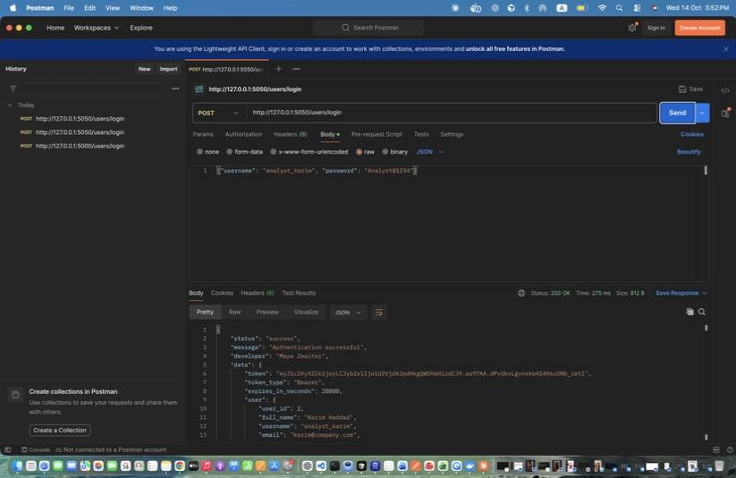
Figure 3: Maya Zeaiter – Login as Security Analyst (Karim) – Stores analyst_token.
Figure 4: Maya Zeaiter – Login as Regular User (by email) – Login with the email instead of the username. Stores user_token.
Figure 5: Maya Zeaiter – Login as Auditor – Stores auditor_token.
Figure 6: Maya Zeaiter – Login FAILED - wrong password – Unsuccessful login: returns 401 and writes a LOGIN_FAILED audit log.
Figure 7: Maya Zeaiter – Login FAILED - suspended account – Suspended accounts cannot authenticate (403).

1. Users and Identity Management (Maya Zeaiter)
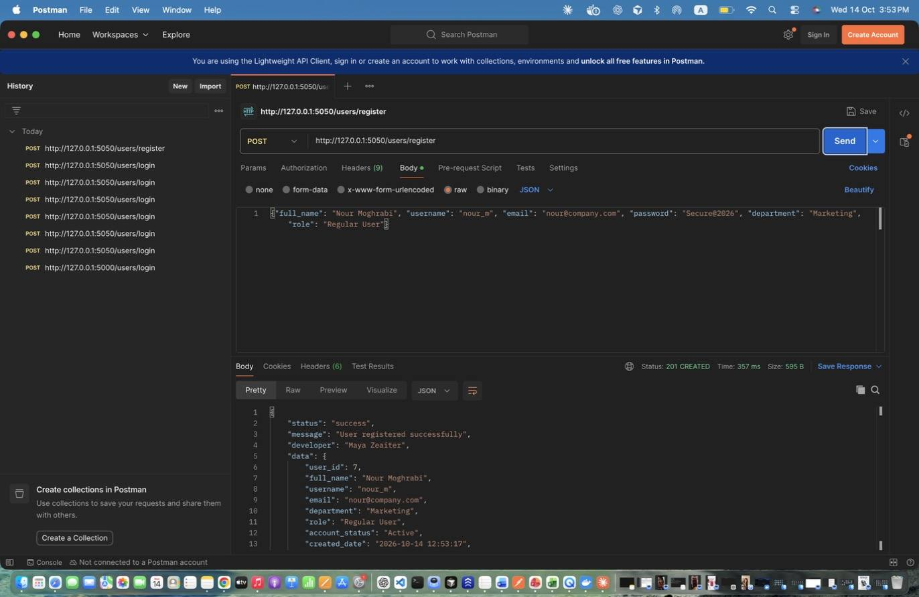
Figure 8: Maya Zeaiter – Register Regular User – Public registration. Password is hashed before storage. Stores the new id in new_user_id.
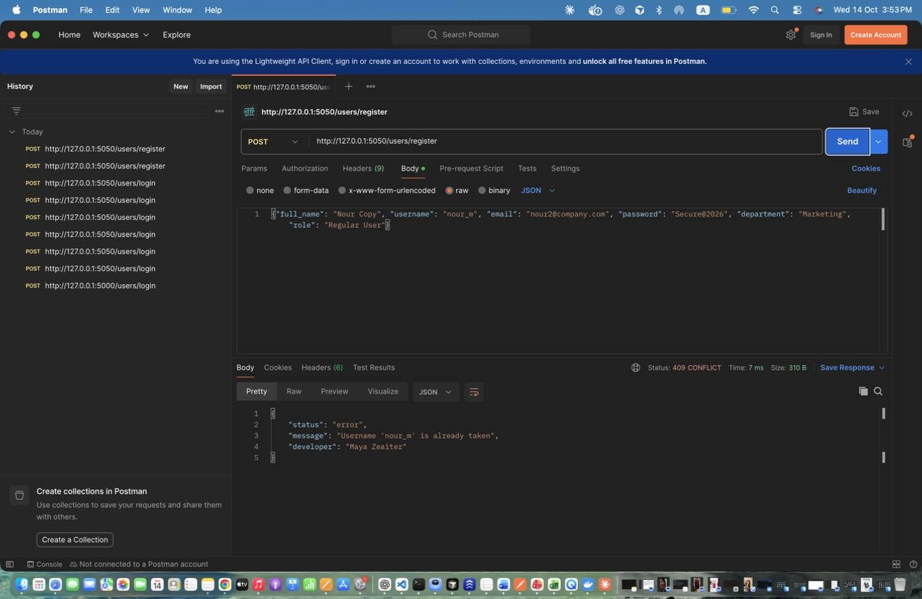
Figure 9: Maya Zeaiter – Register DUPLICATE username – Same username again -> 409 Conflict.
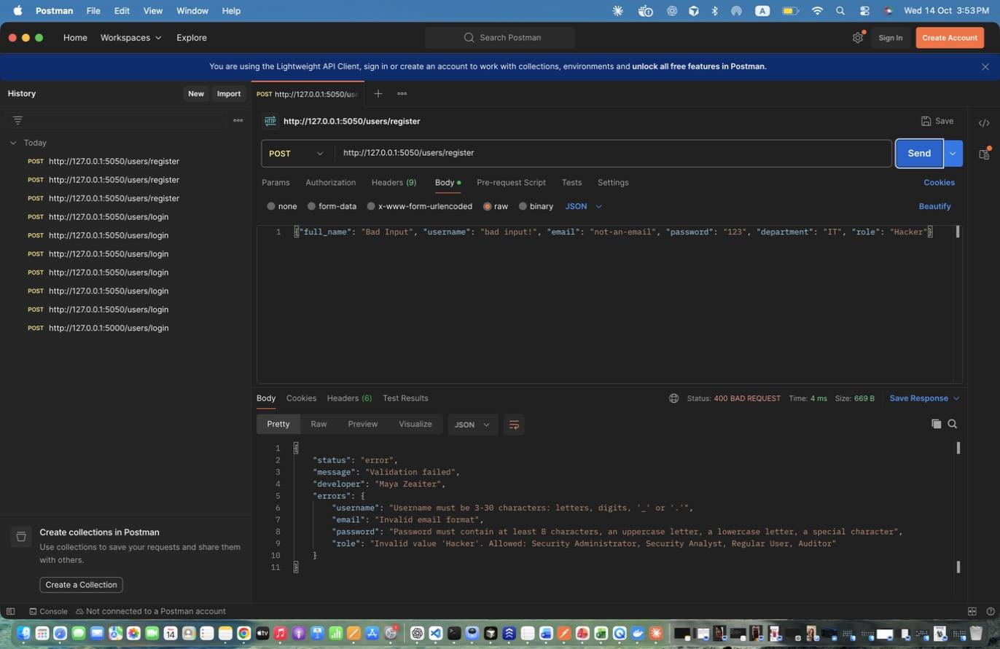
Figure 10: Maya Zeaiter – Register INVALID input – Invalid email, weak password, invalid role -> 400 with per-field errors.
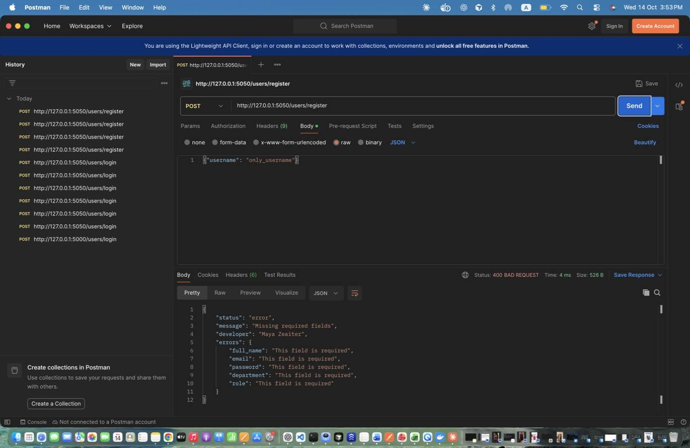
Figure 11: Maya Zeaiter – Register MISSING fields – Missing required fields -> 400.
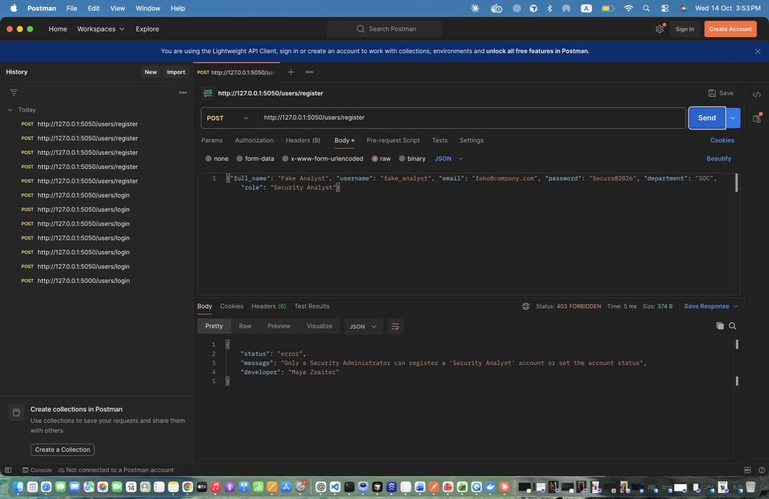
Figure 12: Maya Zeaiter – Register Analyst WITHOUT admin token – Privileged roles need an admin token -> 403.
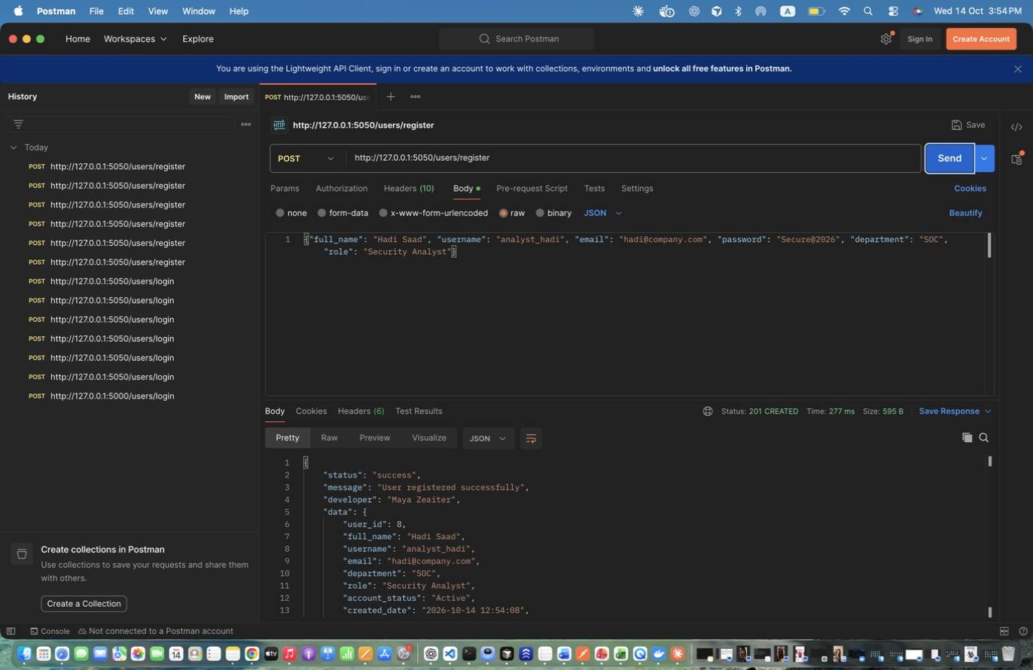
Figure 13: Maya Zeaiter – Register Analyst AS ADMIN – Admin can register any role.
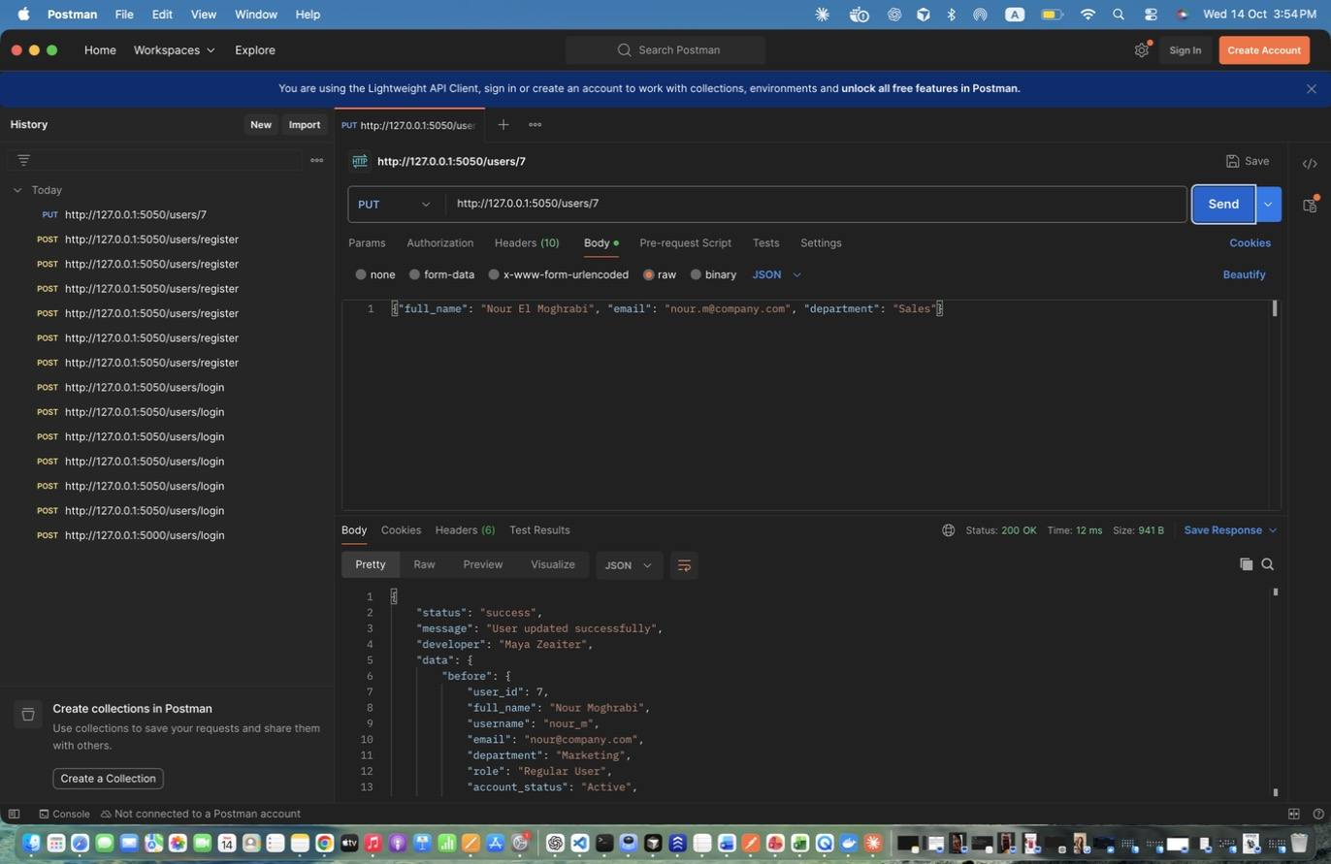
Figure 14: Maya Zeaiter – Update User (admin) – Admin updates name/email/department (and may change role/account_status). Response shows before and after.
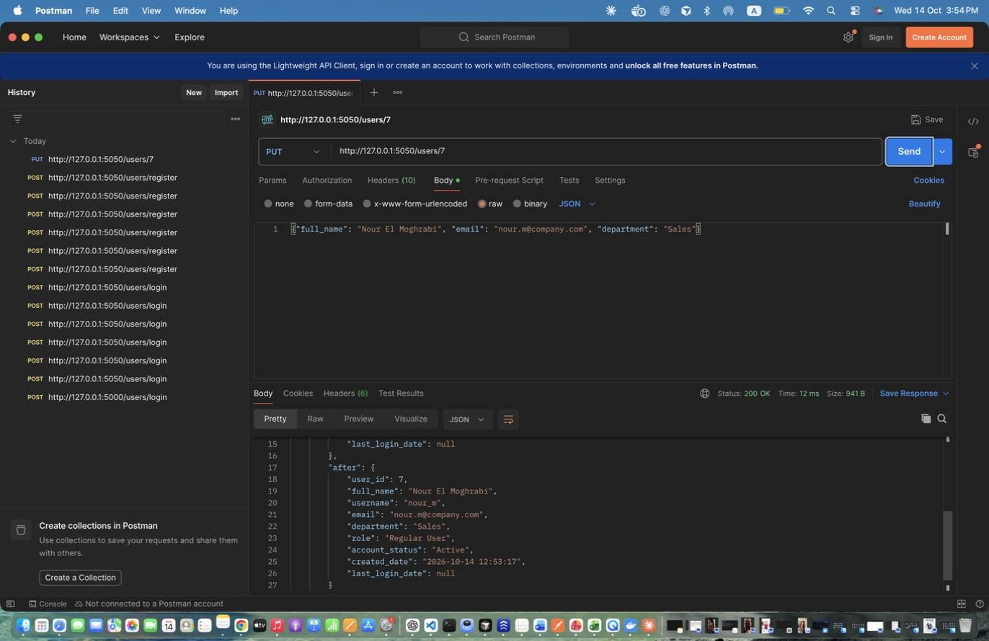
Figure 15: Maya Zeaiter – Update User (admin) – Admin updates name/email/department (and may change role/account_status). Response shows before and after. (response scrolled to show the rest)
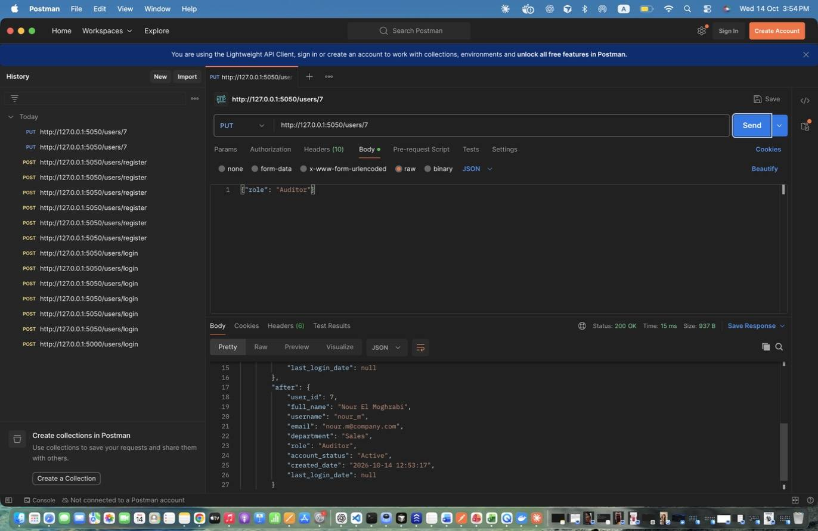
Figure 16: Maya Zeaiter – Update User - change role (admin) – Role change; writes a ROLE_CHANGED audit log.
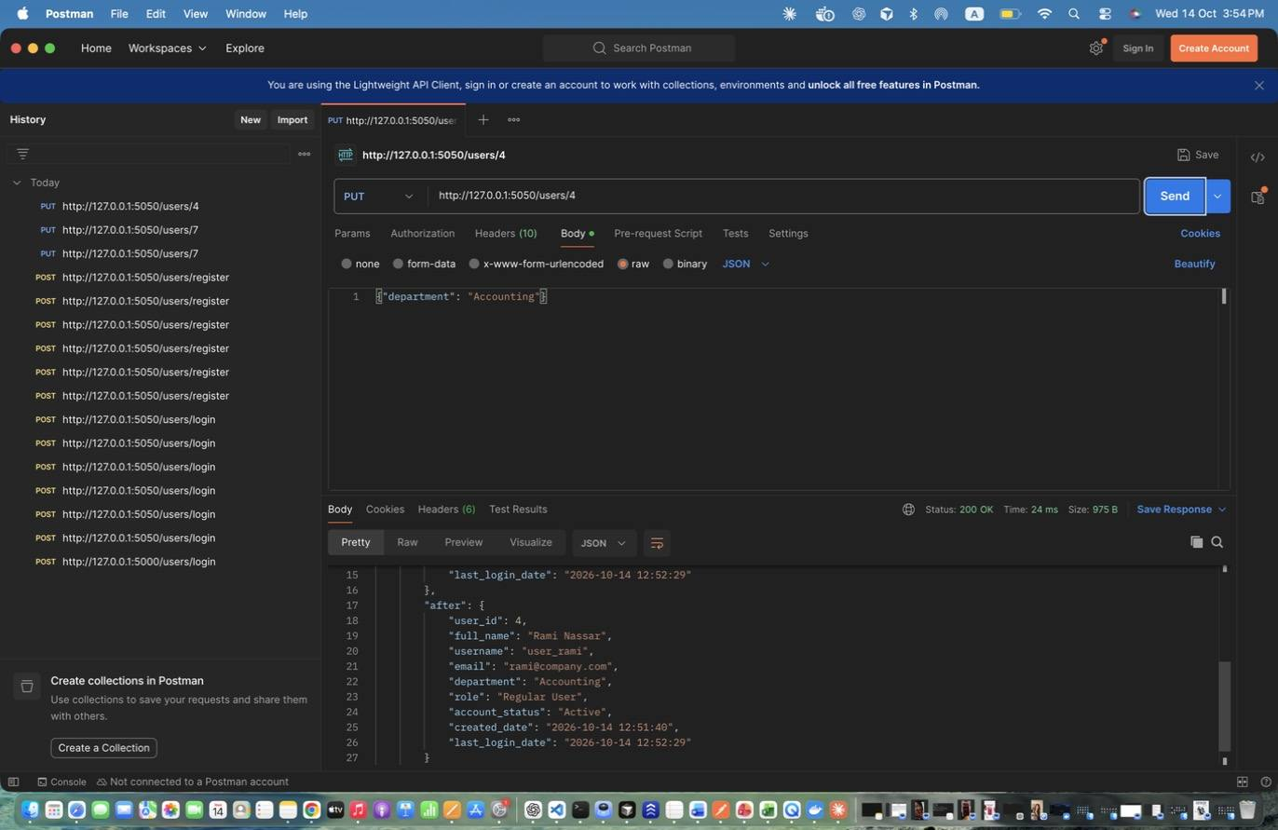
Figure 17: Maya Zeaiter – Update OWN info (regular user) – Regular user (id 4) updates their own department.
Figure 18: Maya Zeaiter – Update OTHER user (regular user) - DENIED – Regular user trying to edit someone else -> 403.
Figure 19: Maya Zeaiter – Retrieve All Users (admin) – Returns count + list of users (password hashes are never returned).
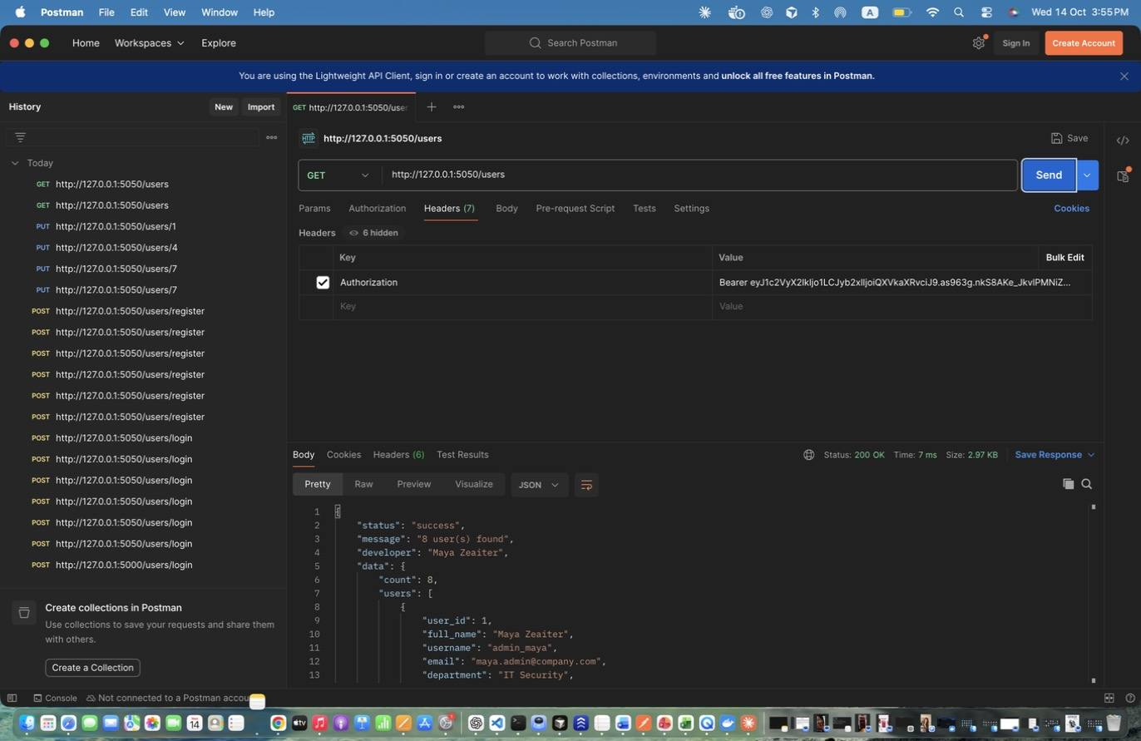
Figure 20: Maya Zeaiter – Retrieve All Users (auditor) – Auditor has read-only access.
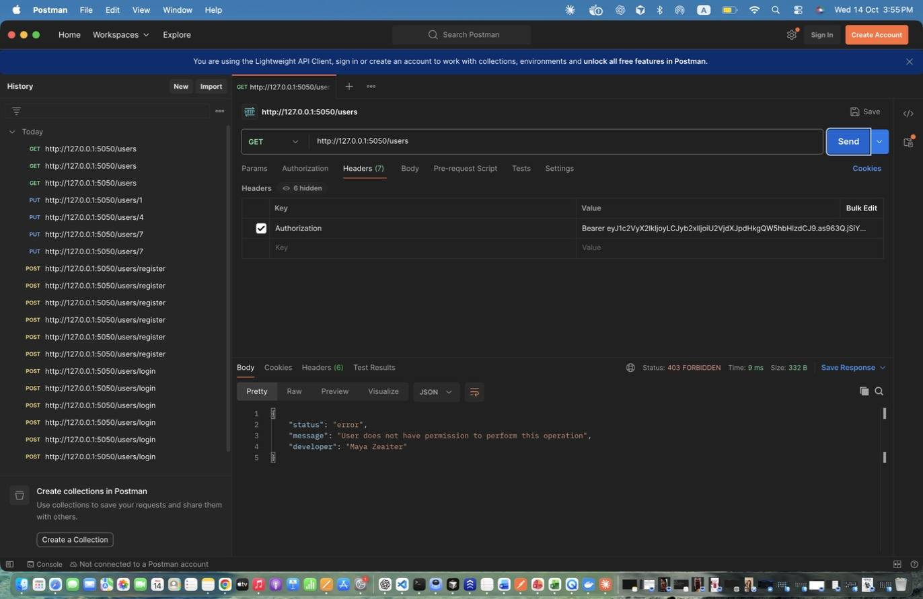
Figure 21: Maya Zeaiter – Retrieve All Users (analyst) - DENIED – Analysts have no user-management access -> 403.
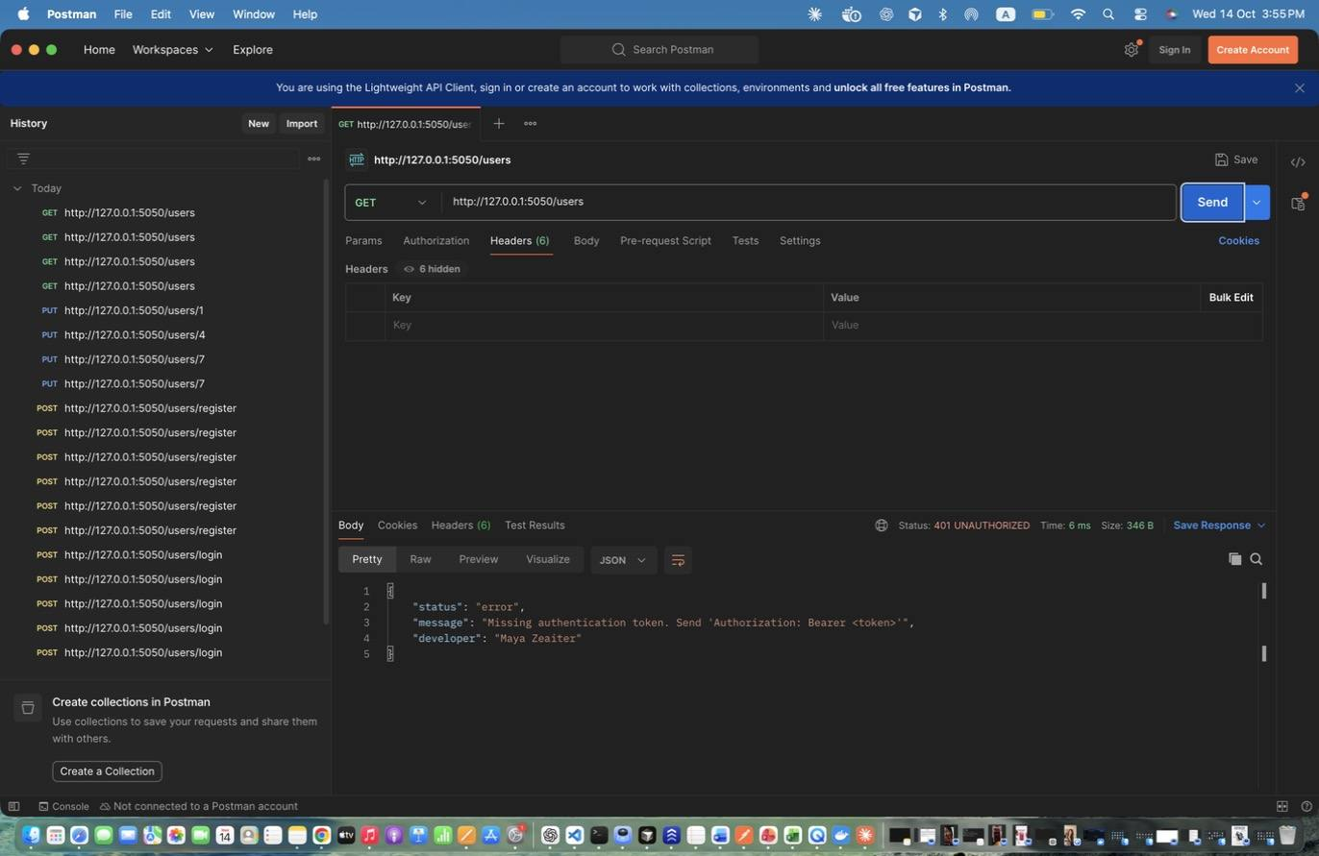
Figure 22: Maya Zeaiter – Retrieve All Users - NO TOKEN – Missing authentication -> 401.
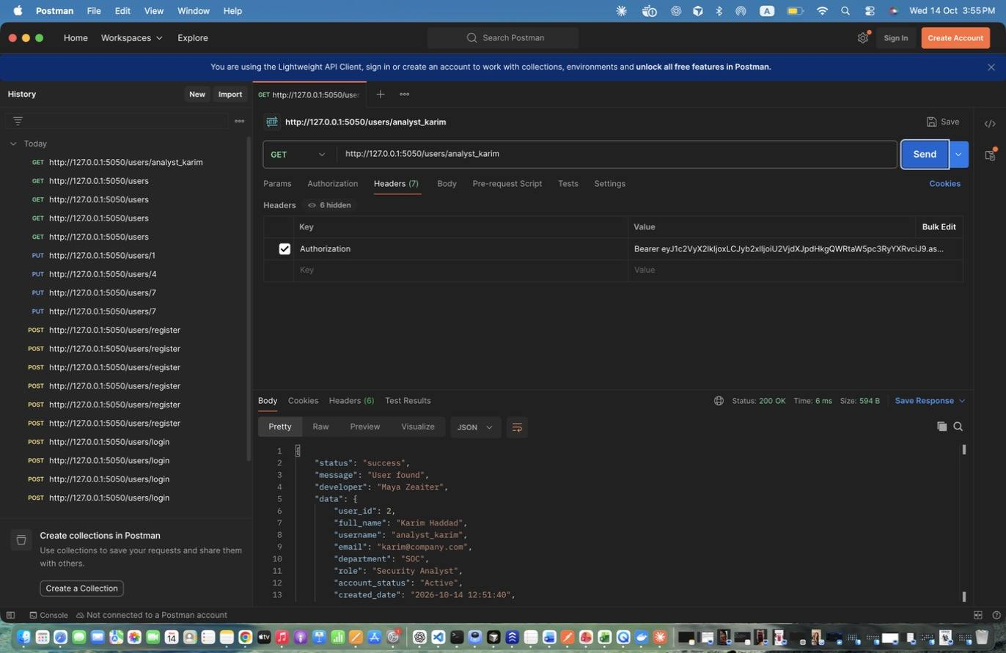
Figure 23: Maya Zeaiter – Retrieve User By Username - existing – Existing user -> 200.
Figure 24: Maya Zeaiter – Retrieve User By Username - non-existing – Unknown username -> 404.
Figure 25: Maya Zeaiter – Retrieve OWN info (regular user) – Regular user reads their own profile.
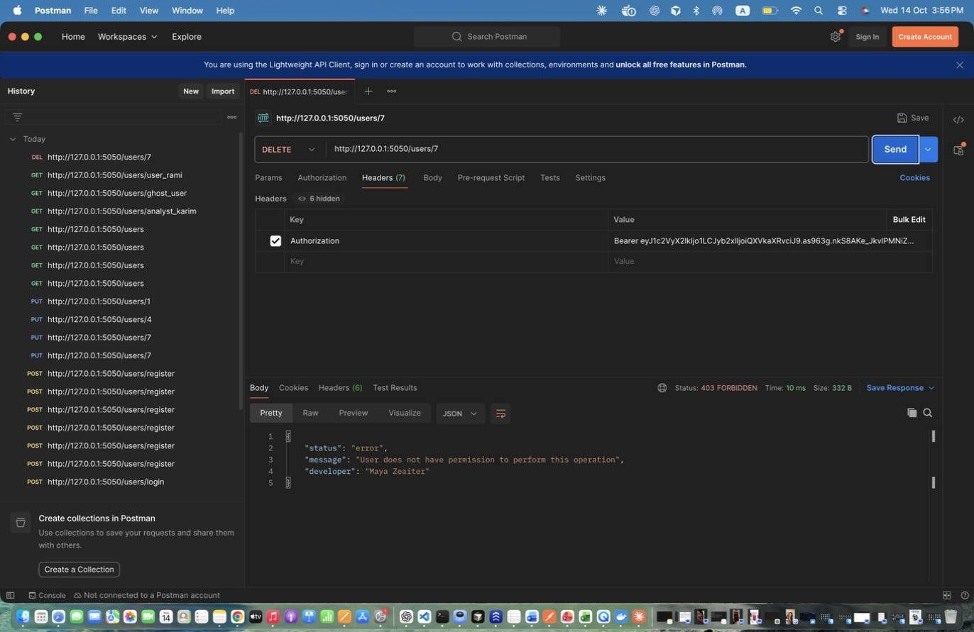
Figure 26: Maya Zeaiter – Delete User - unauthorized (auditor) – Auditor cannot delete -> 403 and UNAUTHORIZED_ACCESS log.
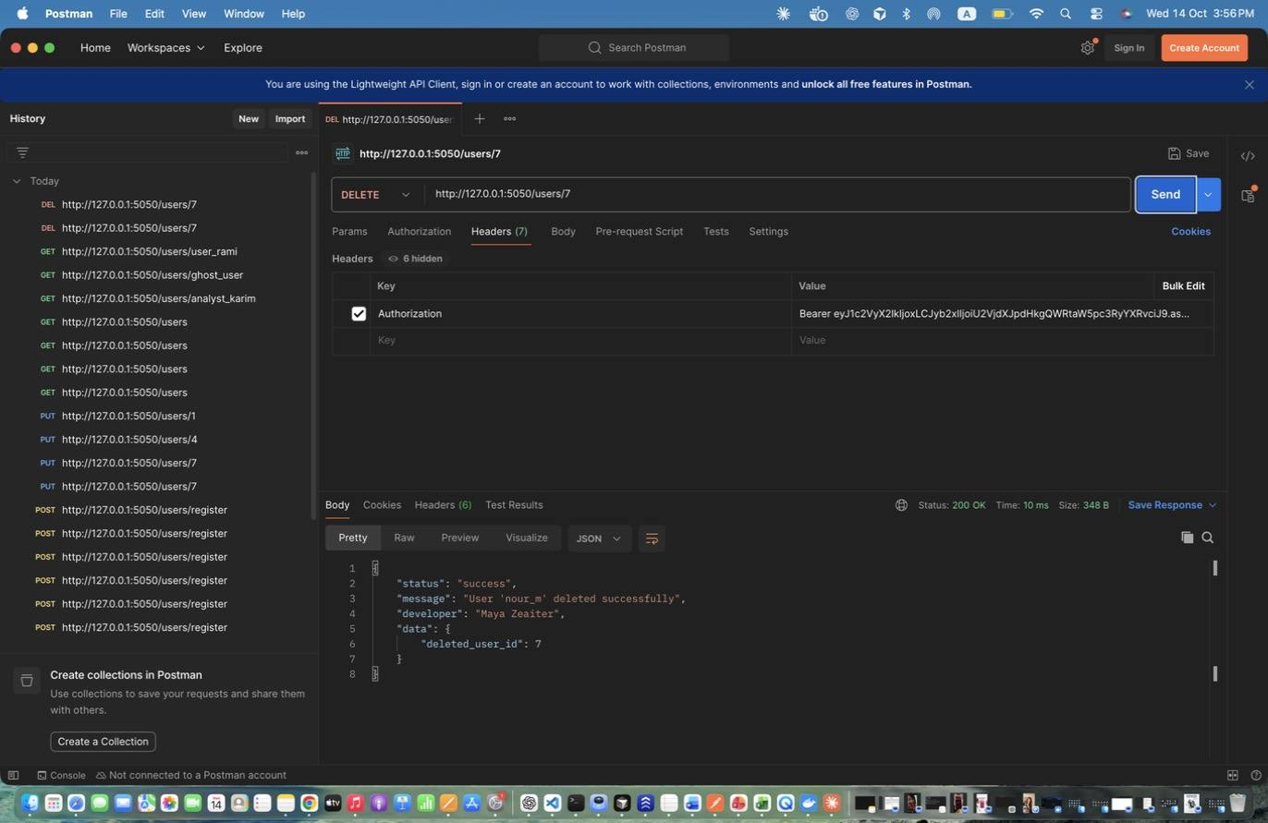
Figure 27: Maya Zeaiter – Delete User (admin) – Successful deletion; writes USER_DELETED log.
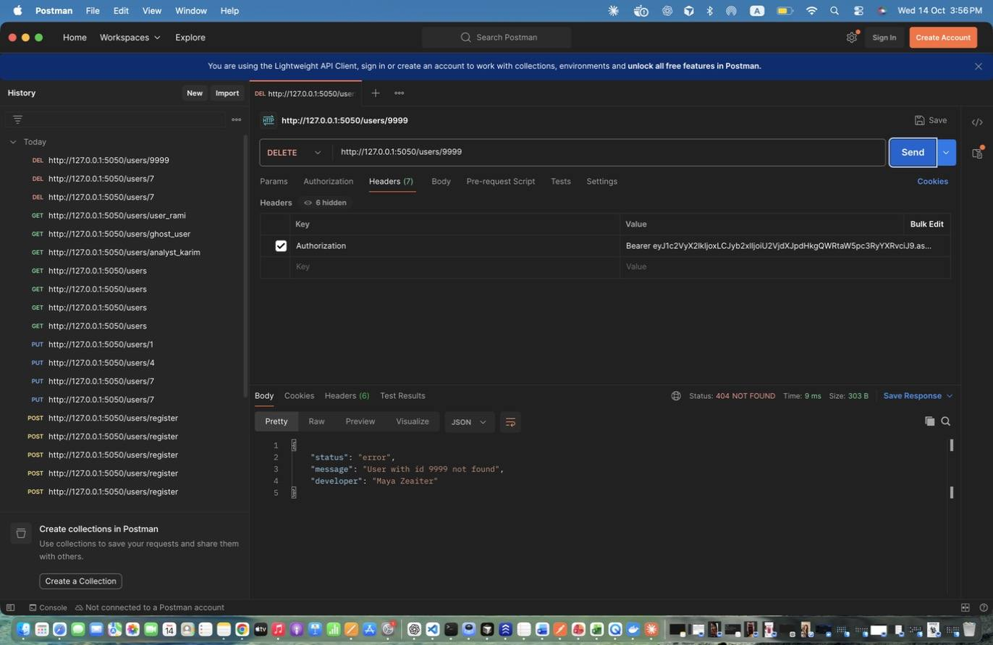
Figure 28: Maya Zeaiter – Delete User - not found – Unknown id -> 404.

2. Asset Management (Maya Zeaiter)
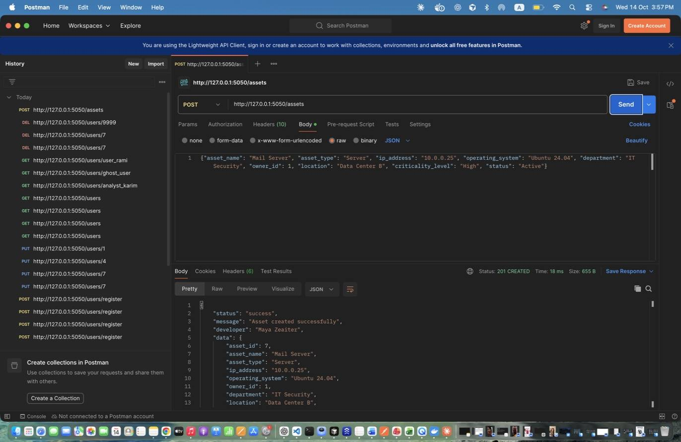
Figure 29: Maya Zeaiter – Add Asset - Server – Creates an asset. Stores id in asset_id.
Figure 30: Maya Zeaiter – Add Asset - Workstation – Second asset with Medium criticality.
Figure 31: Maya Zeaiter – Add Asset - Cloud (IPv6) – IPv6 addresses are also accepted.
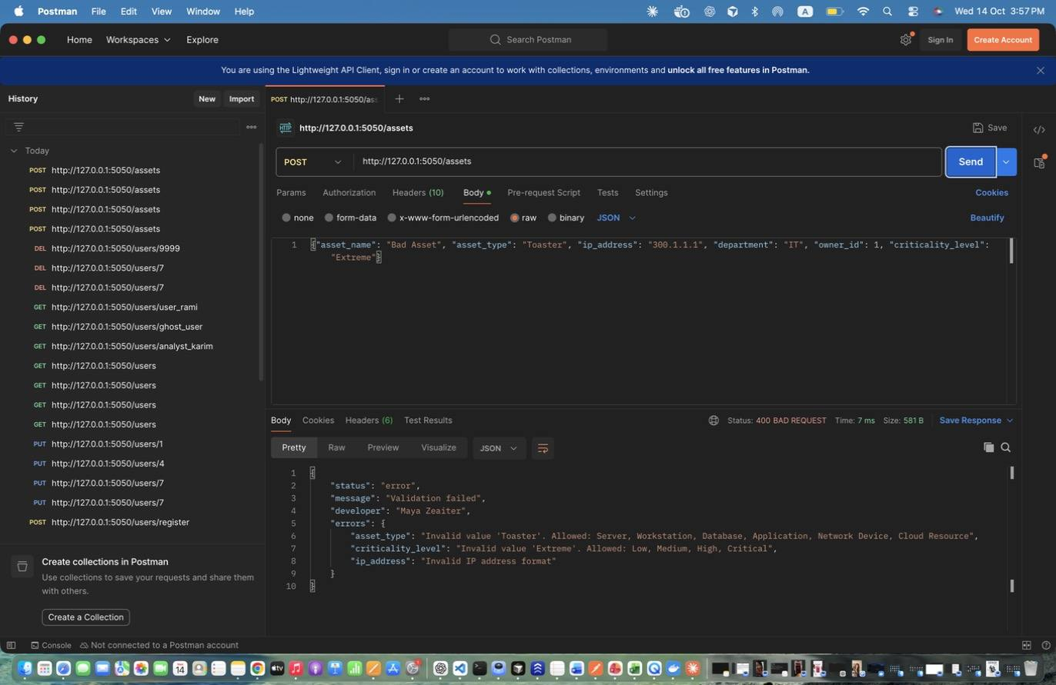
Figure 32: Maya Zeaiter – Add Asset - INVALID input – Invalid IP, type and criticality -> 400.
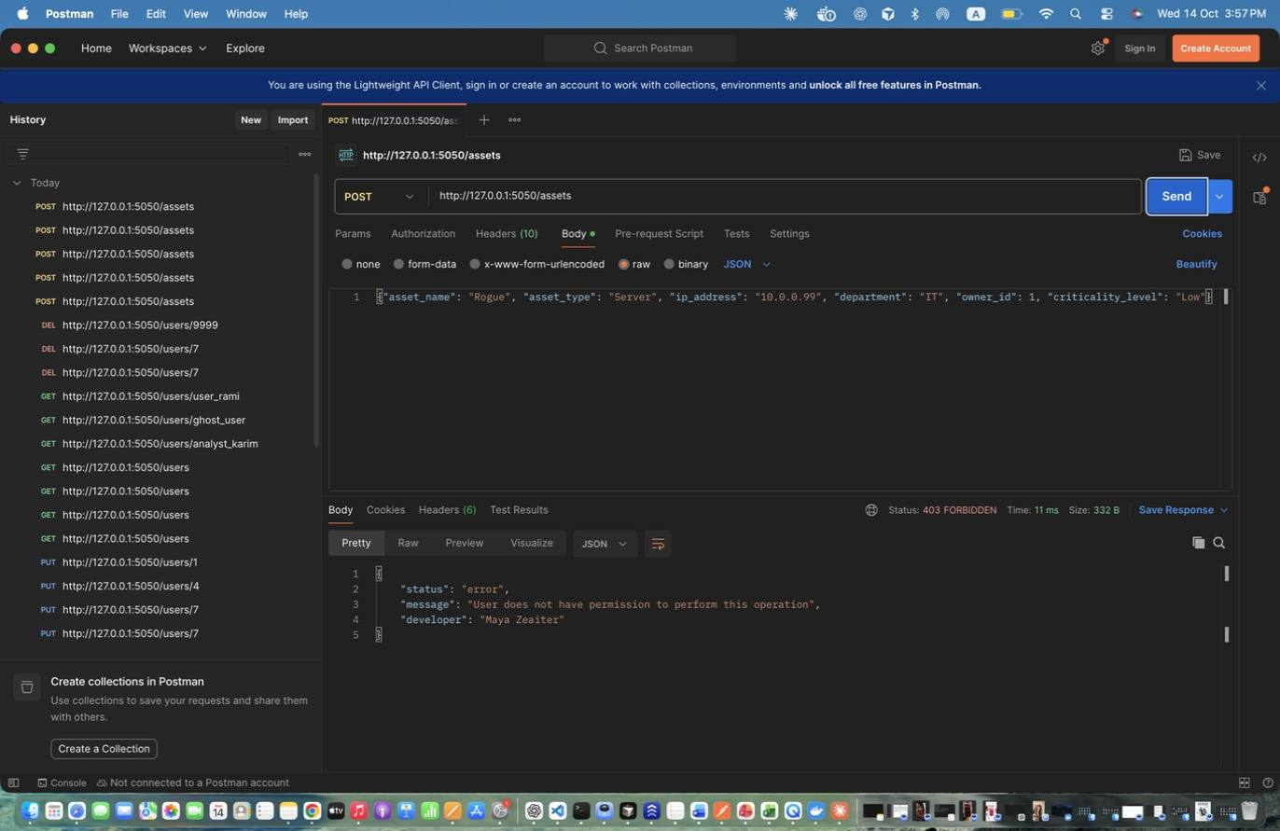
Figure 33: Maya Zeaiter – Add Asset - analyst DENIED – Only admins create assets -> 403.
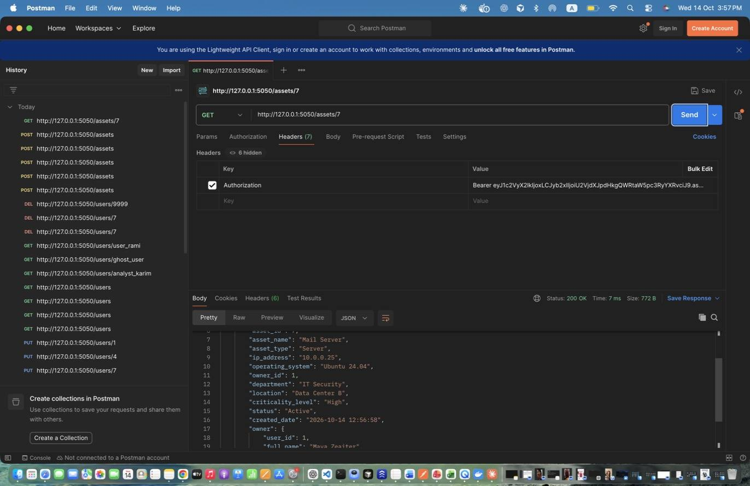
Figure 34: Maya Zeaiter – Retrieve Specific Asset (before update) – Use as the 'before' screenshot.
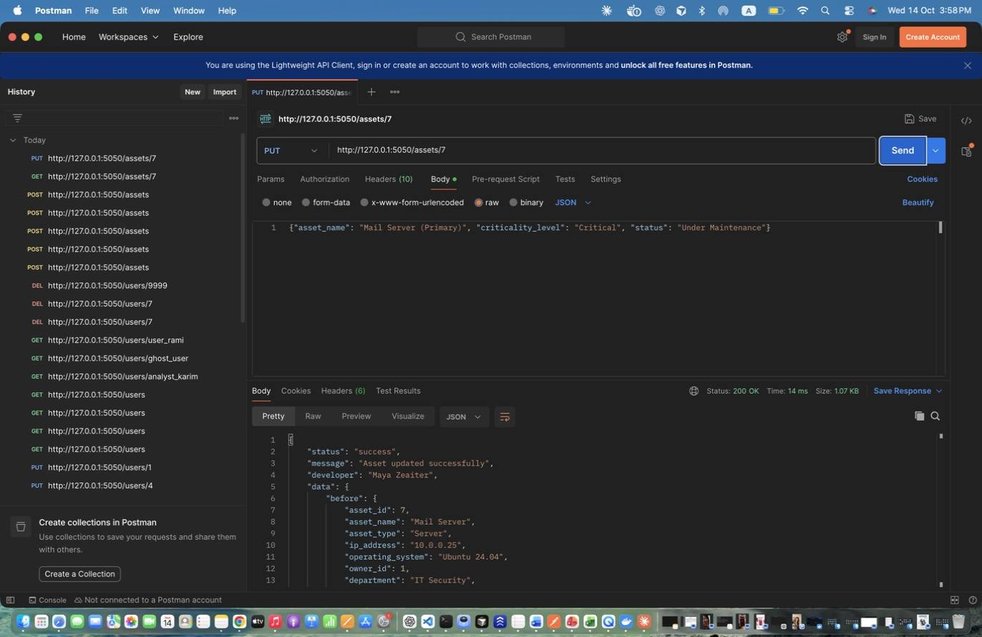
Figure 35: Maya Zeaiter – Update Asset – Updates name/owner/department/criticality/status; response includes before and after.
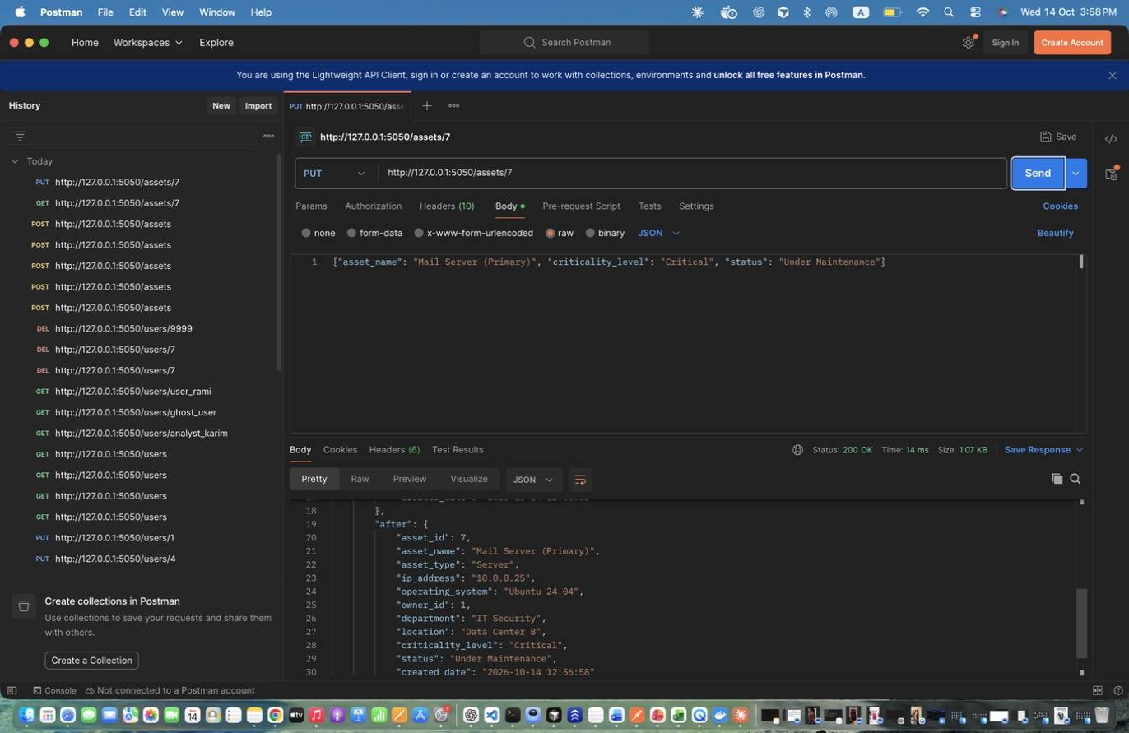
Figure 36: Maya Zeaiter – Update Asset – Updates name/owner/department/criticality/status; response includes before and after. (response scrolled to show the rest)
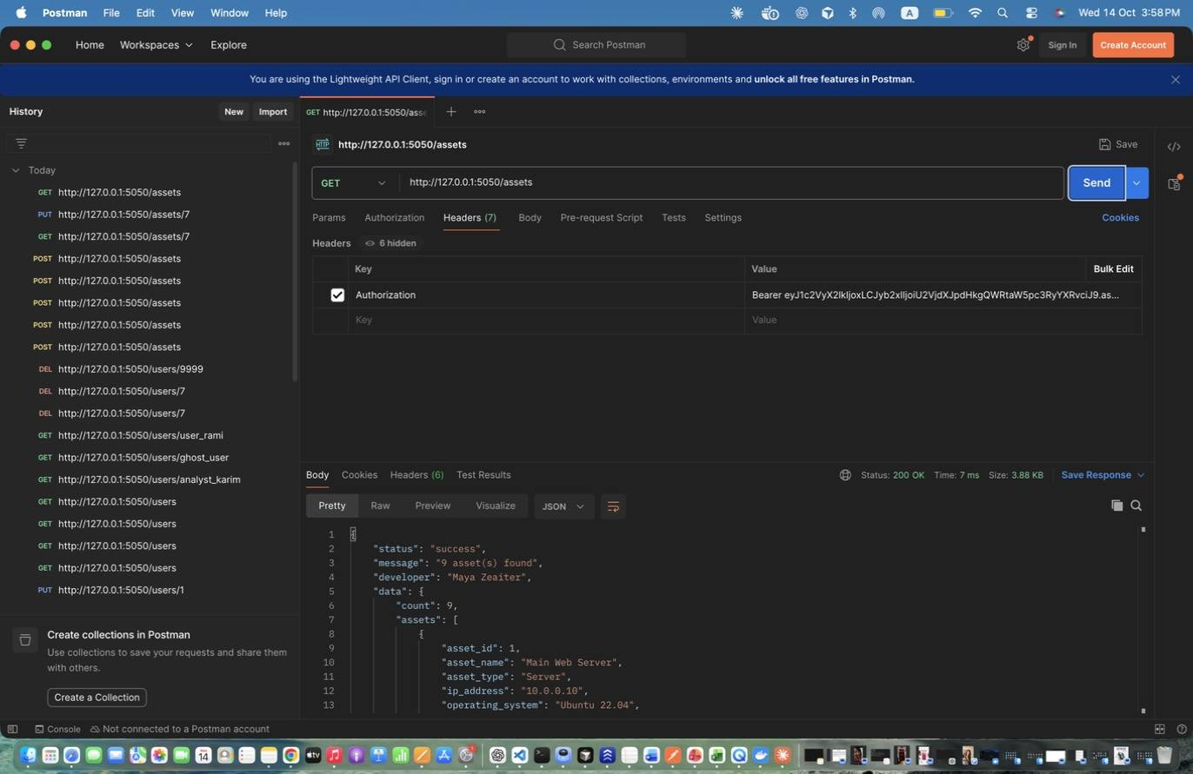
Figure 37: Maya Zeaiter – Retrieve All Assets (admin) – All assets with criticality and status.
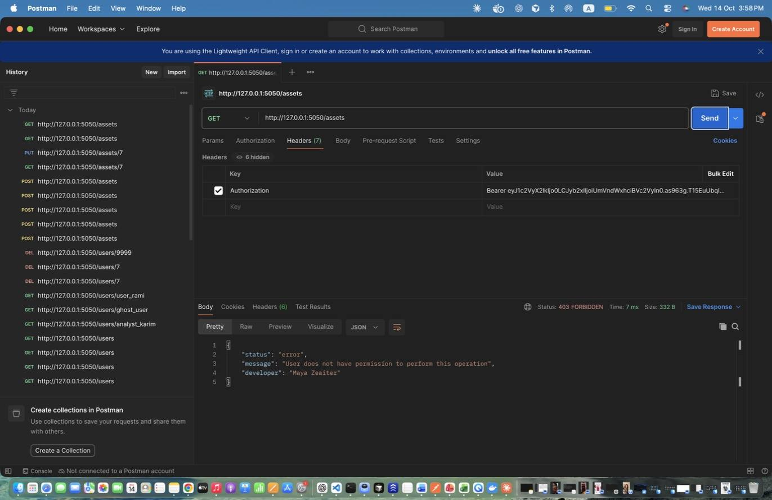
Figure 38: Maya Zeaiter – Retrieve All Assets (regular user) - DENIED – Regular users have no asset access -> 403.
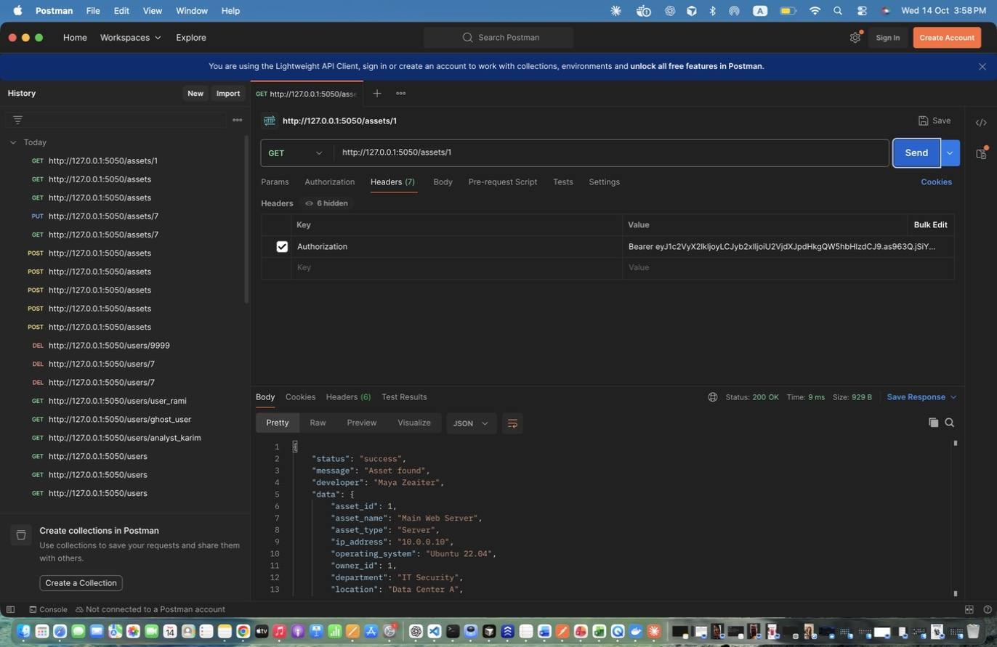
Figure 39: Maya Zeaiter – Retrieve Specific Asset (analyst) – Includes owner and related incidents.
Figure 40: Maya Zeaiter – Retrieve Specific Asset (analyst) – Includes owner and related incidents. (response scrolled to show the rest)
Figure 41: Maya Zeaiter – Retrieve Specific Asset - invalid id – -> 404.
Figure 42: Maya Zeaiter – Search Assets - by criticality – Exact match on criticality level.
Figure 43: Maya Zeaiter – Search Assets - by type – Exact match on asset type.
Figure 44: Maya Zeaiter – Search Assets - by IP prefix – Partial match on IP address.
Figure 45: Maya Zeaiter – Search Assets - by name + department – Combined criteria (AND), case-insensitive partial match.
Figure 46: Maya Zeaiter – Search Assets - invalid criticality – -> 400.
Figure 47: Maya Zeaiter – Search Assets - SQL injection attempt – Parameterised queries: returns 0 results instead of every row.
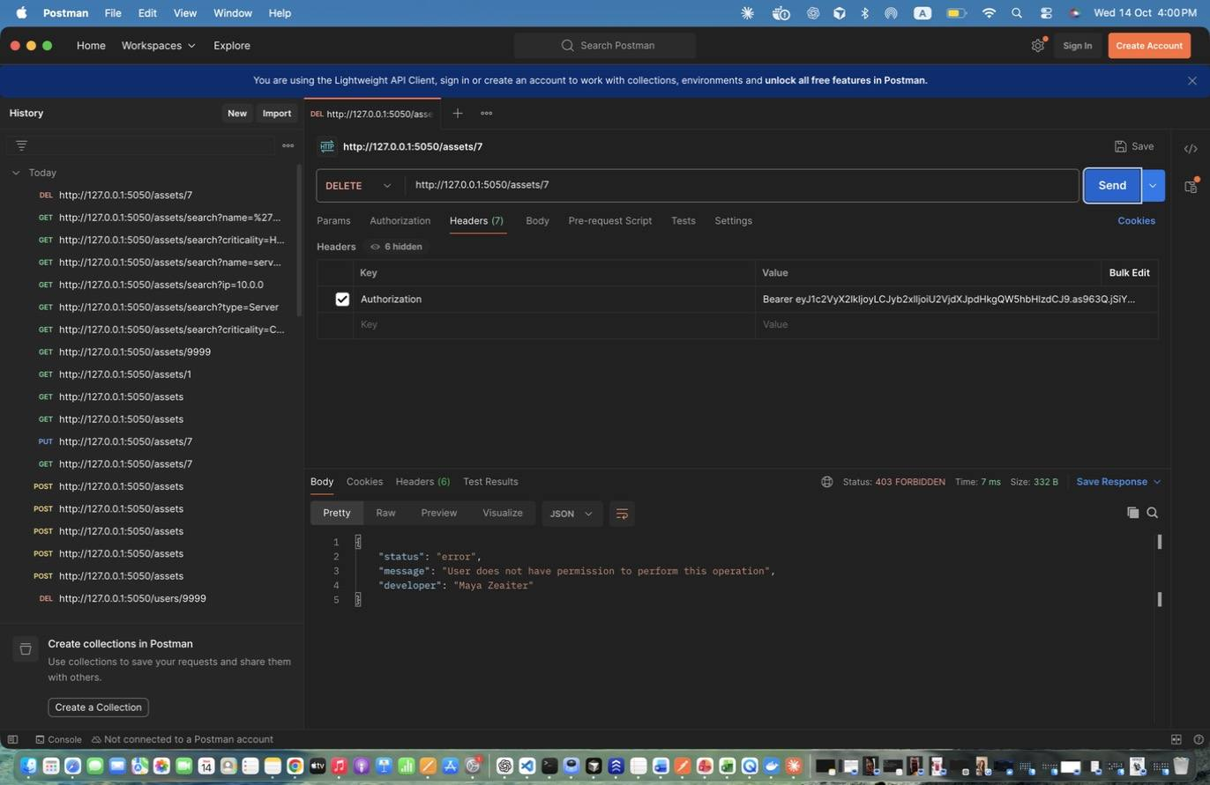
Figure 48: Maya Zeaiter – Delete Asset - analyst DENIED – -> 403.
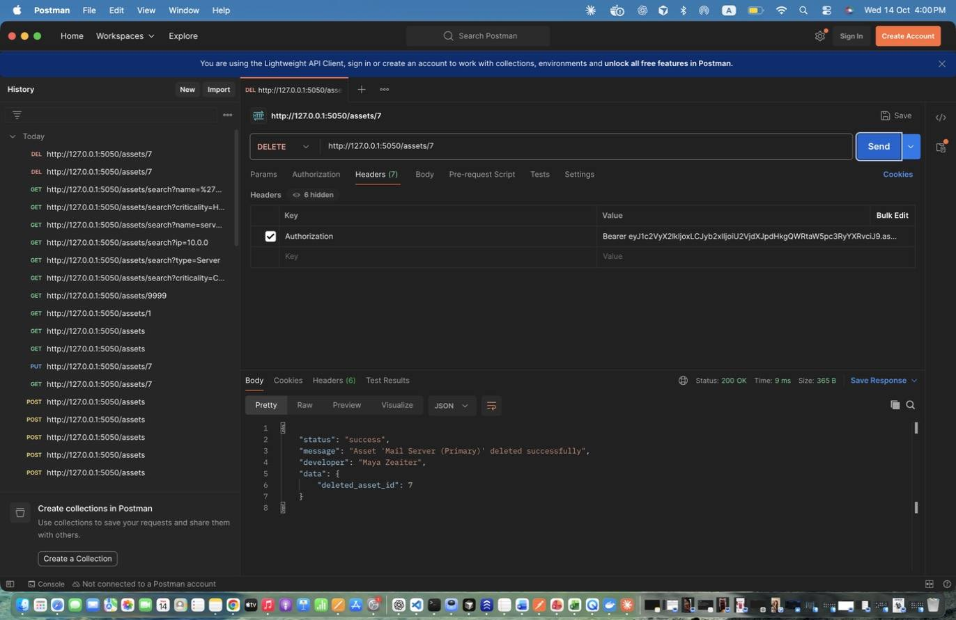
Figure 49: Maya Zeaiter – Delete Asset (admin) – Successful deletion.

3. Incident Management (Maya Zeaiter)
Figure 50: Maya Zeaiter – Create Incident - Critical (admin) – Admin reports a Critical incident. Stores id in incident_id.
Figure 51: Maya Zeaiter – Create Incident - Medium (regular user) – Regular user reports; reporter is taken from the token.
Figure 52: Maya Zeaiter – Create Incident - Low (regular user) – Low severity example.
Figure 53: Maya Zeaiter – Create Incident - INVALID severity – -> 400.
Figure 54: Maya Zeaiter – Create Incident - analyst DENIED – Analysts cannot create incidents -> 403.
Figure 55: Maya Zeaiter – Retrieve All Incidents (admin) – Includes status and assigned analyst.
Figure 56: Maya Zeaiter – Retrieve All Incidents (auditor) – Read-only access.
Figure 57: Maya Zeaiter – Retrieve Specific Incident – Full incident including notes.
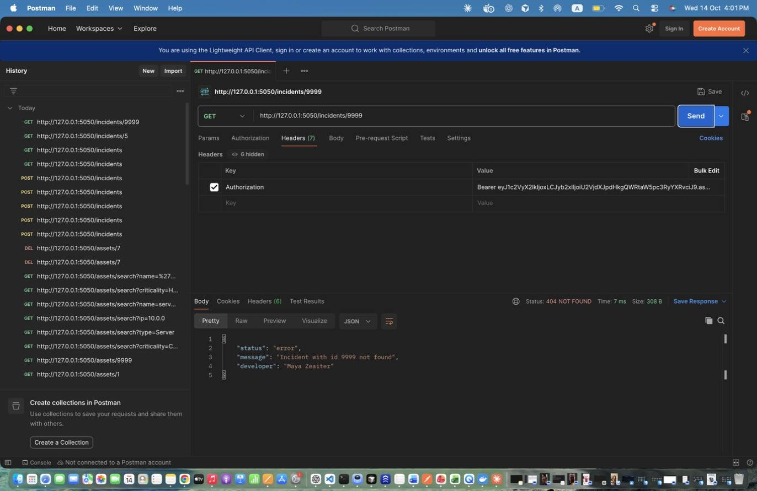
Figure 58: Maya Zeaiter – Retrieve Specific Incident - invalid id – -> 404.
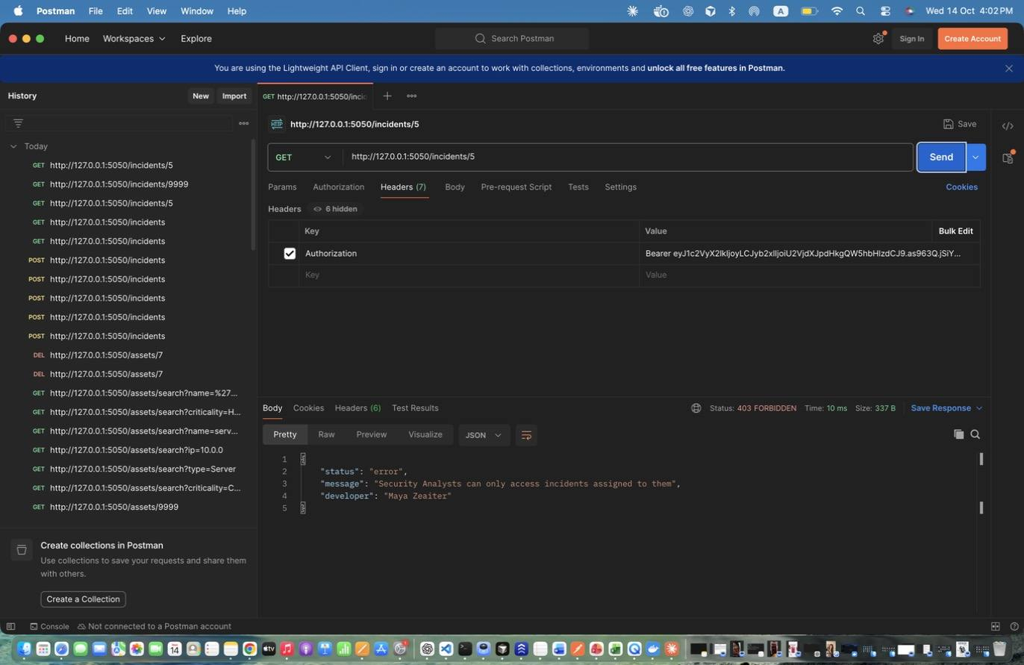
Figure 59: Maya Zeaiter – Retrieve Incident - analyst NOT assigned – Analysts only see incidents assigned to them -> 403 (until assigned).
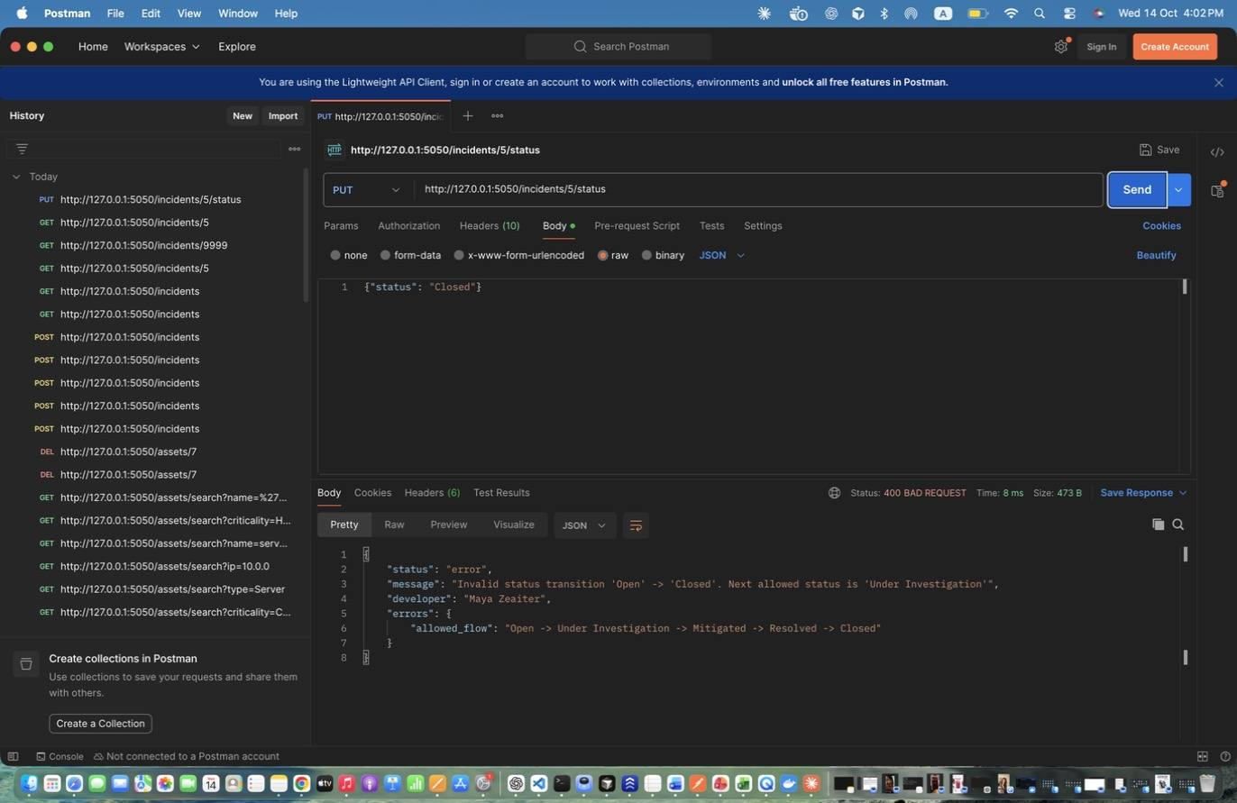
Figure 60: Maya Zeaiter – Update Status - skip steps (Open -> Closed) – Invalid transition -> 400.
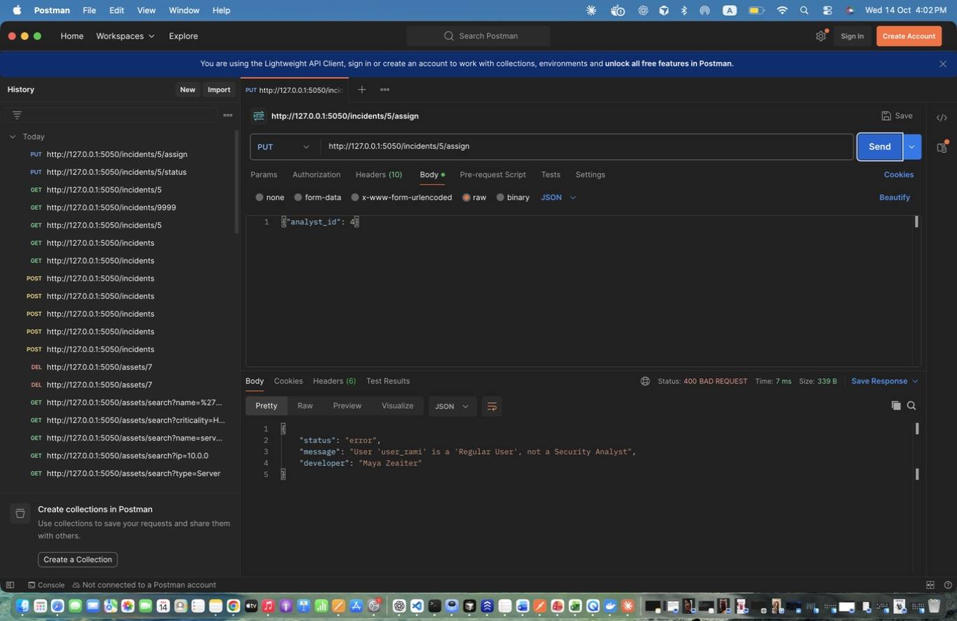
Figure 61: Maya Zeaiter – Assign Incident - to non-analyst – User 4 is a Regular User -> 400.
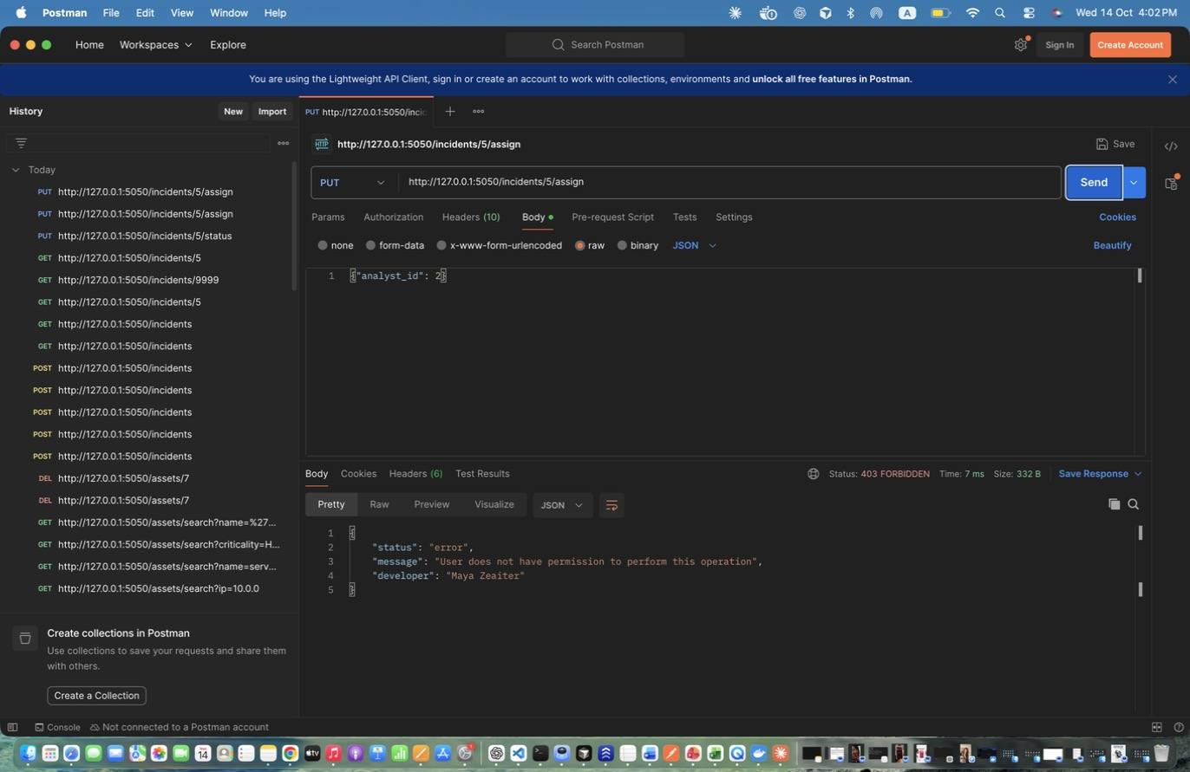
Figure 62: Maya Zeaiter – Assign Incident - by analyst DENIED – -> 403.
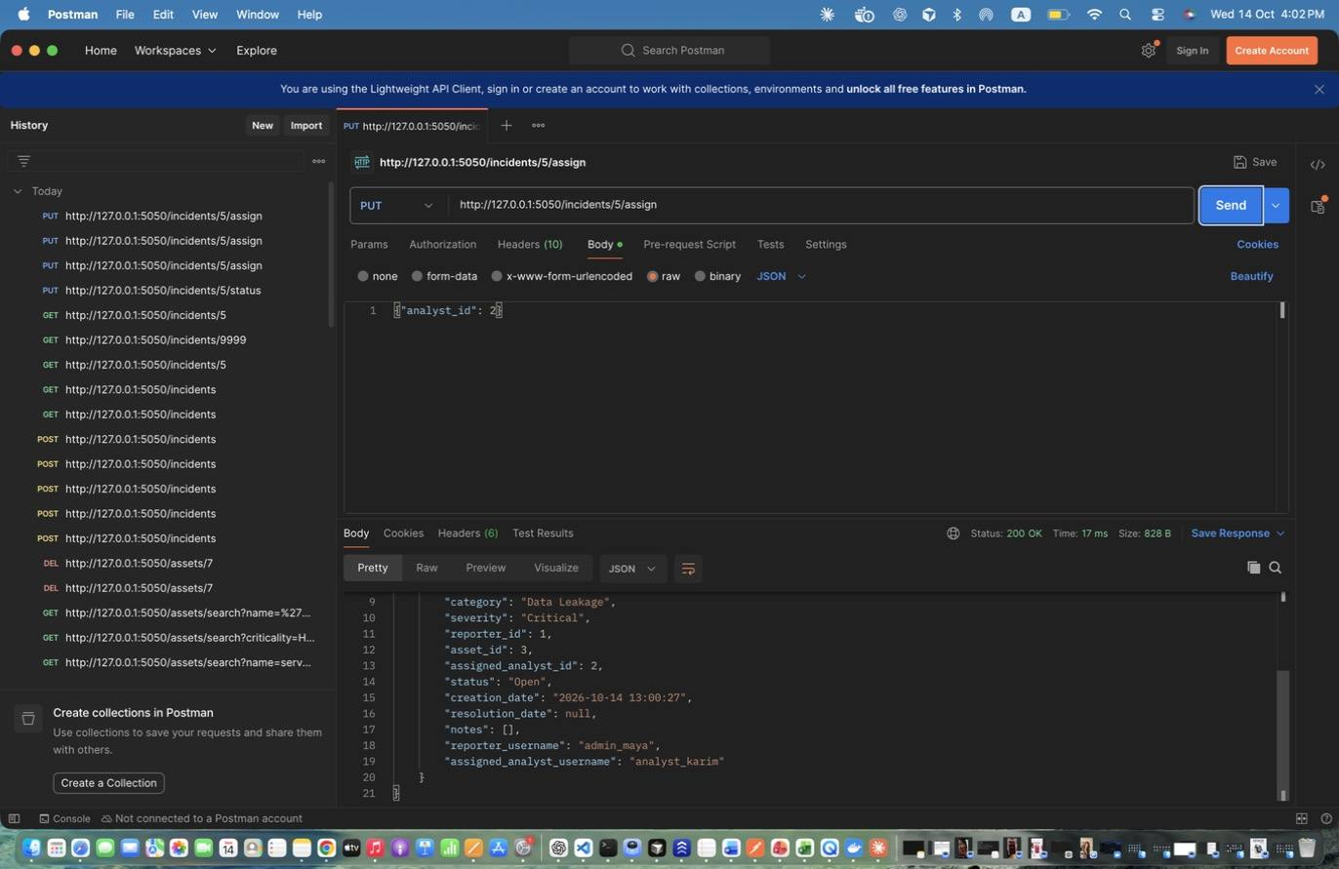
Figure 63: Maya Zeaiter – Assign Incident to Analyst – Assigns to analyst_karim (id 2); logs INCIDENT_ASSIGNED and creates a notification.
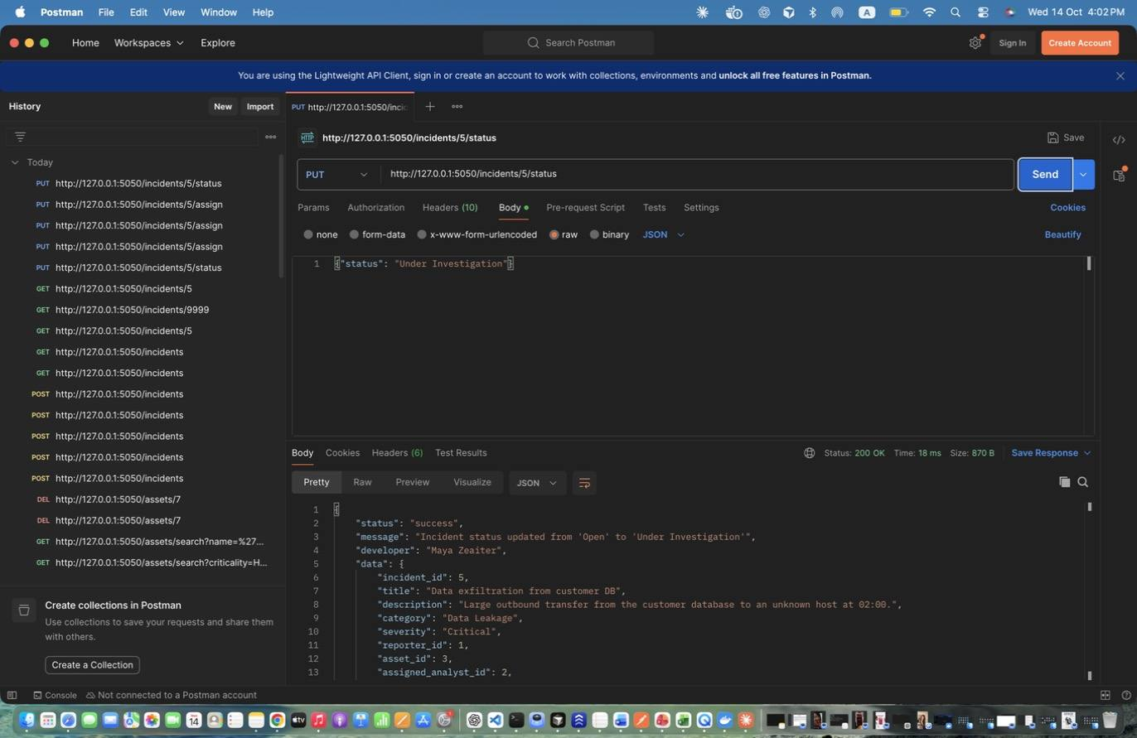
Figure 64: Maya Zeaiter – Status 1: Open -> Under Investigation – Status 1: Open -> Under Investigation
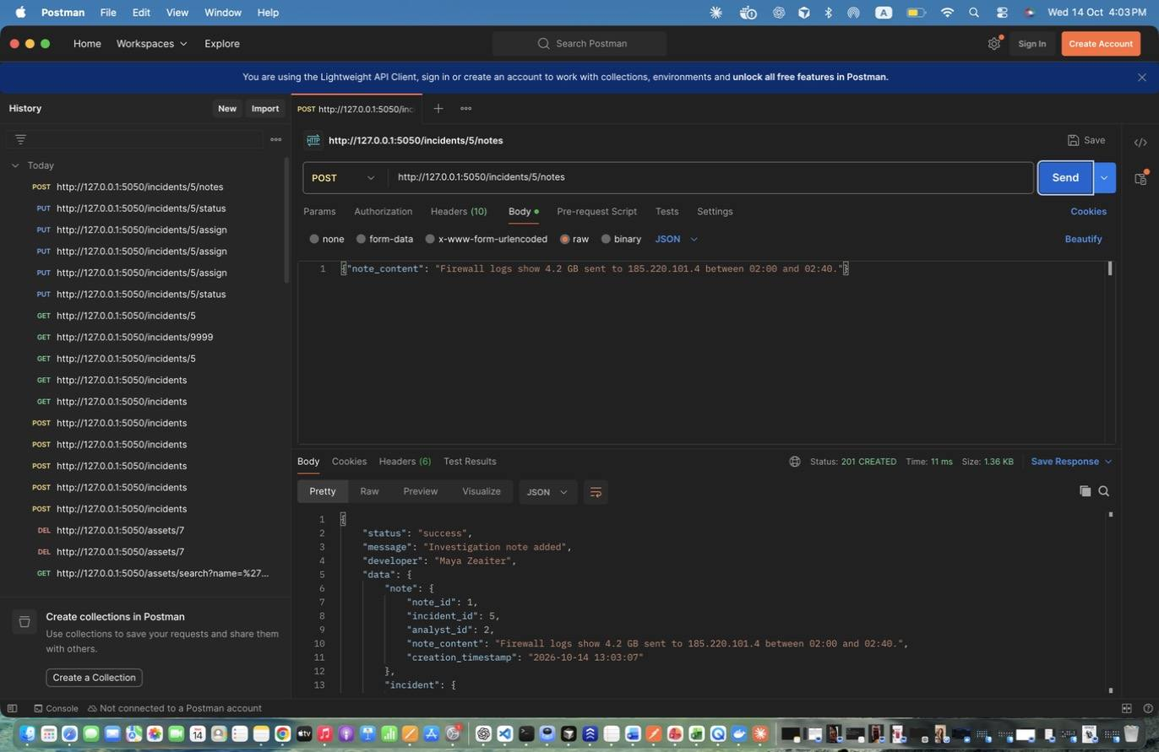
Figure 65: Maya Zeaiter – Add Investigation Note – Note linked to the incident and the analyst.
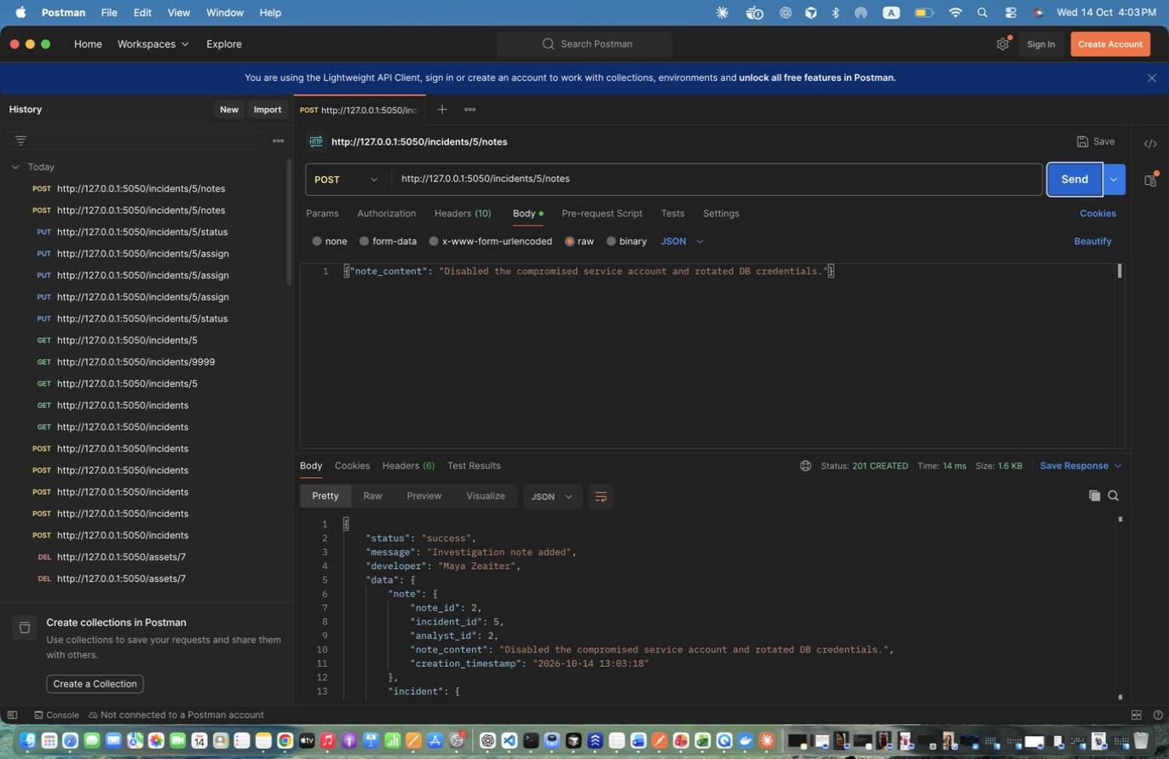
Figure 66: Maya Zeaiter – Add Investigation Note (2) – Add Investigation Note (2)
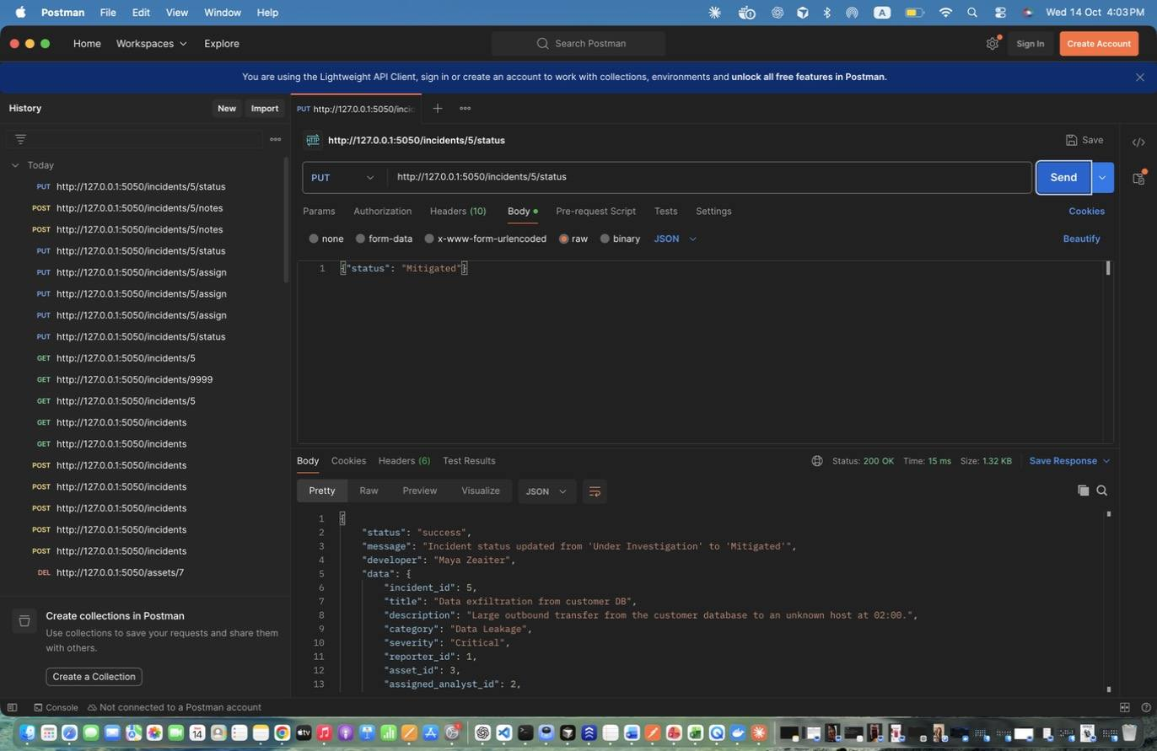
Figure 67: Maya Zeaiter – Status 2: Under Investigation -> Mitigated – Status 2: Under Investigation -> Mitigated
Figure 68: Maya Zeaiter – Status 3: Mitigated -> Resolved – Sets resolution_date.
Figure 69: Maya Zeaiter – Status 3: Mitigated -> Resolved – Sets resolution_date. (response scrolled to show the rest)
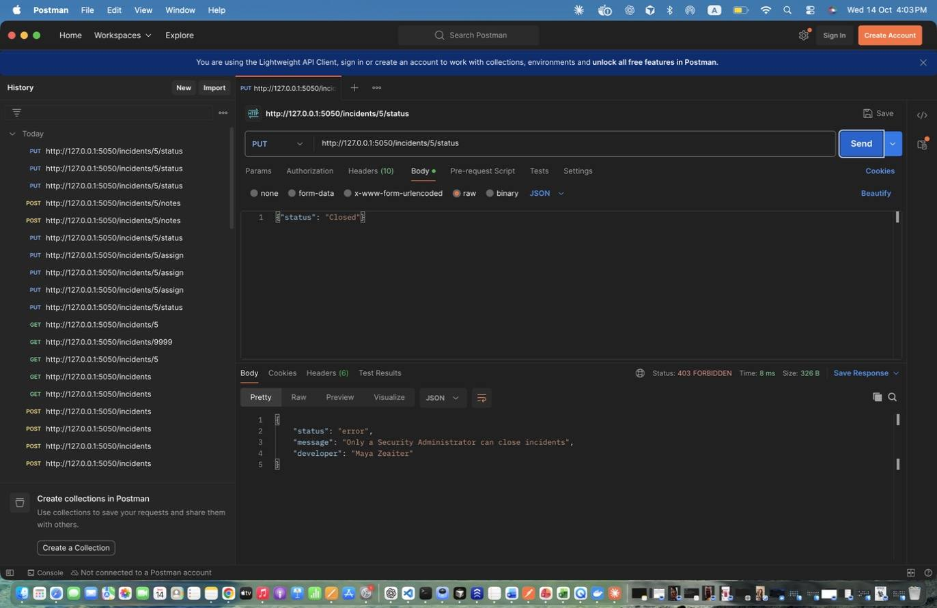
Figure 70: Maya Zeaiter – Status 4: Resolved -> Closed (analyst) DENIED – Only admins close incidents -> 403.
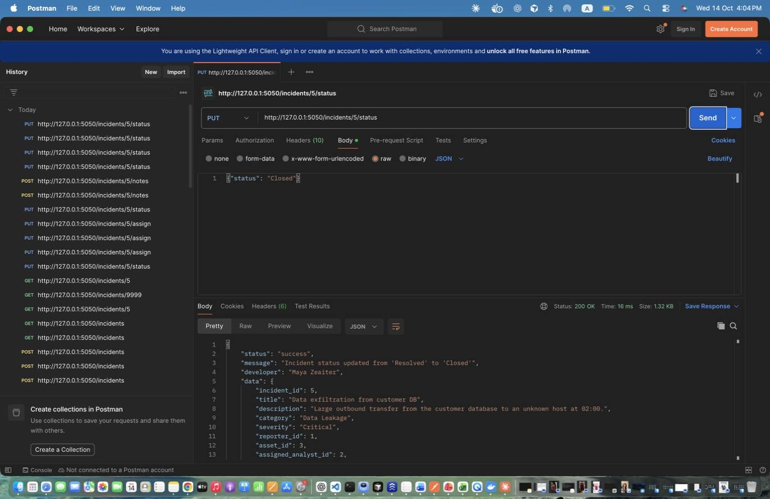
Figure 71: Maya Zeaiter – Status 4: Resolved -> Closed (admin) – Status 4: Resolved -> Closed (admin)
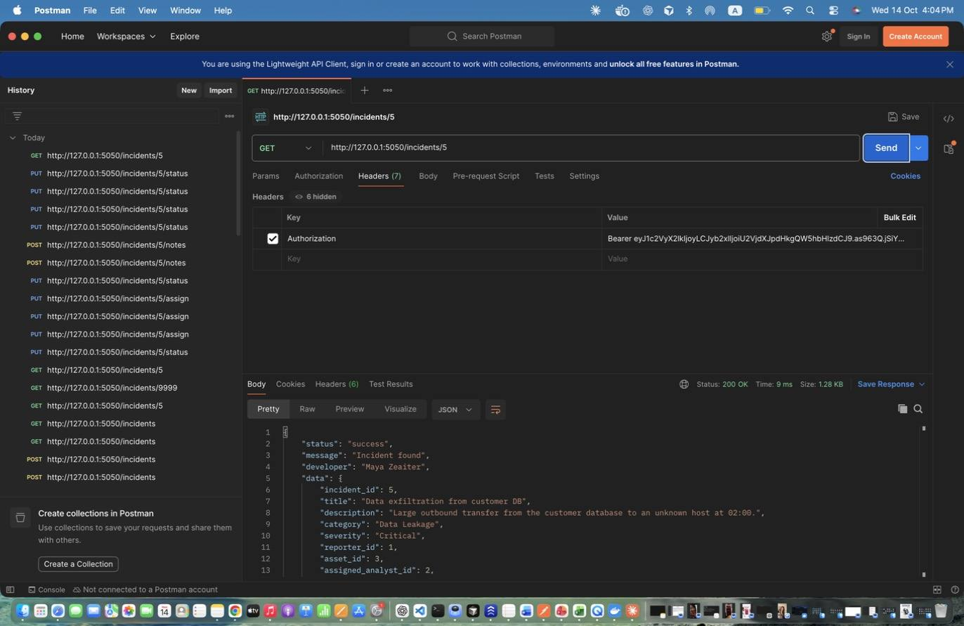
Figure 72: Maya Zeaiter – Retrieve Incident with notes – Shows the final state and both notes.
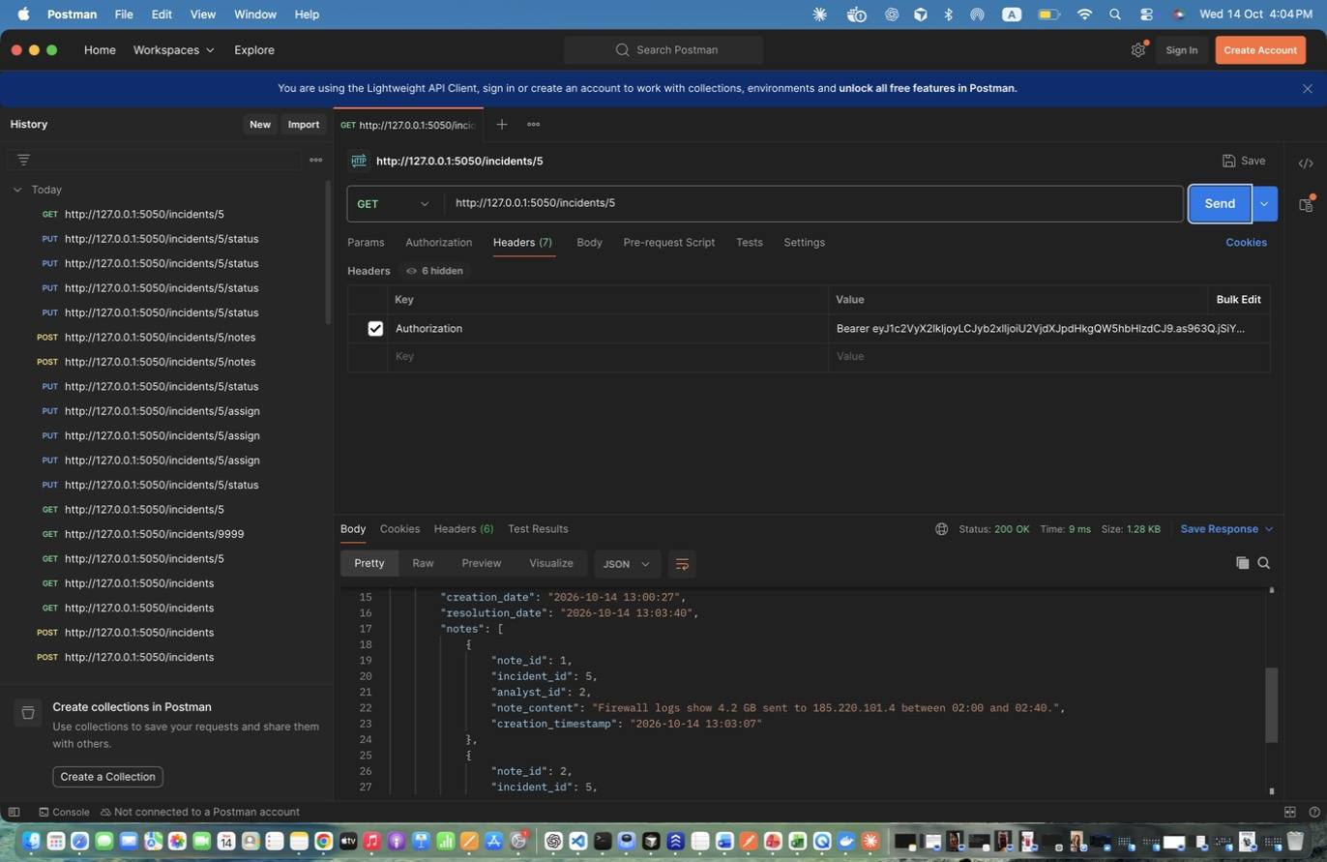
Figure 73: Maya Zeaiter – Retrieve Incident with notes – Shows the final state and both notes. (response scrolled to show the rest)

Database (Maya Zeaiter)
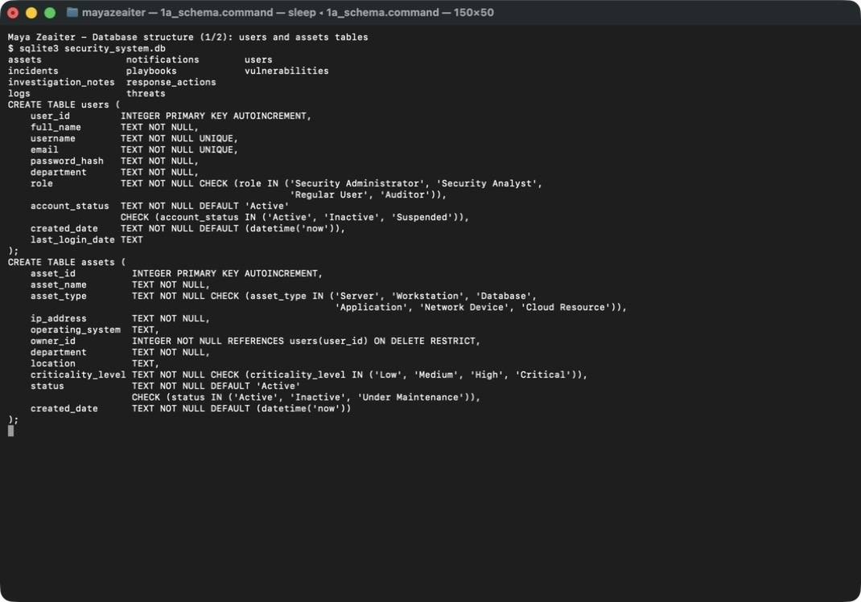
Figure 74: Maya Zeaiter – Database structure – users and assets tables (primary keys, UNIQUE, CHECK constraints, owner_id foreign key)
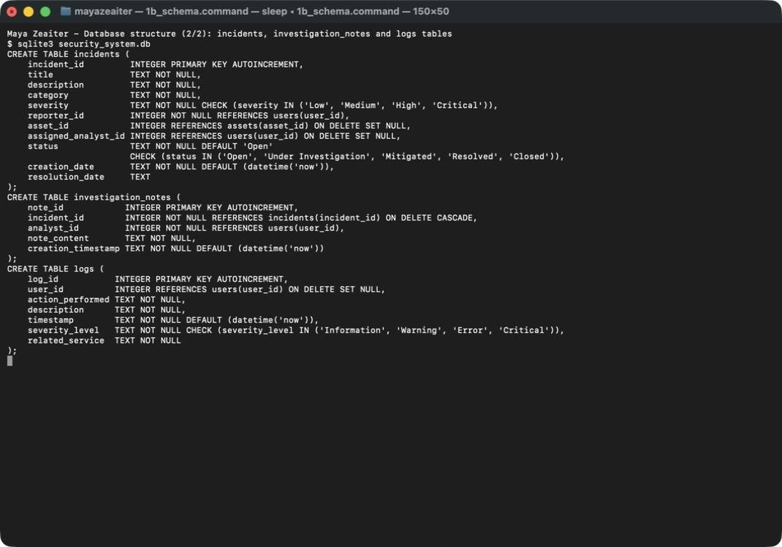
Figure 75: Maya Zeaiter – Database structure – incidents, investigation_notes and logs tables with their foreign keys
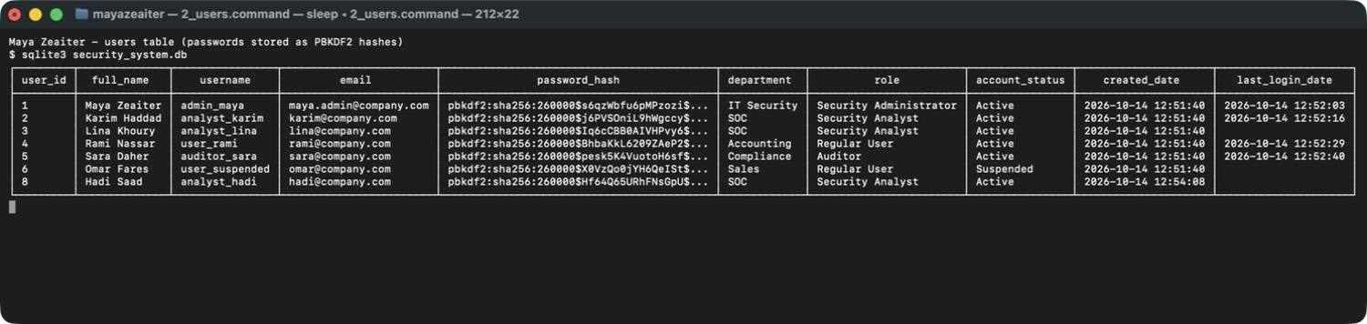
Figure 76: Maya Zeaiter – users table records – passwords are stored only as PBKDF2 hashes; Suspended account and the deleted user (id 7) are visible
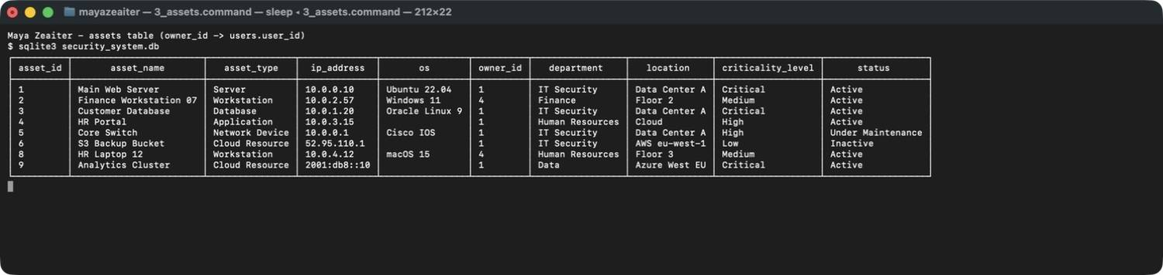
Figure 77: Maya Zeaiter – assets table records – criticality level and status stored as validated text values; asset 7 was deleted
Figure 78: Maya Zeaiter – incidents and investigation_notes records – incident 5 closed with resolution date, two notes linked to it, and the incidents foreign keys
Figure 79: Maya Zeaiter – logs table – counts per action and the automatically recorded failed logins and unauthorized access attempts

GitHub (Maya Zeaiter)
Figure 80: Maya Zeaiter – GitHub commit history (newest commits) – repository Maya_Zeaiter-Zeinab_Harb-Omar_Obeid
Figure 81: Maya Zeaiter – GitHub commit history (older commits) – one commit per implementation step
Figure 82: Maya Zeaiter – GitHub Contributors page – commits by mayazeaiter37 (Maya Zeaiter)

5.2 Services 4–6 (Zeinab Harb)

Architecture of my services
My three services follow the same structure as Services 1–3. Each one is a Flask Blueprint (threats_service.py, logs_service.py, reports_service.py) registered in app.py, and they share the team's helpers:
- Entity classes Threat and AuditLog (dataclasses in models.py). Each holds its allowed values (Threat.TYPES, Threat.SEVERITIES, AuditLog.SEVERITIES) and a to_dict() method.
- Repositories ThreatRepository and LogRepository, which inherit from Maya's BaseRepository. They reuse the generic get_by_id, get_all, insert, delete and search methods and add their own:
- ThreatRepository.find_duplicate() detects an existing type + value pair.
- LogRepository.for_user() and LogRepository.filter() serve the log lookups.
- LogRepository overrides update() to raise an error, so audit logs cannot be modified even from code (polymorphism).
- Shared helpers in common.py:
- require_roles checks authentication and roles; I pass service= so violations are logged under my service.
- write_log() records audit events.
- success() / error_body() build the response format.
- Developer name. I added set_developer(blueprint, name) to common.py. A before_request hook stores g.developer = "Zeinab Harb" for my blueprints, and success()/error_body() read it. Every response from my services, including 401/403 errors raised before my code runs, shows "developer": "Zeinab Harb". Maya's routes are unchanged.
Communication between services. All services run in one Flask application and share one SQLite database. Services 1–3, 4 and 7–9 call write_log() to send events to the Audit Logging Service. The Reports Service reads the tables owned by the other services (users, assets, incidents, threats, logs, vulnerabilities) with read-only SQL aggregate queries.

Service 4: Threat Intelligence (Zeinab Harb)
Responsibility: stores known threat indicators (malicious IPs, suspicious domains, malware hashes, malware signatures and other indicators) so they can be used during incident investigation.
APIs: POST /threats, GET /threats, GET /threats/{id}, GET /threats/search, PUT /threats/{id}, DELETE /threats/{id} (see Section 8 / README for request and response formats).
Database interaction: the threats table. INSERT on create, SELECT on read and search (parameterised), UPDATE of description, severity and source, DELETE on delete.
Add Threat Indicator: type and severity of each added threat.
# | Type | Value | Severity | Why this severity
1 | IP Address | 192.0.2.10 | High → updated to Critical | Brute-forcing RDP on finance workstations is an active attack. It was raised to Critical once confirmed as a command-and-control address.
2 | Domain | update-account-verify.net | Medium | Phishing domain. It needs a user to click, so it is not directly exploitable.
3 | File Hash (SHA-256) | 8148eaa7…8e86 | Critical | Ransomware dropper: infection leads to data encryption and business outage.
4 | Malware Signature | Adware.BrowserHelper.X | Low | Adware is a nuisance with low impact on confidentiality and integrity.

The seed data adds 8 more indicators covering every type and every severity, such as a ransomware C2 IP (Critical), a phishing domain (High) and an sqlmap user agent (Other, Low).
How validation works on insert.
- The body must be non-empty JSON with exactly the five fields. Missing fields give 400; unknown fields give 400.
- threat_type and severity_level must be one of the allowed values.
- threat_value is checked according to its type by normalize_threat_value():
- IPs with Python's ipaddress module;
- domains with a regular expression (labels of letters/digits/hyphens, no leading or trailing hyphen, alphabetic TLD, at most 253 characters);
- hashes must be hexadecimal with a length of 32, 40, 64 or 128 (MD5, SHA-1, SHA-256, SHA-512).
- The value is normalised to a canonical form so that duplicates cannot hide behind formatting. IPs are compressed, and domains and hashes are lowercased (EVIL.com = evil.com).
Threat indicator uniqueness. Before inserting, find_duplicate() looks for the same type + value (case-insensitive). If one exists, the API returns 409 Conflict with the id of the existing threat. The UNIQUE (threat_type, threat_value) constraint in schema.sql is a second safety net at the database level.
Response format of GET /threats. {status, message, developer, data: {count, threats: [...]}}. Each threat contains threat_id, threat_type, threat_value, description, severity_level, source, date_added, sorted by id.
GET /threats/{id} responses.
- Existing id → 200 with "message": "Threat indicator found" and the full threat.
- Non-existing id → 404 with {"status":"error","message":"Threat indicator with id 99999 not found","developer":"Zeinab Harb"}.
- A non-numeric id doesn't match the <int:threat_id> route, so it also returns 404.
How search results are generated.
- Query parameters are mapped to a whitelist of columns:
- type → threat_type and severity → severity_level (exact match, validated against the allowed values);
- value → threat_value and source → source (partial, case-insensitive LIKE %value%).
- Each parameter becomes one WHERE condition, and conditions are combined with AND.
- Values are always bound as SQL parameters (?), so the injection attempt value=' OR '1'='1 is treated as plain text and returns 0 results.
- Unknown parameters, empty values, invalid enum values or no parameters at all return 400.
Validation applied during updates.
- Only description, severity_level and source may be sent.
- threat_type / threat_value are read-only (400), because changing them would create a different indicator and could bypass the duplicate check. To change them, delete the indicator and add a new one.
- severity_level must be valid, and strings cannot be empty or exceed their length limits.
- The response contains before and after, and a THREAT_UPDATED log records each changed field (e.g. severity_level: 'High' -> 'Critical').
Deletion and unauthorized deletion prevention. DELETE /threats/{id} is decorated with @require_roles(ADMIN). An Analyst or Auditor gets 403, and require_roles writes an UNAUTHORIZED_ACCESS (Warning) log. A successful deletion returns the deleted record and writes THREAT_DELETED.
Role decision. The spec's service table lists only GET /threats and GET /threats/{id} for the Auditor. The Auditor role description, however, includes "Search threat indicators". We followed the role description and allowed Auditors to search, which is still read-only.

Service 5: Security Audit Logging (Zeinab Harb)
Responsibility: records and exposes security activity for accountability.
APIs: POST /logs, GET /logs, GET /logs/{id}, GET /logs/search, DELETE /logs/{id}, GET /logs/user/{user_id}.
Database interaction: the logs table (user_id is a foreign key to users). One user generates many logs.
What events generate logs. Logs are created automatically by common.write_log() from every service, plus manually through POST /logs.
Event | Action | Severity | Service
Successful login | LOGIN_SUCCESS | Information | Users and Identity
Failed login (wrong password, unknown user, inactive account) | LOGIN_FAILED | Warning | Users and Identity
User created / deleted / updated | USER_CREATED / USER_DELETED / USER_UPDATED | Information / Warning | Users and Identity
Role change | ROLE_CHANGED | Warning | Users and Identity
Any permission violation (wrong role, not own record) | UNAUTHORIZED_ACCESS | Warning | the service that was called
Asset / incident changes | ASSET_*, INCIDENT_* | Information–Critical | Assets / Incidents
Threat changes | THREAT_CREATED, THREAT_UPDATED, THREAT_DELETED | Information / Warning | Threat Intelligence
Log deleted | LOG_DELETED | Warning | Security Audit Logging
Attempt to modify a log | LOG_MODIFICATION_BLOCKED | Warning | Security Audit Logging

Create Log Record. POST /logs (Admin) adds events that happen outside the API, such as a malware scan or a blocked USB device. Validation:
- user_id must be an existing user (404 otherwise);
- action_performed is normalised to UPPER_SNAKE_CASE (USB device blocked → USB_DEVICE_BLOCKED);
- severity_level must be Information, Warning, Error or Critical;
- related_service must be one of the nine service names;
- timestamp is set by the database (datetime('now'), UTC), so a client cannot back-date a log.
Information displayed by GET /logs. data: {count, logs: [...]}, newest first. Each log shows:
- log_id;
- user_id and username, i.e. who performed the action (from a join with the users table);
- action_performed;
- description (what exactly happened);
- timestamp (UTC);
- severity_level;
- related_service (which service produced it).
GET /logs/{id} responses. An existing id gives 200 with the record. An invalid id gives 404 "Log record with id 99999 not found".
How filtering works (GET /logs/search). LogRepository.filter() builds one WHERE condition per supplied parameter and joins them with AND. Every value is a bound parameter.
Parameter | Condition | Notes
user | user_id = ? if numeric; user_id IN (SELECT user_id FROM users WHERE username = ?) if a username
date | date(timestamp) = ? | Validated as YYYY-MM-DD; invalid → 400
action | action_performed LIKE %value% | Case-insensitive
severity | severity_level = ? | Validated
service | related_service LIKE %value% | Case-insensitive

How logs are filtered by user id (GET /logs/user/{user_id}).
- The route first checks that the user exists. An unknown id gives 404, which distinguishes "no such user" from "no activity".
- It then runs SELECT * FROM logs WHERE user_id = ? ORDER BY log_id DESC.
- The response includes the user's summary (username, full_name, role), the count and the logs.
- A user with no activity (e.g. analyst_lina, who never logged in) returns 200 with count: 0, an empty list and the message "User 'analyst_lina' has no recorded activity".
Audit log protection and access control for deletion.
- Preserve and never modify. There is no update API. PUT/PATCH /logs/{id} returns 405 "Audit logs cannot be modified after creation", and the attempt itself is logged. In code, LogRepository.update() raises an error.
- Only administrators delete. DELETE /logs/{id} uses @require_roles(ADMIN). Analysts, Auditors and Regular Users get 403, and the attempt is logged as UNAUTHORIZED_ACCESS.
- Traceable deletion. A successful deletion writes a new LOG_DELETED record with the deleted log's action, severity and timestamp. Removing evidence therefore always leaves a trace.
Roles:
- Admin: all six APIs.
- Auditor: view all, view one, search, by user.
- Analyst: view one and search only (per the spec table).
- Regular User: none.

Service 6: Security Reports (Zeinab Harb)
Responsibility: generates security statistics from the data of the other services. Reports are read-only and available to the Security Administrator and Auditor only. Analysts and Regular Users get 403, and the attempt is logged.
How information is collected from other services/tables. Each report opens one database connection and runs aggregate SQL queries on the tables owned by the other services:
Report | Source tables (service) | Main queries
Summary | users (1), assets (2), incidents (3), threats (4), logs (5), vulnerabilities (7) | COUNT(*) with conditions, e.g. status NOT IN ('Resolved','Closed') for open incidents and severity_level='Critical' for critical threats; last 5 logs joined with users
Incidents | incidents (3) | COUNT(*), GROUP BY severity, GROUP BY status, GROUP BY category, assigned_analyst_id IS NULL
Assets | assets (2) | COUNT(*), criticality_level='Critical', GROUP BY asset_type / criticality_level / status
Threats | threats (4) | COUNT(*), GROUP BY severity_level, GROUP BY threat_type, ORDER BY date_added DESC LIMIT 5
Vulnerabilities | vulnerabilities (7) joined with assets (2) | COUNT(*), GROUP BY severity_level / status, AVG(cvss_score), critical list with the affected asset name
Activity | logs (5) joined with users (1) | COUNT(*); counts of LOGIN_SUCCESS, LOGIN_FAILED, UNAUTHORIZED_ACCESS; GROUP BY action_performed ORDER BY count DESC LIMIT 5; GROUP BY user_id; GROUP BY severity_level / related_service

Grouped results always list every allowed value, including zeros. For example, the vulnerability report shows "Low": 0, so the reader can see that a category is empty rather than missing. The sum of each group always equals the total.
Threat report: how threat data is collected. The report reads the threats table maintained by the Threat Intelligence Service. "Threats grouped by severity" and "by type" are GROUP BY counts. "Recently added threats" are the 5 newest rows by date_added.
Vulnerability report: how vulnerability data is collected. The report reads the vulnerabilities table maintained by the Vulnerability Management Service (Service 7) and joins assets to show the affected asset's name for each critical vulnerability. Until Service 7's API is complete, seed.py inserts 6 sample vulnerabilities with different severities and statuses.
Activity report: how audit logs are analysed.
- Total user activities = number of rows in logs.
- Login attempts = LOGIN_SUCCESS + LOGIN_FAILED. Failed login attempts = rows with LOGIN_FAILED, including attempts on unknown usernames, which have no user_id.
- Most performed actions = GROUP BY action_performed ORDER BY COUNT(*) DESC, top 5.
- Most active users = GROUP BY user_id joined with users to show usernames.
Successful report generation is deliberately not logged, so viewing a report does not change the activity numbers it reports.
Verifying report values against the database. Run these queries in DB Browser for SQLite and compare them with the report screenshots:
-- Threat report
SELECT COUNT(*) FROM threats;
SELECT severity_level, COUNT(*) FROM threats GROUP BY severity_level;
SELECT threat_type, COUNT(*) FROM threats GROUP BY threat_type;
-- Vulnerability report
SELECT severity_level, COUNT(*) FROM vulnerabilities GROUP BY severity_level;
SELECT status, COUNT(*) FROM vulnerabilities GROUP BY status;
SELECT ROUND(AVG(cvss_score), 2) FROM vulnerabilities;
-- Activity report
SELECT COUNT(*) FROM logs;
SELECT action_performed, COUNT(*) FROM logs GROUP BY action_performed ORDER BY 2 DESC;
-- Summary report
SELECT COUNT(*) FROM incidents WHERE status NOT IN ('Resolved', 'Closed');
SELECT COUNT(*) FROM threats WHERE severity_level = 'Critical';
The automated tests (tests/test_services_4_6.py) also compare each report with these queries.

Postman and database screenshots – Services 4–6 (Zeinab Harb)

1. Authentication (Zeinab Harb)
Figure 83: Zeinab Harb – User Login – failed login with a wrong password is rejected (401) and creates a LOGIN_FAILED audit log

2. Threat Intelligence Service (Service 4) (Zeinab Harb)
Figure 84: Zeinab Harb – Add Threat Indicator – adds a malicious IP address with severity High (201)
Figure 85: Zeinab Harb – Add Threat Indicator – adds a phishing domain with severity Medium; the domain is stored in lowercase (201)
Figure 86: Zeinab Harb – Add Threat Indicator – adds a ransomware SHA-256 file hash with severity Critical (201)
Figure 87: Zeinab Harb – Add Threat Indicator – adds an adware malware signature with severity Low (201)
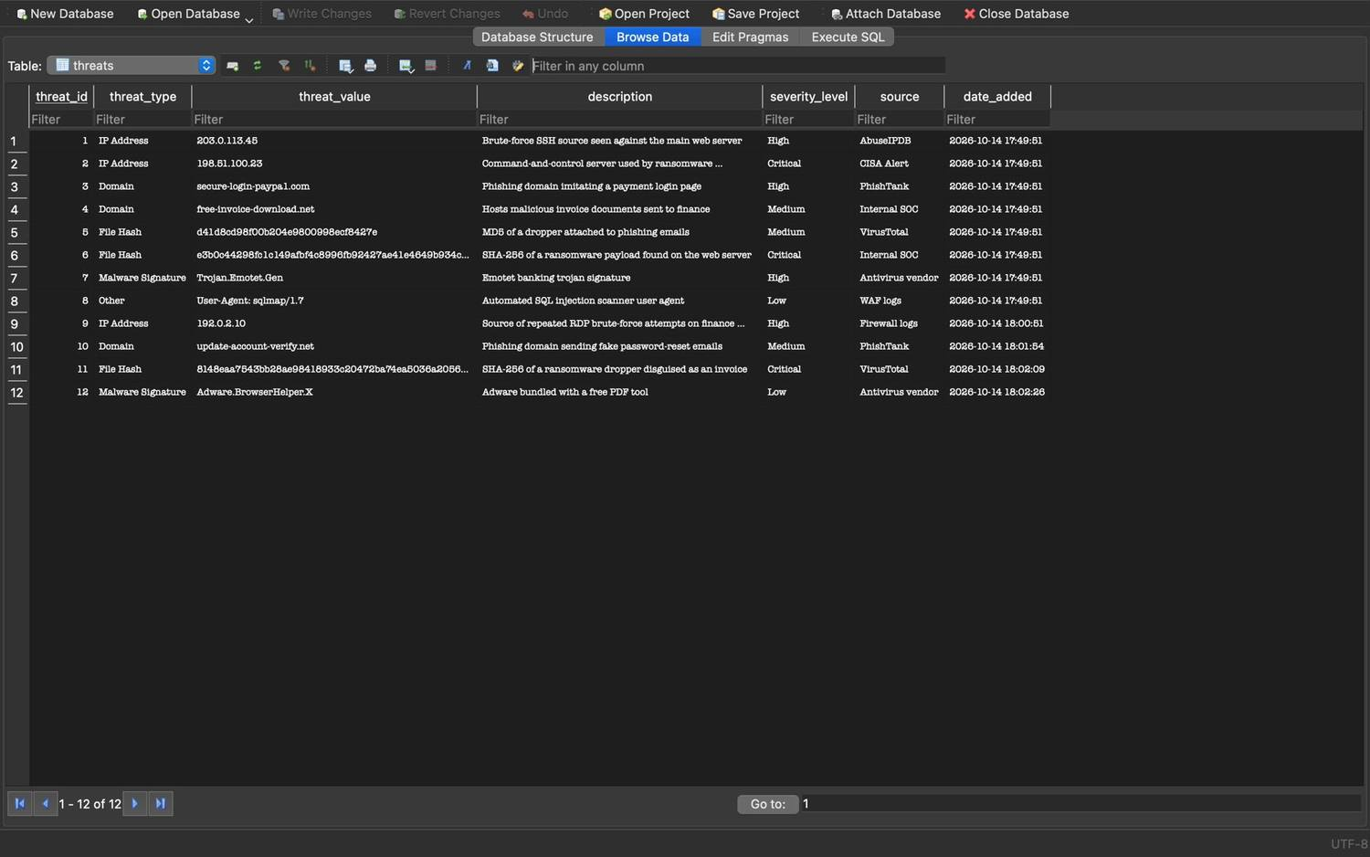
Figure 88: Zeinab Harb – Add Threat Indicator – stored threat records in the database (8 seeded + 4 added, ids 9–12)
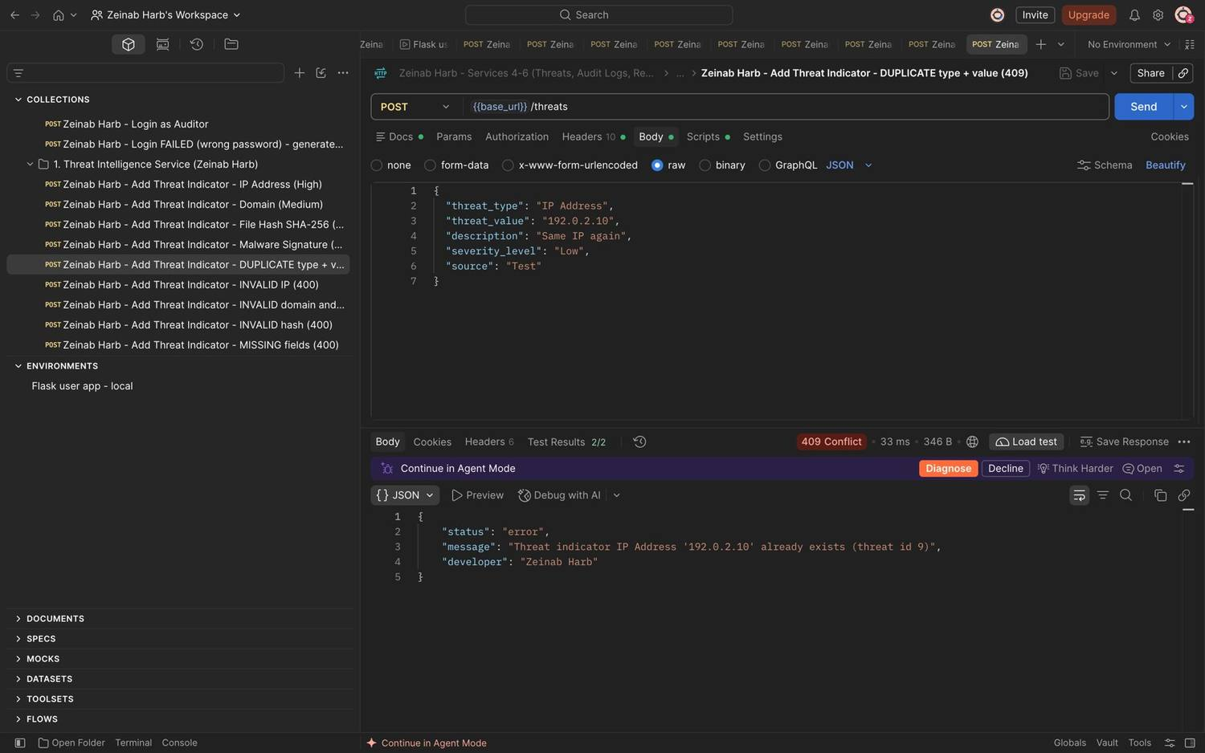
Figure 89: Zeinab Harb – Add Threat Indicator – duplicate threat type and value rejected (409)
Figure 90: Zeinab Harb – Add Threat Indicator – invalid IP address format rejected (400)
Figure 91: Zeinab Harb – Add Threat Indicator – invalid domain format and invalid severity rejected (400)
Figure 92: Zeinab Harb – Add Threat Indicator – invalid file hash format rejected (400)
Figure 93: Zeinab Harb – Add Threat Indicator – missing required fields rejected (400)
Figure 94: Zeinab Harb – Add Threat Indicator – Security Analyst is not allowed to add threats (403)
Figure 95: Zeinab Harb – Retrieve All Threat Indicators – returns every stored threat with severity, source and date added (200)
Figure 96: Zeinab Harb – Retrieve All Threat Indicators – Regular User denied (403)
Figure 97: Zeinab Harb – Retrieve All Threat Indicators – request without a token rejected (401)
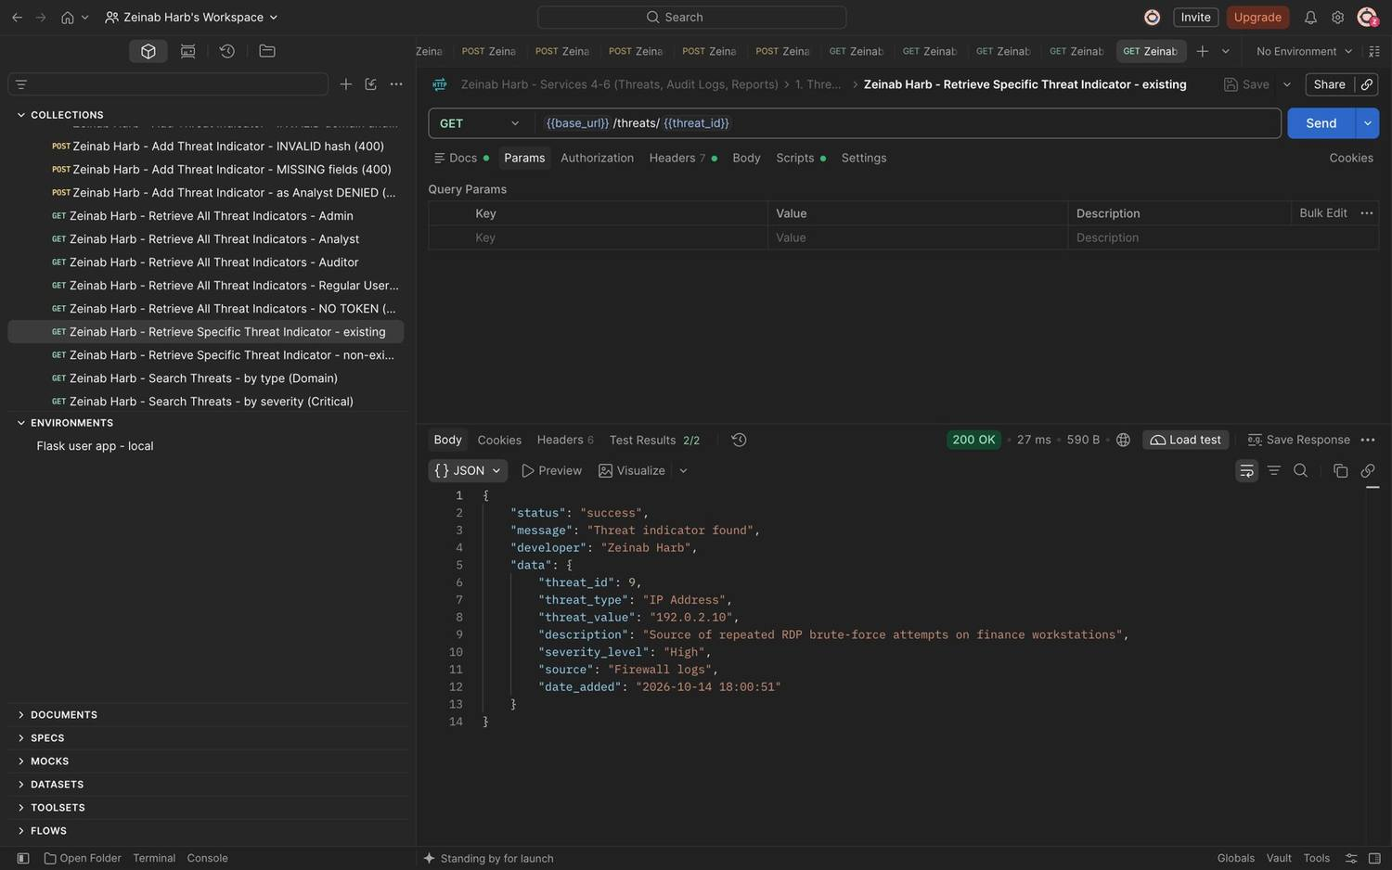
Figure 98: Zeinab Harb – Retrieve Specific Threat Indicator – returns an existing threat (200)
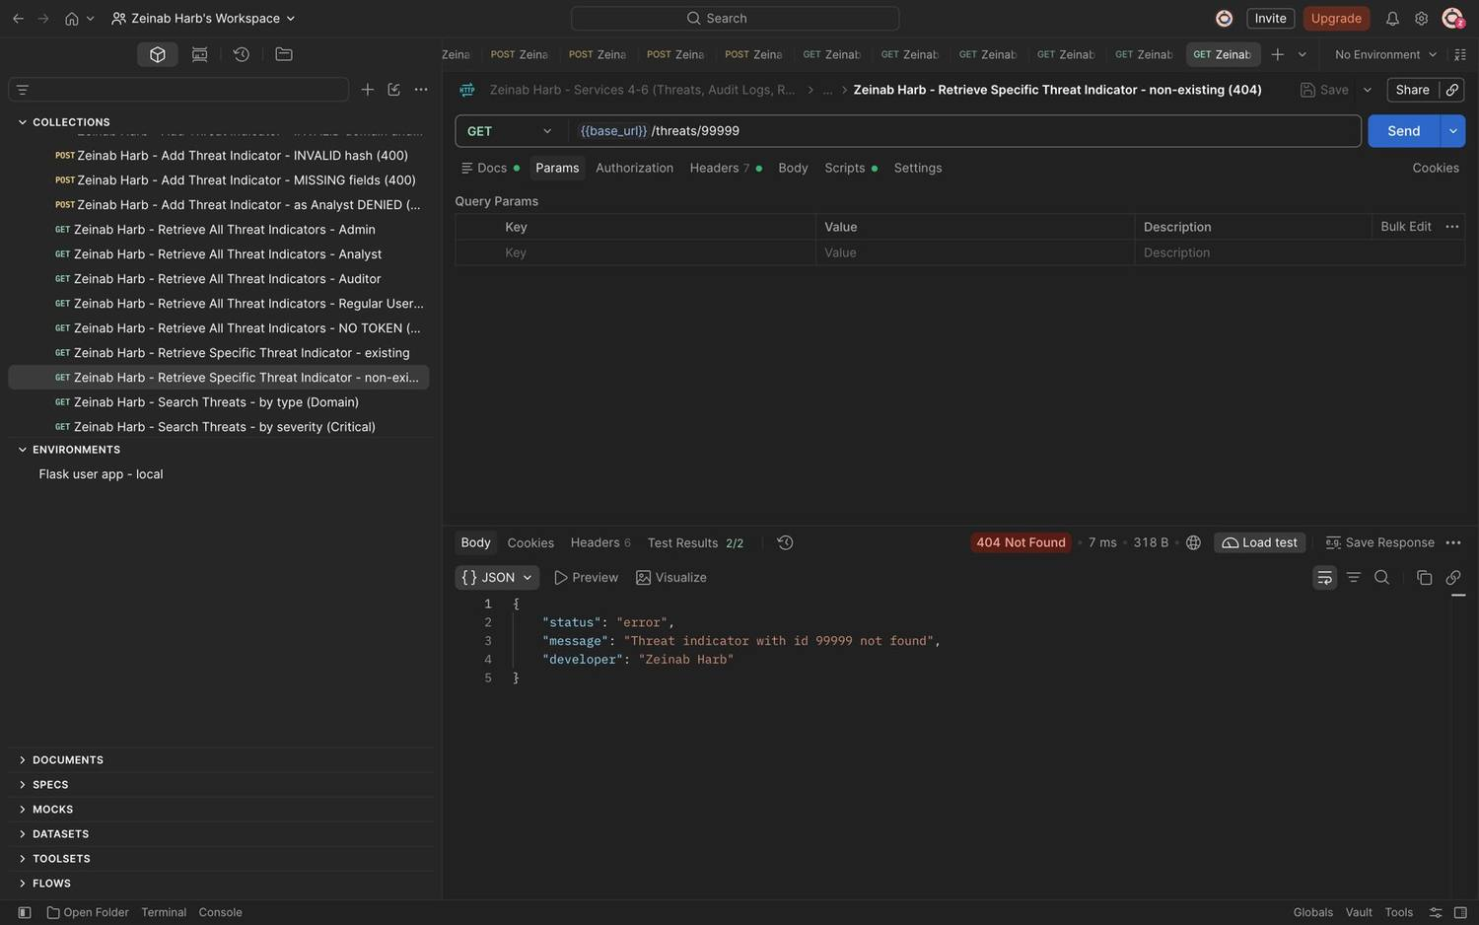
Figure 99: Zeinab Harb – Retrieve Specific Threat Indicator – non-existing threat id returns 404
Figure 100: Zeinab Harb – Search Threat Indicators – search by type (Domain)
Figure 101: Zeinab Harb – Search Threat Indicators – search by severity (Critical)
Figure 102: Zeinab Harb – Search Threat Indicators – partial search by source (soc)
Figure 103: Zeinab Harb – Search Threat Indicators – partial search by threat value (192.0.2)
Figure 104: Zeinab Harb – Search Threat Indicators – combined search by type and severity
Figure 105: Zeinab Harb – Search Threat Indicators – invalid severity value rejected (400)
Figure 106: Zeinab Harb – Search Threat Indicators – SQL injection attempt is treated as text and returns 0 results
Figure 107: Zeinab Harb – Update Threat Information – threat before the update (severity High)
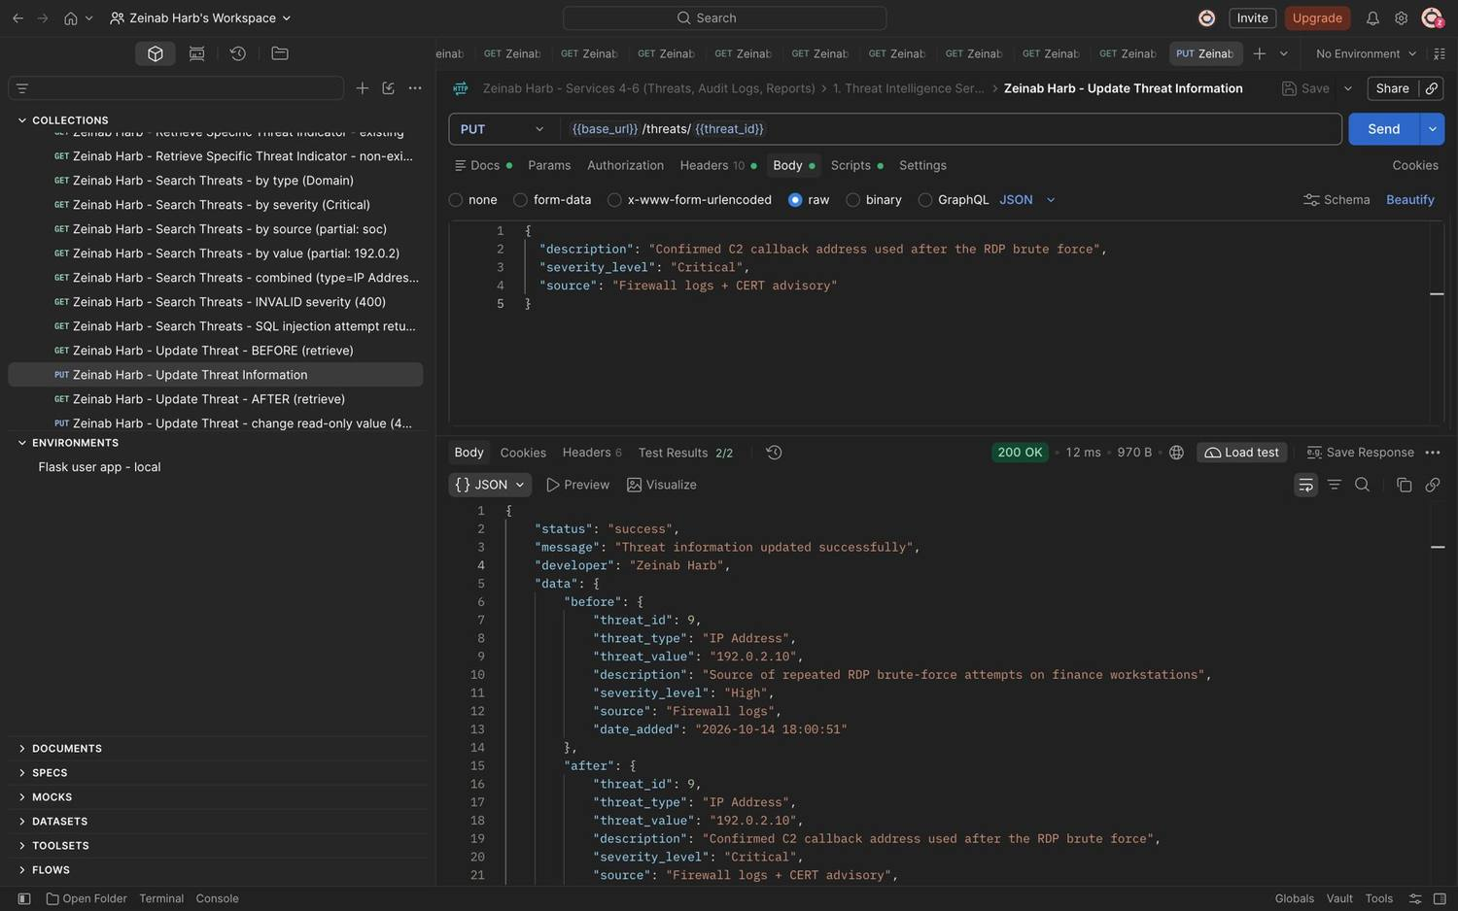
Figure 108: Zeinab Harb – Update Threat Information – updates description, severity and source; response shows before and after (200)
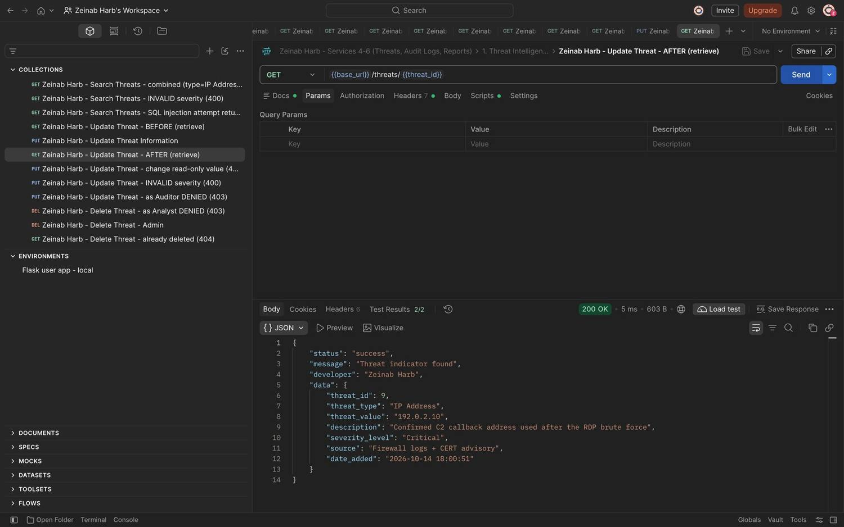
Figure 109: Zeinab Harb – Update Threat Information – threat after the update (severity Critical)
Figure 110: Zeinab Harb – Update Threat Information – changing the read-only threat value rejected (400)
Figure 111: Zeinab Harb – Update Threat Information – invalid severity rejected (400)
Figure 112: Zeinab Harb – Update Threat Information – Auditor not allowed to update threats (403)
Figure 113: Zeinab Harb – Delete Threat Indicator – unauthorized deletion by a Security Analyst prevented (403)
Figure 114: Zeinab Harb – Delete Threat Indicator – Security Administrator deletes a threat (200)
Figure 115: Zeinab Harb – Delete Threat Indicator – the deleted threat no longer exists (404)

3. Security Audit Logging Service (Service 5) (Zeinab Harb)
Figure 116: Zeinab Harb – Security Audit Logging – logs generated automatically by system activities (logins, failed login, threat changes, unauthorized access)
Figure 117: Zeinab Harb – Create Log Record – log record for a Security Analyst activity (201)
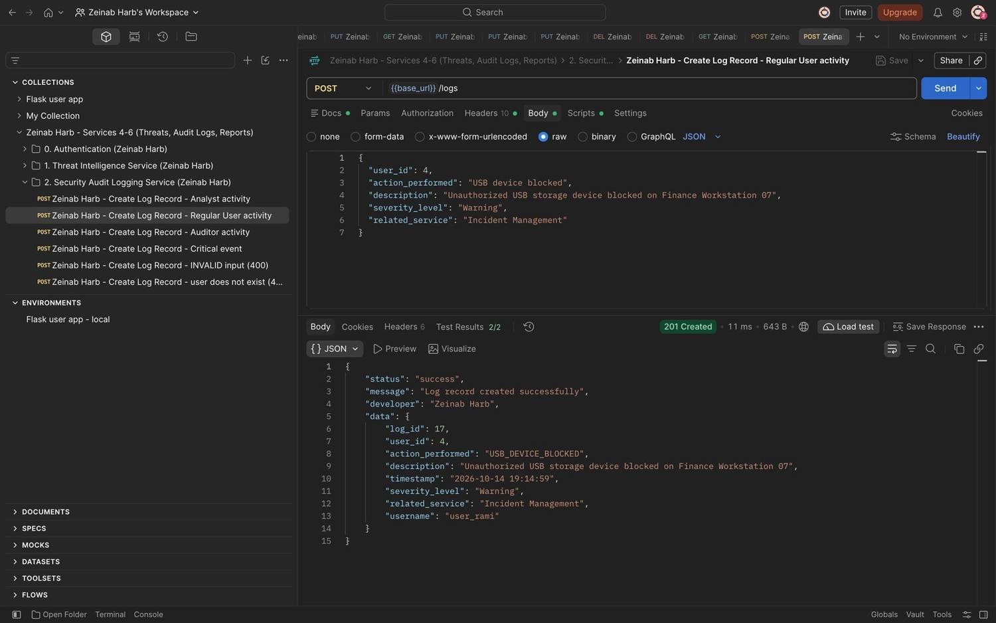
Figure 118: Zeinab Harb – Create Log Record – log record for a Regular User activity; the action is normalised to USB_DEVICE_BLOCKED (201)
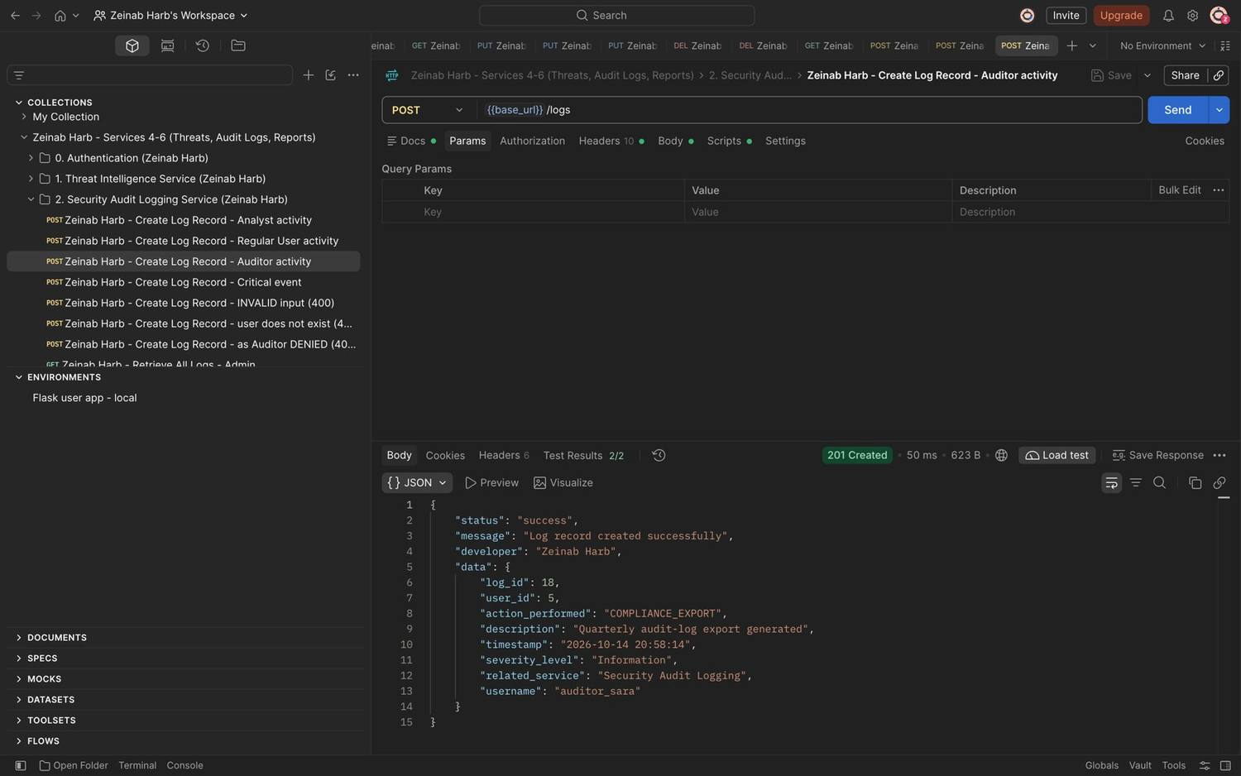
Figure 119: Zeinab Harb – Create Log Record – log record for an Auditor activity (201)
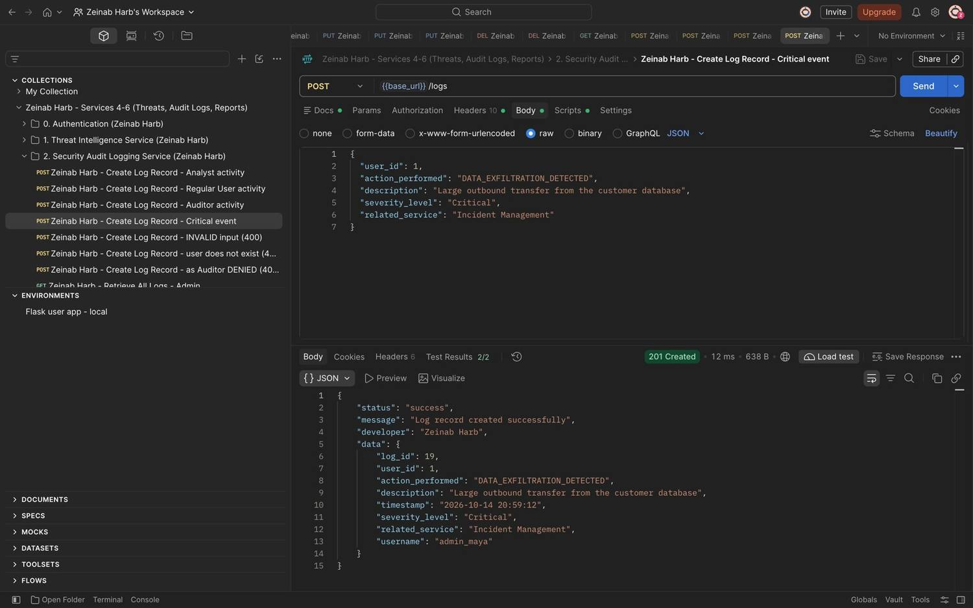
Figure 120: Zeinab Harb – Create Log Record – critical security event logged (201)
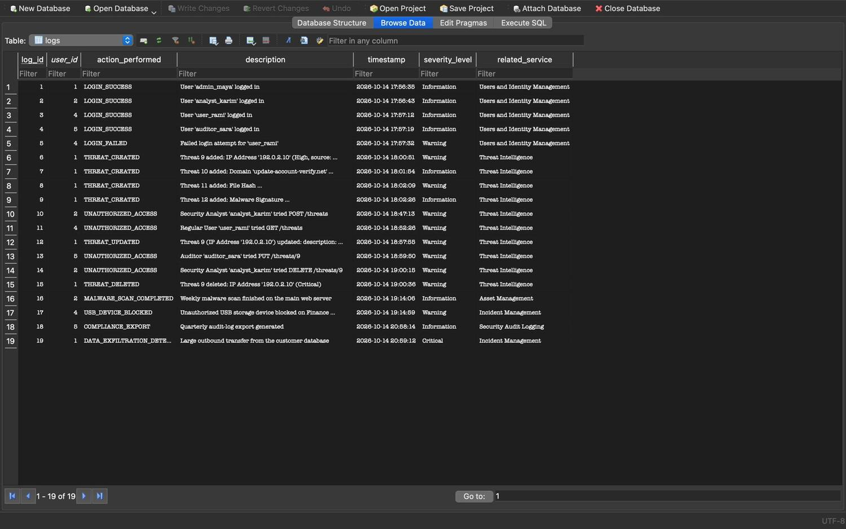
Figure 121: Zeinab Harb – Create Log Record – manually created log records stored in the database
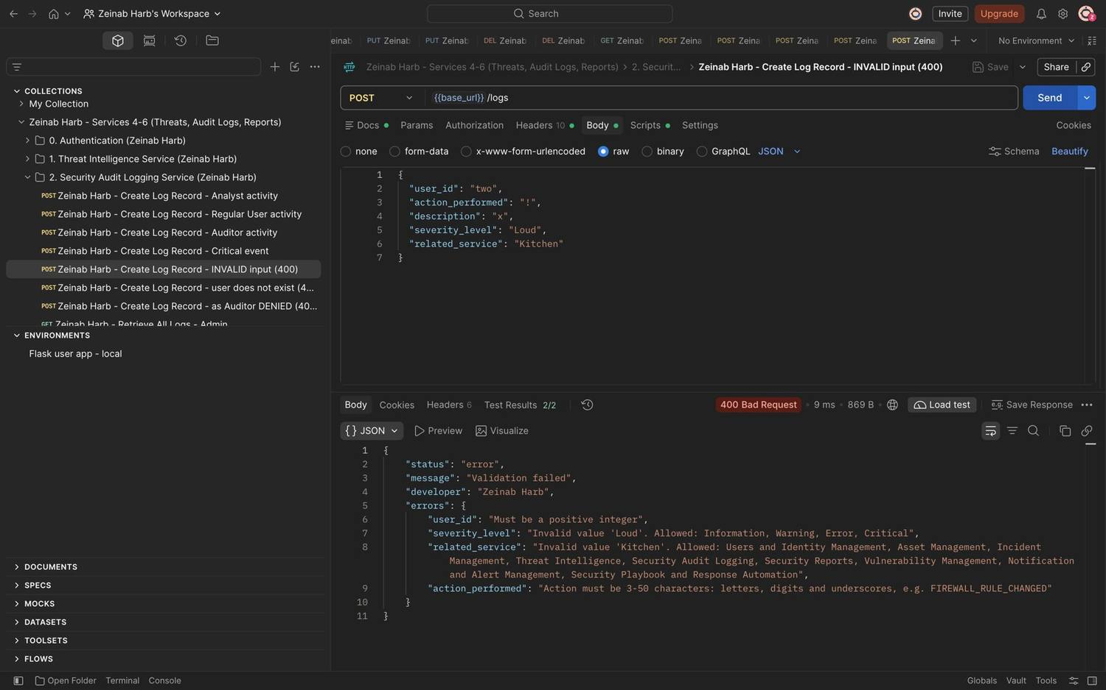
Figure 122: Zeinab Harb – Create Log Record – invalid input rejected with four validation errors (400)
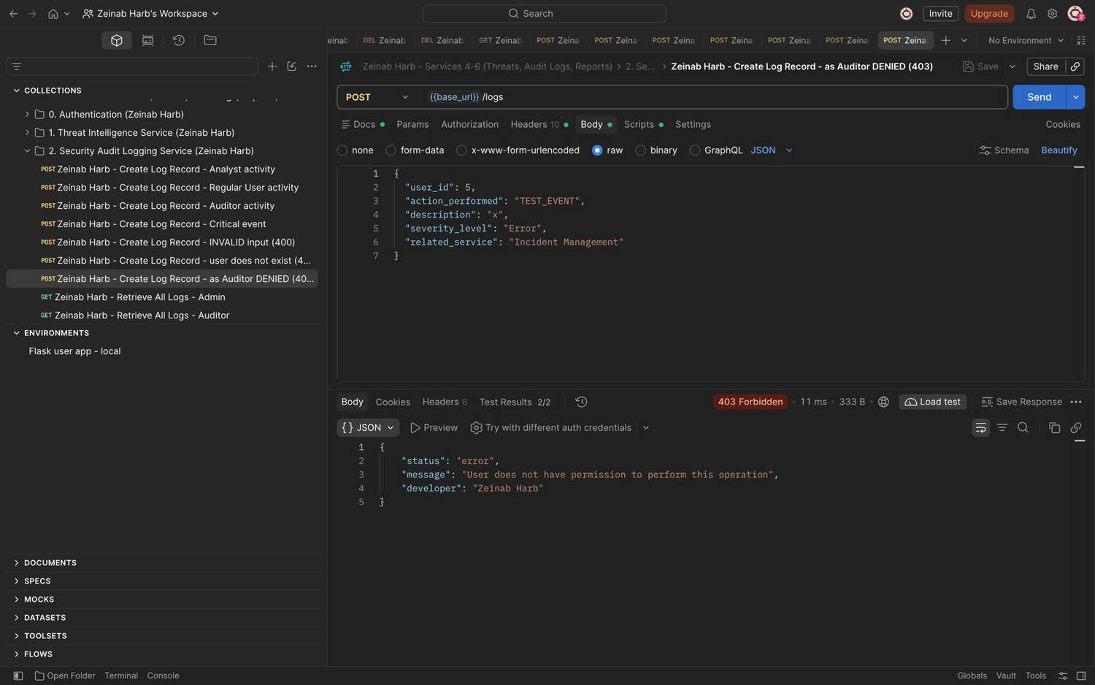
Figure 123: Zeinab Harb – Create Log Record – Auditor cannot create log records (403)
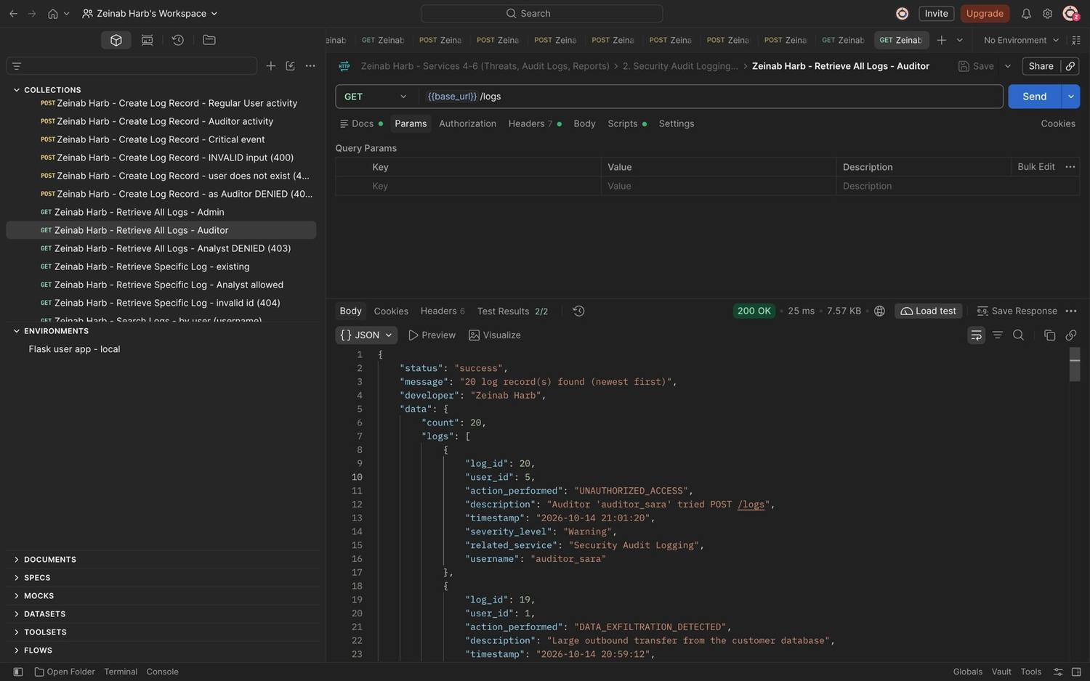
Figure 124: Zeinab Harb – Retrieve All Logs – Auditor views all audit records, newest first (200)
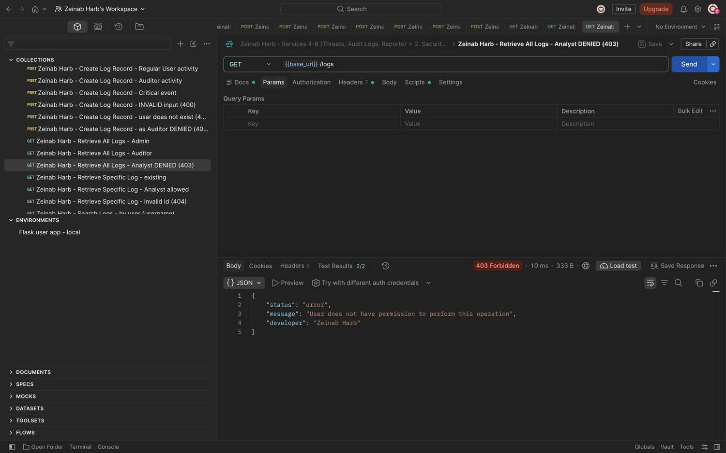
Figure 125: Zeinab Harb – Retrieve All Logs – Security Analyst denied (403)
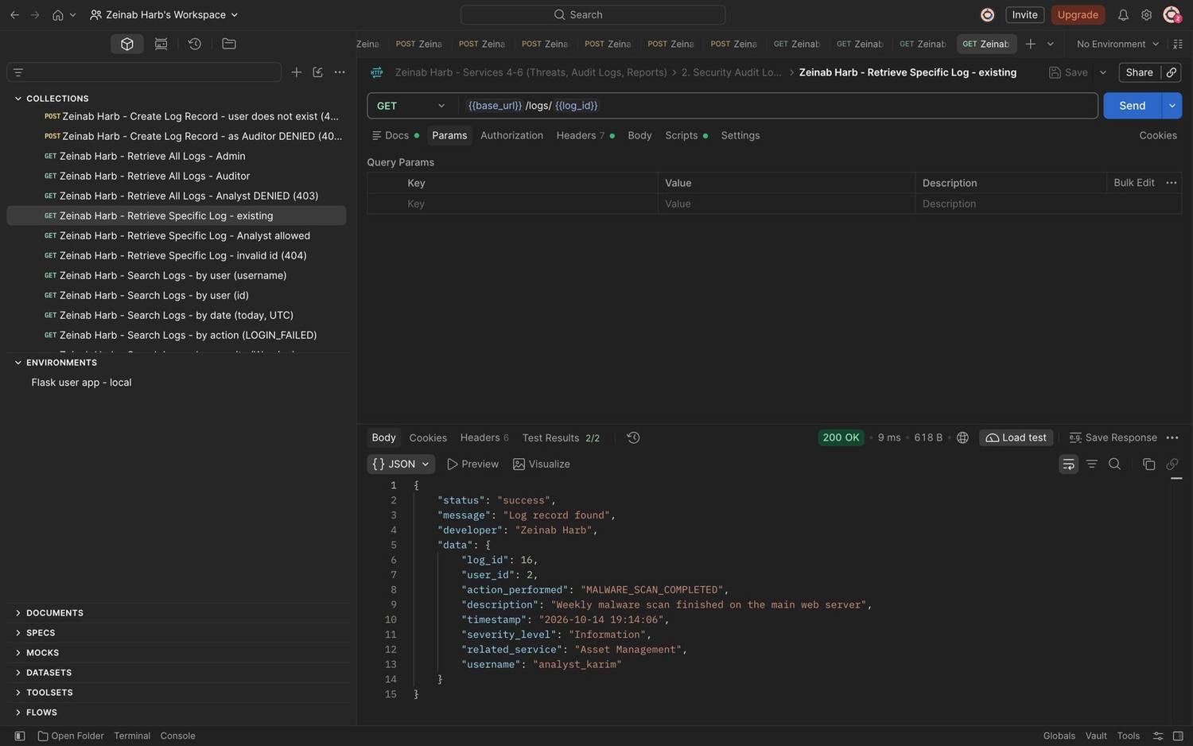
Figure 126: Zeinab Harb – Retrieve Specific Log – returns an existing log record (200)
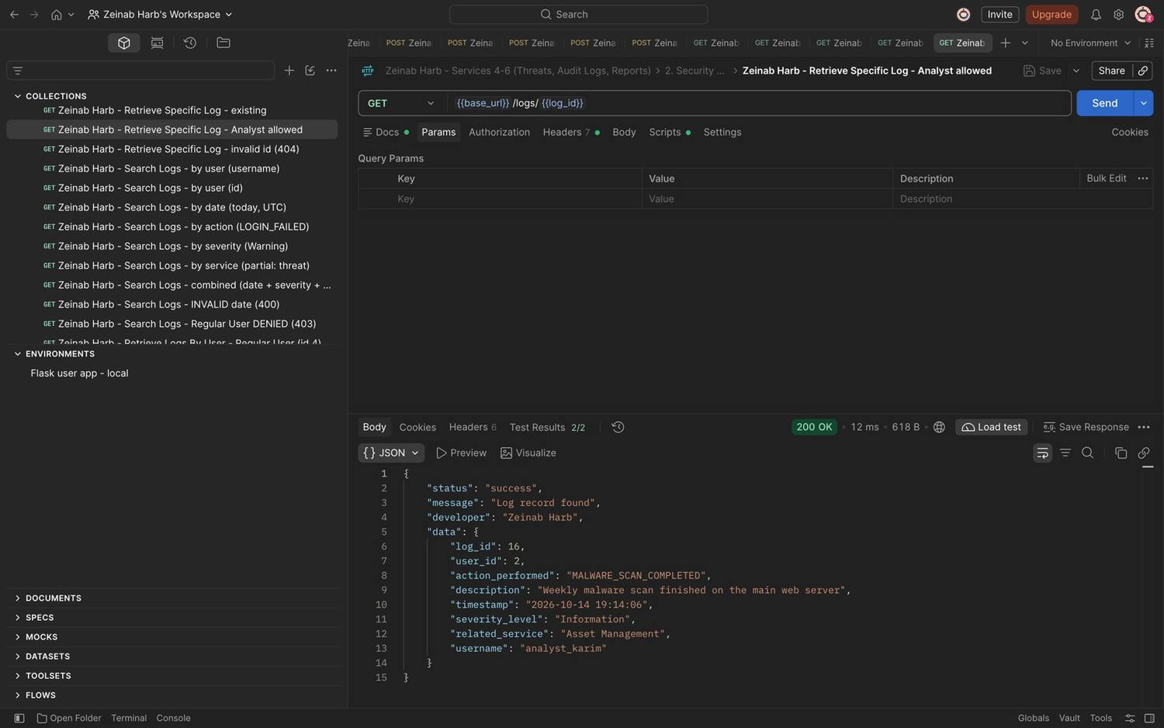
Figure 127: Zeinab Harb – Retrieve Specific Log – Security Analyst is allowed to view a specific log (200)
Figure 128: Zeinab Harb – Retrieve Specific Log – invalid log id returns 404
Figure 129: Zeinab Harb – Search Logs – filter by user (username)
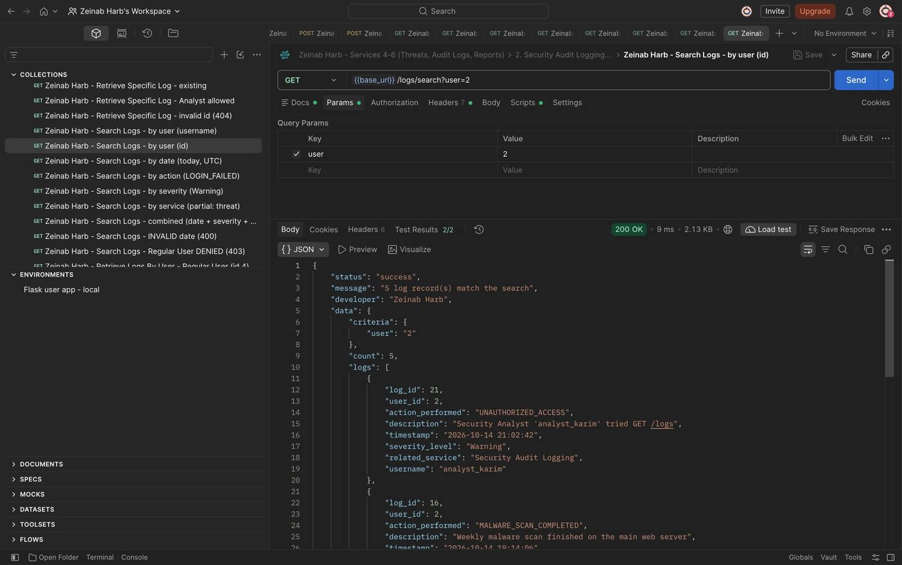
Figure 130: Zeinab Harb – Search Logs – filter by user (user id)
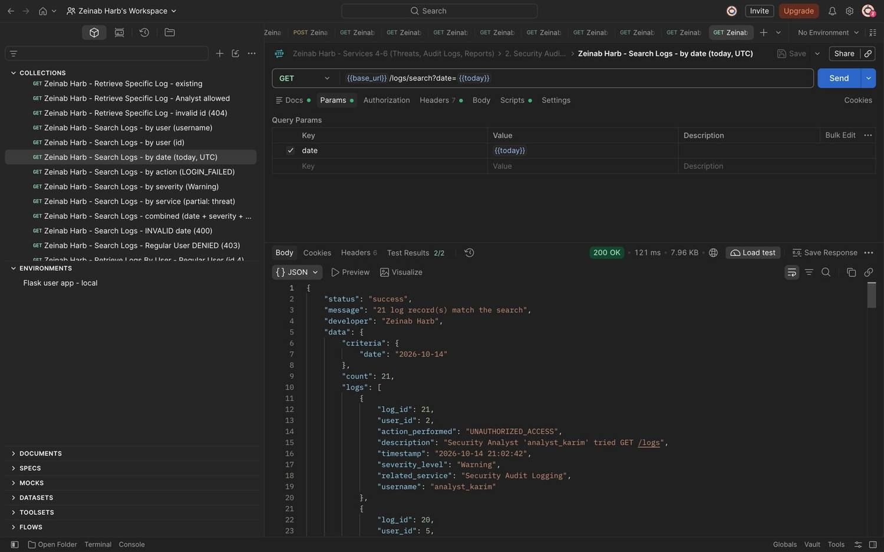
Figure 131: Zeinab Harb – Search Logs – filter by date
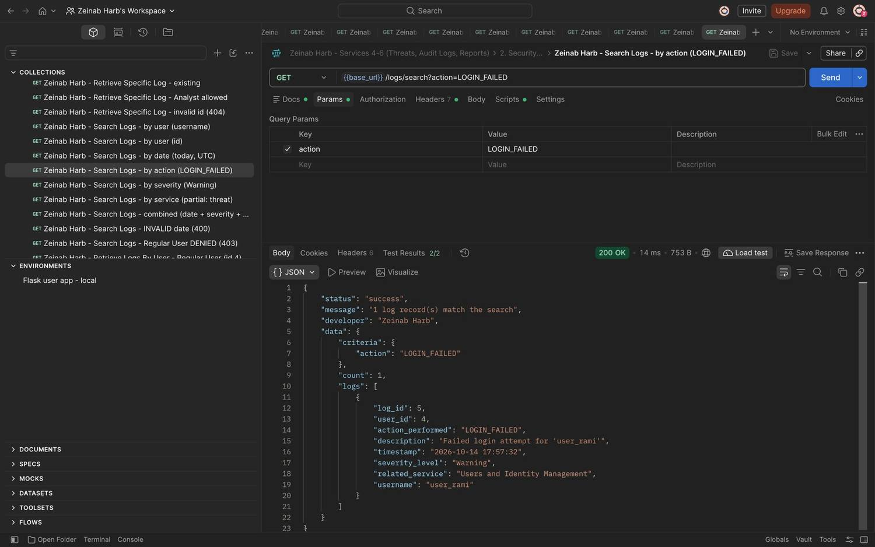
Figure 132: Zeinab Harb – Search Logs – filter by action (LOGIN_FAILED)
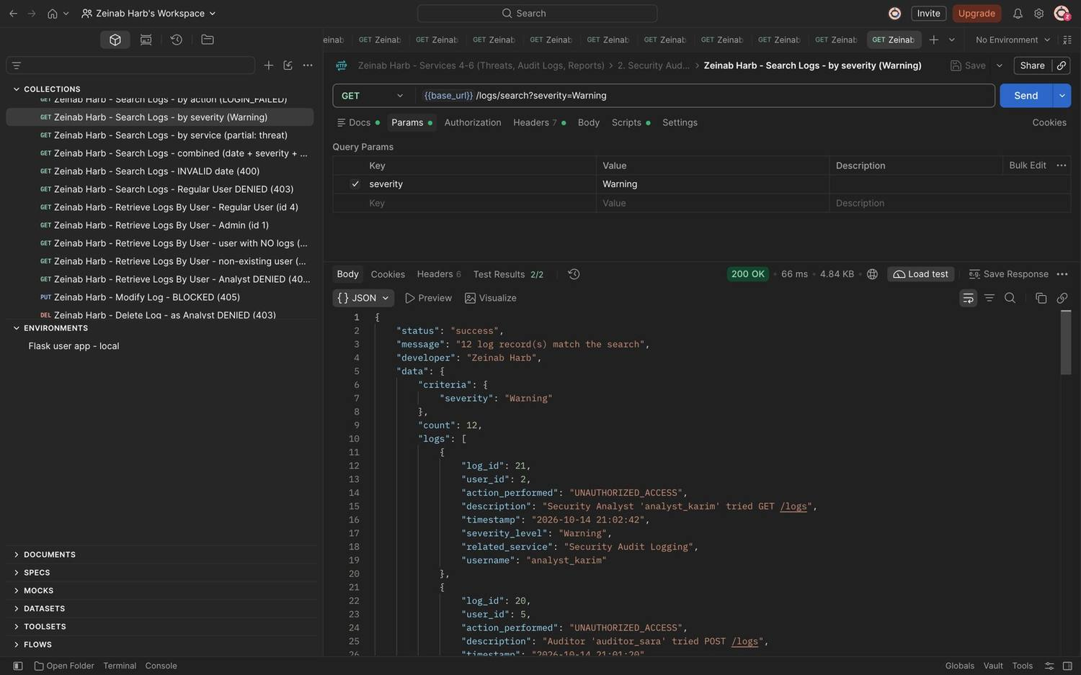
Figure 133: Zeinab Harb – Search Logs – filter by severity (Warning)
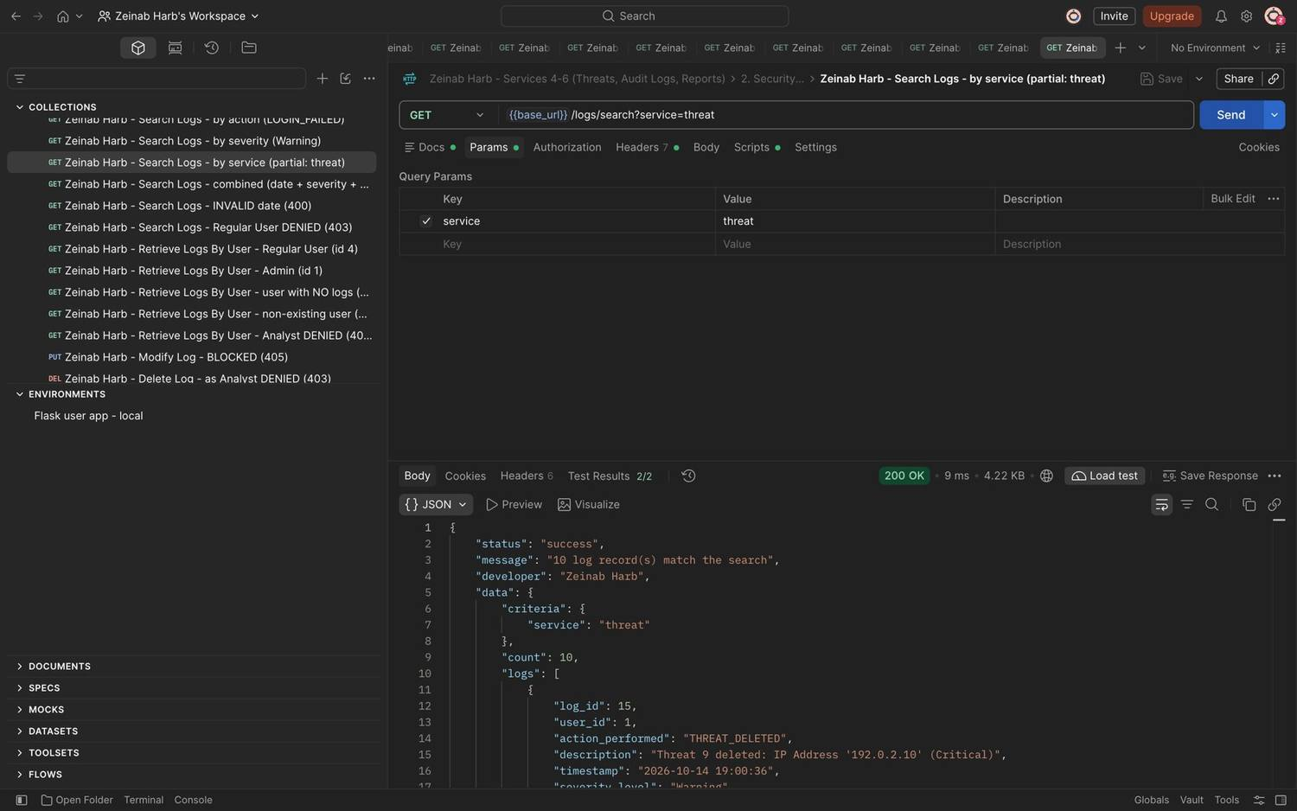
Figure 134: Zeinab Harb – Search Logs – partial filter by related service (threat)
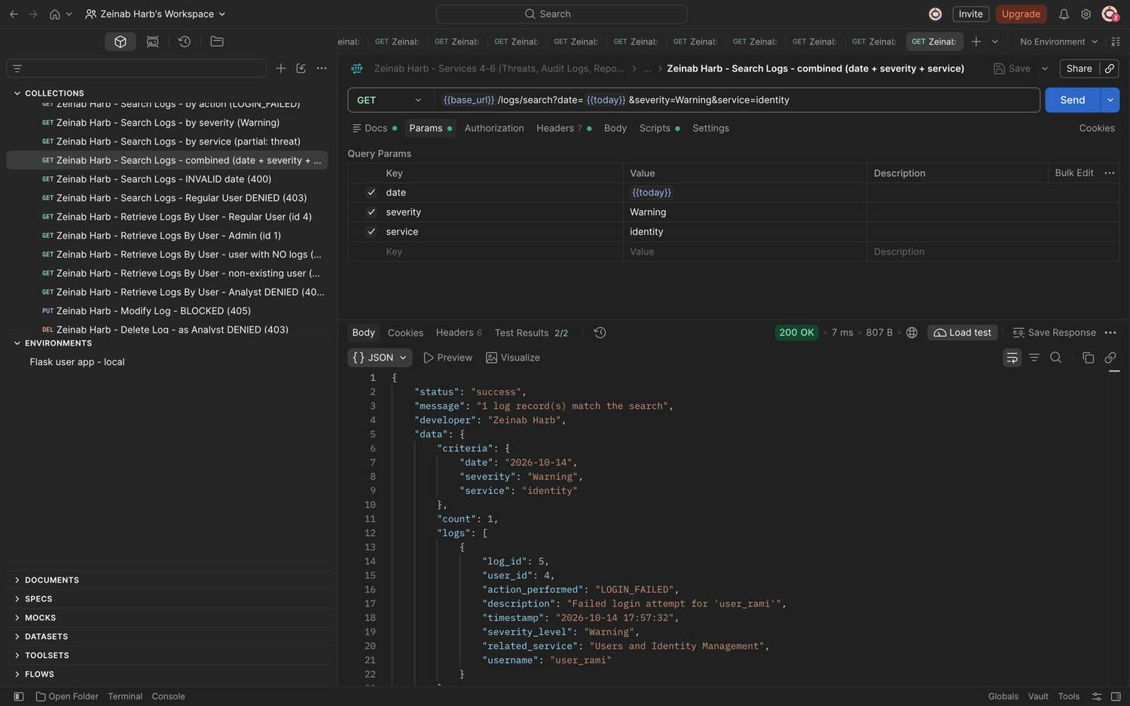
Figure 135: Zeinab Harb – Search Logs – combined date, severity and service filter
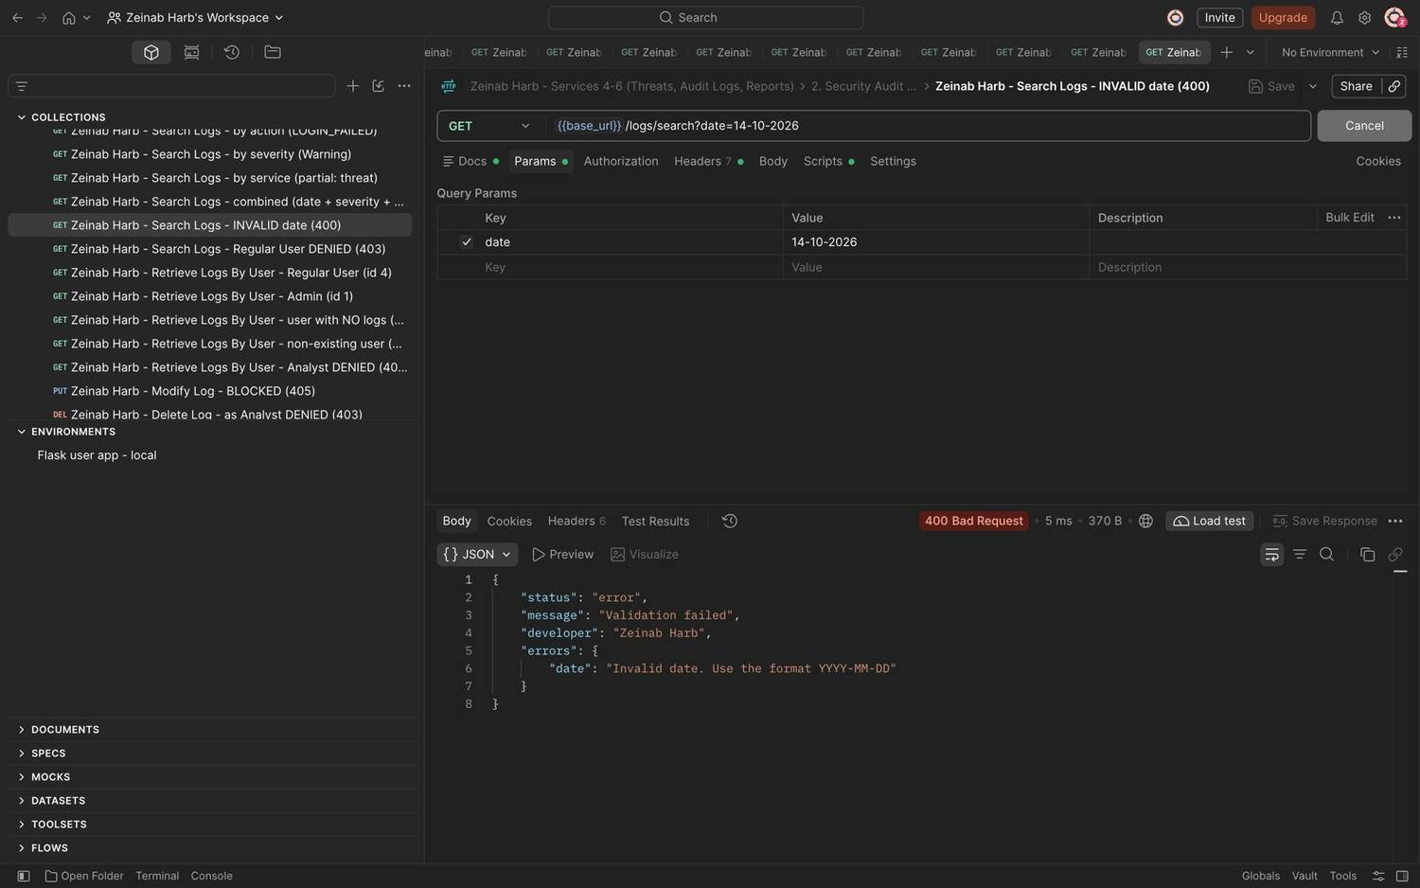
Figure 136: Zeinab Harb – Search Logs – invalid date format rejected (400)
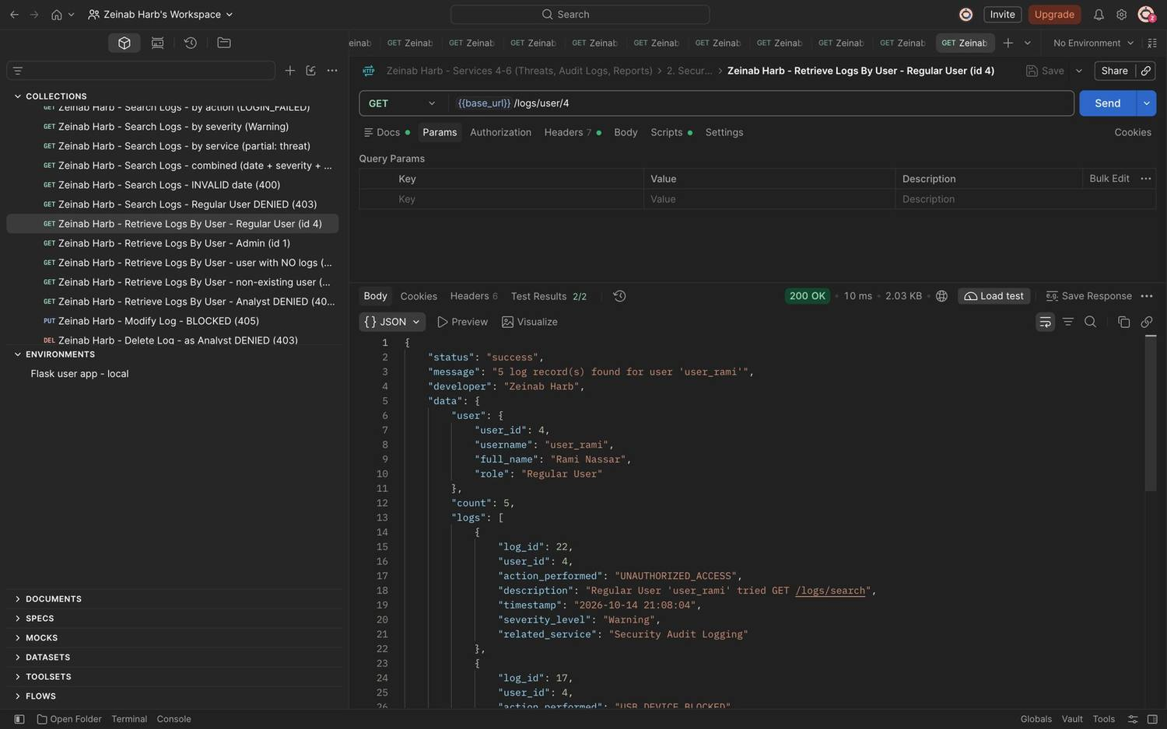
Figure 137: Zeinab Harb – Retrieve Logs By User – returns all logs of the selected user (user_rami, id 4)
Figure 138: Zeinab Harb – Retrieve Logs By User – user with no logs returns an empty list (count 0)
Figure 139: Zeinab Harb – Retrieve Logs By User – non-existing user returns 404
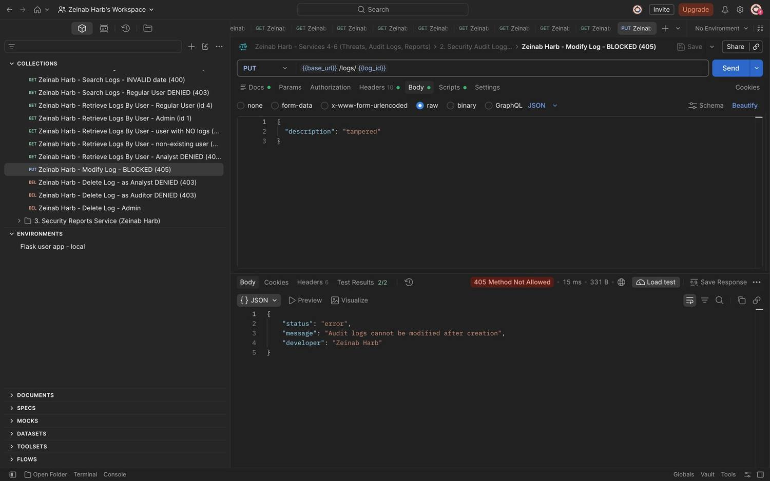
Figure 140: Zeinab Harb – Audit Log Protection – modifying a log record is blocked (405)
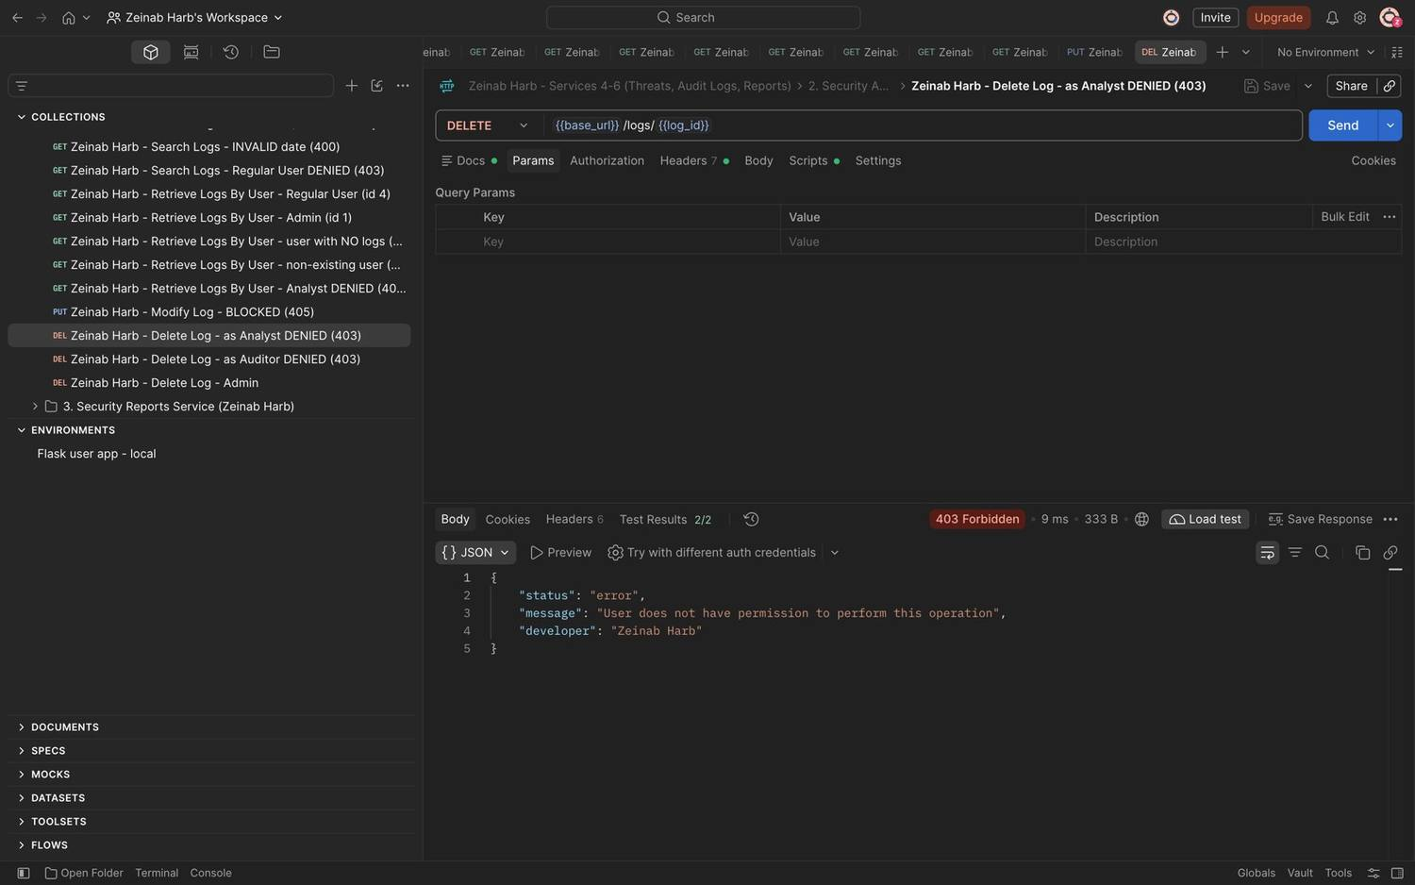
Figure 141: Zeinab Harb – Delete Logs – unauthorized deletion attempt by a Security Analyst denied (403)
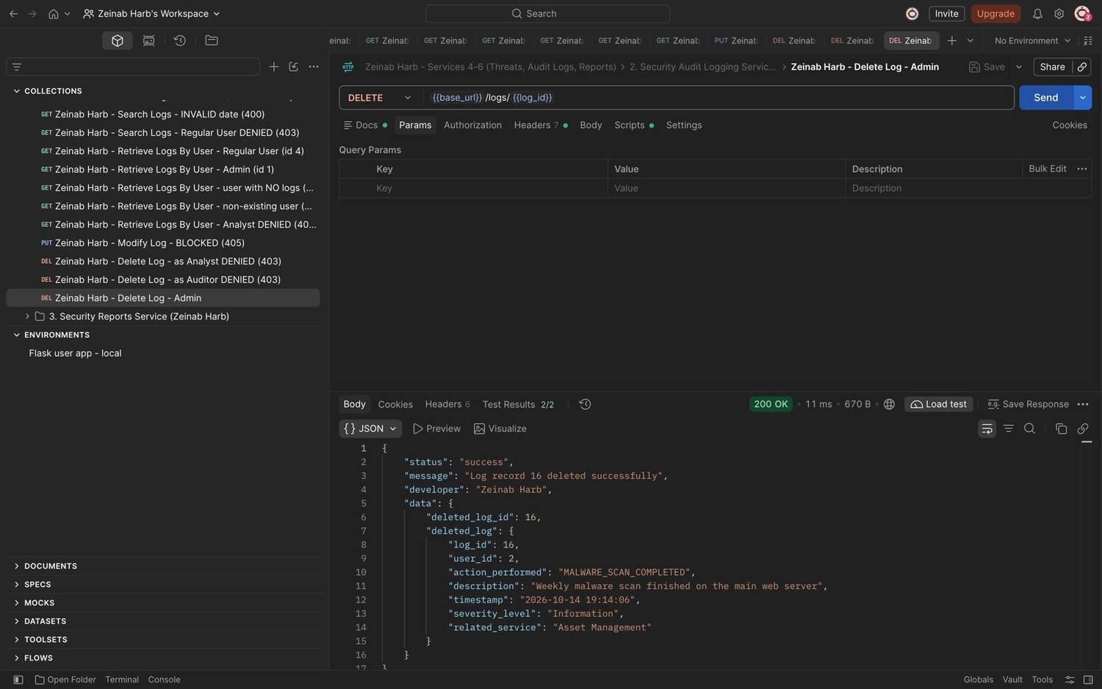
Figure 142: Zeinab Harb – Delete Logs – Security Administrator deletes a log record (200)
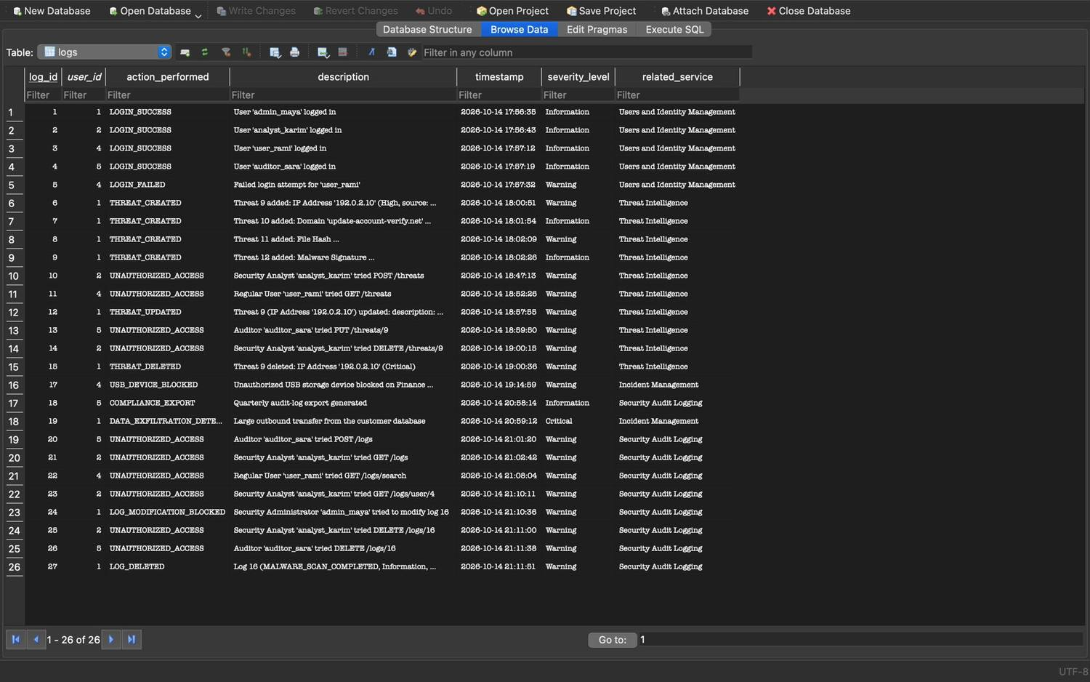
Figure 143: Zeinab Harb – Delete Logs – log 16 removed; LOG_MODIFICATION_BLOCKED and LOG_DELETED records stored in the database

4. Security Reports Service (Service 6) (Zeinab Harb)
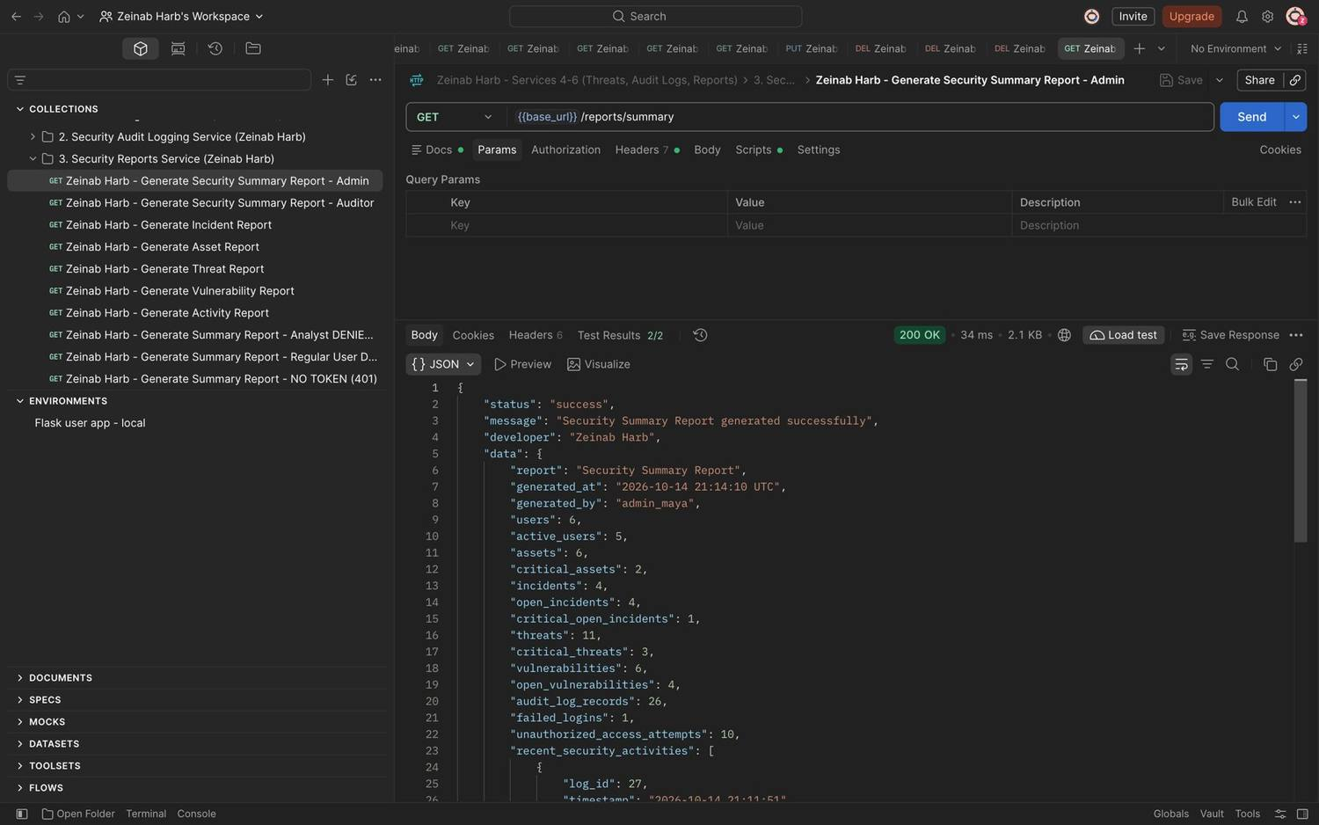
Figure 144: Zeinab Harb – Generate Security Summary Report – overview of the system's security status (200)
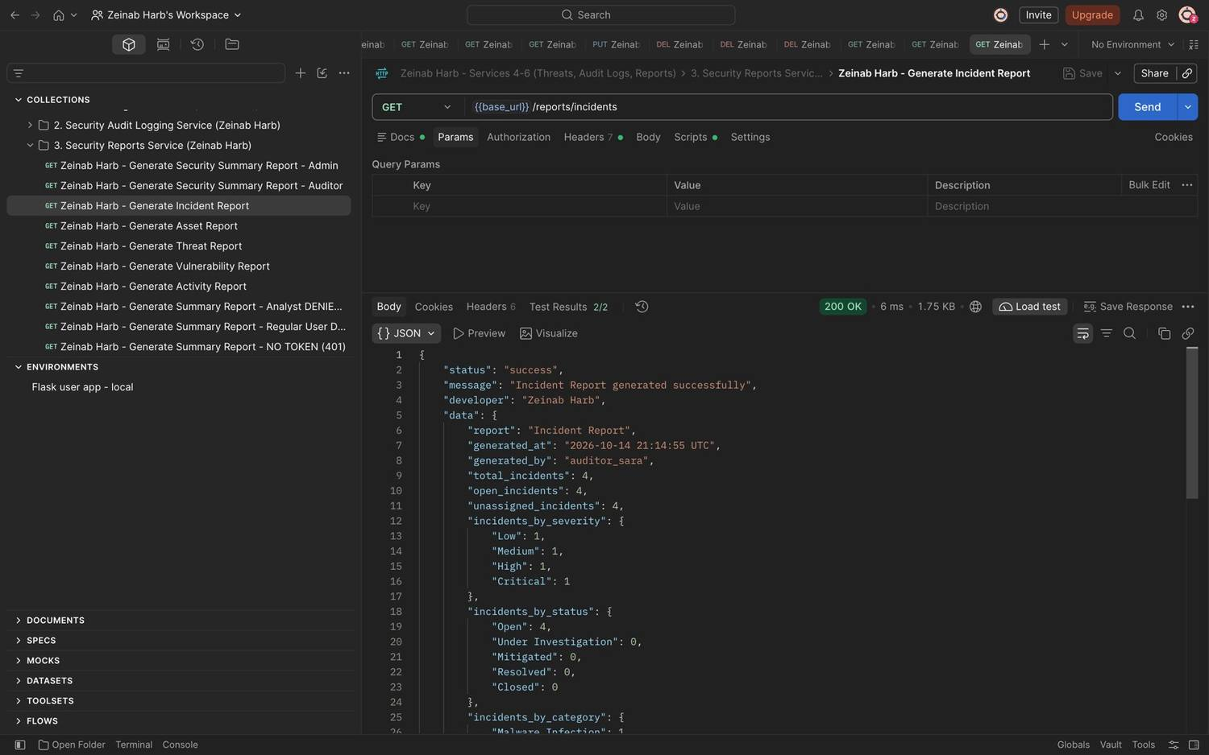
Figure 145: Zeinab Harb – Generate Incident Report – incidents by severity, status and category (200)
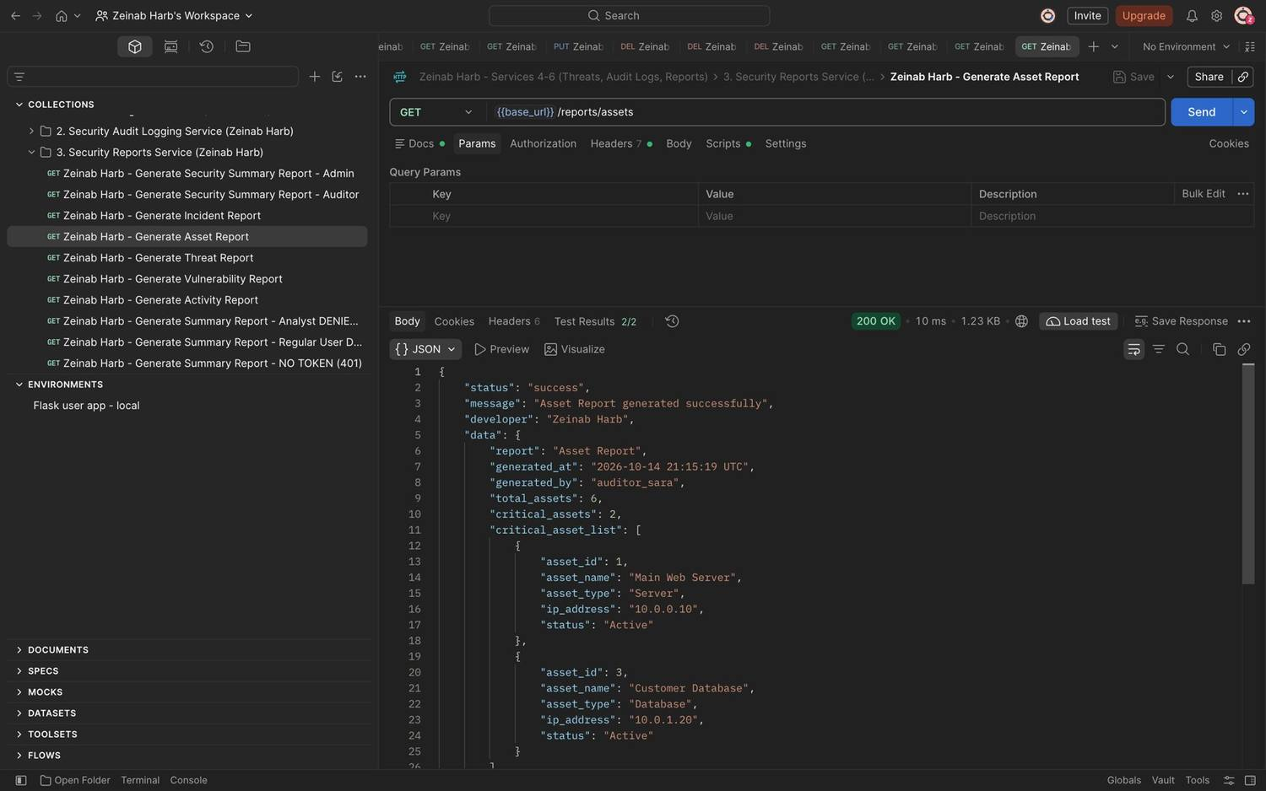
Figure 146: Zeinab Harb – Generate Asset Report – total, critical and by-type asset statistics (200)
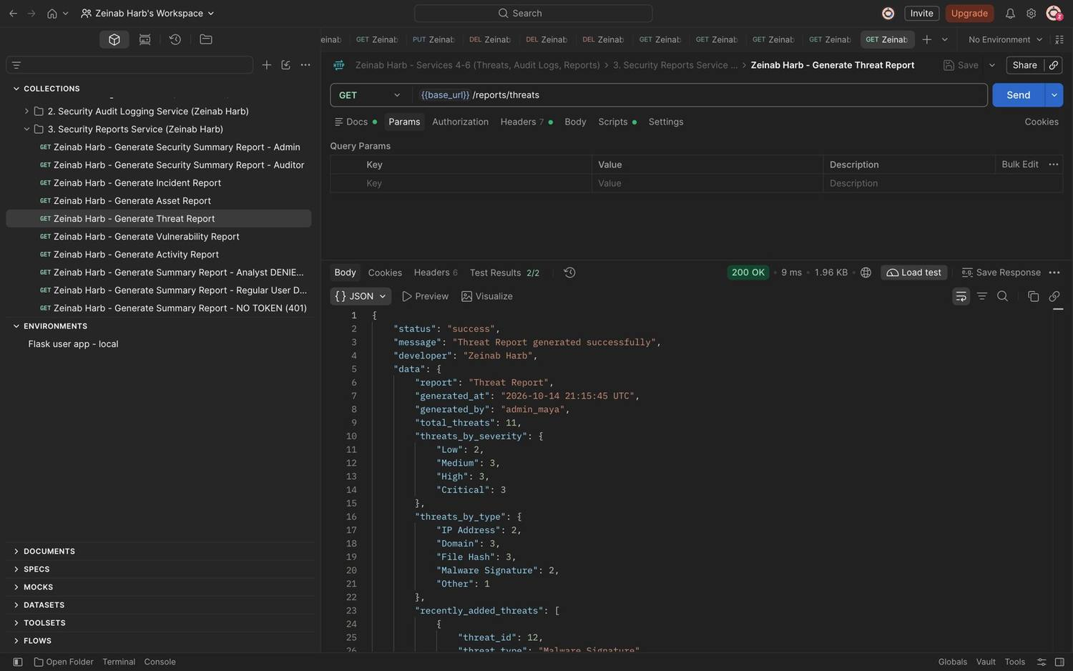
Figure 147: Zeinab Harb – Generate Threat Report – threats by severity and type and recently added threats (200)
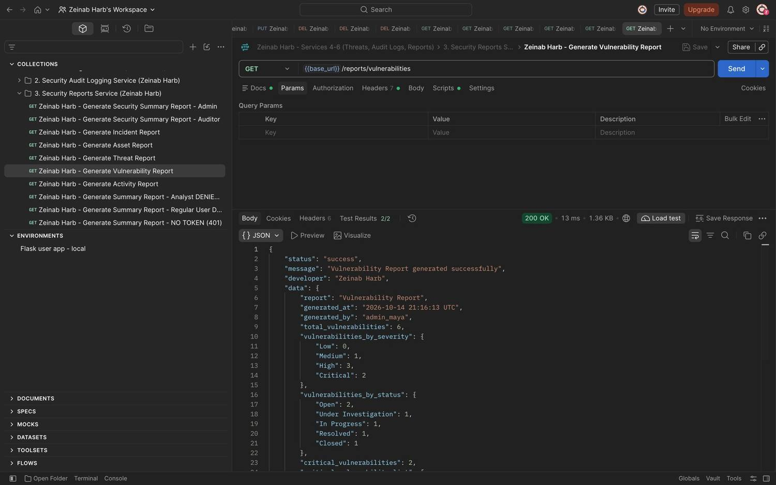
Figure 148: Zeinab Harb – Generate Vulnerability Report – vulnerabilities by severity and status and critical vulnerabilities (200)
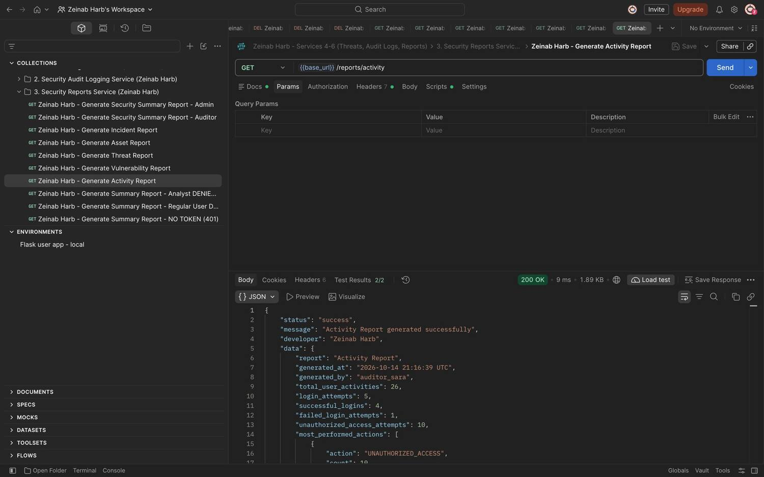
Figure 149: Zeinab Harb – Generate Activity Report – activities, login attempts, failed logins and most performed actions (200)
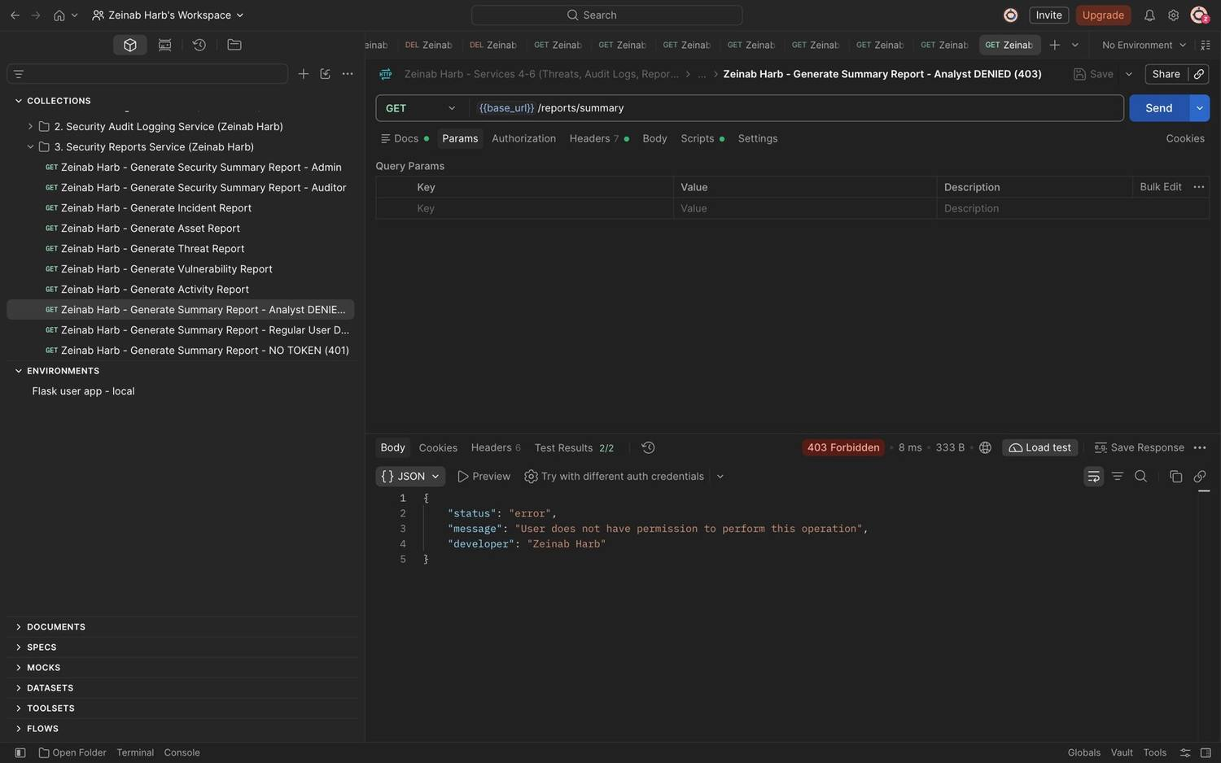
Figure 150: Zeinab Harb – Generate Security Summary Report – Security Analyst denied (403)
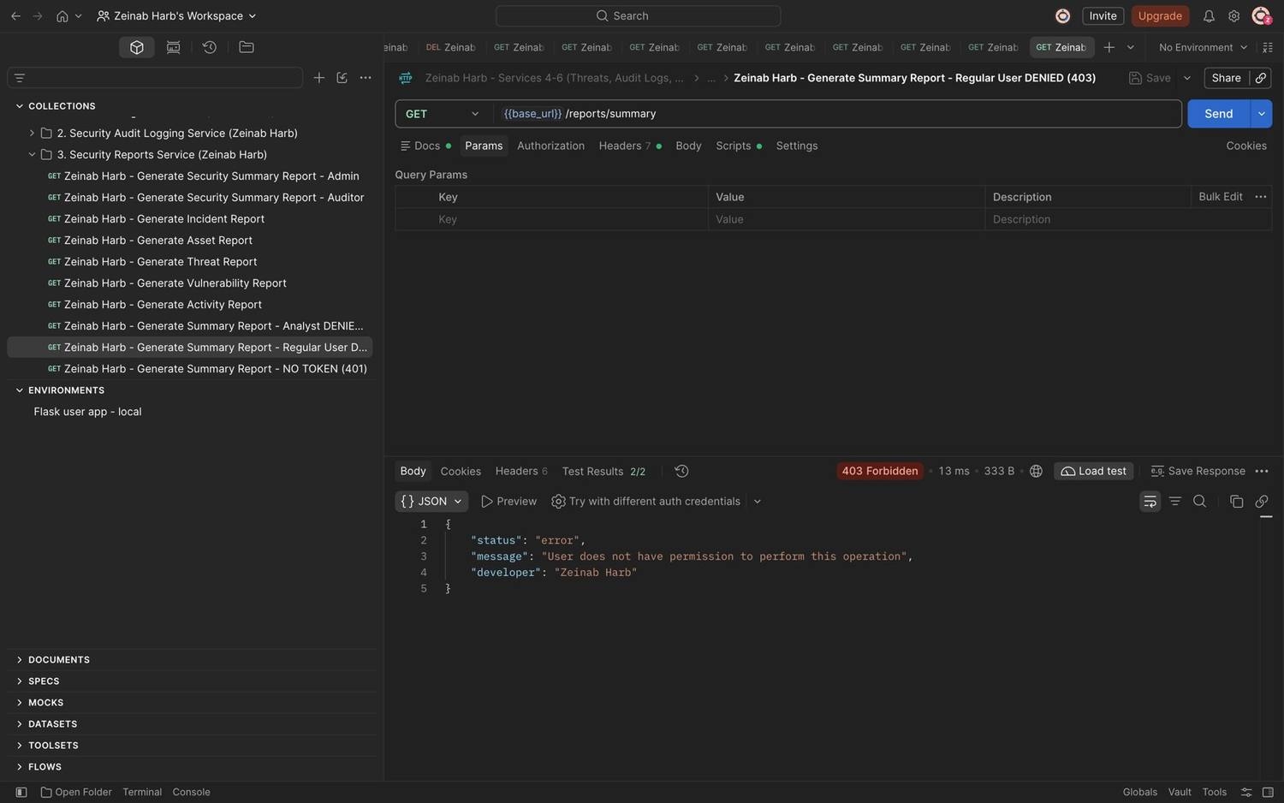
Figure 151: Zeinab Harb – Generate Security Summary Report – Regular User denied (403)

5. Database Design (Zeinab Harb)
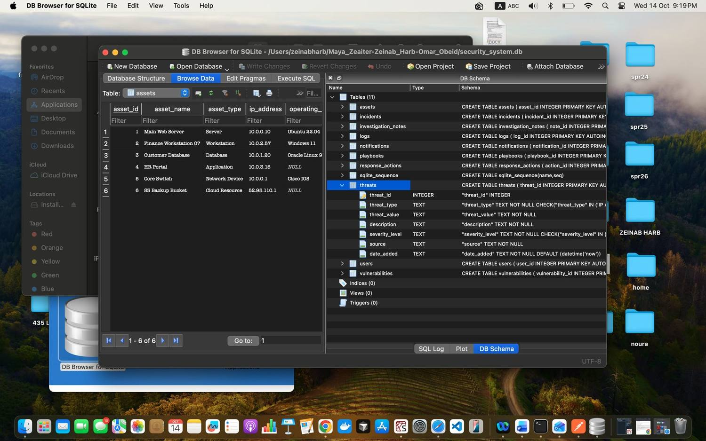
Figure 152: Zeinab Harb – Database Design – structure of the threats table (columns, types and CHECK constraints)
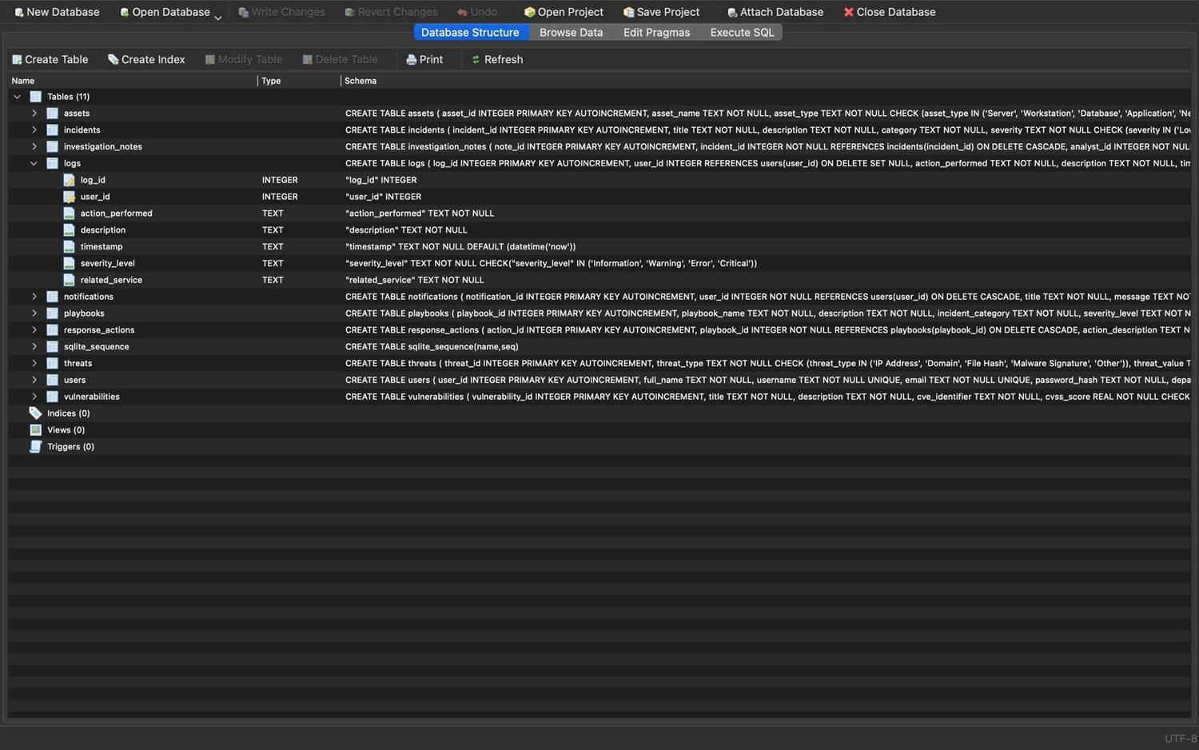
Figure 153: Zeinab Harb – Database Design – structure of the logs table (foreign key to users and severity CHECK constraint)

6. GitHub Version Control (Zeinab Harb)
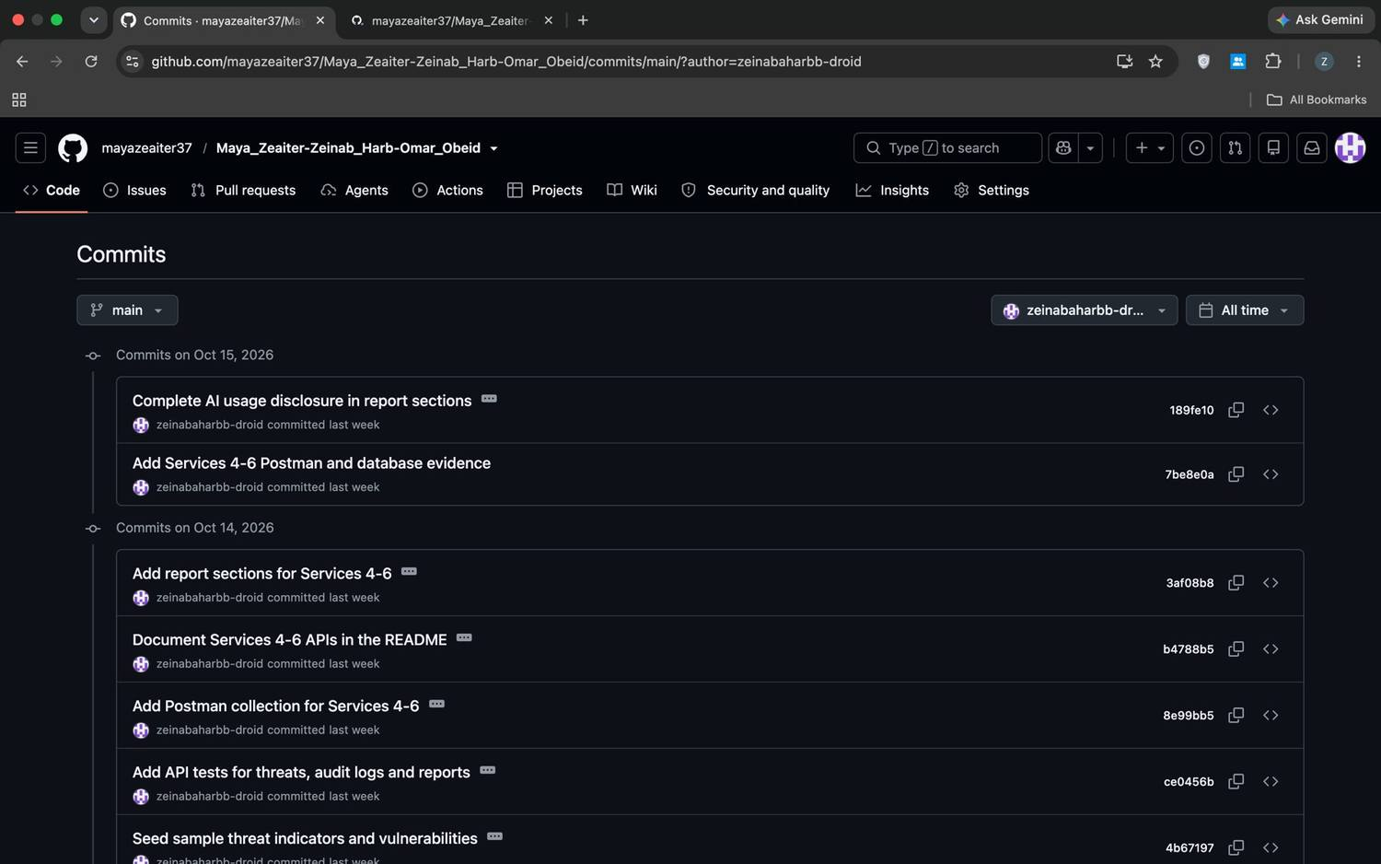
Figure 154: Zeinab Harb – GitHub – commit history of my Services 4–6 work
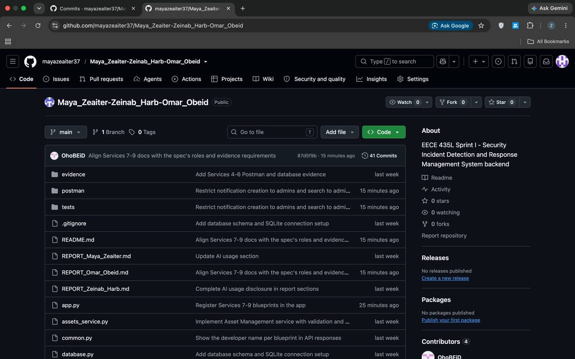
Figure 155: Zeinab Harb – GitHub – repository showing my Services 4–6 files

5.3 Services 7–9 (Omar Obeid)

Architecture of my services
My three services follow the same structure as Services 1–6. Each one is a Flask Blueprint (vulnerabilities_service.py, notifications_service.py, playbooks_service.py) registered in app.py, and they reuse the team's shared code:
- Entity classes Vulnerability, Notification, Playbook and ResponseAction (dataclasses in models.py). Each holds its allowed values (e.g. Vulnerability.STATUS_FLOW, Notification.TYPES) and a to_dict() method. The two entities with a lifecycle (Vulnerability, ResponseAction) have next_status() and can_transition_to(), the same design Maya used for Incident. Vulnerability.severity_for_score() encodes the CVSS v3 rating scale. Playbook.progress() computes how many steps are completed.
- Repositories VulnerabilityRepository, NotificationRepository, PlaybookRepository and ActionRepository inherit from Maya's BaseRepository. They reuse get_by_id, get_all, insert, update, delete and search, and add their own queries:
- VulnerabilityRepository.find_duplicate(): same CVE on the same asset.
- NotificationRepository.for_user(), filter() and mark_read(). get_all() is overridden to return newest first.
- ActionRepository.for_playbook() returns steps ordered by step_number; step_taken() and unfinished_before() enforce step rules.
- PlaybookRepository overrides get_by_id() and get_all() to attach each playbook's ordered actions (composition: a playbook has actions).
- Shared helpers in common.py:
- require_roles(..., service=SERVICE) checks the token and role and logs violations under my service names.
- deny() handles record-level rules ("only your own notifications").
- write_log() records audit events.
- success()/error_body() build the response format.
- Developer name. I call Zeinab's set_developer(blueprint, "Omar Obeid") on my three blueprints, so every response from my routes, including 401/403 errors, shows "developer": "Omar Obeid". Every route also has a (Omar Obeid) comment.
- Validators added to validators.py: check_cve(), check_cvss() and parse_datetime().
Communication between services. All services run in one Flask application and share one SQLite database.
- My Notification Service exposes send_notification(), which the Vulnerability and Playbook services call. Maya's Incident Service already inserts "Incident Assignment" notifications into the same table.
- My services send every change and every permission violation to Zeinab's Audit Logging Service through write_log().
- Zeinab's GET /reports/vulnerabilities and summary report read my vulnerabilities table, so I kept its columns exactly as defined in schema.sql.
- Playbooks reuse the incident categories defined by the Incident Management Service, so a playbook always matches a real incident category.

Service 7: Vulnerability Management (Omar Obeid)
Responsibility: tracks known weaknesses (CVEs) found on the organisation's assets, from discovery until they are closed.
APIs: POST /vulnerabilities, GET /vulnerabilities, GET /vulnerabilities/{id}, PUT /vulnerabilities/{id}, GET /vulnerabilities/search, DELETE /vulnerabilities/{id} (request and response formats are in the README).
Database interaction: the vulnerabilities table, with affected_asset_id as a foreign key to assets. It uses INSERT on create, parameterised SELECT on read and search, UPDATE of the five updatable fields, and DELETE.
How a vulnerability record is validated on creation.
- The body must be non-empty JSON with exactly the seven fields; missing or unknown fields give 400.
- CVE format: ^CVE-(\d{4})-(\d{4,})$, the official CVE ID syntax (four or more digits after the year). The year must be between 1999, when the CVE list started, and next year. Input is upper-cased before checking and storing, so cve-2023-48795 is accepted and stored as CVE-2023-48795.
- CVSS score: a number (not a string or boolean) between 0.0 and 10.0 with one decimal place, as CVSS scores are published.
- Severity: must be Low, Medium, High or Critical and agree with the CVSS score using the CVSS v3 qualitative scale. A score of 9.8 labelled "Low" is rejected with the expected rating in the message. This prevents a critical vulnerability from being hidden in reports by a wrong label.
CVSS score | Severity
0.0–3.9 | Low
4.0–6.9 | Medium
7.0–8.9 | High
9.0–10.0 | Critical

- Affected asset: must exist in the assets table (404 otherwise).
- Duplicates: the same CVE on the same asset returns 409 with the existing id. The same CVE on different assets is allowed, because each affected asset needs its own remediation.
New records start as Open. When the severity is High or Critical, the asset's owner automatically receives a Vulnerability Alert notification.
How vulnerability severity is stored. Severity is stored twice, in two forms:
- cvss_score is a REAL column with CHECK (cvss_score BETWEEN 0 AND 10). It holds the numeric score, e.g. 7.5.
- severity_level is a TEXT column with CHECK IN ('Low','Medium','High','Critical'). It holds the qualitative rating.
The API guarantees that the two always agree (on create and on every update), so reports can group by severity_level while still showing the exact score. Zeinab's vulnerability report uses both: counts by severity_level and AVG(cvss_score).
Vulnerability records created for evidence (Postman):
CVE | Asset | CVSS | Severity | Why
CVE-2021-41773 | 1 Main Web Server | 7.5 | High | Apache path traversal, exploitable remotely without authentication.
CVE-2022-22965 | 3 Customer Database | 9.8 | Critical | Spring4Shell remote code execution on a critical asset.
CVE-2023-48795 | 2 Finance Workstation | 5.9 | Medium | Terrapin SSH attack needs a man-in-the-middle position, so its impact is lower.

The seed data adds six more (Log4Shell, regreSSHion, etc.) covering every status.
Returned response format (GET /vulnerabilities) and GET /vulnerabilities/{id}. The response is {status, message, developer, data: {count, vulnerabilities: [...]}}. Each record includes an affected_asset summary (name, IP, criticality) taken from the Asset Management table, so the reader does not need a second request. An unknown id gives 404 "Vulnerability with id 99999 not found".
How status transitions are enforced (PUT /vulnerabilities/{id}).
- The lifecycle is Open → Under Investigation → In Progress → Resolved → Closed. A status change must be exactly the next step (can_transition_to()). Skipping (Open → Resolved) or going back (Closed → Open) returns 400 with the allowed flow and the next permitted status.
- Moving to Resolved sets resolution_date automatically. An explicit resolution_date is only accepted when the record is Resolved or Closed, cannot be in the future and cannot be before creation_date.
- If cvss_score or severity_level changes, the pair must still agree after the update (e.g. lowering 7.5 to 6.5 requires Medium).
- title, cve_identifier, affected_asset_id and discovery_source are read-only (400). Changing them would describe a different finding, so the record should be deleted and recreated.
- The response contains before and after. The audit log records each changed field (e.g. status: 'Open' -> 'Under Investigation') as VULNERABILITY_STATUS_CHANGED or VULNERABILITY_UPDATED.
How search results are generated (GET /vulnerabilities/search).
- Parameters map to a whitelist of columns:
- cve → cve_identifier (partial, case-insensitive LIKE);
- severity → severity_level and status → status (exact, validated);
- asset → affected_asset_id (positive integer).
- Each parameter becomes one WHERE condition joined with AND, through BaseRepository.search().
- All values are bound parameters, so cve=' OR '1'='1 returns 0 rows.
- No parameters, unknown parameters or invalid values return 400.
Deletion. Only the Security Administrator can delete (@require_roles(ADMIN)). Analysts get 403 and an UNAUTHORIZED_ACCESS log. A successful deletion returns the deleted record and writes VULNERABILITY_DELETED (Warning).

Service 8: Notification and Alert Management (Omar Obeid)
Responsibility: delivers alerts and messages to individual users and tracks whether they have been read.
APIs: POST /notifications, GET /notifications/user/{user_id}, GET /notifications/{id}, PUT /notifications/{id}/read, GET /notifications/search, DELETE /notifications/{id}.
Database interaction: the notifications table, with user_id as a foreign key to users. One user has many notifications.
How notifications are generated.
Source | Type | Recipient
POST /notifications (Security Administrator) | any of the five types | the given user
Incident assigned (Service 3, Maya) | Incident Assignment | the assigned analyst
High/Critical vulnerability recorded (Service 7) | Vulnerability Alert | the owner of the affected asset
Response action assigned (Service 9) | System Notification | the assigned responder

Validation on creation:
- all five fields are required;
- notification_type must be one of the five types and severity_level one of Low–Critical;
- user_id must be an existing user (404) whose account is Active. Suspended or inactive accounts are rejected with 400, because nobody would read the alert.
Every notification starts as Unread with read_date = NULL, and creation_date is set by the database.
Retrieve user notifications, including the empty result.
- The caller must be the user themself, an Administrator or an Auditor; otherwise 403 and a logged violation.
- The route then checks that the user exists. An unknown id gives 404, which distinguishes "no such user" from "no notifications".
- It returns {user, count, unread_count, notifications} newest first.
- A user with no notifications (analyst_lina in the seed data) gets 200 with count: 0, an empty list and the message "User 'analyst_lina' has no notifications". This is a valid, successful result, not an error.
How a notification is marked as read. PUT /notifications/{id}/read (no body):
- Only the recipient or an Administrator may mark it. An Analyst marking someone else's gets 403, and an Auditor, who is read-only, gets 403.
- It sets status = 'Read' and read_date = datetime('now') in one UPDATE. For the evidence, show the row in DB Browser before (Unread, read_date NULL) and after (Read, with a timestamp).
- If the notification is already read, it returns 200 with "already read on …" and keeps the original `read_date`, so the first time the user saw the alert is preserved.
Privacy rule. Users see and read only their own notifications unless they are an Administrator or Auditor. This applies to GET /notifications/{id} and the user list. In search, Analysts are restricted to their own inbox automatically and asking for another user returns 403. Regular Users have no search access, as in the spec's authorization table.
Search. user (numeric id or username), type, severity and status, combined with AND by NotificationRepository.filter(). All values are validated and bound as parameters.
Deletion. Administrator only; it writes NOTIFICATION_DELETED (Warning).

Service 9: Security Playbook and Response Automation (Omar Obeid)
Responsibility: stores predefined incident-response procedures (playbooks) as ordered steps (response actions) and tracks who is doing each step and how far the response has progressed.
APIs: POST /playbooks, GET /playbooks, GET /playbooks/{id}, POST /playbooks/{id}/actions, PUT /actions/{id}/status, DELETE /playbooks/{id}.
Database interaction: playbooks (with created_by → users) and response_actions (with playbook_id → playbooks ON DELETE CASCADE and assigned_user_id → users). One playbook has many actions, and UNIQUE (playbook_id, step_number) applies.
How playbooks are organized. A playbook is the procedure for one incident category at one severity level (e.g. "Ransomware Containment" for Malware Infection / Critical). It contains an ordered list of response actions, each identified by a unique step_number. Reading a playbook returns the procedure header, its steps in order, and its progress.
Creating a playbook.
- All four fields are required.
- incident_category must be one of the incident categories of Service 3 (Malware Infection, Phishing Attack, …), so every playbook maps to a real incident type.
- severity_level must be Low–Critical.
- The name must be unique, case-insensitive (409).
- created_by is taken from the token, not from the body, so it cannot be faked.
How response actions are ordered and kept unique.
- step_number must be a positive integer.
- Before inserting, step_taken() checks whether the playbook already has that step. If it does, the API returns 409 and lists the existing steps. The UNIQUE (playbook_id, step_number) constraint is a second safety net in the database.
- Steps can be added in any order (e.g. 1, 3, then 2). GET /playbooks/{id} always returns them ORDER BY step_number, together with progress {total_steps, completed_steps, percent_complete}.
- An optional assigned_user_id must be an Active Security Administrator or Analyst (400 for a Regular User or Auditor). The assignee receives a notification.
How response action status updates work (PUT /actions/{id}/status).
- One step at a time. The lifecycle is Pending → In Progress → Completed; skipping or going back returns 400.
- Steps run in order. A step can only move to In Progress when every earlier step of the same playbook is Completed (unfinished_before()). Otherwise the API returns 409 and names the blocking steps, e.g. "Complete the earlier steps first: step 1 (Pending)".
- Assignment.
- If the step has no assignee, whoever starts it becomes the assignee.
- An Administrator can (re)assign any step to an Active Admin or Analyst.
- An Analyst can only update steps assigned to them or unassigned ones, and can only assign themselves (403 and a logged violation otherwise).
- Completion date. Completed sets completion_date to the current UTC time, or to the given completion_date (YYYY-MM-DD or YYYY-MM-DD HH:MM:SS, not in the future). A completion date on a non-Completed status is rejected.
- The response contains before, after and the playbook's updated progress.
Deleting a playbook. Administrator only. Its response actions are deleted automatically by ON DELETE CASCADE. The response reports how many actions were removed, and PLAYBOOK_DELETED (Warning) is logged with that number.

Postman and database screenshots – Services 7–9 (Omar Obeid)

Vulnerability Management Service (Service 7) (Omar Obeid)
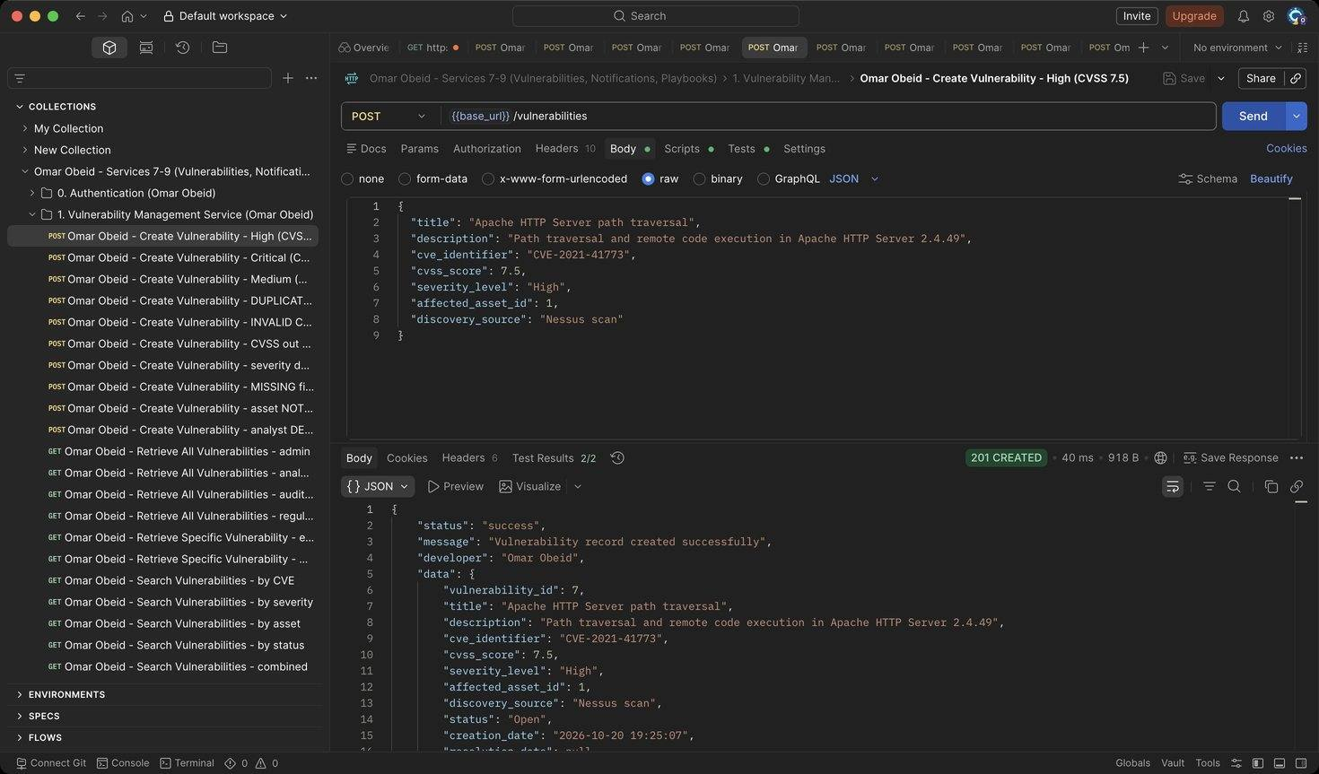
Figure 156: Omar Obeid – Create Vulnerability – High (CVSS 7.5): Records CVE-2021-41773 on asset 1. A High/Critical vulnerability also sends a Vulnerability Alert notification to the asset owner. (HTTP 201)
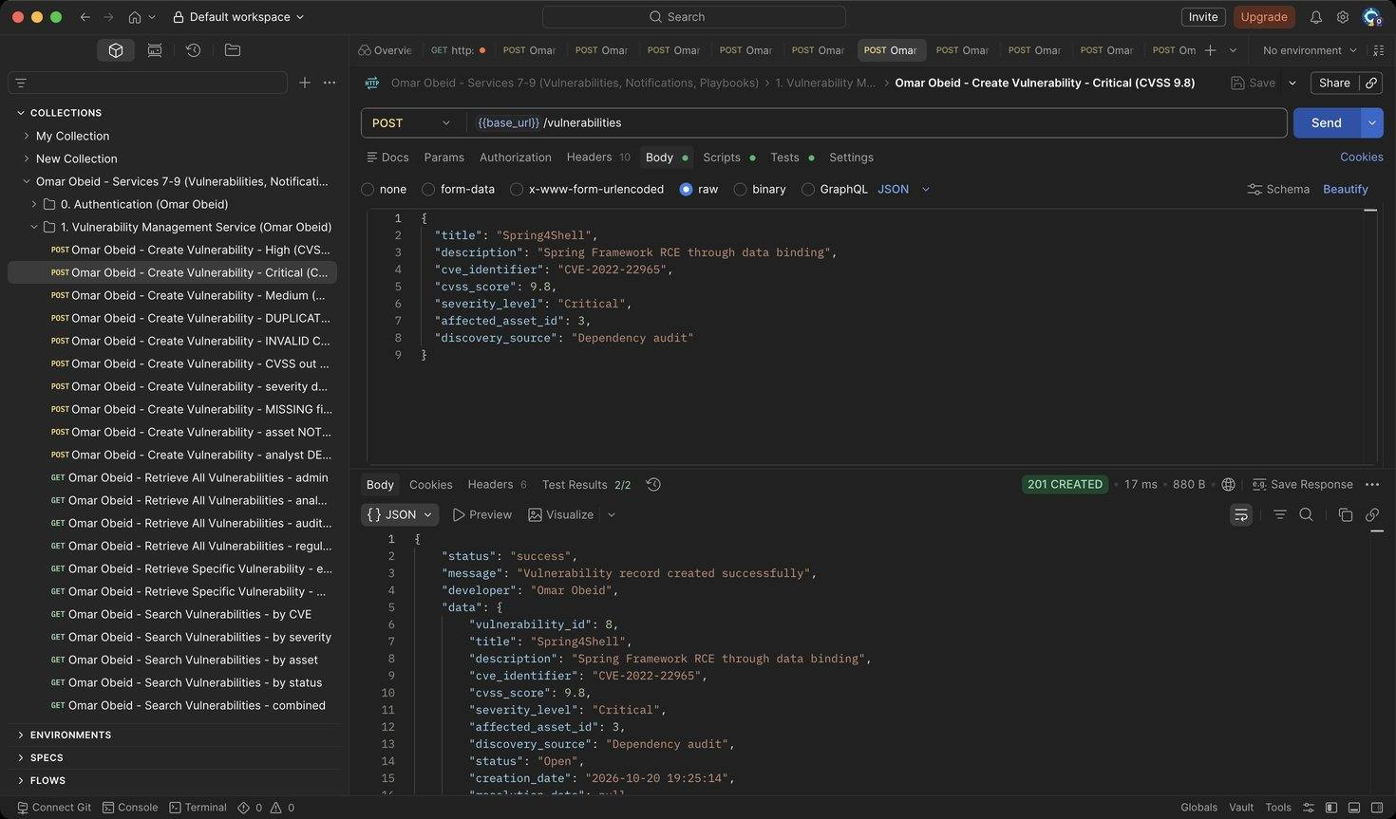
Figure 157: Omar Obeid – Create Vulnerability – Critical (CVSS 9.8): Spring4Shell on the customer database (HTTP 201)
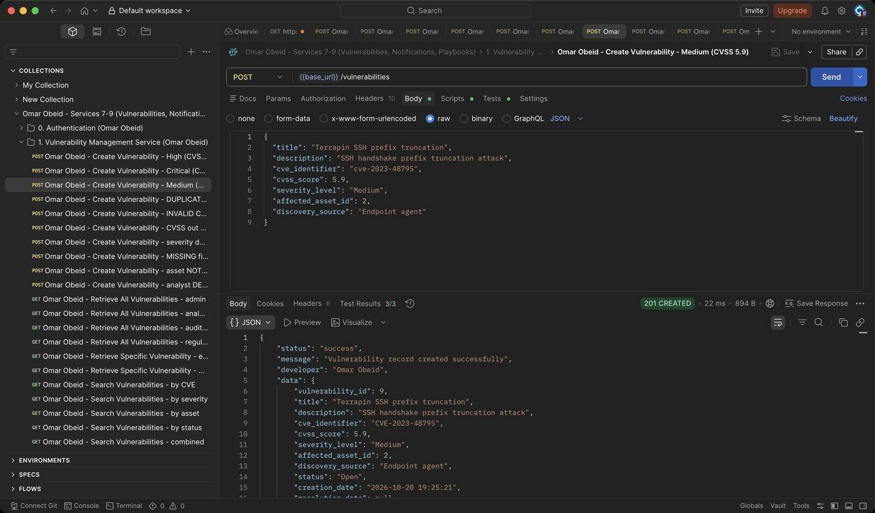
Figure 158: Omar Obeid – Create Vulnerability – Medium (CVSS 5.9): Terrapin SSH attack on the finance workstation. (HTTP 201)
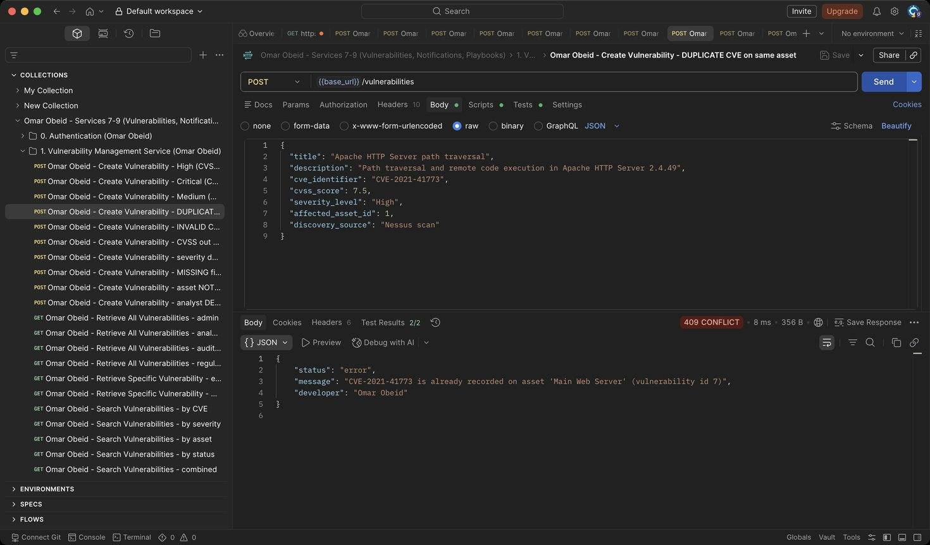
Figure 159: Omar Obeid – Create Vulnerability – DUPLICATE CVE on same asset: Same CVE on the same asset is rejected (HTTP 409)
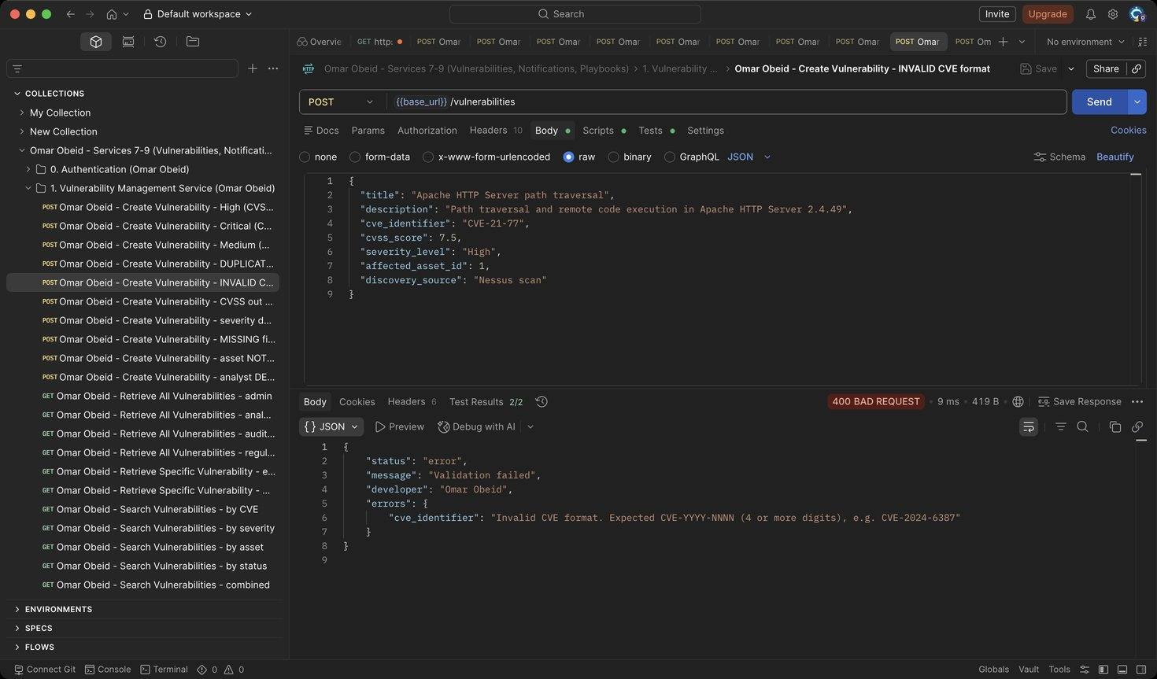
Figure 160: Omar Obeid – Create Vulnerability – INVALID CVE format: CVE must look like CVE-YYYY-NNNN (4+ digits) (HTTP 400)
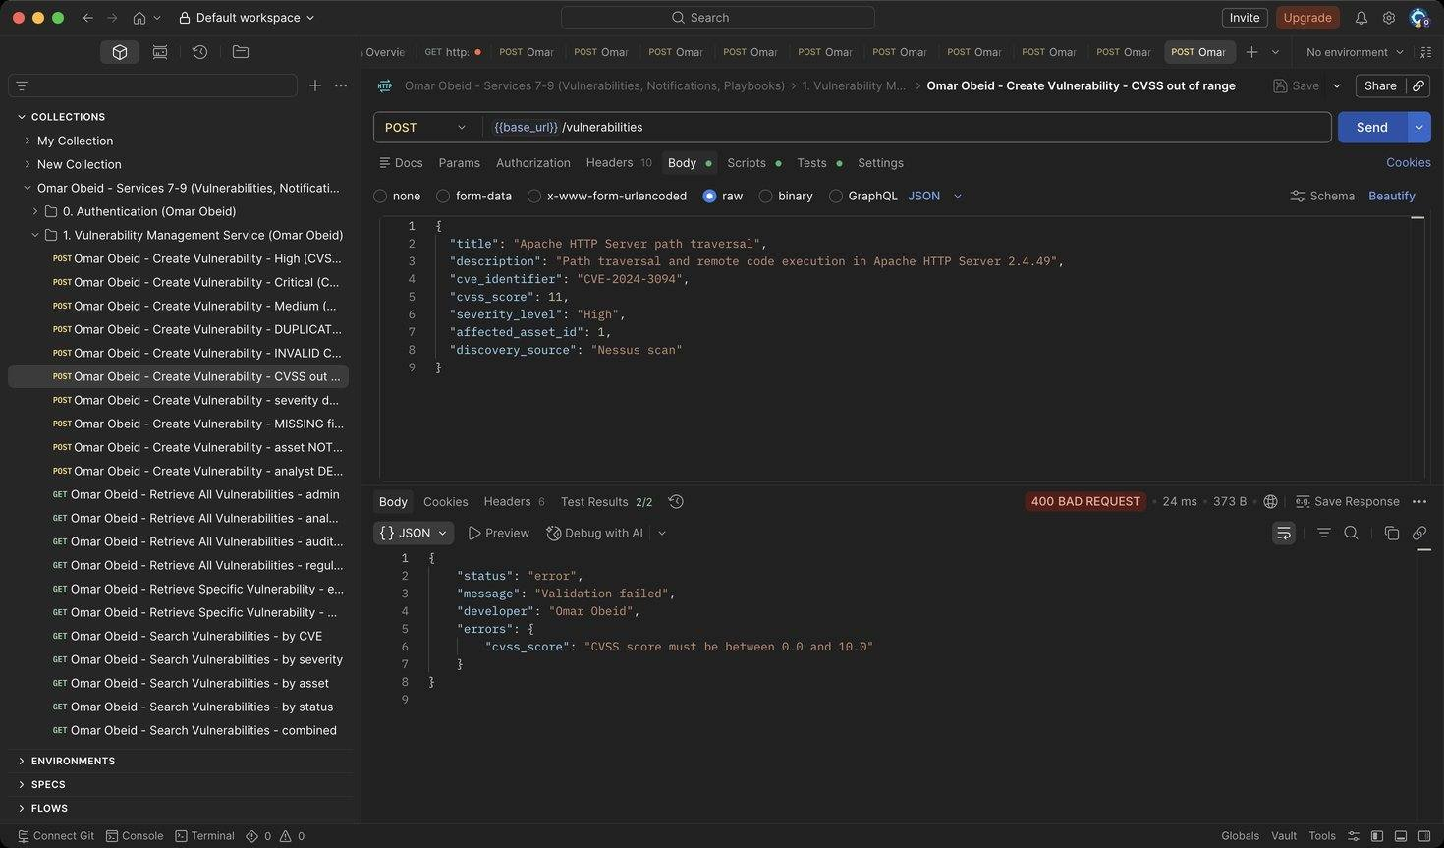
Figure 161: Omar Obeid – Create Vulnerability – CVSS out of range: CVSS must be between 0.0 and 10.0 (HTTP 400)
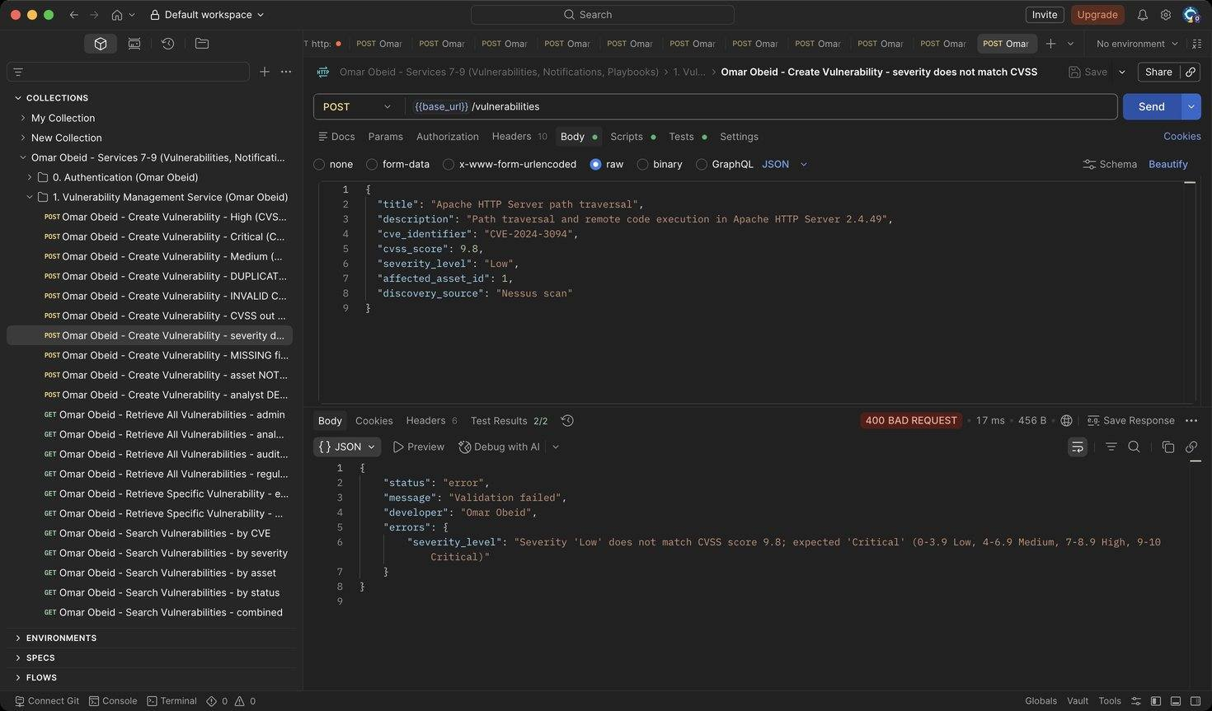
Figure 162: Omar Obeid – Create Vulnerability – severity does not match CVSS: CVSS 9.8 must be rated Critical, not Low (HTTP 400)
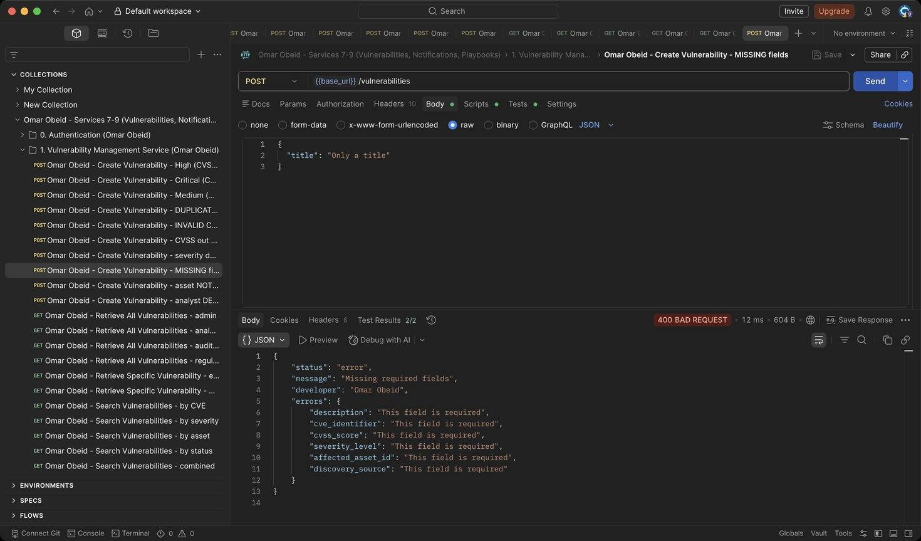
Figure 163: Omar Obeid – Create Vulnerability – MISSING fields: Every field is required (HTTP 400)
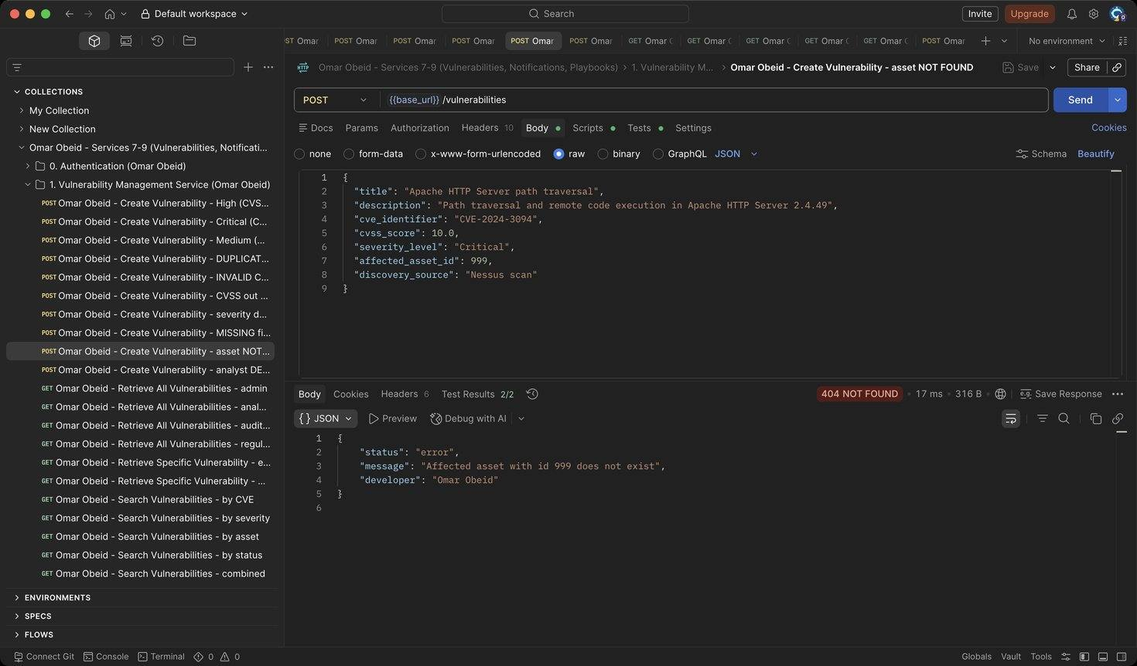
Figure 164: Omar Obeid – Create Vulnerability – asset NOT FOUND: The affected asset must exist (HTTP 404)
Figure 165: Omar Obeid – Create Vulnerability – analyst DENIED: Only the Security Administrator can create records (HTTP 403)
Figure 166: Omar Obeid – Retrieve All Vulnerabilities – admin: Lists every record (HTTP 200)
Figure 167: Omar Obeid – Retrieve All Vulnerabilities – analyst: Analysts can list (HTTP 200)
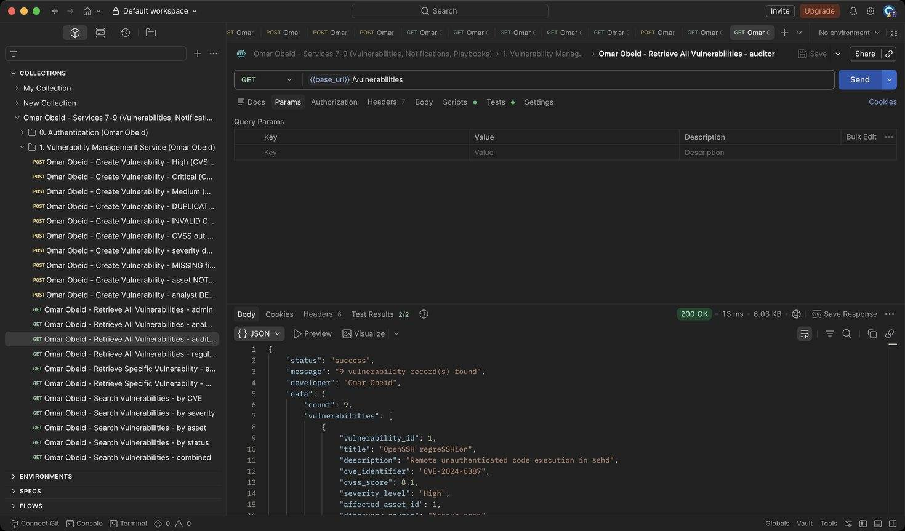
Figure 168: Omar Obeid – Retrieve All Vulnerabilities – auditor: Auditors can list (HTTP 200)
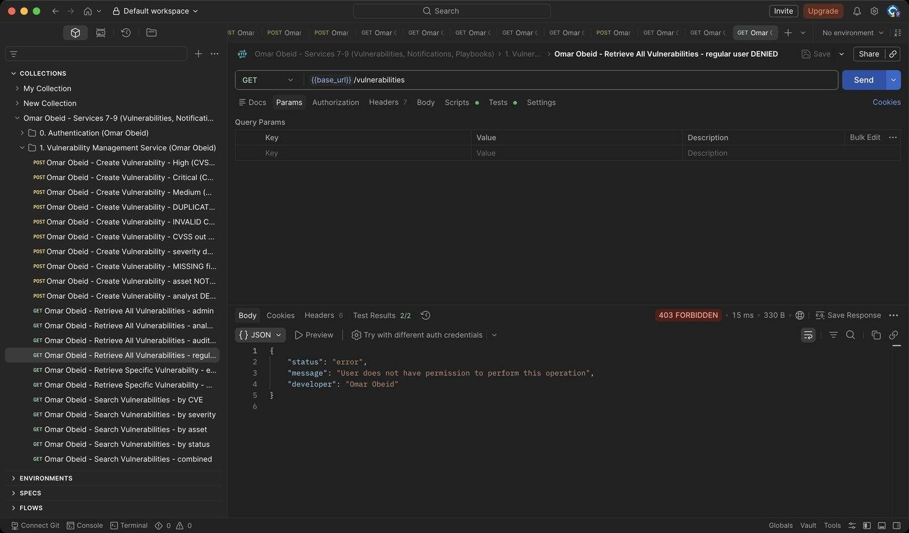
Figure 169: Omar Obeid – Retrieve All Vulnerabilities – regular user DENIED: Regular users have no access to vulnerabilities (HTTP 403)
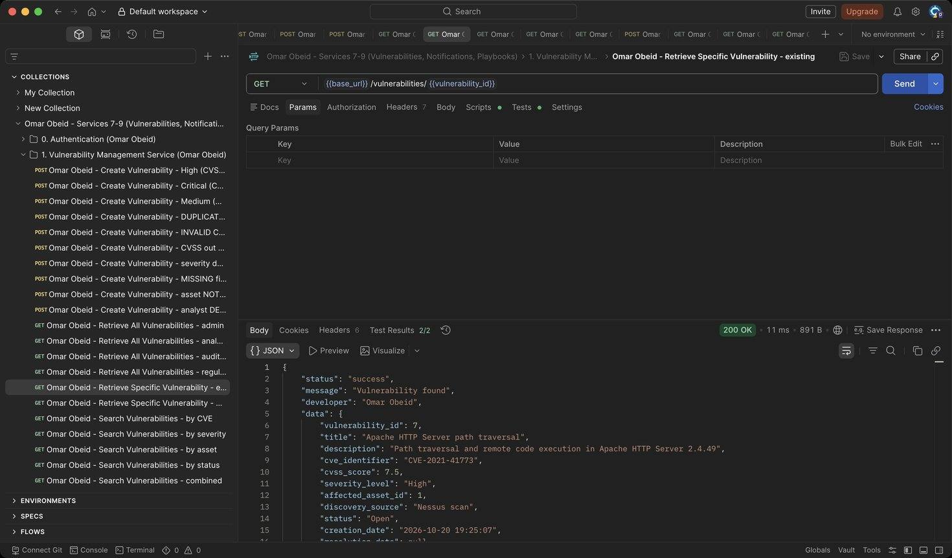
Figure 170: Omar Obeid – Retrieve Specific Vulnerability – existing: Includes the affected asset's name, IP and criticality (HTTP 200)
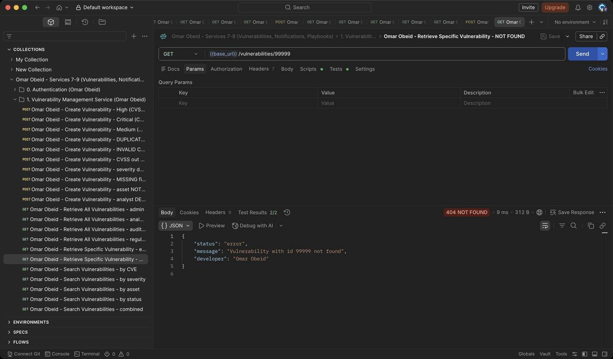
Figure 171: Omar Obeid – Retrieve Specific Vulnerability – NOT FOUND: Unknown id (HTTP 404)
Figure 172: Omar Obeid – Search Vulnerabilities – by CVE: Partial, case-insensitive CVE match (Log4Shell) (HTTP 200)
Figure 173: Omar Obeid – Search Vulnerabilities – by severity: Exact severity (HTTP 200)
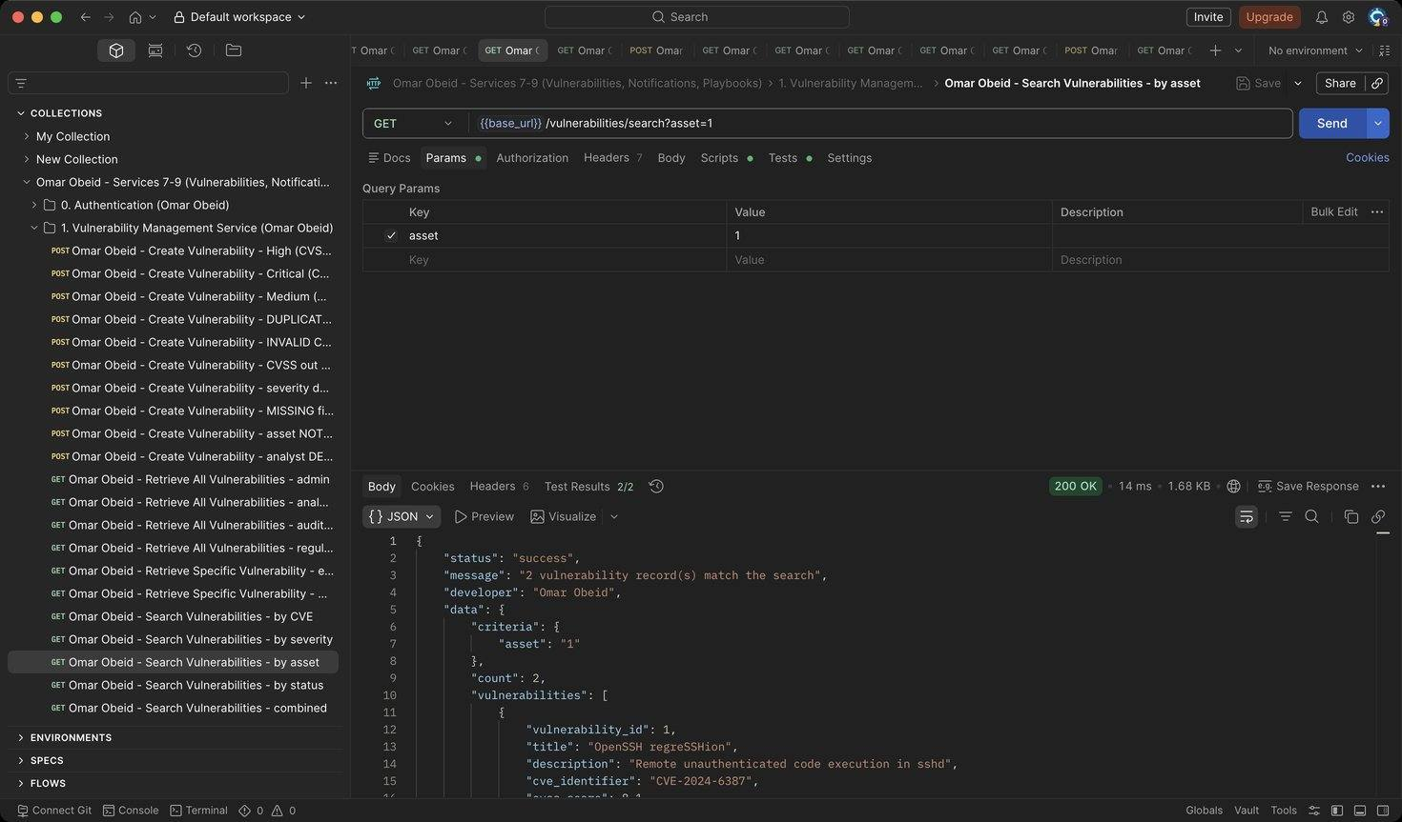
Figure 174: Omar Obeid – Search Vulnerabilities – by asset: All vulnerabilities on asset 1 (HTTP 200)
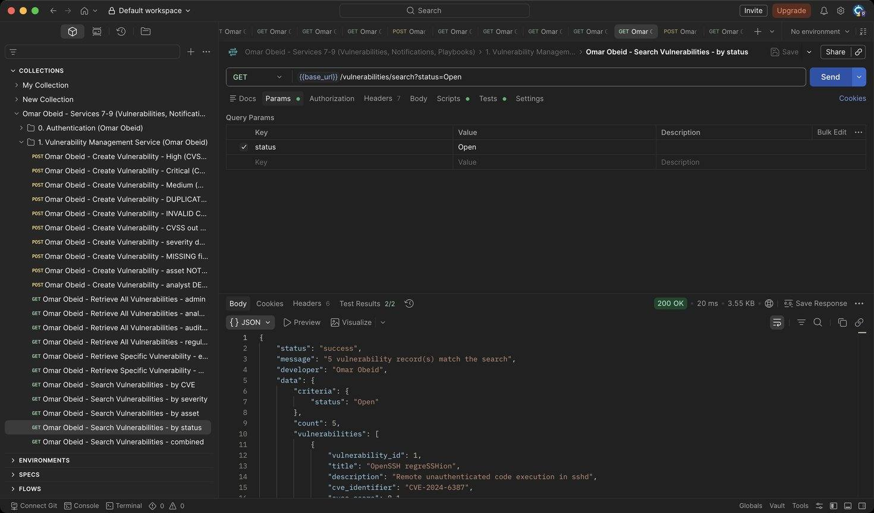
Figure 175: Omar Obeid – Search Vulnerabilities – by status: Exact status (HTTP 200)
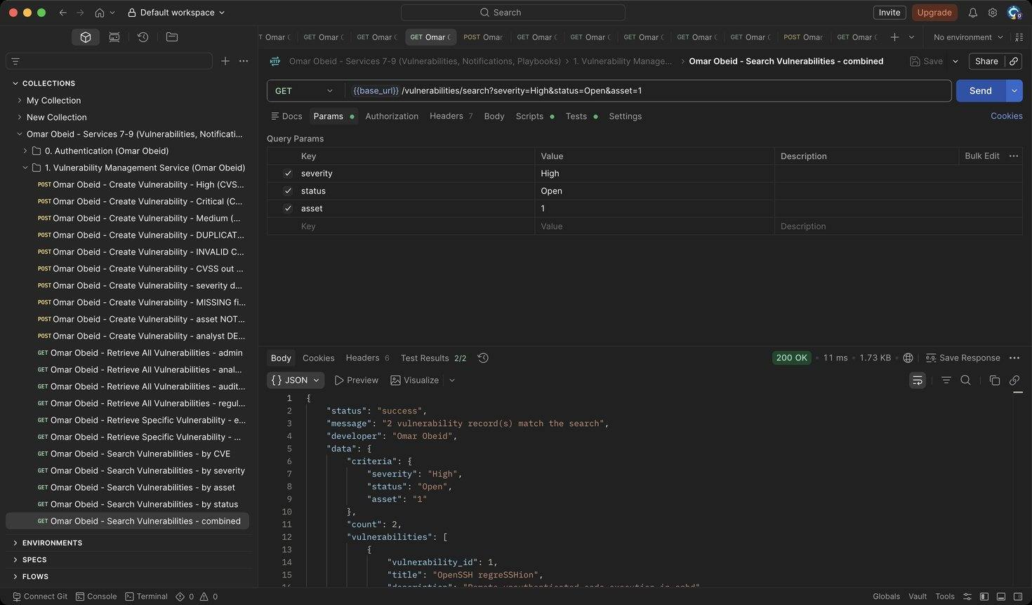
Figure 176: Omar Obeid – Search Vulnerabilities – combined: Criteria are combined with AND (HTTP 200)
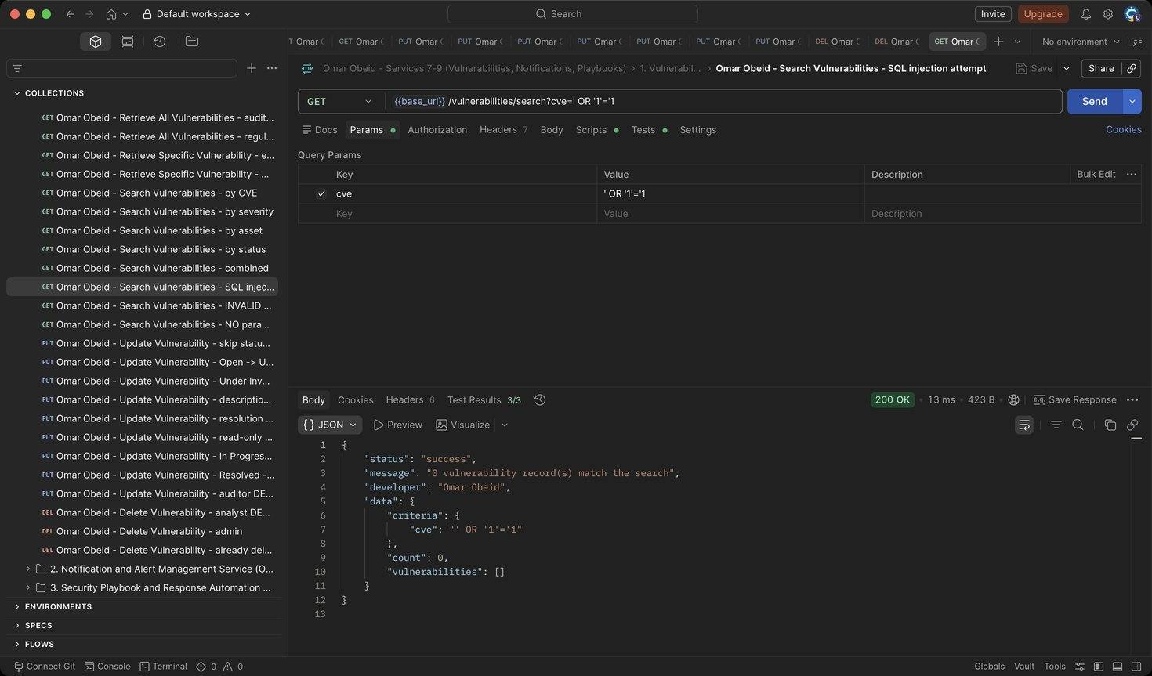
Figure 177: Omar Obeid – Search Vulnerabilities – SQL injection attempt: The value is a bound parameter: 0 results (HTTP 200)
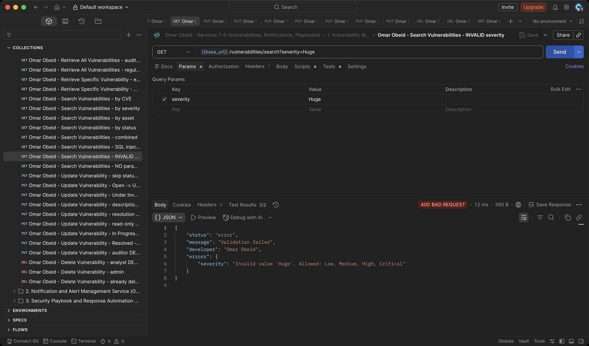
Figure 178: Omar Obeid – Search Vulnerabilities – INVALID severity: Severity must be Low, Medium, High or Critical (HTTP 400)
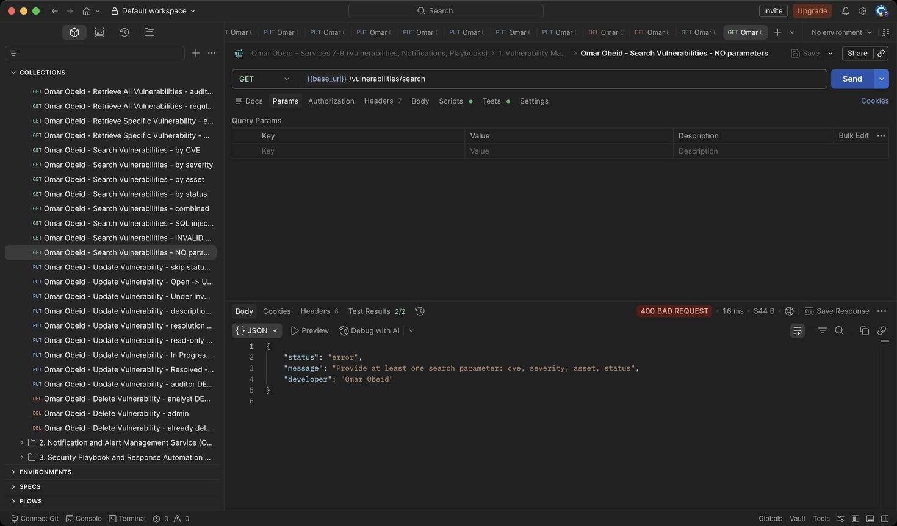
Figure 179: Omar Obeid – Search Vulnerabilities – NO parameters: At least one criterion is required (HTTP 400)
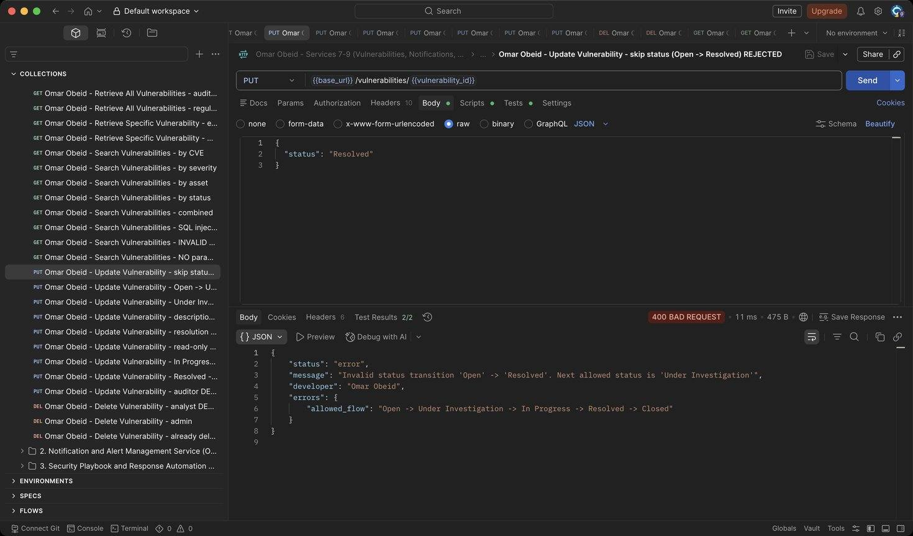
Figure 180: Omar Obeid – Update Vulnerability – skip status (Open -> Resolved) REJECTED: Status must follow Open -> Under Investigation -> In Progress -> Resolved -> Closed (HTTP 400)
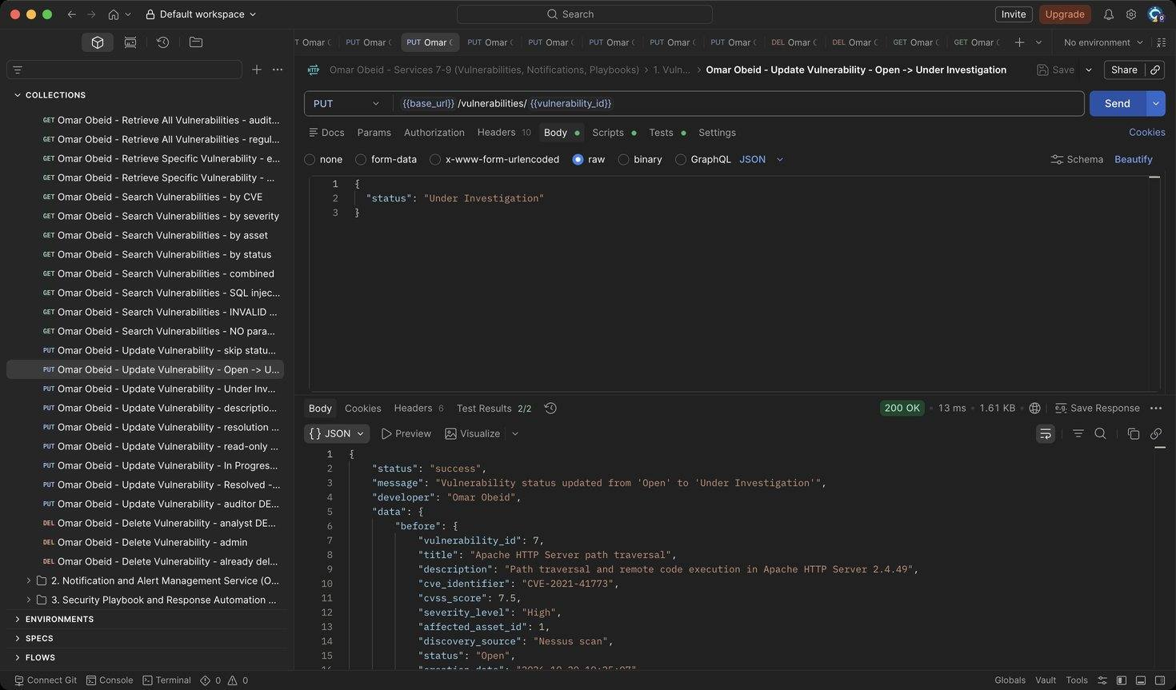
Figure 181: Omar Obeid – Update Vulnerability – Open -> Under Investigation: Response contains before and after (HTTP 200)
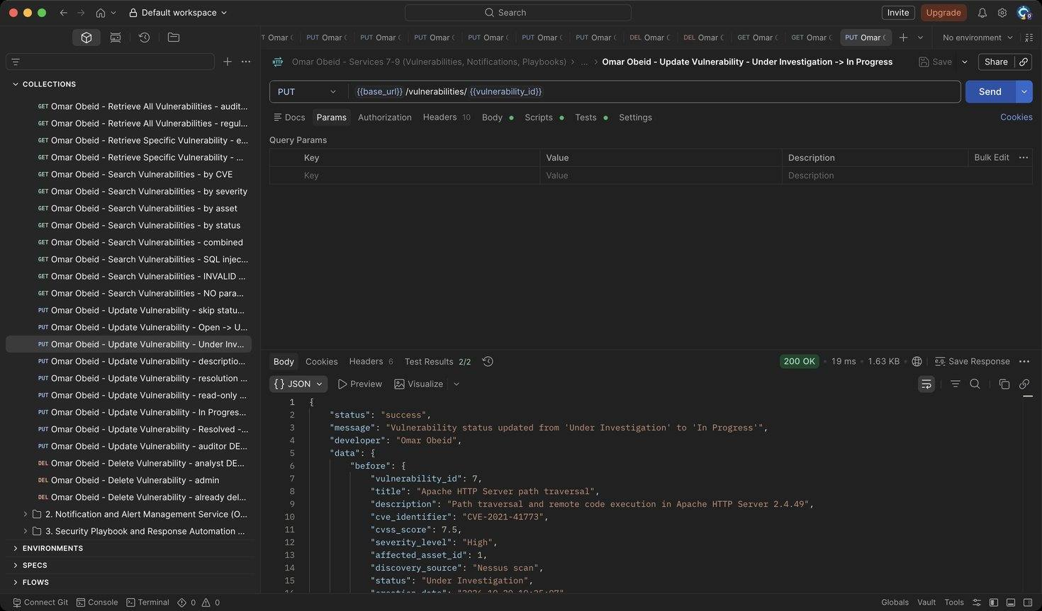
Figure 182: Omar Obeid – Update Vulnerability – Under Investigation -> In Progress: Next step (HTTP 200)
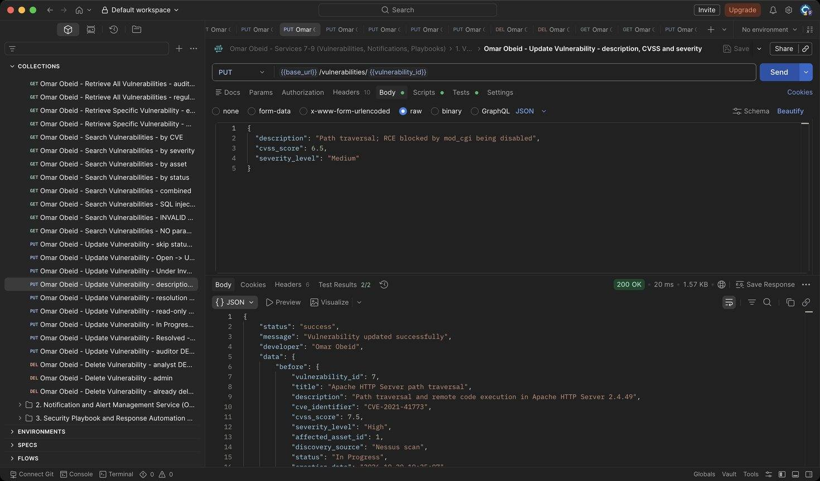
Figure 183: Omar Obeid – Update Vulnerability – description, CVSS and severity: CVSS 7.5 -> 6.5 so severity must become Medium (HTTP 200)
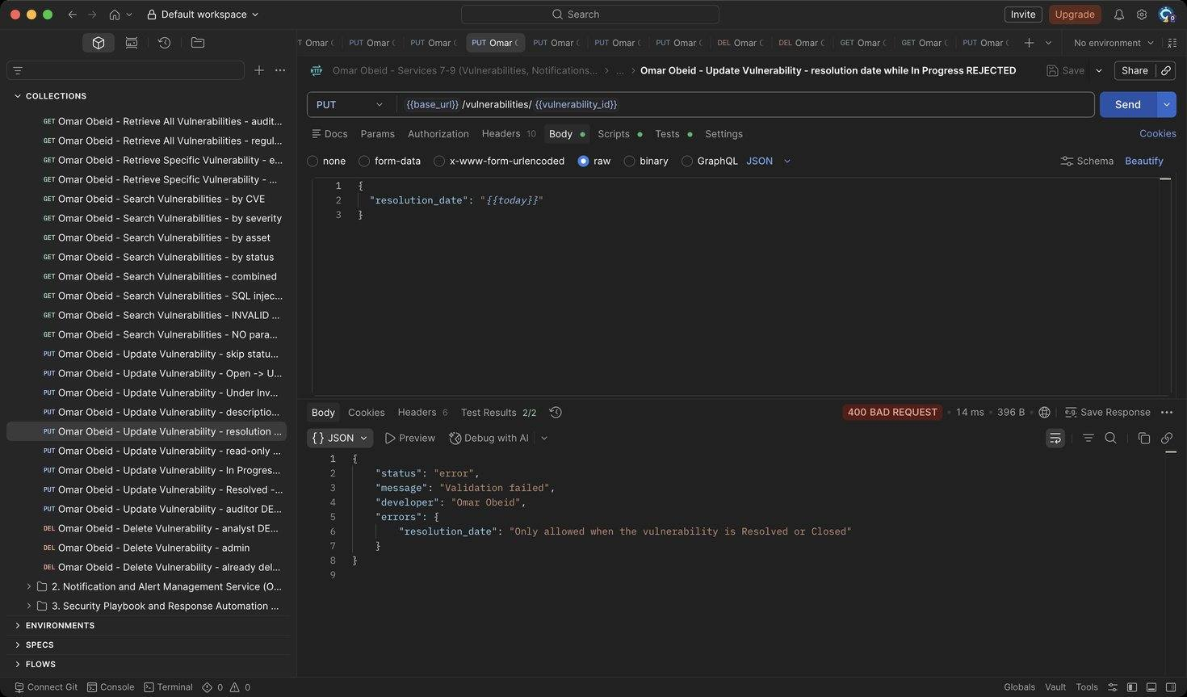
Figure 184: Omar Obeid – Update Vulnerability – resolution date while In Progress REJECTED: A resolution date is only allowed once the record is Resolved or Closed (HTTP 400)
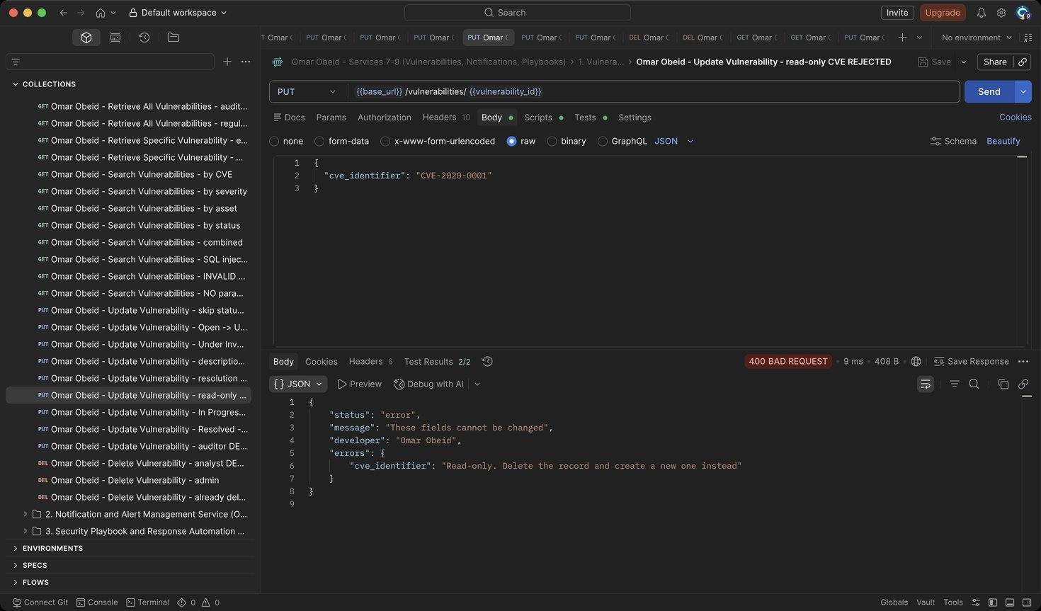
Figure 185: Omar Obeid – Update Vulnerability – read-only CVE REJECTED: CVE, title, asset and source cannot be changed (HTTP 400)
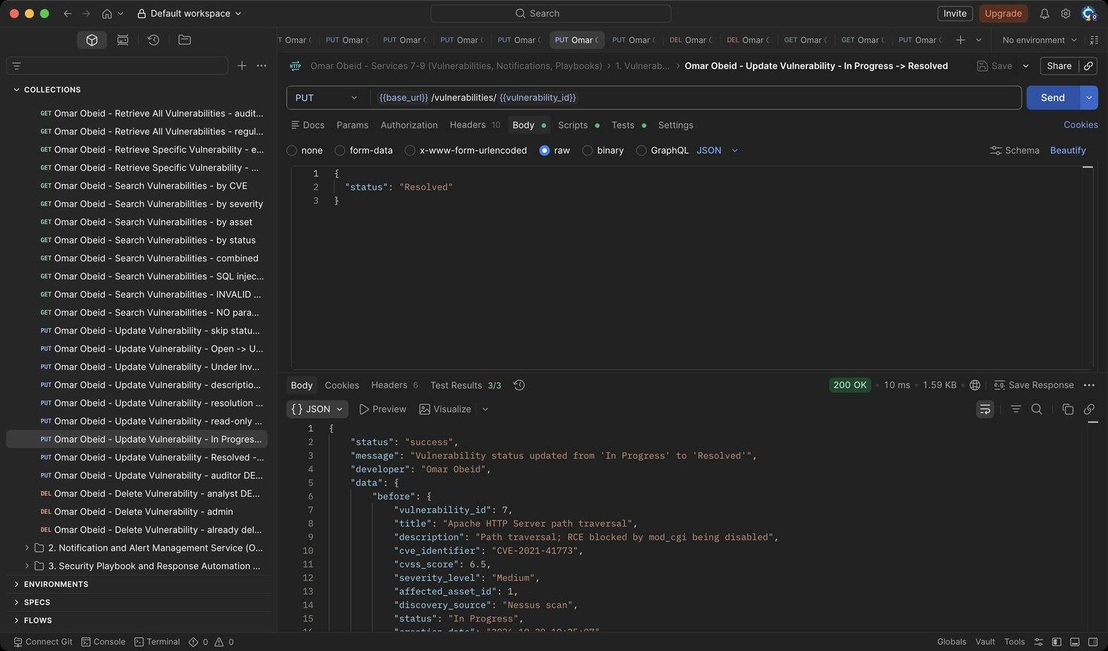
Figure 186: Omar Obeid – Update Vulnerability – In Progress -> Resolved: resolution_date is set automatically (HTTP 200)
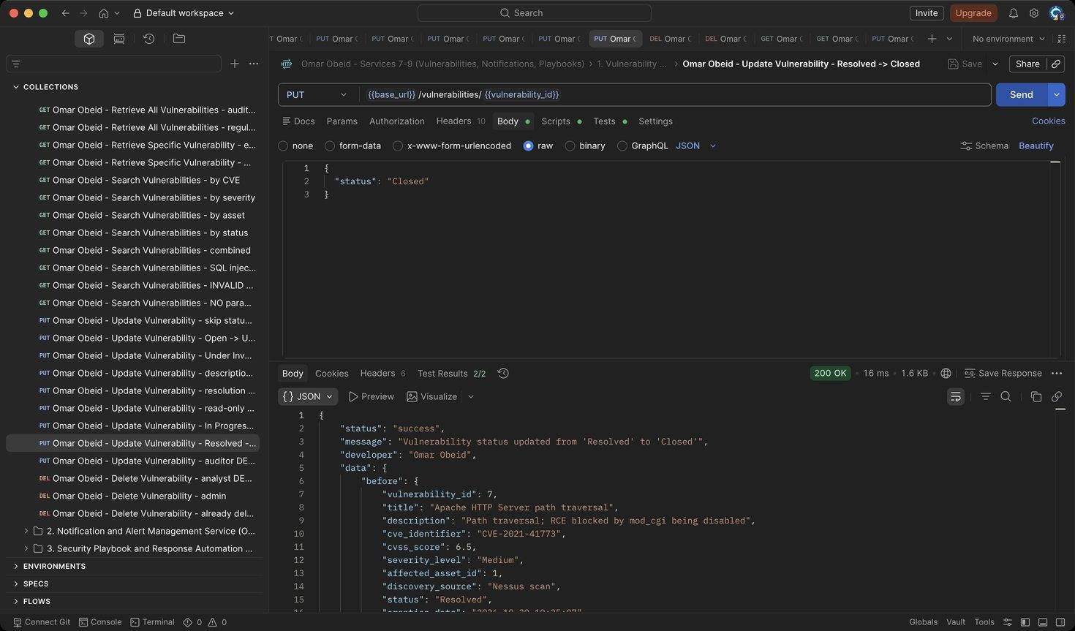
Figure 187: Omar Obeid – Update Vulnerability – Resolved -> Closed: Final state (HTTP 200)
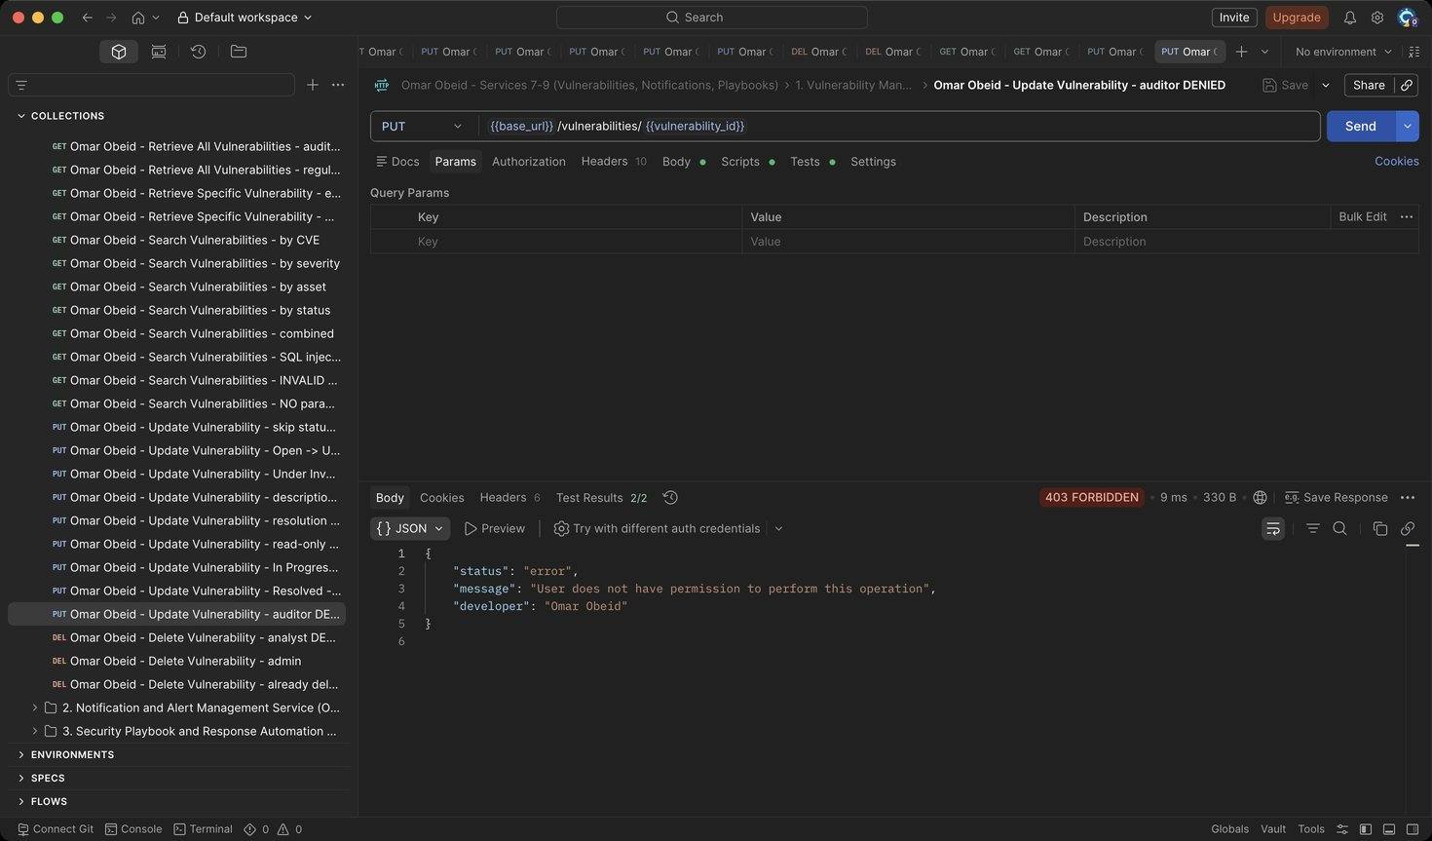
Figure 188: Omar Obeid – Update Vulnerability – auditor DENIED: Auditors are read-only (HTTP 403)
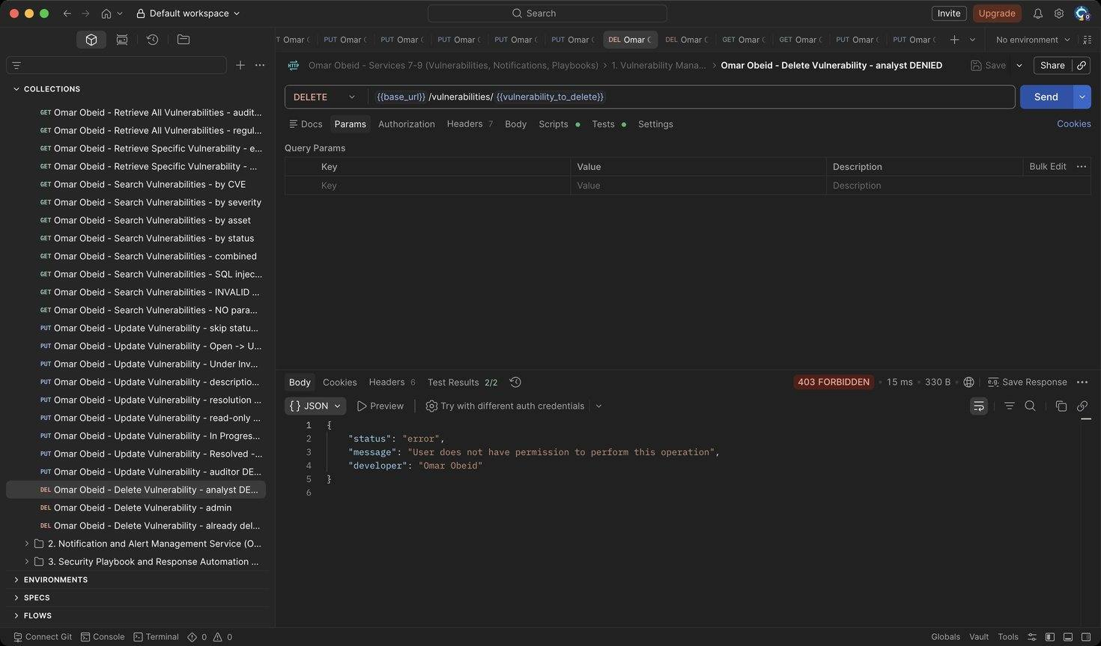
Figure 189: Omar Obeid – Delete Vulnerability – analyst DENIED: Only the Security Administrator can delete. The attempt is logged (HTTP 403)
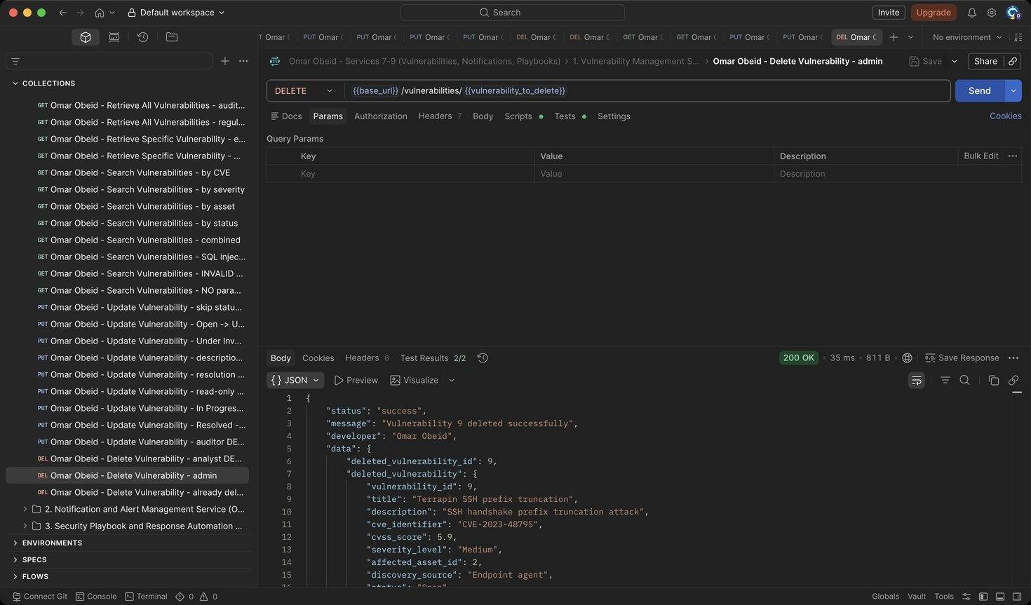
Figure 190: Omar Obeid – Delete Vulnerability – admin: Writes a VULNERABILITY_DELETED audit log (HTTP 200)
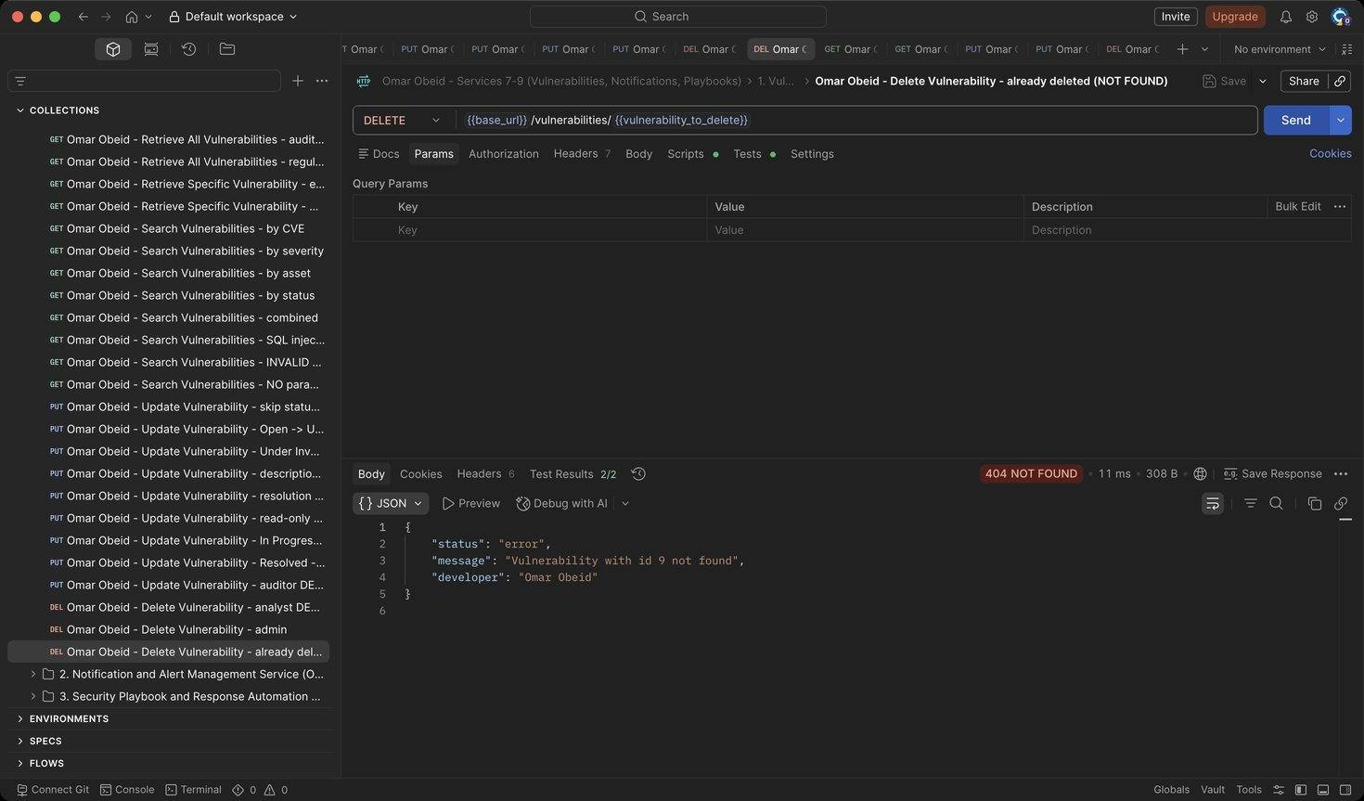
Figure 191: Omar Obeid – Delete Vulnerability – already deleted (NOT FOUND): The record is gone (HTTP 404)

Notification and Alert Management Service (Service 8) (Omar Obeid)
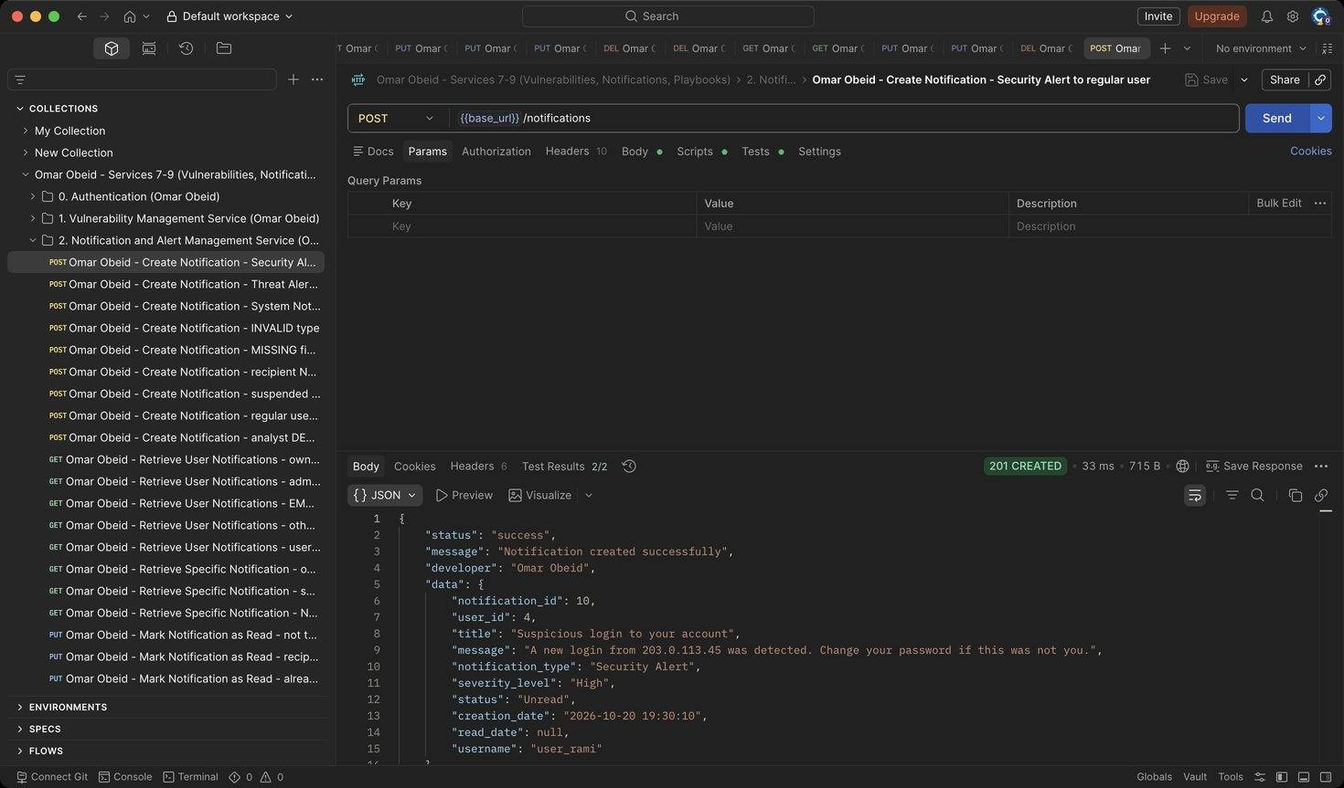
Figure 192: Omar Obeid – Create Notification – Security Alert to regular user: Starts as Unread. (HTTP 201)
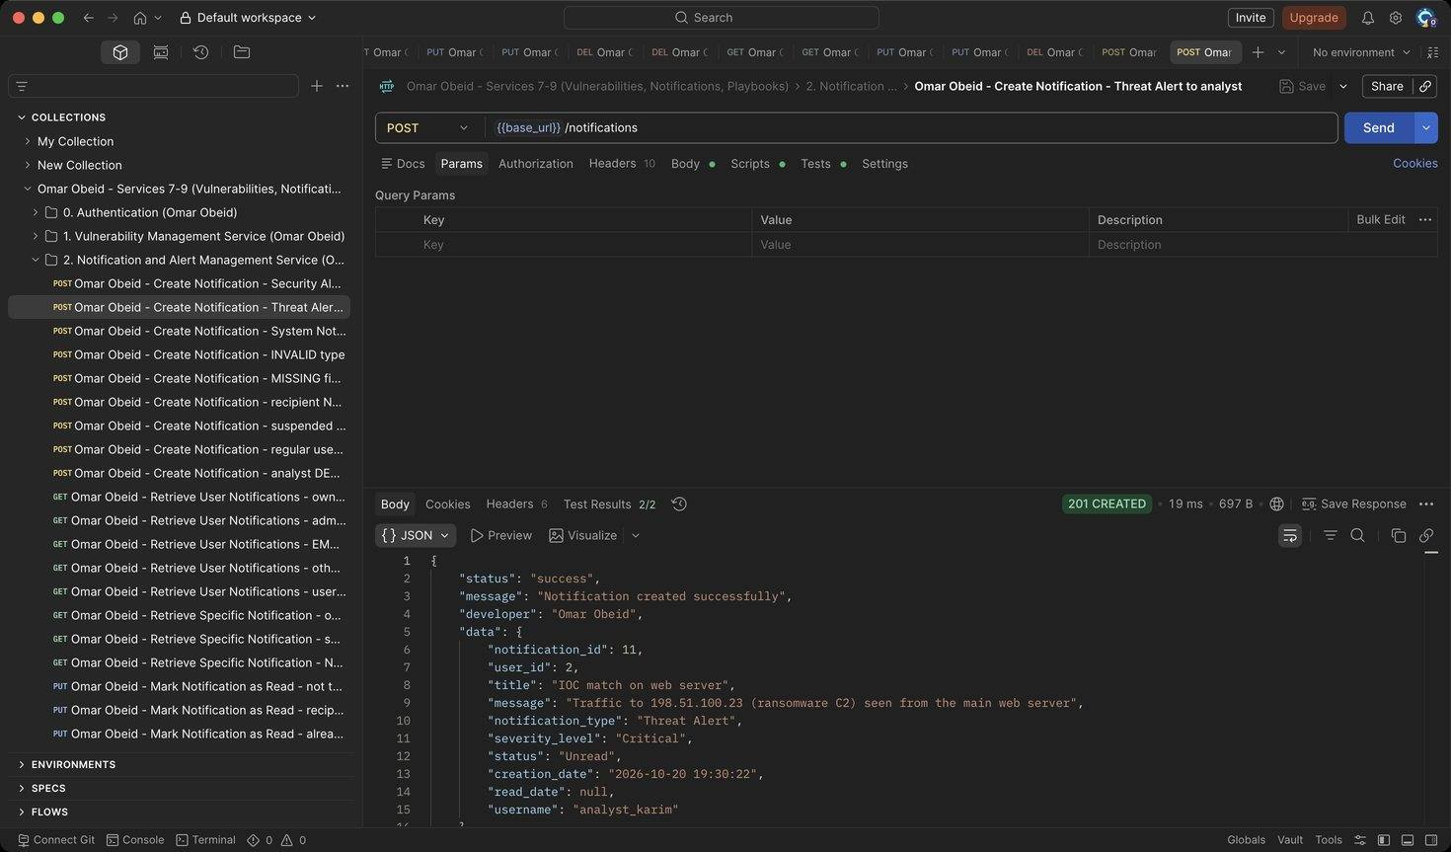
Figure 193: Omar Obeid – Create Notification – Threat Alert to analyst: Critical threat alert for analyst_karim (HTTP 201)
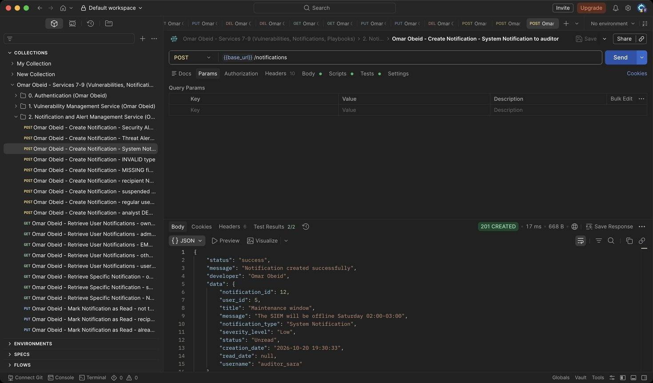
Figure 194: Omar Obeid – Create Notification – System Notification to auditor: Low-severity system message (HTTP 201)
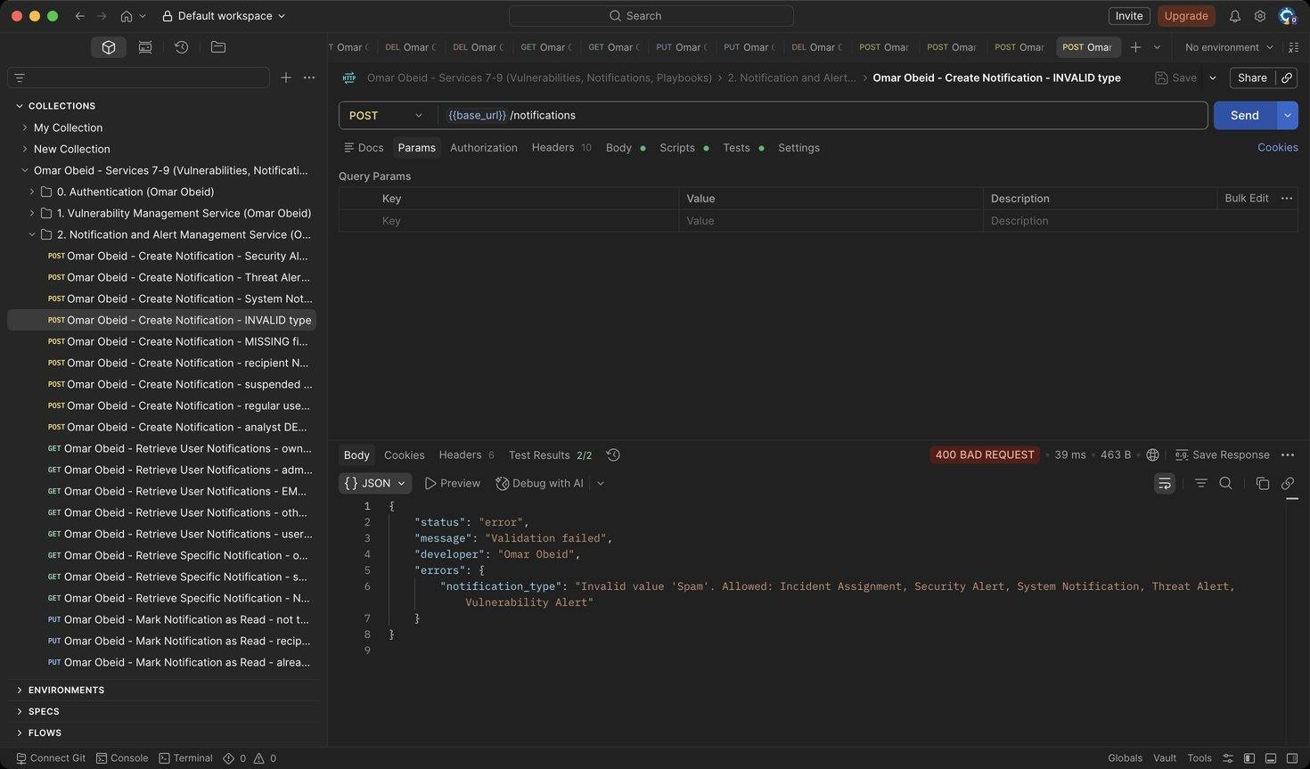
Figure 195: Omar Obeid – Create Notification – INVALID type: Type must be one of the five notification types (HTTP 400)
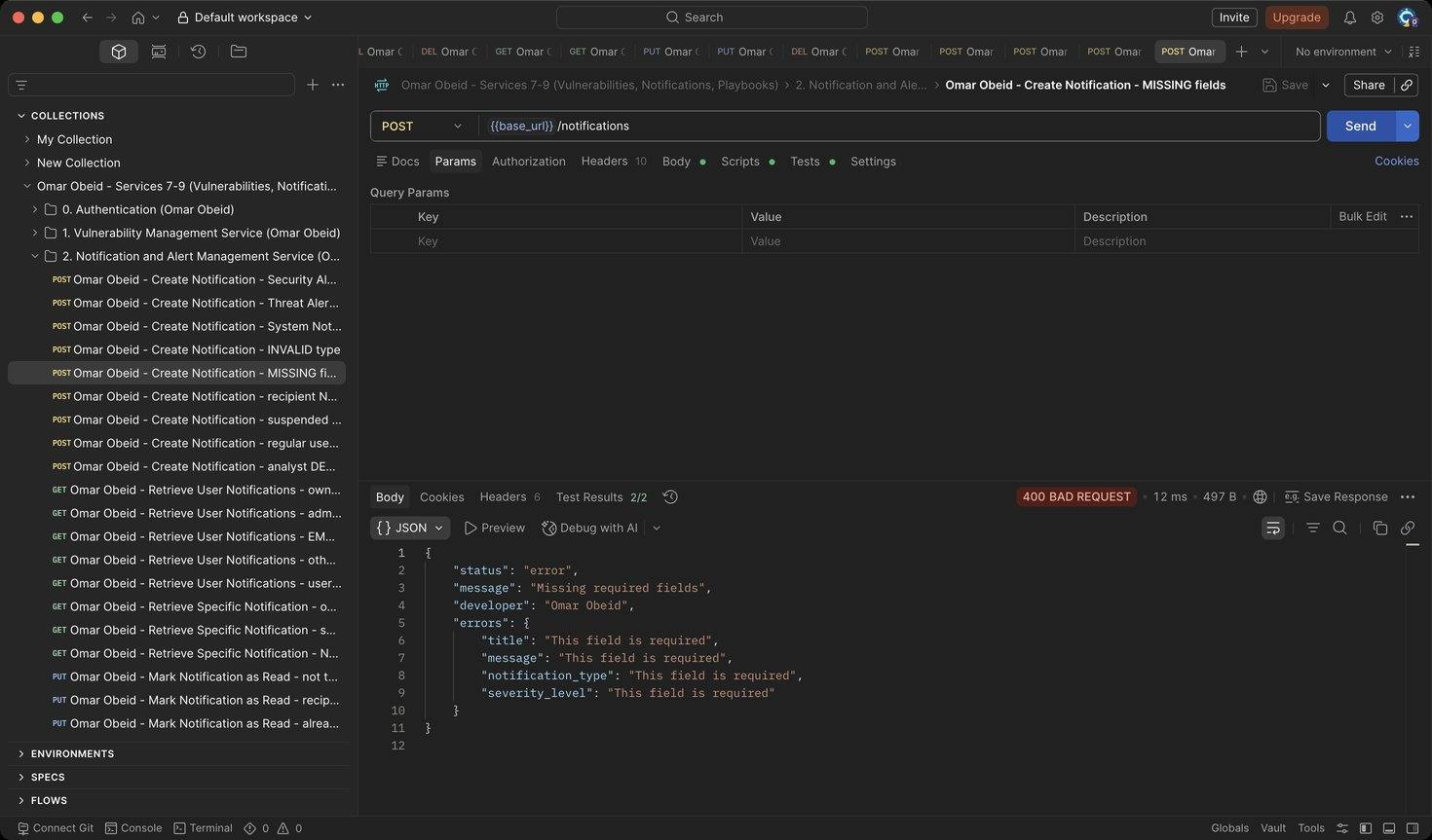
Figure 196: Omar Obeid – Create Notification – MISSING fields: All fields required (HTTP 400)
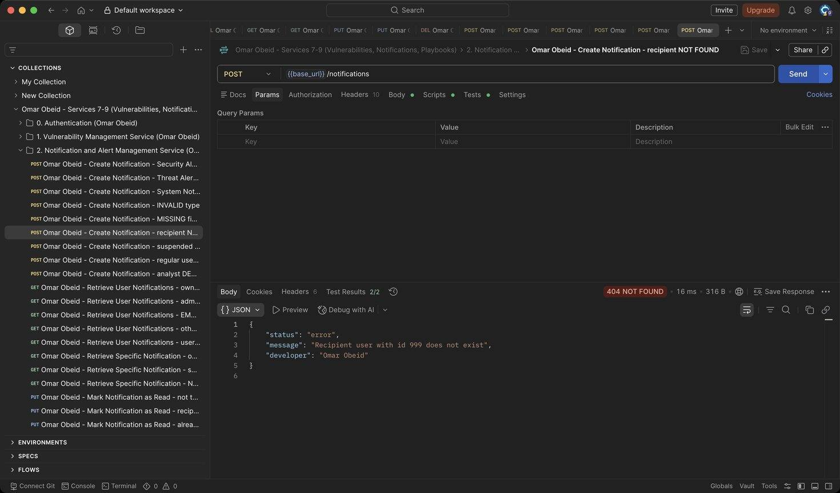
Figure 197: Omar Obeid – Create Notification – recipient NOT FOUND: The user must exist (HTTP 404)
Figure 198: Omar Obeid – Create Notification – suspended recipient REJECTED: Suspended or inactive accounts cannot be notified (HTTP 400)
Figure 199: Omar Obeid – Create Notification – regular user DENIED: Only the Security Administrator creates notifications (HTTP 403)
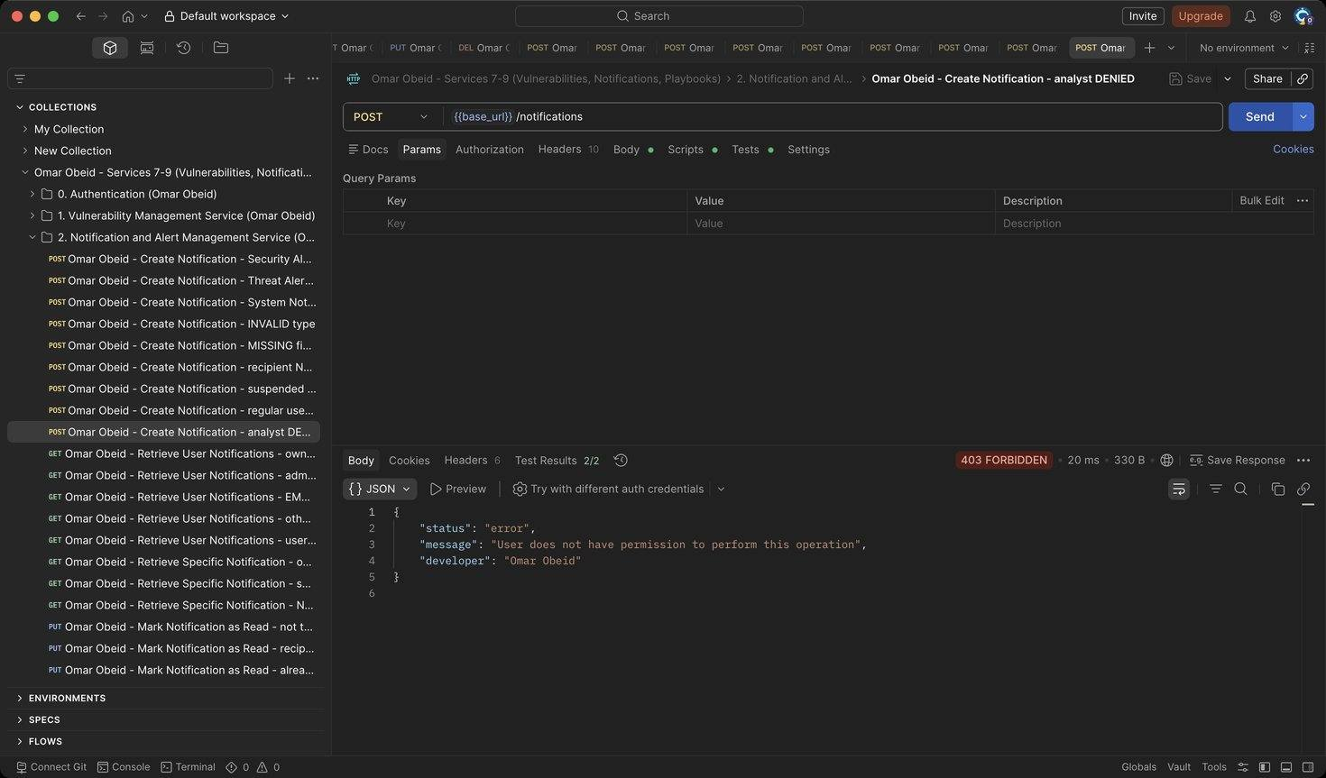
Figure 200: Omar Obeid – Create Notification – analyst DENIED: Only the Security Administrator creates notifications (HTTP 403)
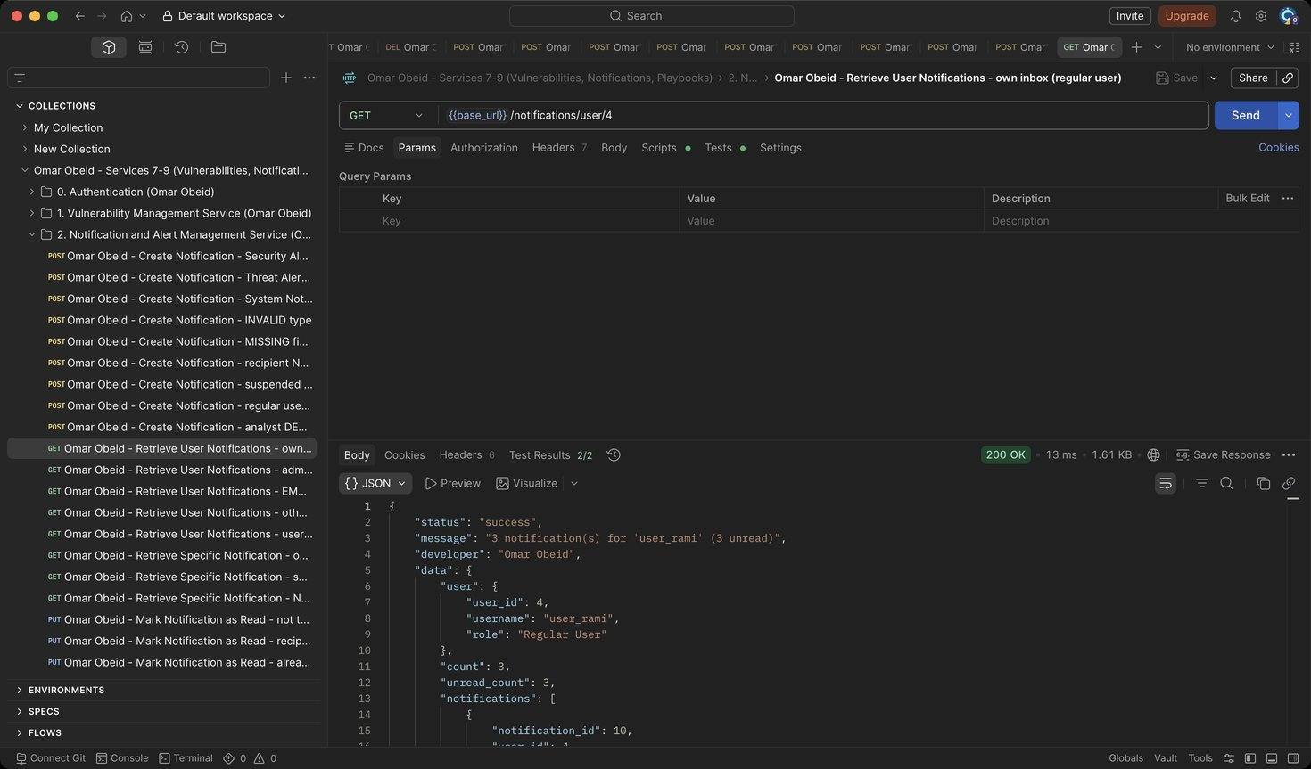
Figure 201: Omar Obeid – Retrieve User Notifications – own inbox (regular user): Newest first, with count and unread_count (HTTP 200)
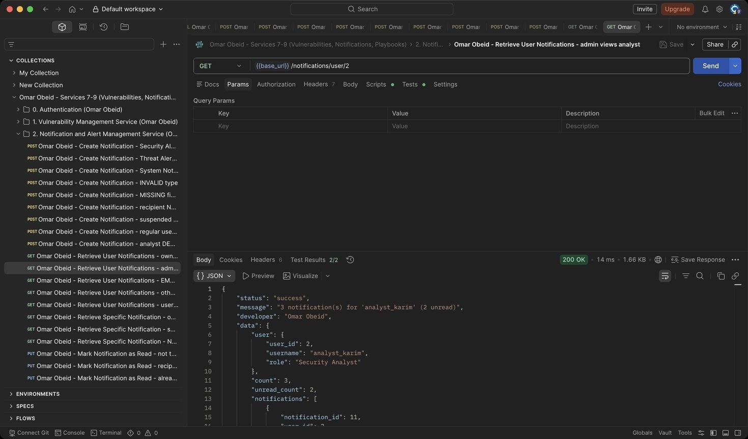
Figure 202: Omar Obeid – Retrieve User Notifications – admin views analyst: Administrators and Auditors can view any inbox (HTTP 200)
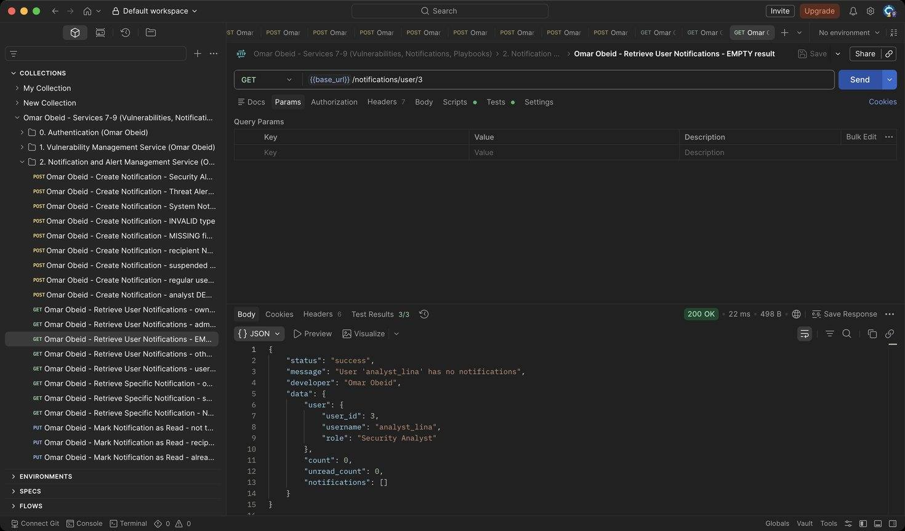
Figure 203: Omar Obeid – Retrieve User Notifications – EMPTY result: analyst_lina has no notifications: count 0 and an empty list (HTTP 200)
Figure 204: Omar Obeid – Retrieve User Notifications – other user's inbox DENIED: Users can only see their own notifications (HTTP 403)
Figure 205: Omar Obeid – Retrieve User Notifications – user NOT FOUND: Unknown user (HTTP 404)
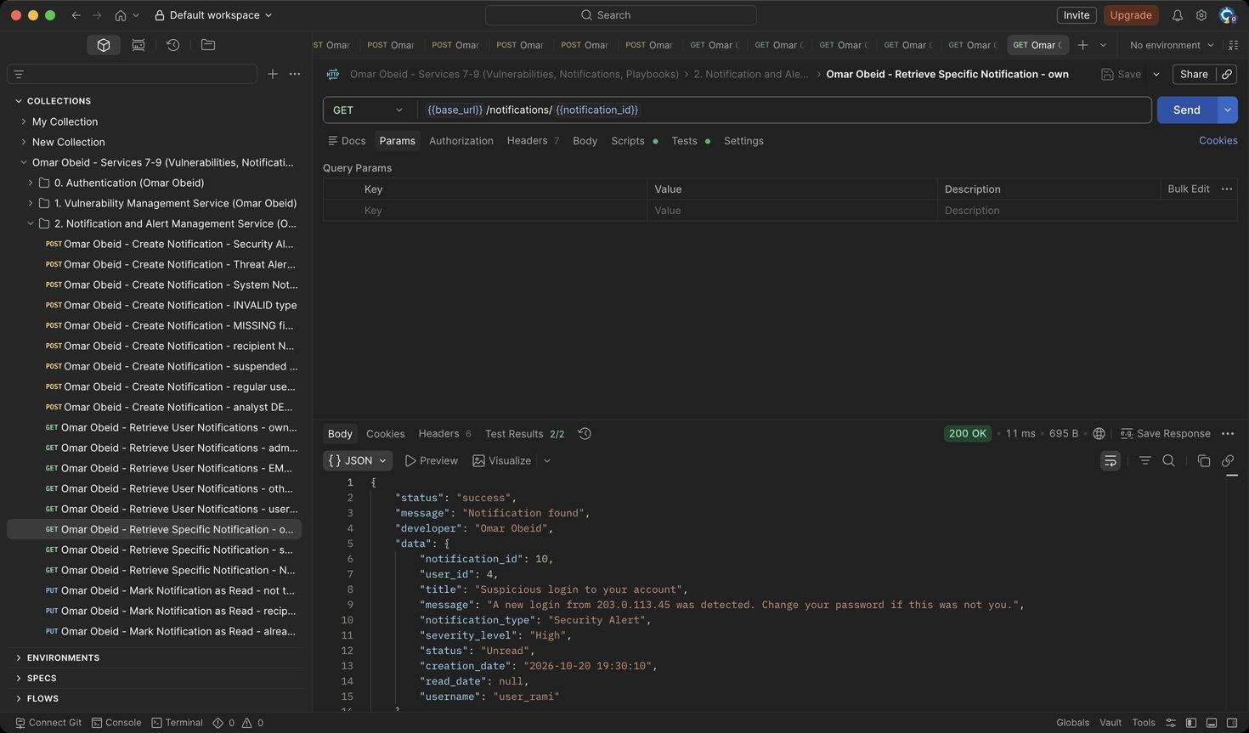
Figure 206: Omar Obeid – Retrieve Specific Notification – own: The recipient can open it (HTTP 200)
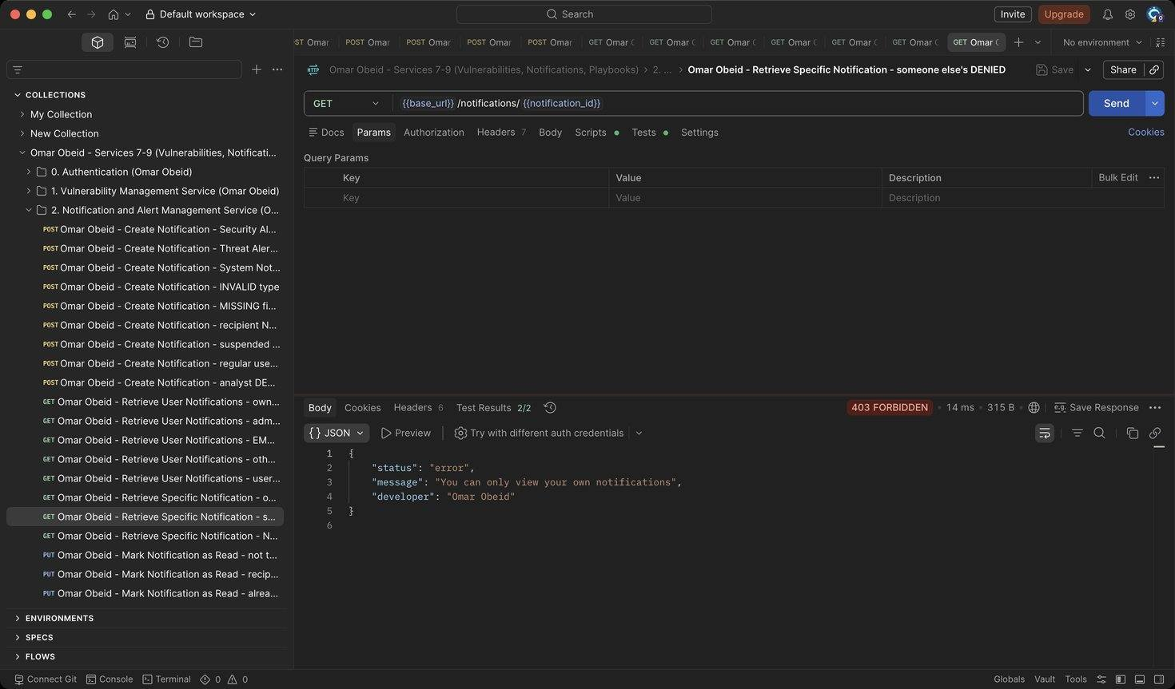
Figure 207: Omar Obeid – Retrieve Specific Notification – someone else's DENIED: Not the recipient (HTTP 403)
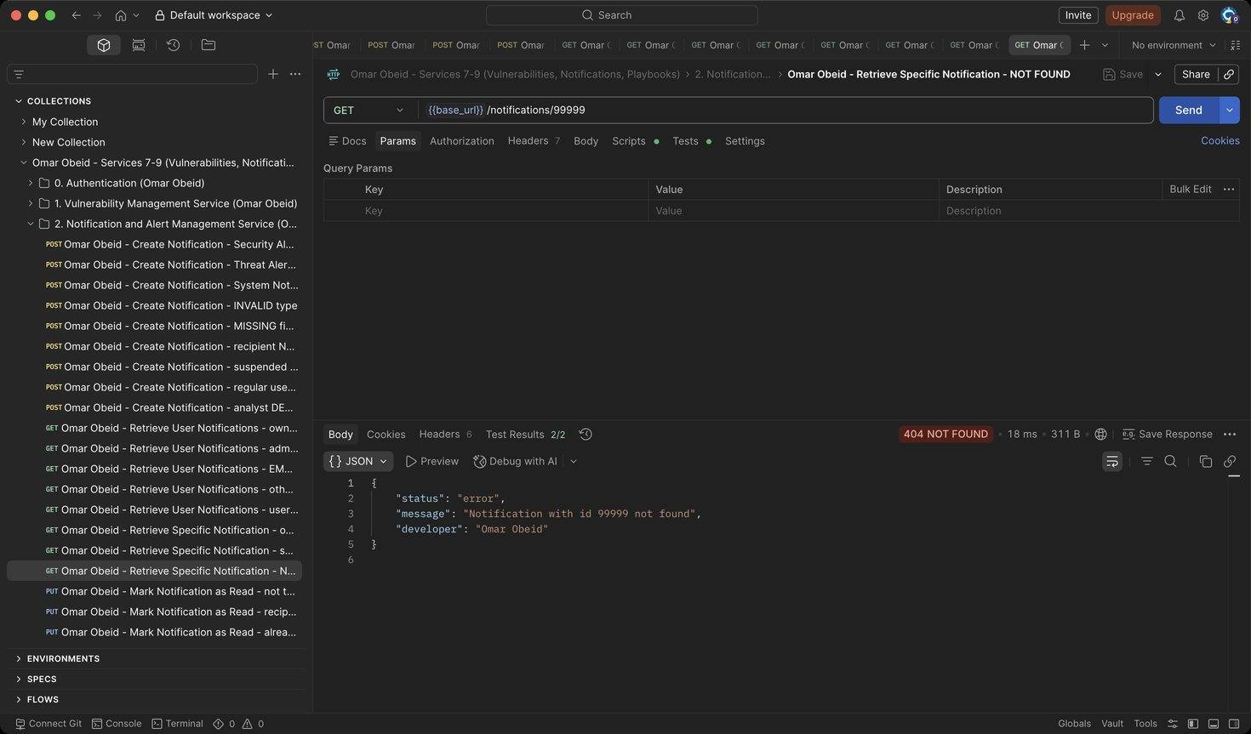
Figure 208: Omar Obeid – Retrieve Specific Notification – NOT FOUND: Unknown id (HTTP 404)
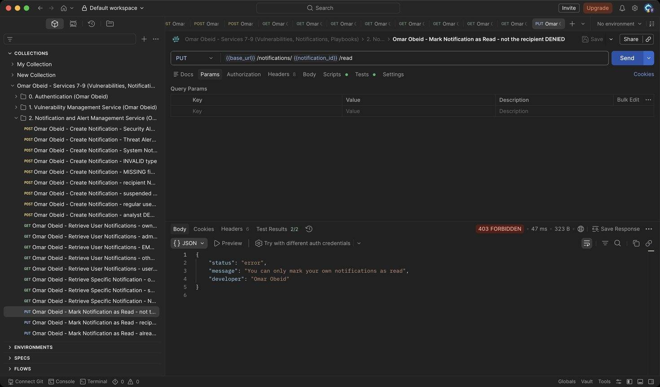
Figure 209: Omar Obeid – Mark Notification as Read – not the recipient DENIED: Only the recipient (or an administrator) can mark it read (HTTP 403)
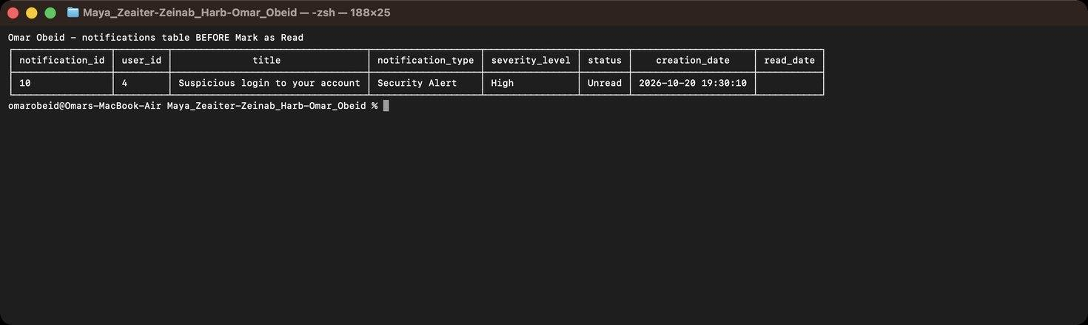
Figure 210: Omar Obeid – Mark Notification as Read – notifications row 10 in the database BEFORE the update (status Unread, read_date empty)
Figure 211: Omar Obeid – Mark Notification as Read – recipient: Status becomes Read and read_date is set (HTTP 200)
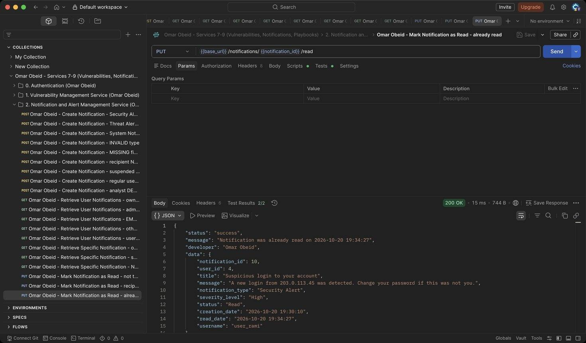
Figure 212: Omar Obeid – Mark Notification as Read – already read: Idempotent: the original read_date is kept (HTTP 200)
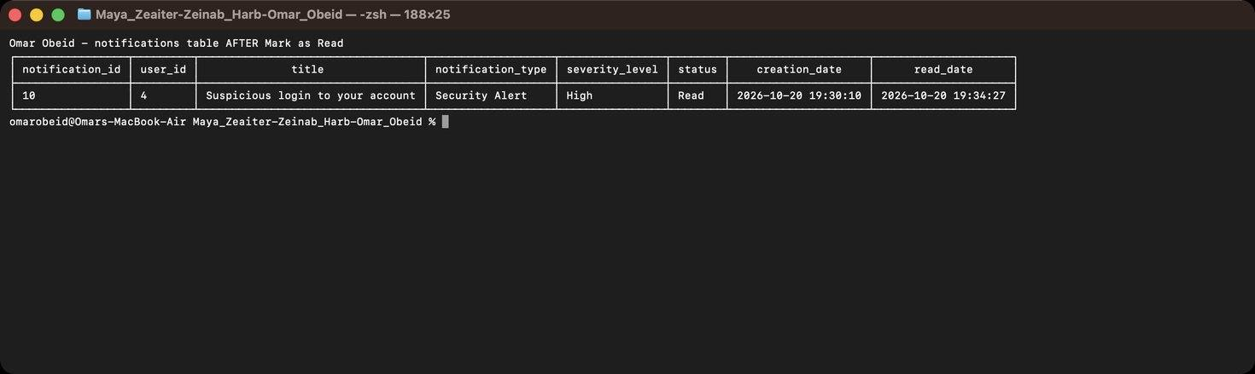
Figure 213: Omar Obeid – Mark Notification as Read – the same row AFTER the update (status Read, read_date set)
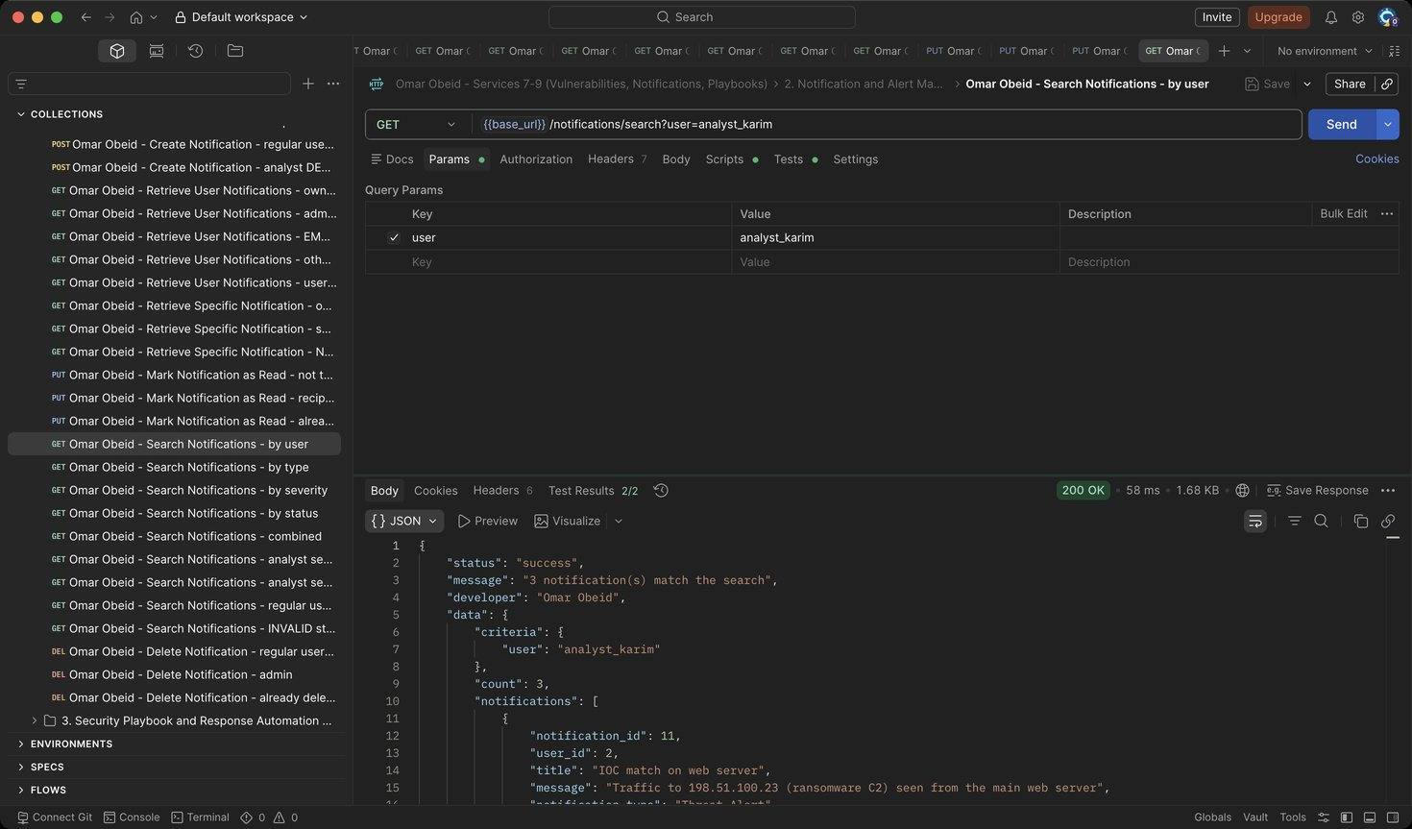
Figure 214: Omar Obeid – Search Notifications – by user: User id or username (HTTP 200)
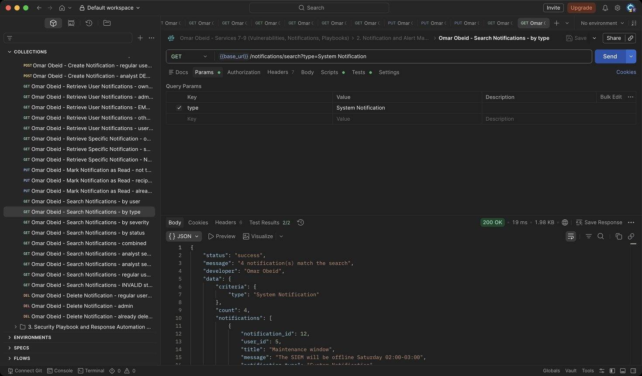
Figure 215: Omar Obeid – Search Notifications – by type: Exact type (HTTP 200)
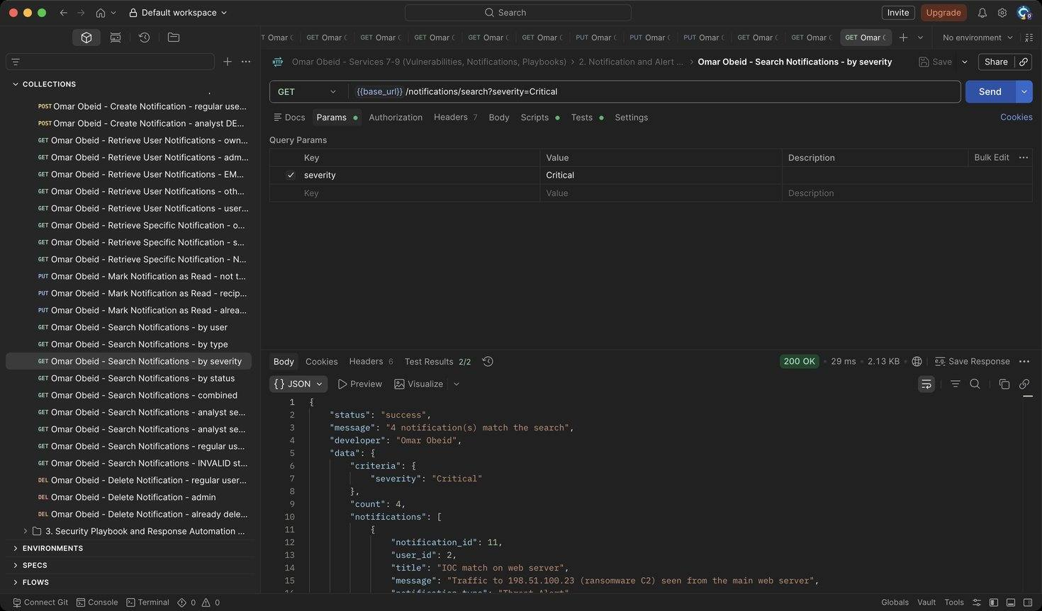
Figure 216: Omar Obeid – Search Notifications – by severity: Exact severity (HTTP 200)
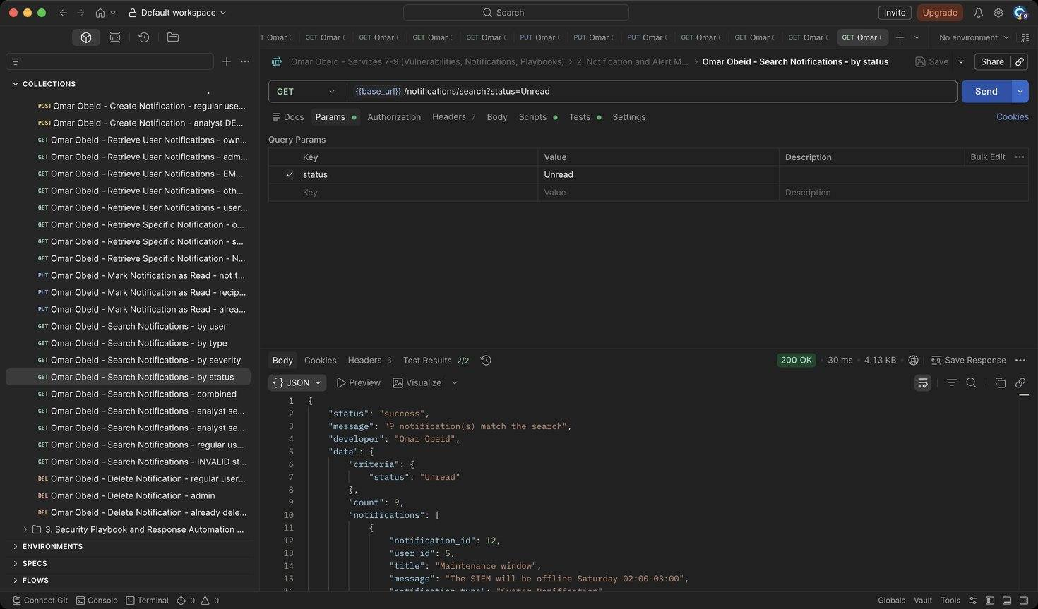
Figure 217: Omar Obeid – Search Notifications – by status: Unread or Read (HTTP 200)
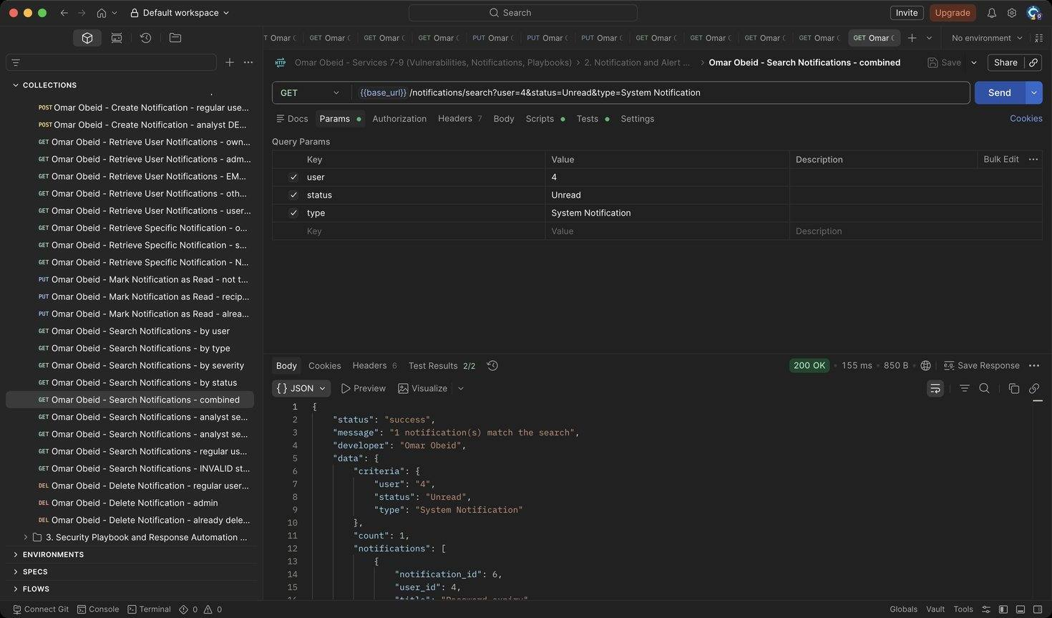
Figure 218: Omar Obeid – Search Notifications – combined: Criteria combined with AND (HTTP 200)
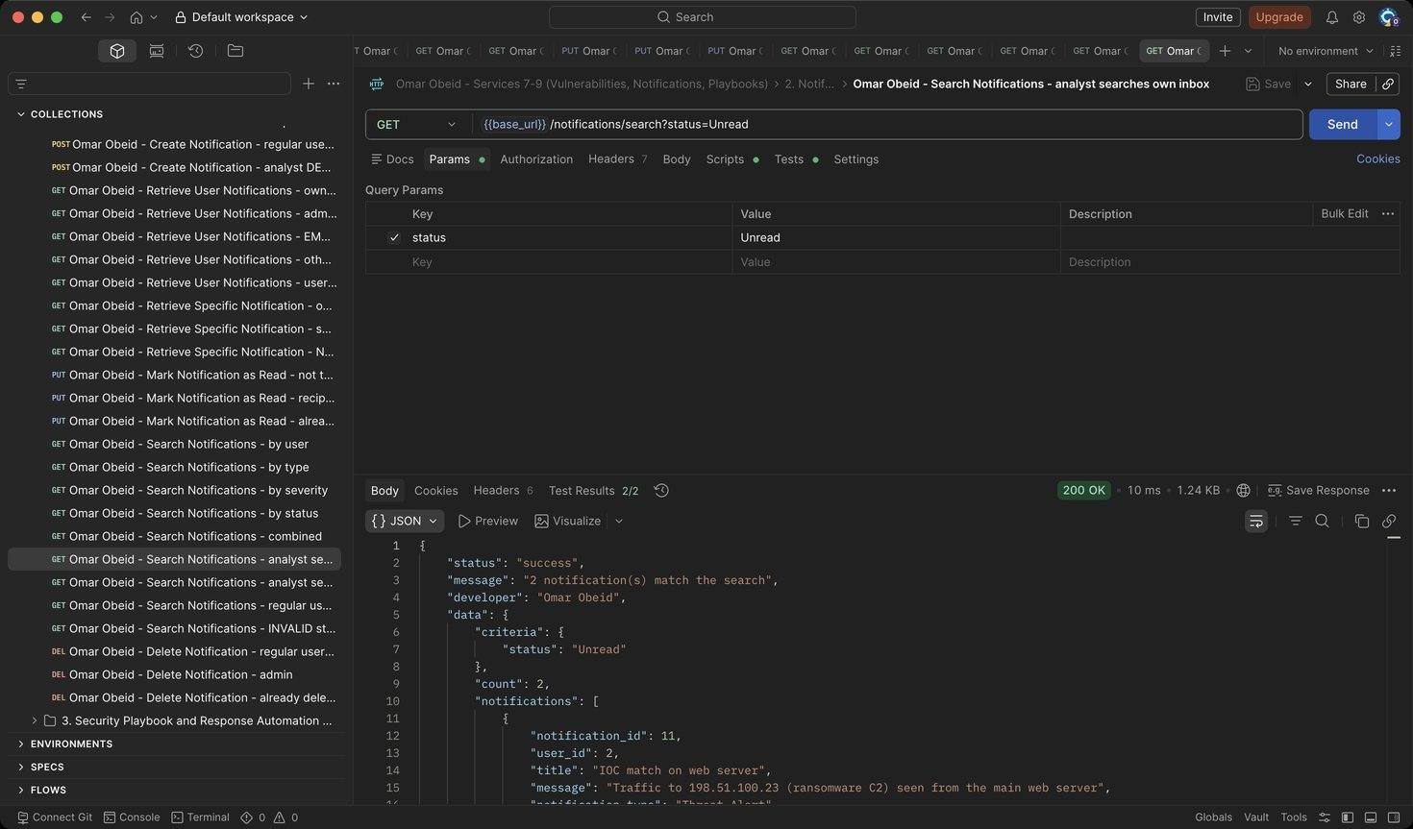
Figure 219: Omar Obeid – Search Notifications – analyst searches own inbox: Results are limited to the analyst's own notifications (HTTP 200)
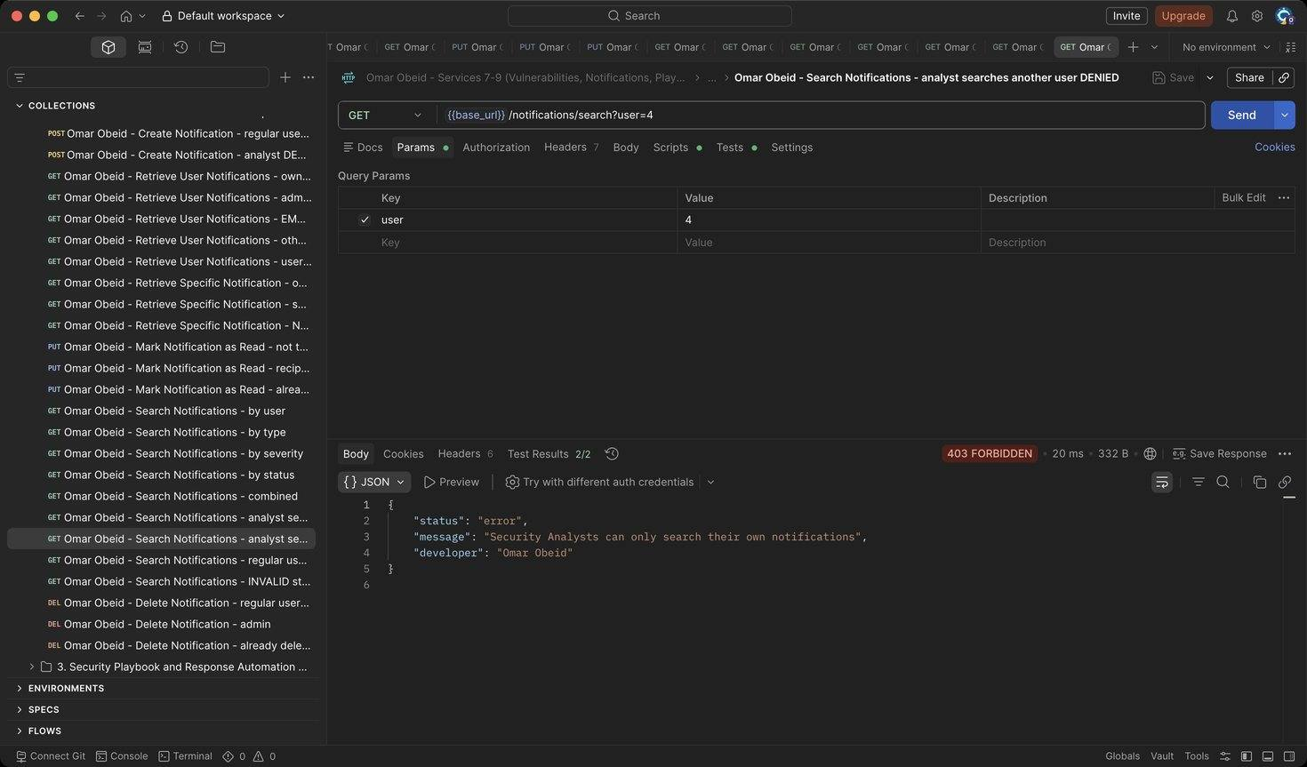
Figure 220: Omar Obeid – Search Notifications – analyst searches another user DENIED: Analysts cannot search other users' notifications (HTTP 403)
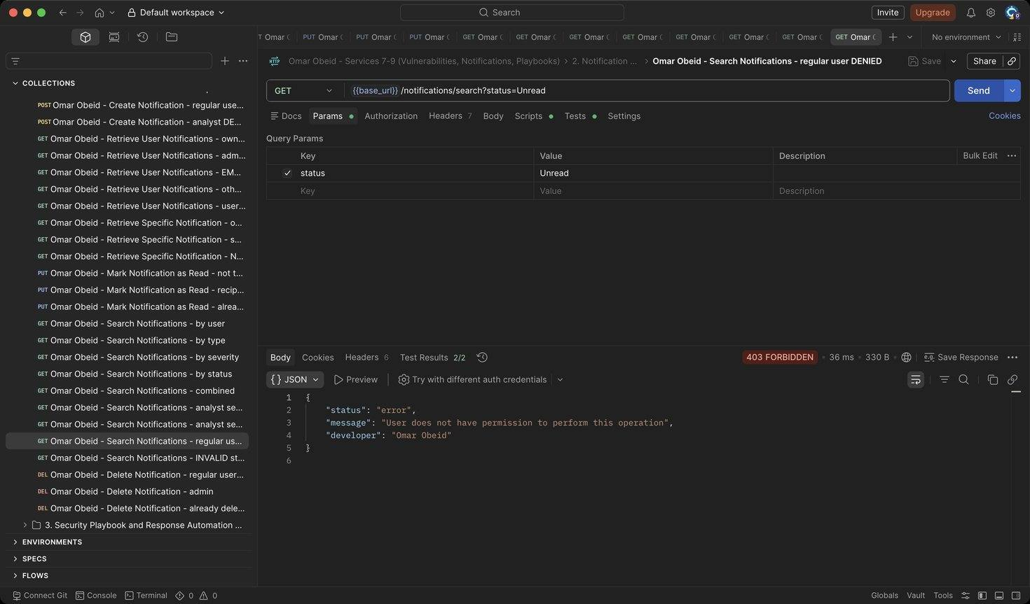
Figure 221: Omar Obeid – Search Notifications – regular user DENIED: Regular users have no search access (HTTP 403)
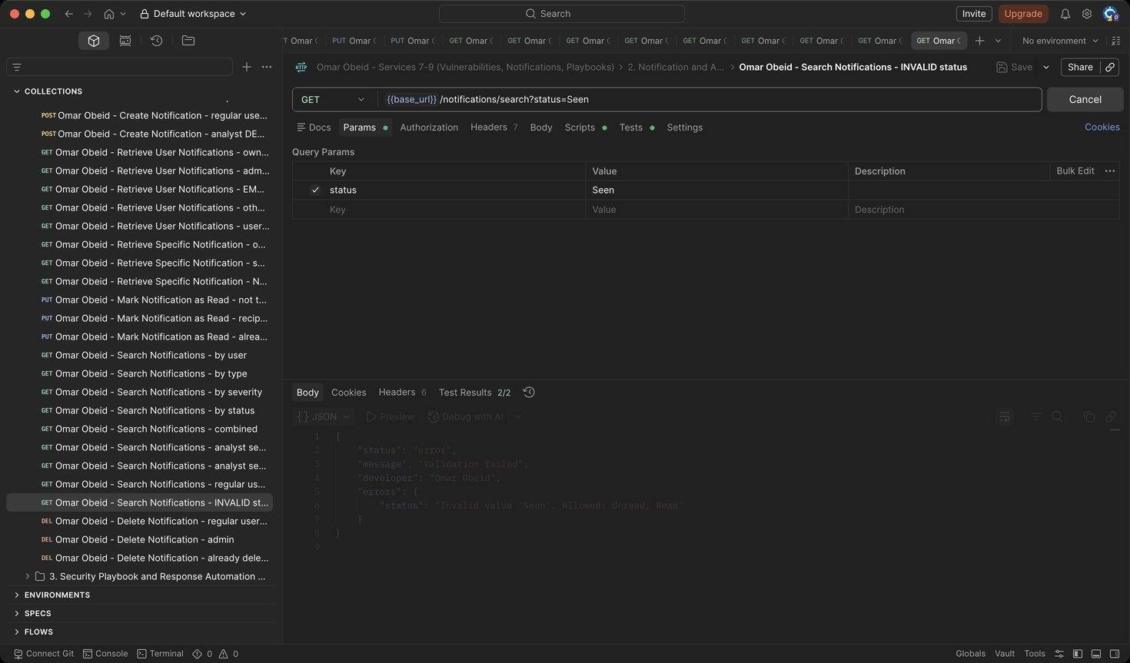
Figure 222: Omar Obeid – Search Notifications – INVALID status: Status must be Unread or Read (HTTP 400)
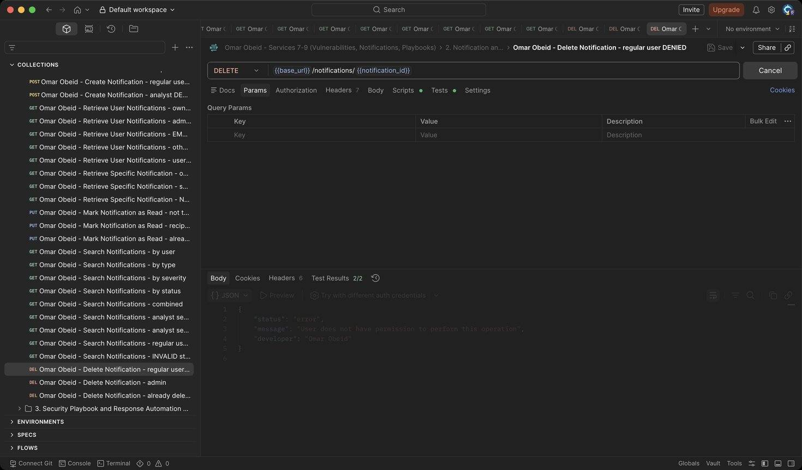
Figure 223: Omar Obeid – Delete Notification – regular user DENIED: Only the Security Administrator deletes (HTTP 403)
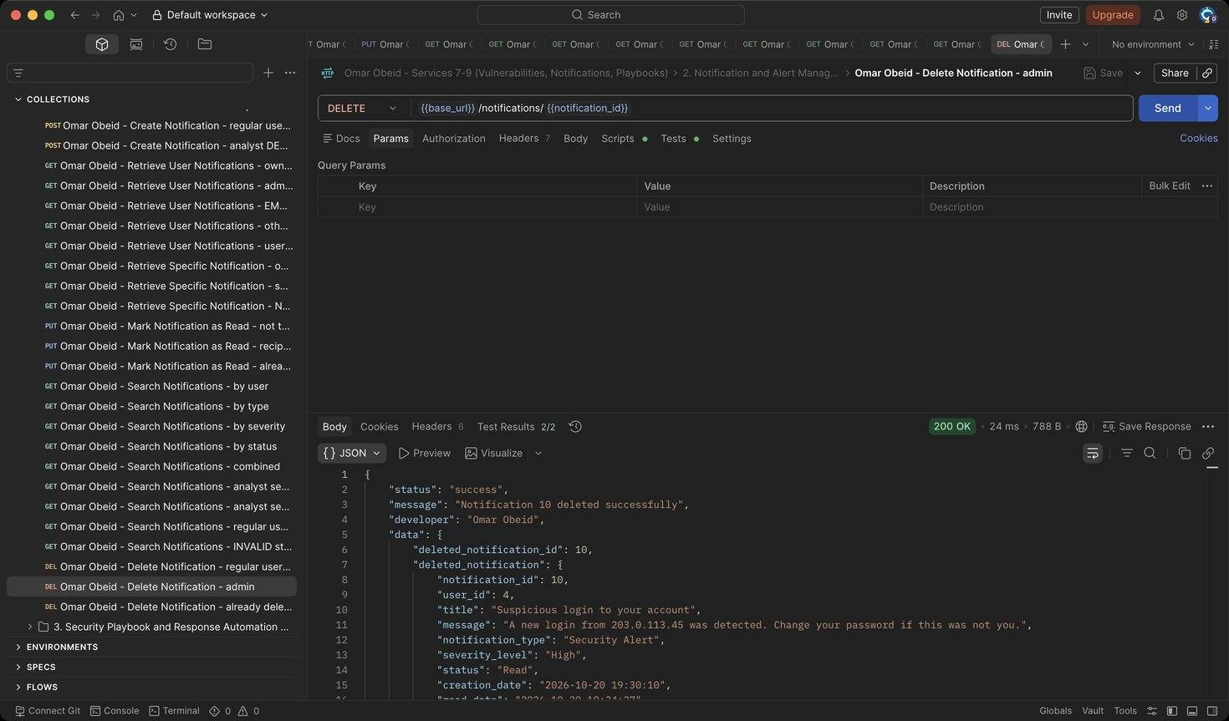
Figure 224: Omar Obeid – Delete Notification – admin: Writes an audit log (HTTP 200)
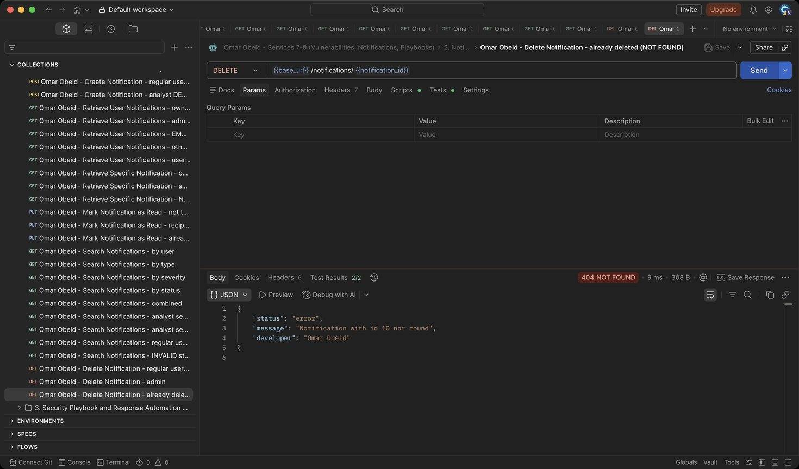
Figure 225: Omar Obeid – Delete Notification – already deleted (NOT FOUND): The record is gone (HTTP 404)

Security Playbook and Response Automation Service (Service 9) (Omar Obeid)
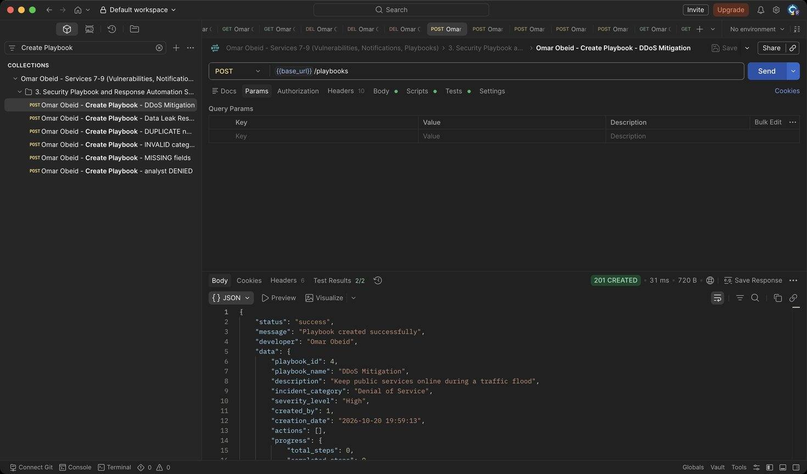
Figure 226: Omar Obeid – Create Playbook – DDoS Mitigation: created_by is the logged-in administrator. (HTTP 201)
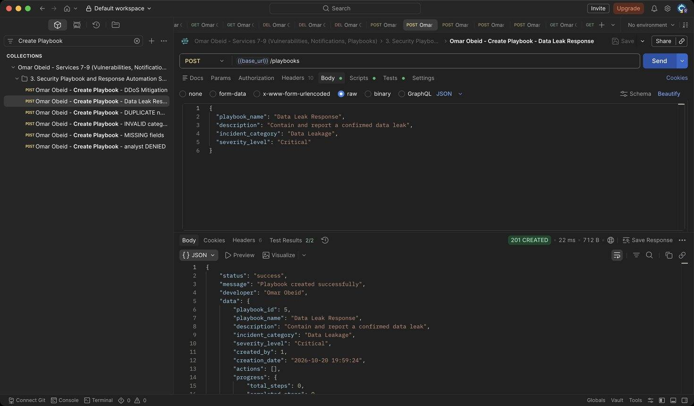
Figure 227: Omar Obeid – Create Playbook – Data Leak Response: Second playbook (deleted at the end). (HTTP 201)
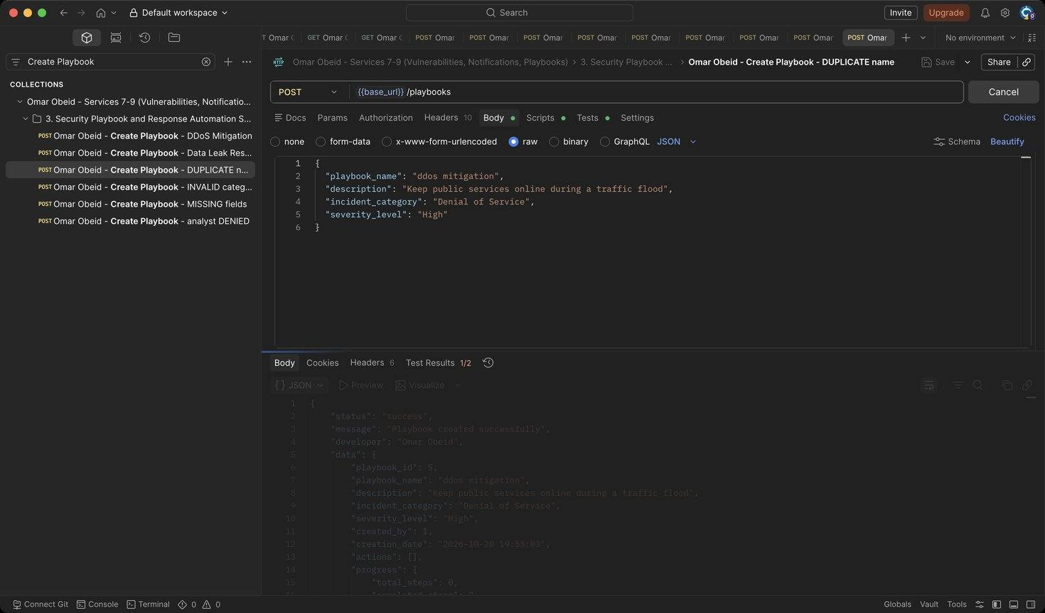
Figure 228: Omar Obeid – Create Playbook – DUPLICATE name: Names are unique (case-insensitive) (HTTP 409)
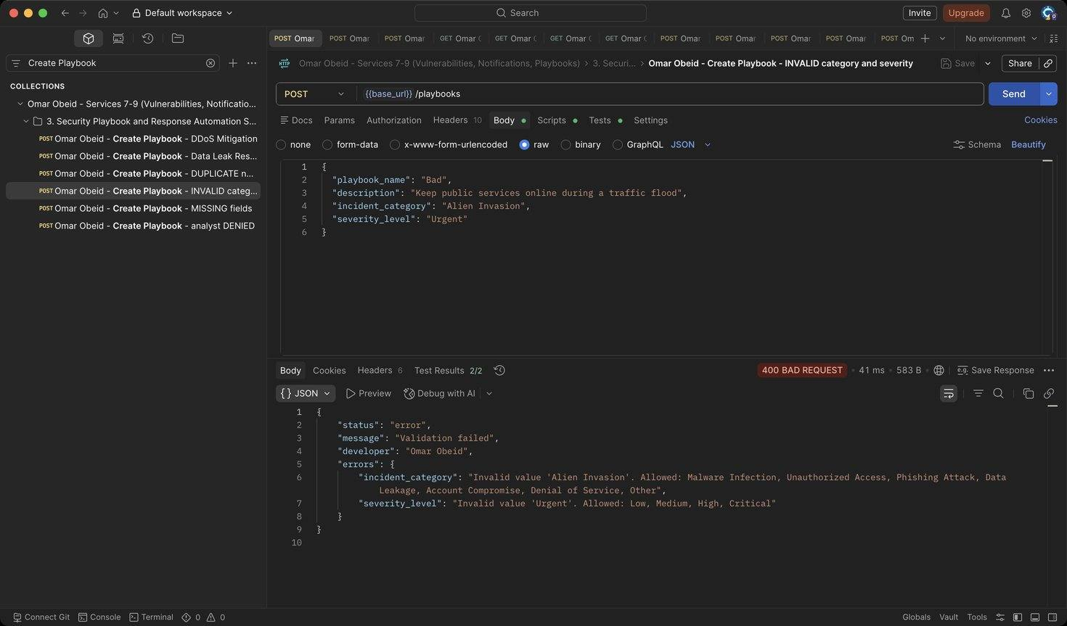
Figure 229: Omar Obeid – Create Playbook – INVALID category and severity: Category must be an incident category; severity Low-Critical (HTTP 400)
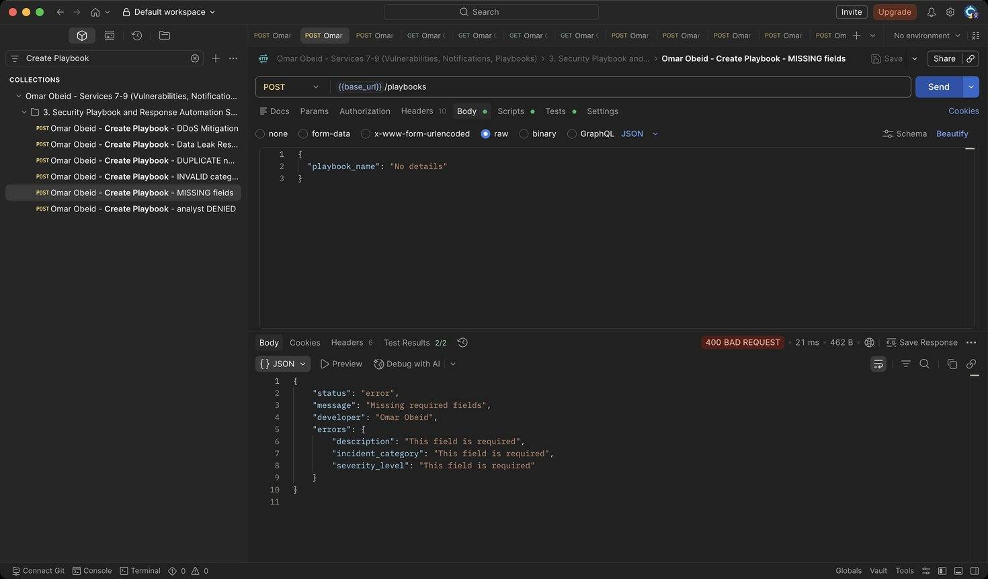
Figure 230: Omar Obeid – Create Playbook – MISSING fields: All fields required (HTTP 400)
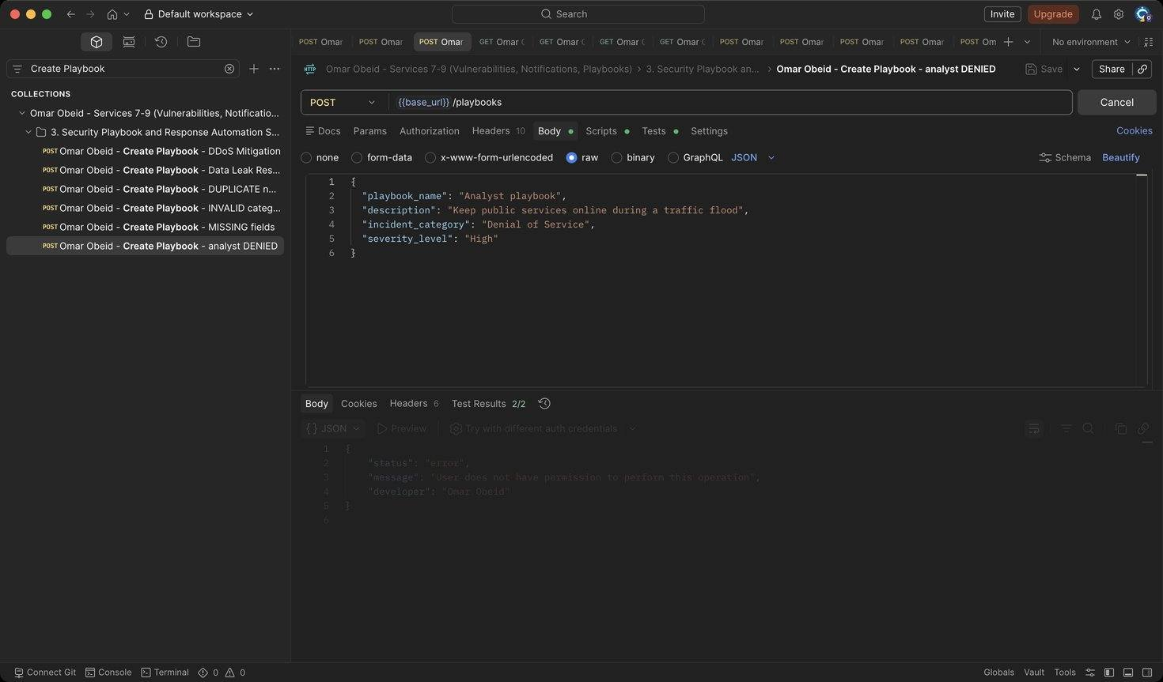
Figure 231: Omar Obeid – Create Playbook – analyst DENIED: Only administrators create (HTTP 403)
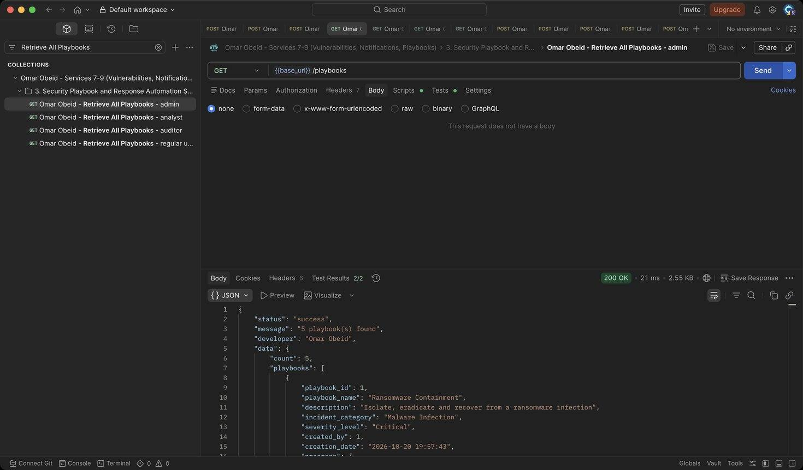
Figure 232: Omar Obeid – Retrieve All Playbooks – admin: Each playbook with its progress (HTTP 200)
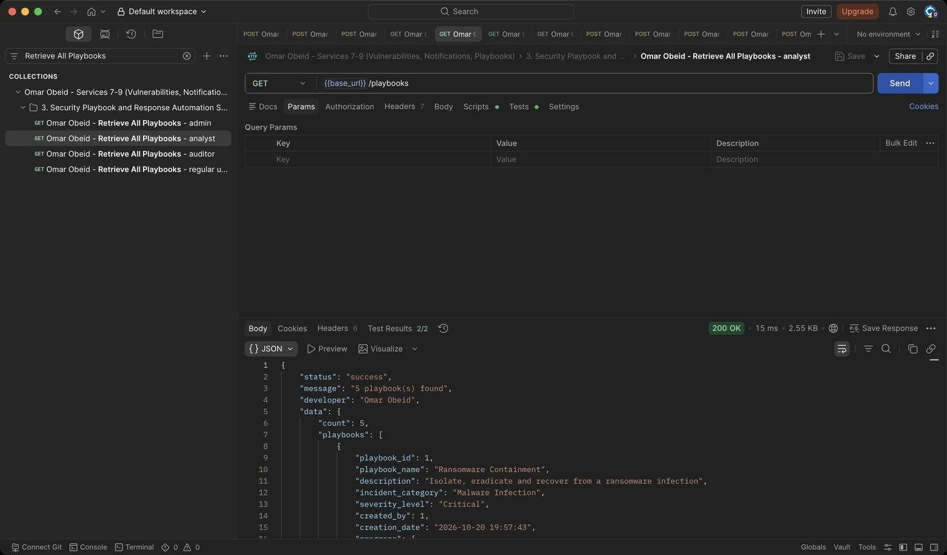
Figure 233: Omar Obeid – Retrieve All Playbooks – analyst: Analysts can list (HTTP 200)
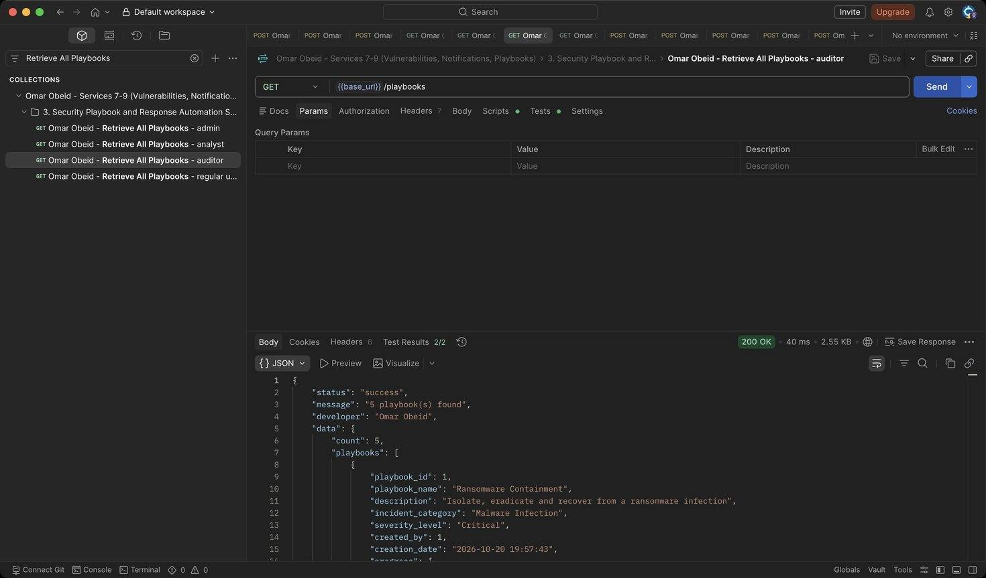
Figure 234: Omar Obeid – Retrieve All Playbooks – auditor: Auditors can list (HTTP 200)
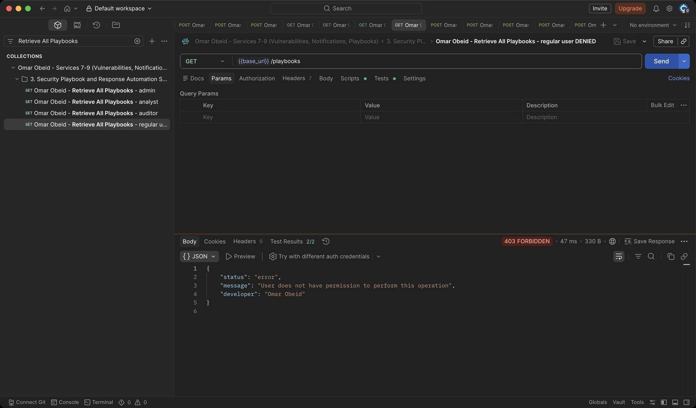
Figure 235: Omar Obeid – Retrieve All Playbooks – regular user DENIED: No access (HTTP 403)
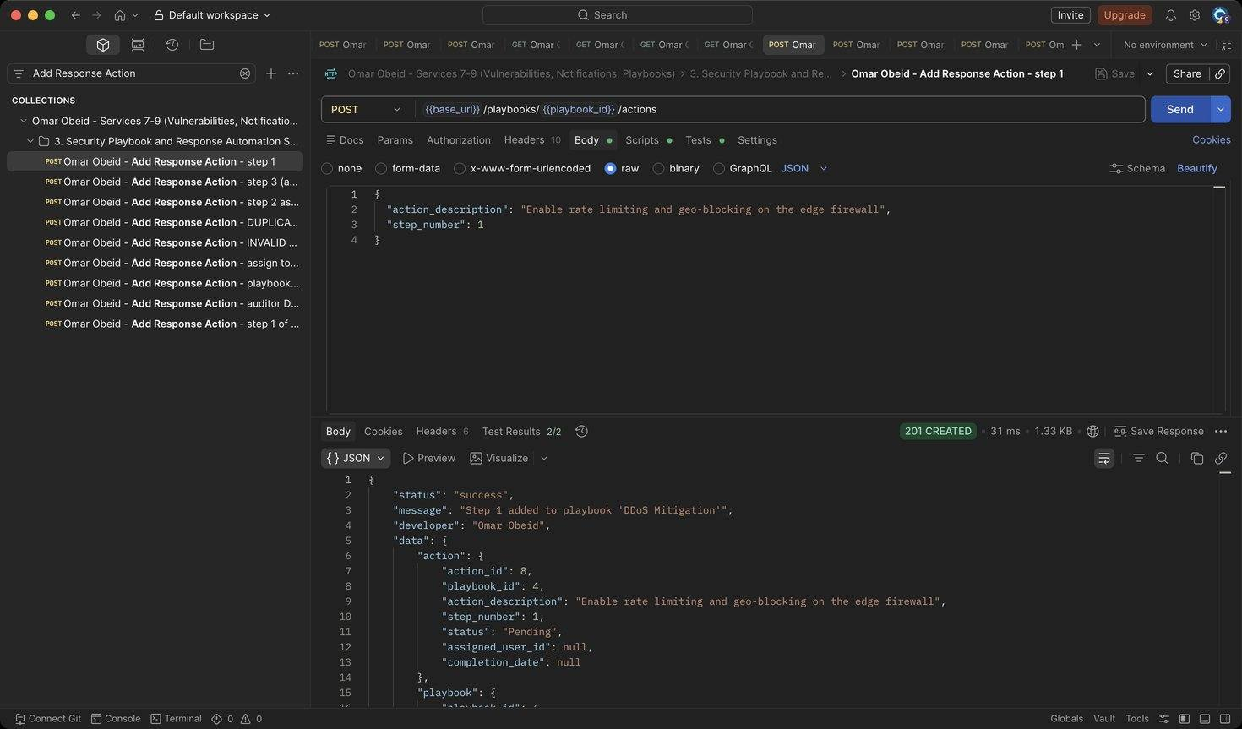
Figure 236: Omar Obeid – Add Response Action – step 1 (HTTP 201)
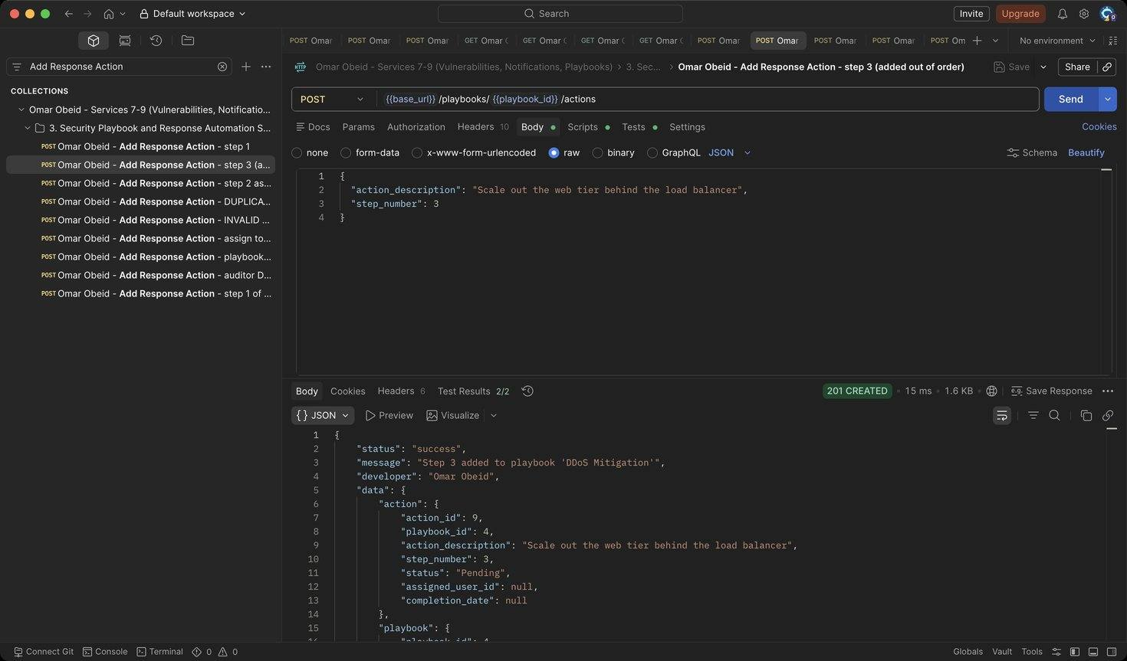
Figure 237: Omar Obeid – Add Response Action – step 3 (added out of order): Steps can be added in any order; they are returned sorted. (HTTP 201)
Figure 238: Omar Obeid – Add Response Action – step 2 assigned to analyst_lina: The assignee gets a System Notification. (HTTP 201)
Figure 239: Omar Obeid – Add Response Action – DUPLICATE step number: step_number is unique per playbook (HTTP 409)
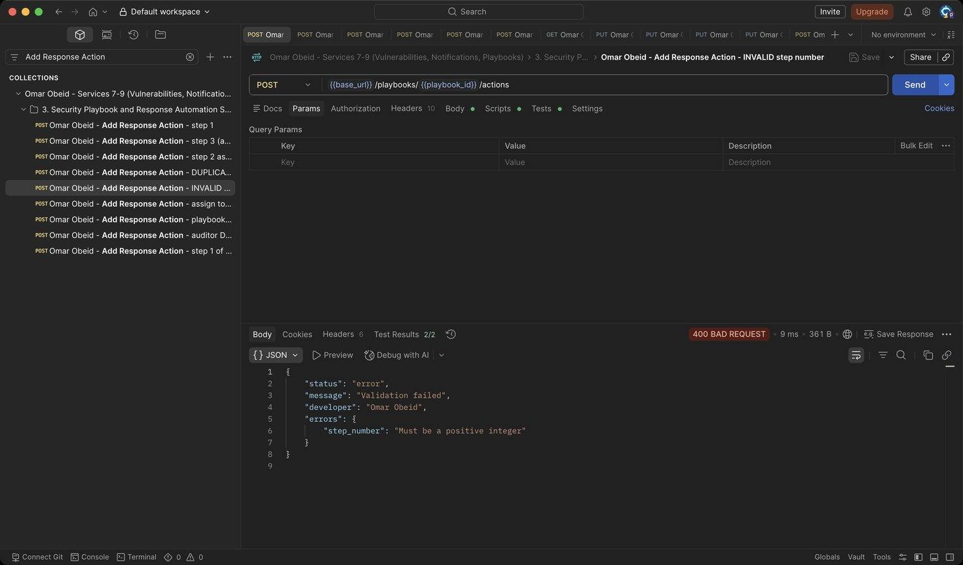
Figure 240: Omar Obeid – Add Response Action – INVALID step number: Must be a positive integer (HTTP 400)
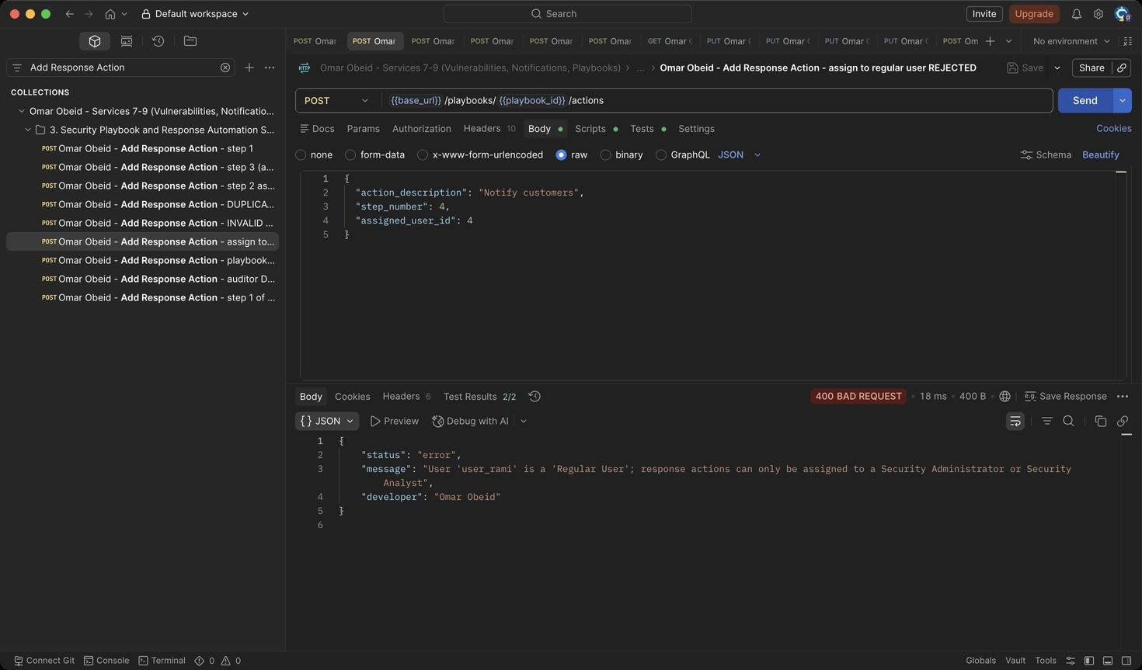
Figure 241: Omar Obeid – Add Response Action – assign to regular user REJECTED: Only administrators and analysts can be assigned (HTTP 400)
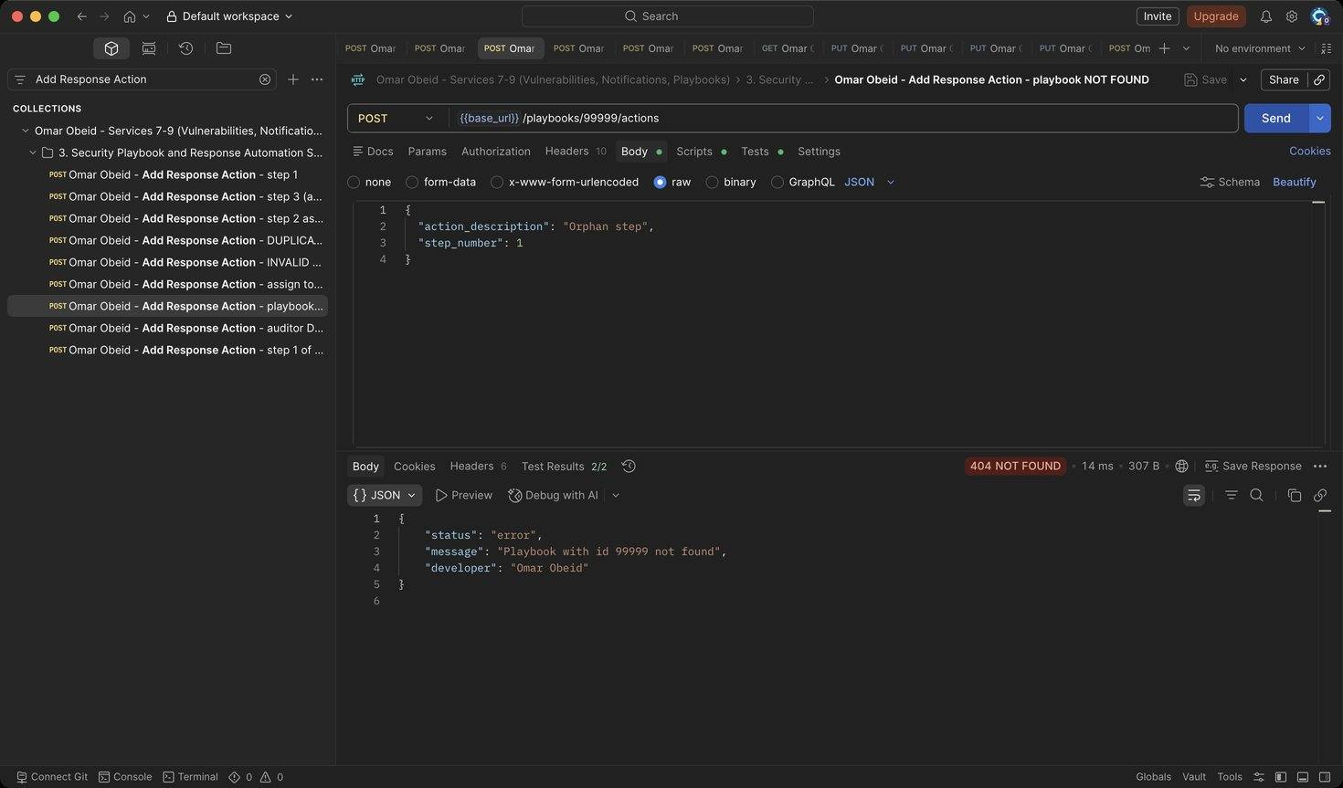
Figure 242: Omar Obeid – Add Response Action – playbook NOT FOUND: Unknown playbook (HTTP 404)
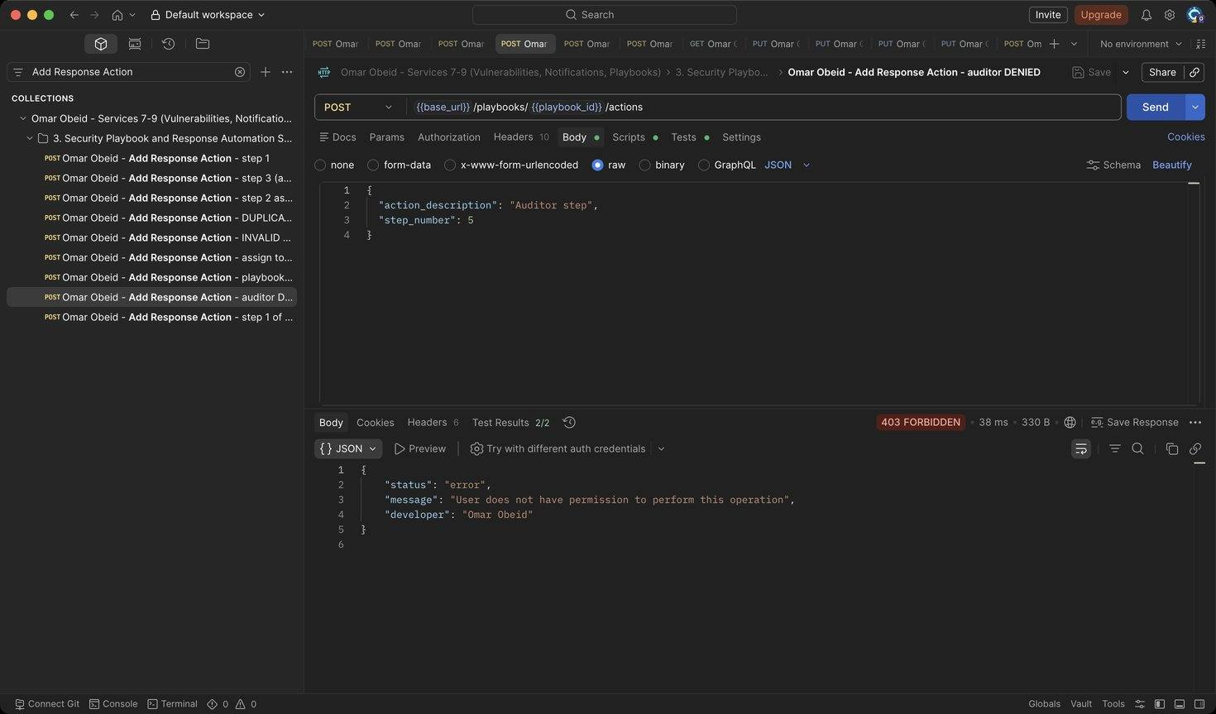
Figure 243: Omar Obeid – Add Response Action – auditor DENIED: Auditors are read-only (HTTP 403)
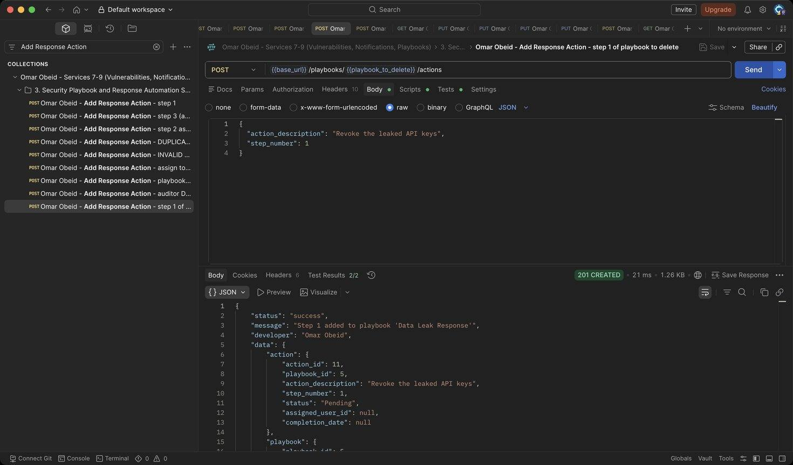
Figure 244: Omar Obeid – Add Response Action – step 1 of playbook to delete: Shows that deleting a playbook removes its actions (HTTP 201)
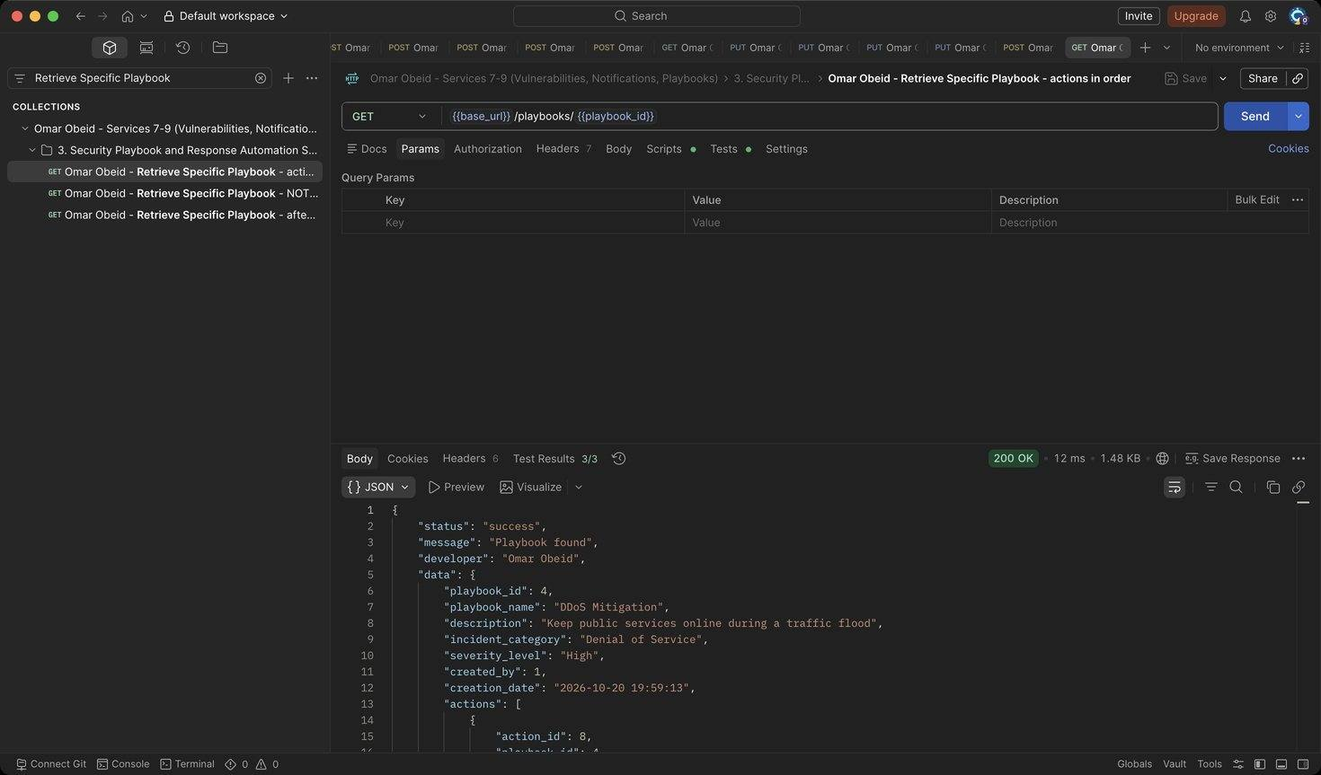
Figure 245: Omar Obeid – Retrieve Specific Playbook – actions in order: Steps returned 1, 2, 3 with progress 0% (HTTP 200)
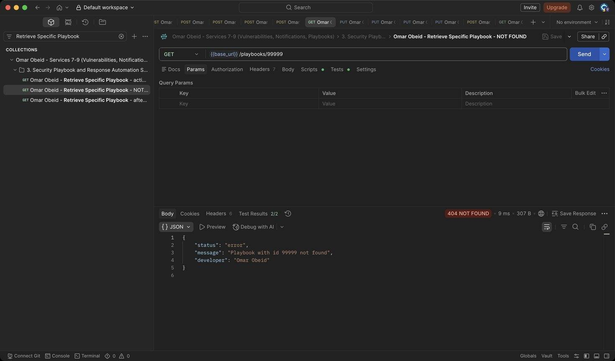
Figure 246: Omar Obeid – Retrieve Specific Playbook – NOT FOUND: Unknown id (HTTP 404)
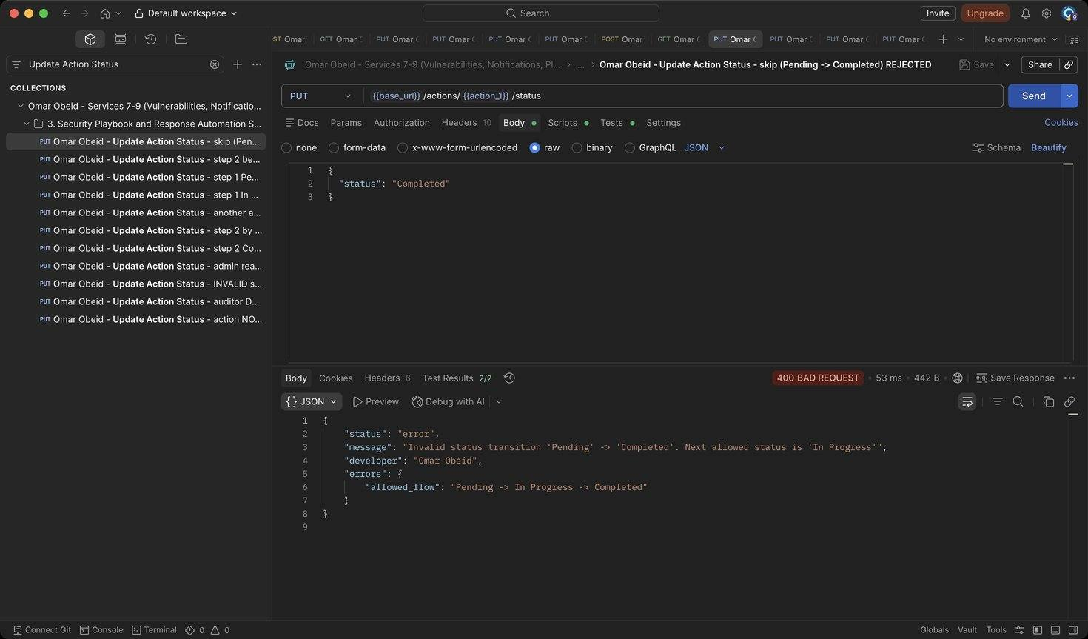
Figure 247: Omar Obeid – Update Action Status – skip (Pending -> Completed) REJECTED: Pending -> In Progress -> Completed only (HTTP 400)
Figure 248: Omar Obeid – Update Action Status – step 2 before step 1 is done REJECTED: Steps are executed in order (HTTP 409)
Figure 249: Omar Obeid – Update Action Status – step 1 Pending -> In Progress: Unassigned step: the analyst who starts it becomes the assignee (HTTP 200)
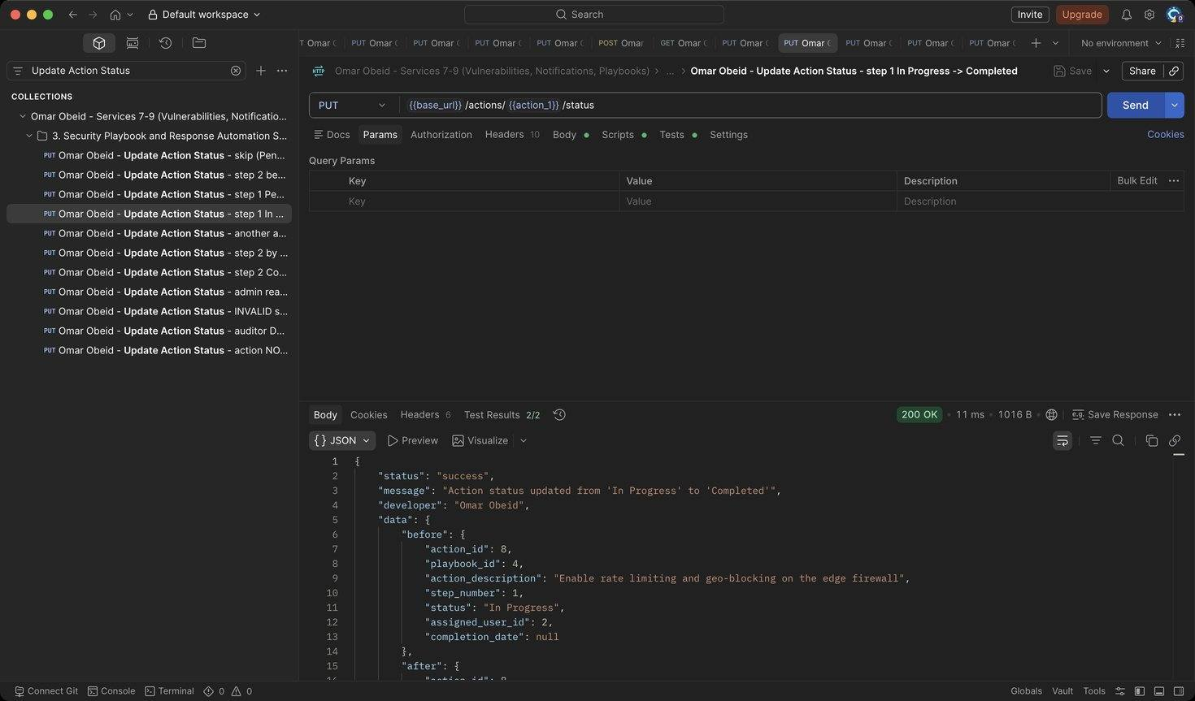
Figure 250: Omar Obeid – Update Action Status – step 1 In Progress -> Completed: completion_date is set automatically; progress 1/3 (HTTP 200)
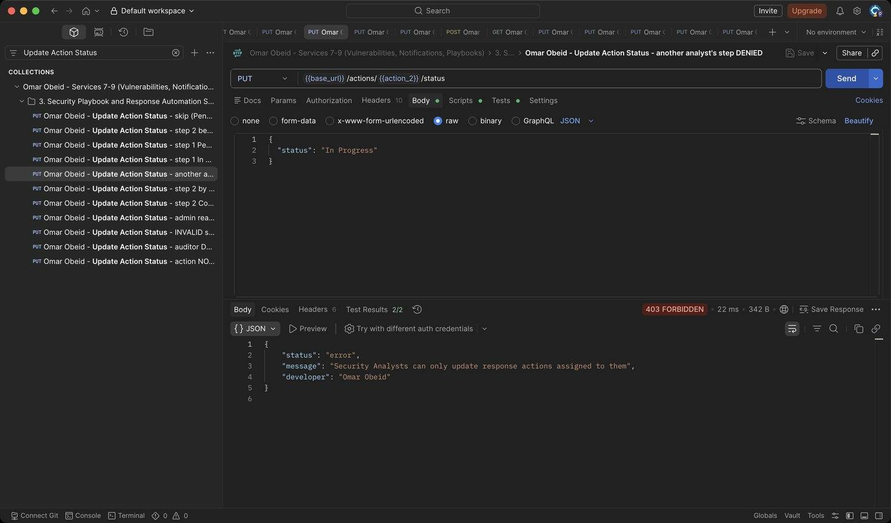
Figure 251: Omar Obeid – Update Action Status – another analyst's step DENIED: Step 2 belongs to analyst_lina (HTTP 403)
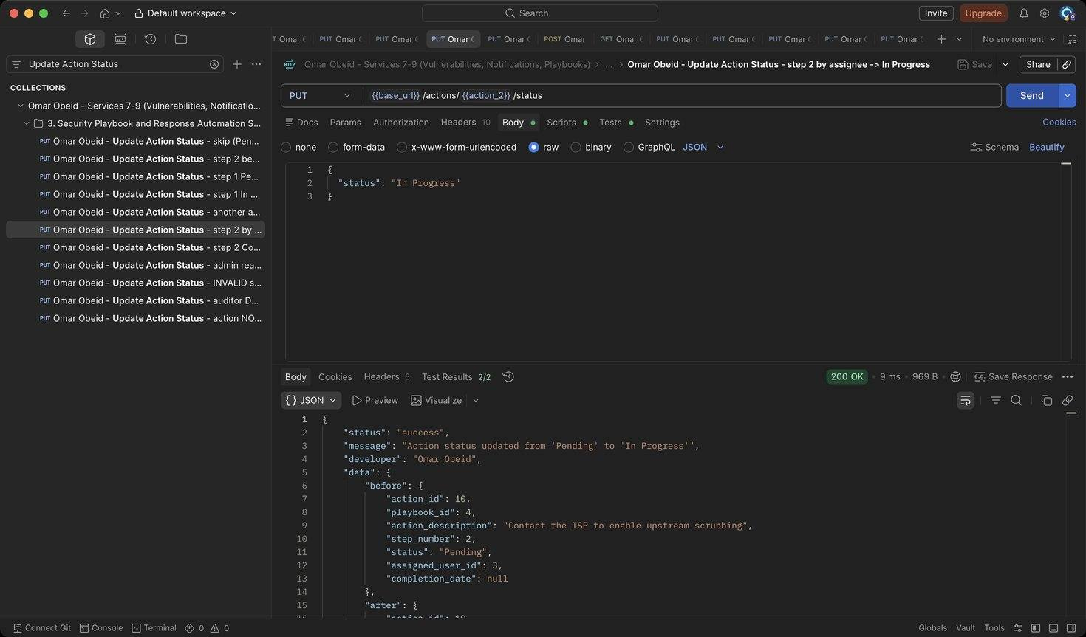
Figure 252: Omar Obeid – Update Action Status – step 2 by assignee -> In Progress: Assigned analyst starts the step (HTTP 200)
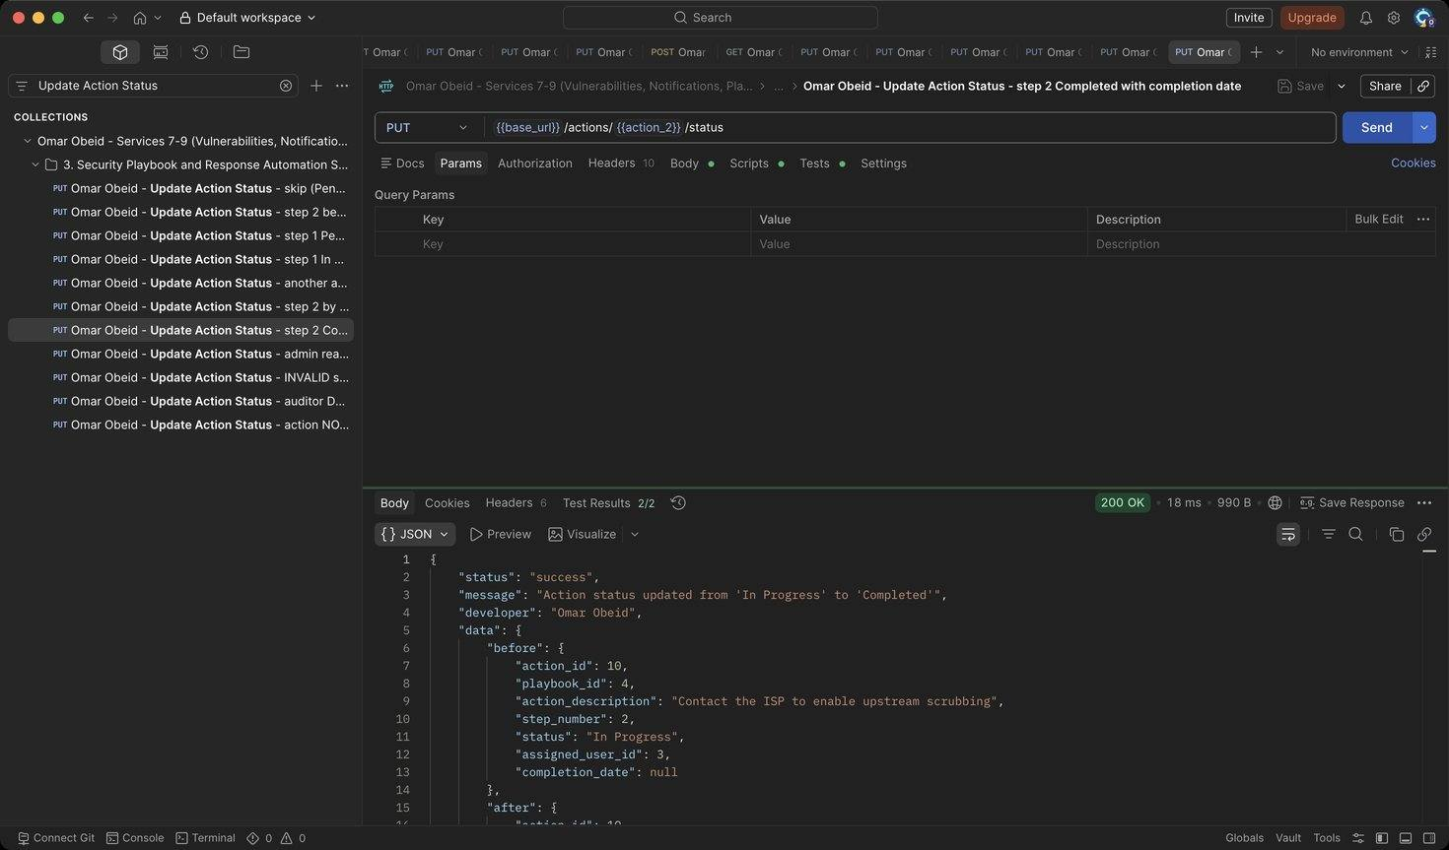
Figure 253: Omar Obeid – Update Action Status – step 2 Completed with completion date: Explicit completion date (YYYY-MM-DD) (HTTP 200)
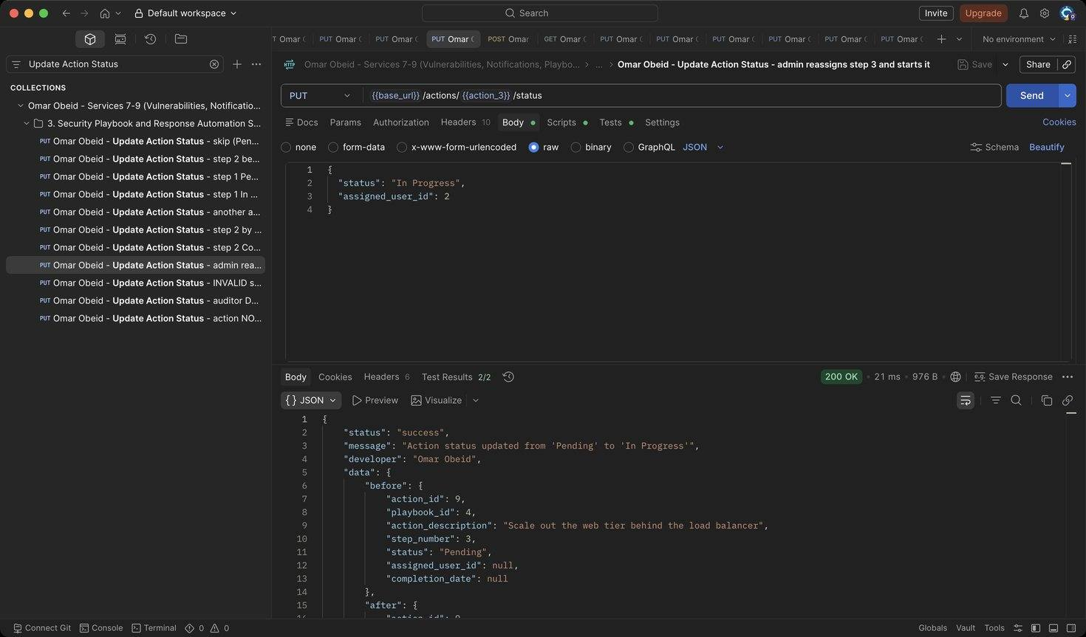
Figure 254: Omar Obeid – Update Action Status – admin reassigns step 3 and starts it: Assigns step 3 to analyst_karim (id 2), who is notified (HTTP 200)
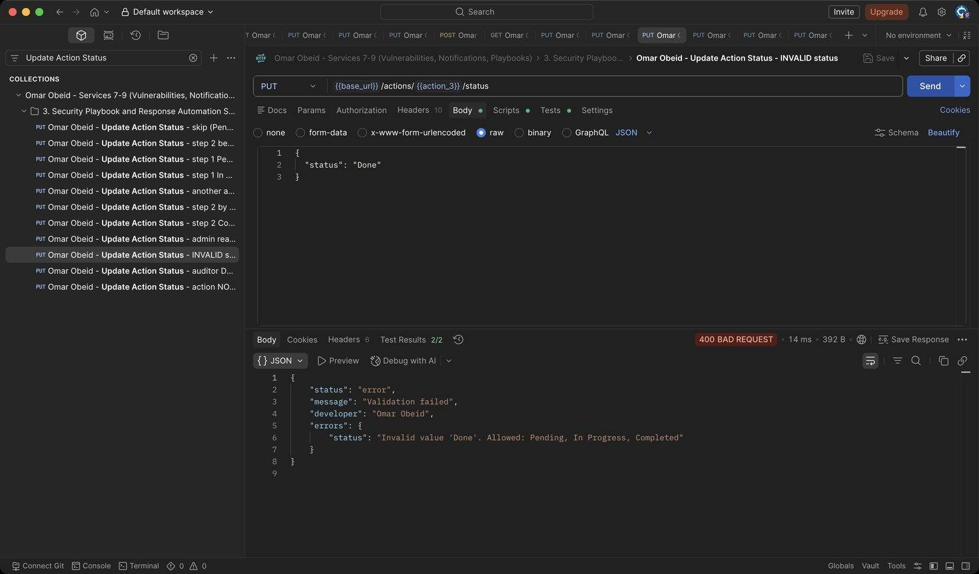
Figure 255: Omar Obeid – Update Action Status – INVALID status: Status must be Pending, In Progress or Completed (HTTP 400)
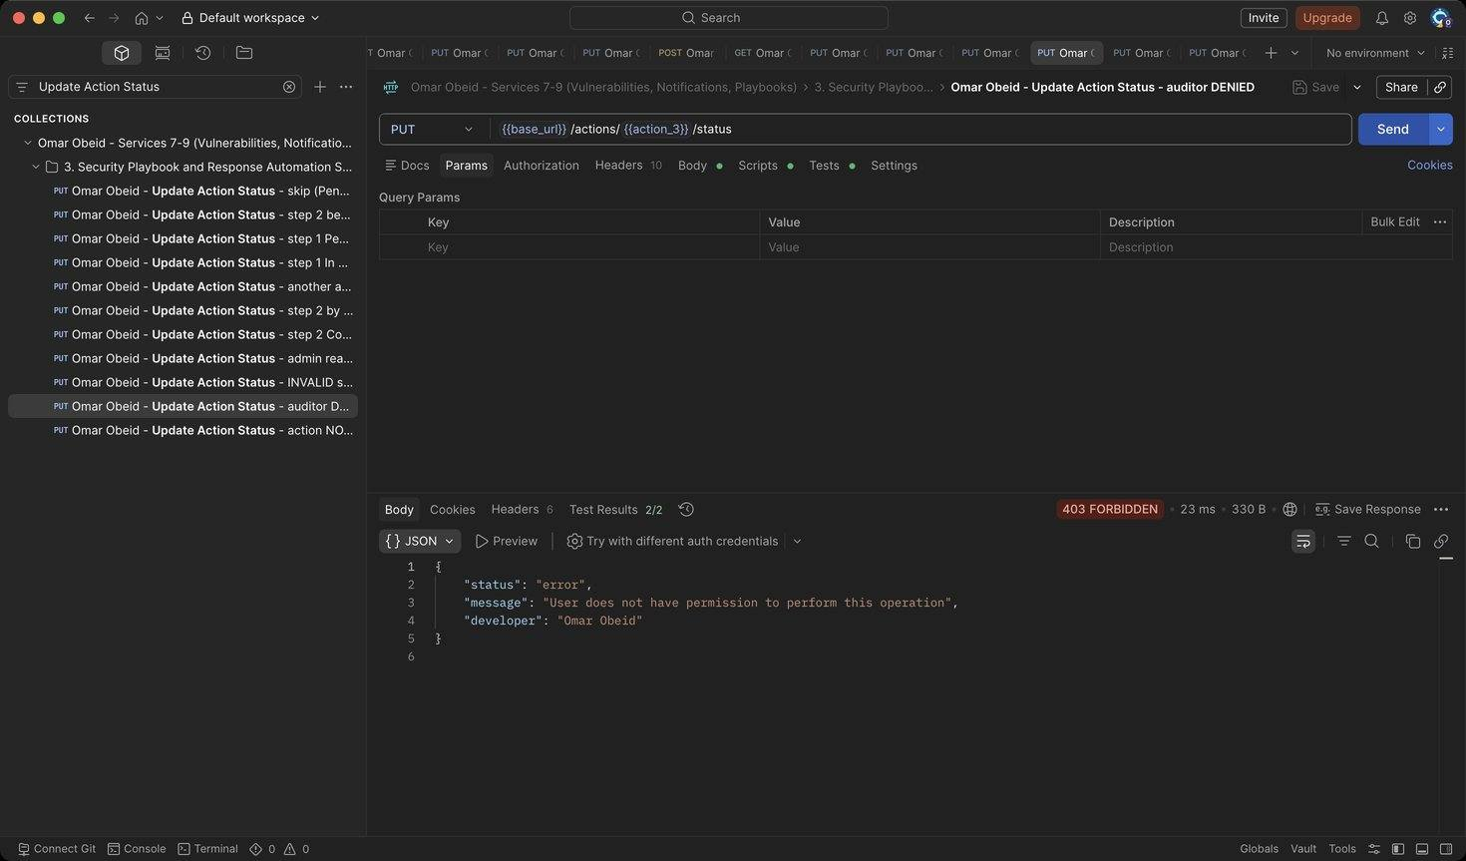
Figure 256: Omar Obeid – Update Action Status – auditor DENIED: Auditors are read-only (HTTP 403)
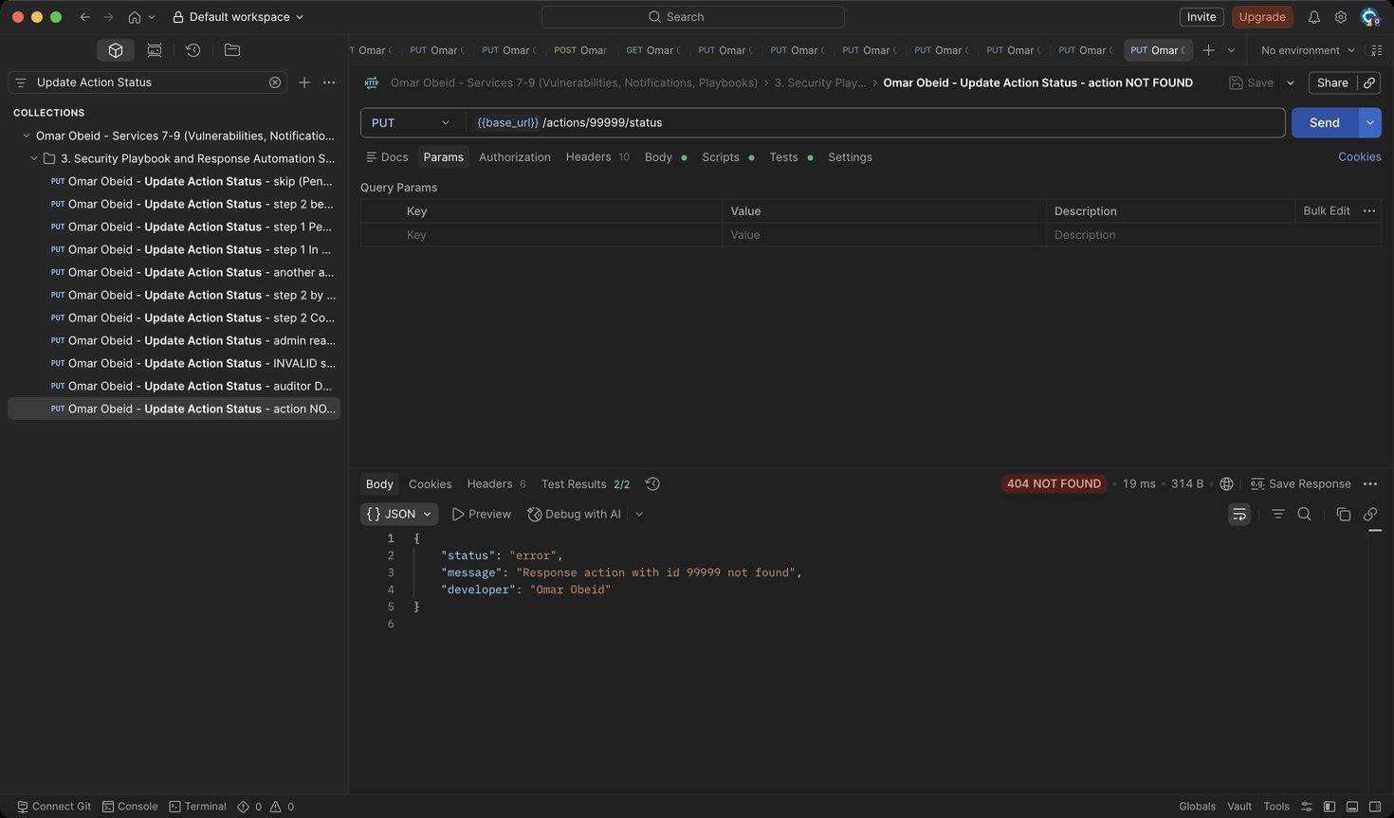
Figure 257: Omar Obeid – Update Action Status – action NOT FOUND: Unknown id (HTTP 404)
Figure 258: Omar Obeid – Retrieve Specific Playbook – after progress: 2 of 3 steps completed (67%) (HTTP 200)
Figure 259: Omar Obeid – Delete Playbook – analyst DENIED: Only administrators delete playbooks (HTTP 403)
Figure 260: Omar Obeid – Delete Playbook – admin (removes its actions): Response shows how many response actions were removed (ON DELETE CASCADE) (HTTP 200)
Figure 261: Omar Obeid – Delete Playbook – already deleted (NOT FOUND): The playbook is gone (HTTP 404)

6. Database Design
The team shares one SQLite database with ten tables, all created by schema.sql. Every connection enables PRAGMA foreign_keys = ON; enumerations are stored as text with CHECK constraints; uniqueness rules are enforced by UNIQUE constraints (usernames, emails, threat type + value, playbook step numbers) in addition to API validation.
Figure 262: Database schema diagram: tables, primary keys, foreign keys and relationships (Omar Obeid)

6.1 Tables of Services 1–3 (Maya Zeaiter)
Table | PK | Foreign keys | Notes
users | user_id | — | username, email UNIQUE; CHECK on role, account_status
assets | asset_id | owner_id → users (RESTRICT) | CHECK on type, criticality, status
incidents | incident_id | reporter_id → users, asset_id → assets (SET NULL), assigned_analyst_id → users (SET NULL) | CHECK on severity, status
investigation_notes | note_id | incident_id → incidents (CASCADE), analyst_id → users

Design decisions:
- Enumerations are stored as readable text with CHECK constraints, so the database rejects invalid values even if the API is bypassed.
- PRAGMA foreign_keys = ON is set on every connection.
- Deletes are designed to protect history. A user who owns assets or reported incidents cannot be deleted (409), and should be set to Inactive instead. Deleting an asset keeps its incidents but unlinks them.
- schema.sql also creates the tables for my teammates' services (threats, logs, vulnerabilities, notifications, playbooks and response_actions), so the team shares one database.

6.2 Tables of Services 4–6 (Zeinab Harb)
threats
Field | Type | Notes
threat_id | INTEGER | Primary key, autoincrement
threat_type | TEXT | CHECK IN ('IP Address','Domain','File Hash','Malware Signature','Other')
threat_value | TEXT | NOT NULL, stored normalised
description | TEXT | NOT NULL
severity_level | TEXT | CHECK IN ('Low','Medium','High','Critical')
source | TEXT | NOT NULL
date_added | TEXT | Default datetime('now')

UNIQUE (threat_type, threat_value) prevents duplicate indicators.
logs
Field | Type | Notes
log_id | INTEGER | Primary key, autoincrement
user_id | INTEGER | Foreign key → users(user_id), ON DELETE SET NULL
action_performed | TEXT | NOT NULL
description | TEXT | NOT NULL
timestamp | TEXT | Default datetime('now')
severity_level | TEXT | CHECK IN ('Information','Warning','Error','Critical')
related_service | TEXT | NOT NULL

Relationship: Users → Logs (one-to-many). One user generates many audit records, and each record belongs to at most one user. ON DELETE SET NULL keeps the audit trail when a user account is deleted, because deleting a user must not erase the evidence of what they did. user_id may also be NULL for failed logins with an unknown username.
Design decisions.
- Threat types and severities are enforced twice, by API validation (clear 400 messages) and by CHECK constraints (database safety net).
- Threat values are normalised before storage so the UNIQUE constraint is meaningful.
- Timestamps are generated by the database, not the client.
- Reports have no table of their own: they are computed live from current data, so they can never be out of date.

6.3 Tables of Services 7–9 (Omar Obeid)
vulnerabilities
Field | Type | Notes
vulnerability_id | INTEGER | Primary key, autoincrement
title | TEXT | NOT NULL
description | TEXT | NOT NULL
cve_identifier | TEXT | NOT NULL, stored upper-case
cvss_score | REAL | CHECK (cvss_score BETWEEN 0 AND 10)
severity_level | TEXT | CHECK IN ('Low','Medium','High','Critical')
affected_asset_id | INTEGER | Foreign key → assets(asset_id), ON DELETE CASCADE
discovery_source | TEXT | NOT NULL
status | TEXT | Default 'Open', CHECK IN ('Open','Under Investigation','In Progress','Resolved','Closed')
creation_date | TEXT | Default datetime('now')
resolution_date | TEXT | NULL until Resolved

notifications
Field | Type | Notes
notification_id | INTEGER | Primary key, autoincrement
user_id | INTEGER | Foreign key → users(user_id), ON DELETE CASCADE
title | TEXT | NOT NULL
message | TEXT | NOT NULL
notification_type | TEXT | CHECK on the five types
severity_level | TEXT | CHECK IN ('Low','Medium','High','Critical')
status | TEXT | Default 'Unread', CHECK IN ('Unread','Read')
creation_date | TEXT | Default datetime('now')
read_date | TEXT | NULL until read

playbooks
Field | Type | Notes
playbook_id | INTEGER | Primary key, autoincrement
playbook_name | TEXT | NOT NULL, unique (enforced by the API, case-insensitive)
description | TEXT | NOT NULL
incident_category | TEXT | NOT NULL, one of the incident categories
severity_level | TEXT | CHECK IN ('Low','Medium','High','Critical')
created_by | INTEGER | Foreign key → users(user_id), ON DELETE SET NULL
creation_date | TEXT | Default datetime('now')

response_actions
Field | Type | Notes
action_id | INTEGER | Primary key, autoincrement
playbook_id | INTEGER | Foreign key → playbooks(playbook_id), ON DELETE CASCADE
action_description | TEXT | NOT NULL
step_number | INTEGER | NOT NULL, UNIQUE (playbook_id, step_number)
status | TEXT | Default 'Pending', CHECK IN ('Pending','In Progress','Completed')
assigned_user_id | INTEGER | Foreign key → users(user_id), ON DELETE SET NULL
completion_date | TEXT | NULL until Completed

Relationships.
- Assets → Vulnerabilities (one-to-many). An asset can have many vulnerabilities, and each vulnerability affects exactly one asset. ON DELETE CASCADE applies: a vulnerability has no meaning once its asset is removed from inventory.
- Users → Notifications (one-to-many). ON DELETE CASCADE applies: a deleted user's inbox is removed with them.
- Users → Playbooks (created_by, one-to-many). ON DELETE SET NULL keeps the playbook when its author leaves.
- Playbooks → Response Actions (one-to-many, composition). ON DELETE CASCADE applies: steps cannot exist without their playbook.
- Users → Response Actions (assigned_user_id, one-to-many). ON DELETE SET NULL returns the step to unassigned.
Design decisions.
- Every status and type is enforced twice: by API validation, which gives clear 400 messages, and by CHECK constraints, as a database safety net.
- Dates (creation_date, read_date, default completion_date/resolution_date) are generated by the server in UTC, not trusted from the client.
- Playbook progress is computed from the actions on every read rather than stored, so it can never be out of date.

Database screenshots – Services 7–9 (Omar Obeid)
Figure 263: Omar Obeid – Database Design – schema of the vulnerabilities and notifications tables (PK, FK, CHECK constraints)
Figure 264: Omar Obeid – Database Design – schema of the playbooks and response_actions tables (FK, UNIQUE playbook_id + step_number)
Figure 265: Omar Obeid – Database Design – stored vulnerability records after the Postman run (asset, CVE, CVSS, severity, status, resolution date)
Figure 266: Omar Obeid – Database Design – stored notification records (types, severities, Unread/Read status, read dates)
Figure 267: Omar Obeid – Database Design – stored playbooks and their ordered response actions (deleted playbook 5 and its actions are gone)
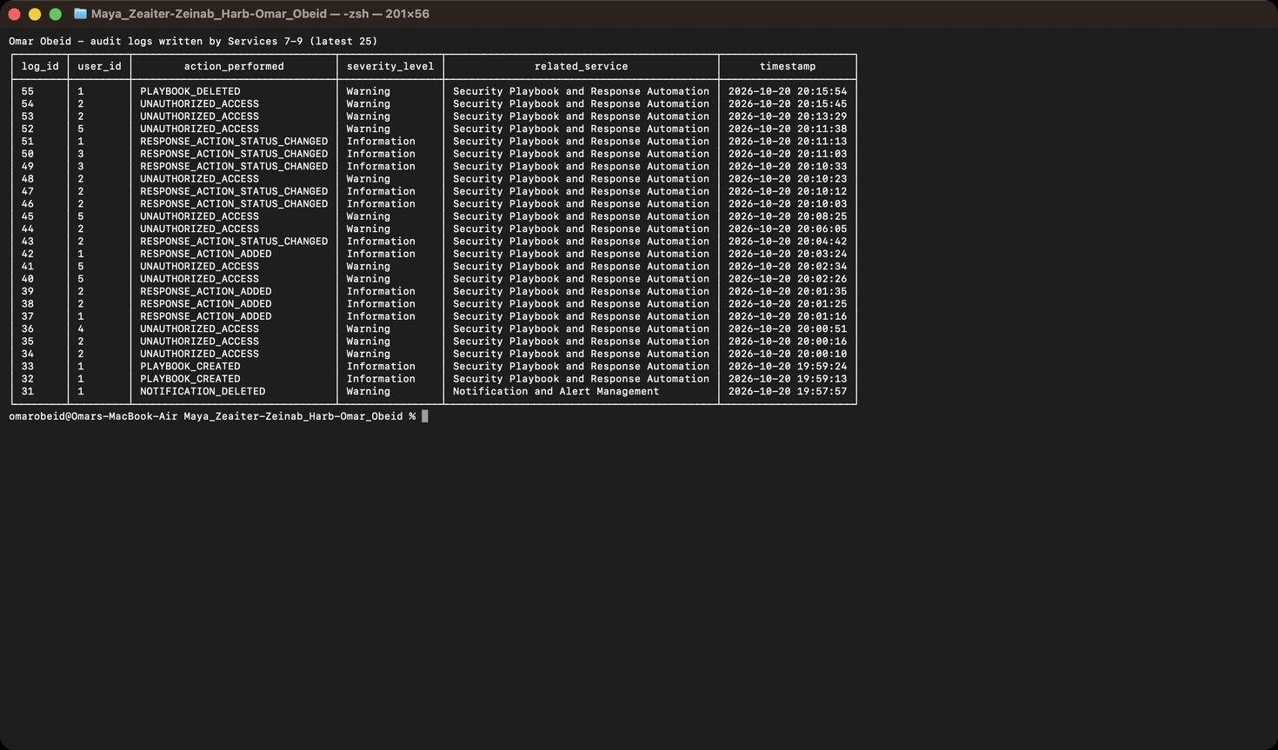
Figure 268: Omar Obeid – Security Audit Logging – log records written by Services 7–9 (creates, updates, deletes, reads, unauthorized attempts)

7. Error Handling and Validation

7.1 Services 1–3 (Maya Zeaiter)
- Any route can raise ApiError(message, status_code, errors). A single handler in app.py converts it into {"status":"error","message":...,"errors":{field: reason}}. 404, 405, database-constraint errors (409) and unexpected exceptions (500, with no stack trace leaked) are handled the same way, so the error format is consistent.
- Validation covers:
- empty or non-JSON bodies;
- missing required fields;
- unexpected or extra fields (e.g. a Regular User sending role);
- wrong types;
- string length limits;
- email, username and password rules;
- IPv4/IPv6 format;
- all enumerations;
- positive integer IDs;
- existence of referenced users and assets;
- the incident status workflow.
- Every SQL query uses parameter placeholders. Only whitelisted column names are ever put into the query text, which protects against SQL injection.

7.2 Services 4–6 (Zeinab Harb)
- My services raise Maya's ApiError, so errors use the same {"status":"error","message":...,"developer":"Zeinab Harb","errors":{field: reason}} format.
Code | Cases in my services
400 | Validation, unknown fields or parameters, read-only fields, bad dates
401 | Missing or invalid token
403 | Role not allowed
404 | Threat, log or user not found
405 | Log modification
409 | Duplicate threat

- Threat validation: required fields; type and severity enums; IP, domain and hash formats; string lengths; duplicate detection; read-only fields on update.
- Log validation: positive integer user_id that must exist; action format; severity and service enums; date format for search.
- Security checks:
- SQL injection: every value is a bound parameter, and only whitelisted column names appear in SQL text.
- Empty requests and unexpected fields are rejected.
- Every permission violation is logged.

7.3 Services 7–9 (Omar Obeid)
My services raise Maya's ApiError, so every error has the format {"status":"error","message":...,"developer":"Omar Obeid","errors":{field: reason}}.
Code | Cases in my services
400 | Missing/unknown fields; bad CVE format; CVSS out of range; severity not matching CVSS; invalid enum values; skipped or backward status transitions; read-only fields; invalid or future dates; bad search parameters; suspended recipient; assigning a step to a Regular User or Auditor
401 | Missing or invalid token
403 | Role not allowed; another user's notification; an Analyst updating another analyst's step
404 | Vulnerability, asset, notification, user, playbook or action not found
409 | Duplicate CVE on an asset; duplicate playbook name; duplicate step number; starting a step before earlier steps are completed

Security checks:
- SQL injection: every value is a bound parameter, and only whitelisted column names appear in the SQL text.
- Empty and non-JSON bodies are rejected.
- null values on update are rejected.
- Every permission violation is written to the audit log.
Screenshots of validation tests: Maya Zeaiter – Figures 2–82; Zeinab Harb – Figures 83–155; Omar Obeid – Figures 156–261 (every invalid-input, missing-field, duplicate, not-found and invalid-transition request is shown with its 400/404/409 response).

8. API Documentation (Maya Zeaiter, Zeinab Harb, Omar Obeid)
Each member documented their own APIs in the repository README (reproduced below). The Postman collections are included in the repository and the submission: postman/Maya_Zeaiter_Services_1-3.postman_collection.json, postman/Zeinab_Harb_Services_4-6.postman_collection.json and postman/Omar_Obeid_Services_7-9.postman_collection.json. Run the Authentication folder first: it stores the four role tokens.

Response format
{ "status": "success", "message": "...", "developer": "Maya Zeaiter", "data": { } }
{ "status": "error", "message": "...", "developer": "Maya Zeaiter", "errors": { "field": "reason" } }
Code | Meaning
400 | Validation error, invalid status transition, empty or non-JSON body
401 | Missing, invalid or expired token; wrong username/password
403 | Role not allowed, not the caller's own record, inactive or suspended account
404 | User, asset, incident, threat, log, vulnerability, notification, playbook or action not found
405 | Attempt to modify an audit log (logs are append-only)
409 | Duplicate username/email, duplicate threat indicator (same type + value), duplicate CVE on the same asset, duplicate playbook name or step number, a playbook step started before the earlier steps are completed, or a record that is still referenced (e.g. deleting a user who reported incidents)

Protected routes need the header Authorization: Bearer <token> (the token comes from POST /users/login).

Service 1: Users and Identity Management (Maya Zeaiter)
API | Method & endpoint | Roles
User Registration | POST /users/register | Public (Regular User only); Admin (any role)
User Login | POST /users/login | Public
Update User | PUT /users/{id} | Admin (any user, incl. role/status); Regular User (own name/email/department)
Delete User | DELETE /users/{id} | Admin
Retrieve All Users | GET /users | Admin, Auditor
Retrieve User By Username | GET /users/{username} | Admin, Auditor; Regular User (own)

POST /users/register
{ "full_name": "Nour Moghrabi", "username": "nour_m", "email": "nour@company.com",
"password": "Secure@2026", "department": "Marketing", "role": "Regular User" }
Validation: all fields required; username is 3–30 characters from [A-Za-z0-9_.] and must be unique; email must be valid and unique; password needs at least 8 characters with an uppercase letter, a lowercase letter, a digit and a symbol; role must be one of Security Administrator, Security Analyst, Regular User, Auditor. The admin may also send account_status (Active/Inactive/Suspended).
→ 201 with the user (without the password hash) · 400 · 403 (privileged role without an admin token) · 409 (duplicate).
POST /users/login
{ "username": "admin_maya", "password": "Admin@1234" }
username also accepts the email address. → 200 with { token, token_type, expires_in_seconds, user } · 401 · 403 (inactive or suspended account).
PUT /users/{id}: { "full_name": "...", "email": "...", "department": "..." }. The admin can also send role and account_status. → 200 { before, after } · 400 · 403 · 404 · 409.
DELETE /users/{id} → 200 · 400 (deleting yourself) · 403 · 404 · 409 (the user still owns assets or reported incidents).
GET /users → 200 { count, users: [...] }. GET /users/{username} → 200 user · 404.

Service 2: Asset Management (Maya Zeaiter)
API | Method & endpoint | Roles
Add New Asset | POST /assets | Admin
Update Asset | PUT /assets/{id} | Admin
Delete Asset | DELETE /assets/{id} | Admin
Retrieve All Assets | GET /assets | Admin, Auditor
Retrieve Specific Asset | GET /assets/{id} | Admin, Analyst, Auditor
Search Assets | GET /assets/search | Admin, Analyst, Auditor

POST /assets
{ "asset_name": "Mail Server", "asset_type": "Server", "ip_address": "10.0.0.25",
"operating_system": "Ubuntu 24.04", "department": "IT Security", "owner_id": 1,
"location": "Data Center B", "criticality_level": "High", "status": "Active" }
Required: asset_name, asset_type, ip_address, department, owner_id, criticality_level.
asset_type ∈ Server, Workstation, Database, Application, Network Device, Cloud Resource · criticality_level ∈ Low, Medium, High, Critical · status ∈ Active, Inactive, Under Maintenance (default Active) · ip_address must be a valid IPv4 or IPv6 address · owner_id must be an existing user.
→ 201 · 400 · 403 · 404 (owner not found).
PUT /assets/{id} takes any subset of the fields above → 200 { before, after }.
GET /assets/{id} returns the asset plus owner and related_incidents.
GET /assets/search query params: name, ip, department (partial, case-insensitive), type, criticality, status (exact). Several params are combined with AND, e.g. /assets/search?name=server&criticality=Critical.

Service 3: Incident Management (Maya Zeaiter)
API | Method & endpoint | Roles
Create Incident | POST /incidents | Admin, Regular User
Retrieve All Incidents | GET /incidents | Admin, Auditor
Retrieve Specific Incident | GET /incidents/{id} | Admin, Auditor; Analyst (assigned); Regular User (reported)
Assign Incident | PUT /incidents/{id}/assign | Admin
Update Incident Status | PUT /incidents/{id}/status | Admin; Analyst (assigned, not Closed)
Add Investigation Notes | POST /incidents/{id}/notes | Admin; Analyst (assigned)

POST /incidents
{ "title": "Data exfiltration from customer DB", "description": "...",
"category": "Data Leakage", "severity": "Critical", "asset_id": 3 }
category ∈ Malware Infection, Unauthorized Access, Phishing Attack, Data Leakage, Account Compromise, Denial of Service, Other · severity ∈ Low, Medium, High, Critical. The reporter is the logged-in user; an admin may pass reporter_id.
PUT /incidents/{id}/assign: { "analyst_id": 2 }. Checks that the incident exists and is not Closed, and that the user exists, is a Security Analyst and is Active. It writes an audit log and a notification.
PUT /incidents/{id}/status: { "status": "Under Investigation" }. Only the next step is allowed:
Open → Under Investigation → Mitigated → Resolved → Closed. Starting the investigation requires an assigned analyst, only an admin can close an incident, and Resolved sets resolution_date.
POST /incidents/{id}/notes: { "note_content": "..." } → 201 { note, incident } (the incident includes all its notes).

Service 4: Threat Intelligence (Zeinab Harb)
API | Method & endpoint | Roles
Add Threat Indicator | POST /threats | Admin
Retrieve All Threat Indicators | GET /threats | Admin, Analyst, Auditor
Retrieve Specific Threat Indicator | GET /threats/{id} | Admin, Analyst, Auditor
Search Threat Indicators | GET /threats/search | Admin, Analyst, Auditor
Update Threat Information | PUT /threats/{id} | Admin
Delete Threat Indicator | DELETE /threats/{id} | Admin

Regular Users get 403 on every threat route. The spec's service table leaves Auditor search out, but the Auditor role description lists "Search threat indicators", so Auditors may search.
POST /threats
{ "threat_type": "IP Address", "threat_value": "192.0.2.10",
"description": "Source of repeated RDP brute-force attempts", "severity_level": "High", "source": "Firewall logs" }
All five fields are required. threat_type ∈ IP Address, Domain, File Hash, Malware Signature, Other · severity_level ∈ Low, Medium, High, Critical. threat_value is validated by type:
- IP Address: valid IPv4/IPv6, stored in canonical form.
- Domain: labels of letters, digits and hyphens plus a TLD, stored lowercase.
- File Hash: hexadecimal MD5 (32), SHA-1 (40), SHA-256 (64) or SHA-512 (128), stored lowercase.
- Malware Signature / Other: free text up to 255 characters.
→ 201 threat · 400 · 403 · 409 (same type + value already exists).
GET /threats → 200 { count, threats: [ {threat_id, threat_type, threat_value, description, severity_level, source, date_added} ] }.
GET /threats/{id} → 200 threat · 404.
GET /threats/search query params: type, severity (exact, validated) and value, source (partial, case-insensitive). Parameters combine with AND, e.g. /threats/search?type=Domain&severity=High. At least one is required; unknown parameters → 400.
PUT /threats/{id}: { "description": "...", "severity_level": "Critical", "source": "..." }, any subset. threat_type and threat_value are read-only (400). → 200 { before, after } · 400 · 403 · 404.
DELETE /threats/{id} → 200 { deleted_threat_id, deleted_threat } · 403 · 404.
Creates, updates and deletes write THREAT_CREATED / THREAT_UPDATED / THREAT_DELETED audit logs.

Service 5: Security Audit Logging (Zeinab Harb)
API | Method & endpoint | Roles
Create Log Record | POST /logs | Admin
Retrieve All Logs | GET /logs | Admin, Auditor
Retrieve Specific Log | GET /logs/{id} | Admin, Auditor, Analyst
Search Logs | GET /logs/search | Admin, Auditor, Analyst
Delete Logs | DELETE /logs/{id} | Admin
Retrieve Logs By User | GET /logs/user/{user_id} | Admin, Auditor

Logs are generated automatically by every service through common.write_log():
- LOGIN_SUCCESS, LOGIN_FAILED
- USER_CREATED, USER_DELETED, ROLE_CHANGED
- UNAUTHORIZED_ACCESS
- ASSET_*, INCIDENT_*, THREAT_*, LOG_DELETED
POST /logs adds manual records:
{ "user_id": 2, "action_performed": "MALWARE_SCAN_COMPLETED", "description": "Weekly scan finished",
"severity_level": "Information", "related_service": "Asset Management" }
- user_id must be an existing user.
- action_performed is normalised to UPPER_SNAKE_CASE (3–50 characters).
- severity_level ∈ Information, Warning, Error, Critical.
- related_service must be one of the nine service names.
→ 201 · 400 · 403 · 404.
GET /logs → 200 { count, logs: [...] }, newest first. Each log includes username.
GET /logs/{id} → 200 · 404.
GET /logs/search query params:
- user: a user id or a username.
- date: YYYY-MM-DD, compared with the UTC date of timestamp.
- action, service: partial, case-insensitive.
- severity: exact.
Parameters combine with AND.
GET /logs/user/{user_id} → 200 { user, count, logs }. count is 0 with an empty list when the user has no activity, and the response is 404 when the user does not exist.
DELETE /logs/{id} → 200 · 403 · 404. Every deletion writes a new LOG_DELETED record.
Audit log protection: there is no update. PUT/PATCH /logs/{id} return 405 and log the attempt as LOG_MODIFICATION_BLOCKED.
Timestamps are stored in UTC (SQLite datetime('now')).

Service 6: Security Reports (Zeinab Harb)
All report routes: Admin and Auditor only (Analyst and Regular User → 403). Each report returns report, generated_at, generated_by and the statistics below. Grouped counts list every allowed value, including zeros.
API | Endpoint | Contents (data source)
Security Summary | GET /reports/summary | users, active_users, assets, critical_assets, incidents, open_incidents, critical_open_incidents, threats, critical_threats, vulnerabilities, open_vulnerabilities, audit_log_records, failed_logins, unauthorized_access_attempts, recent_security_activities (all tables)
Incident Report | GET /reports/incidents | total, open, unassigned, by severity, by status, by category, recent (incidents)
Asset Report | GET /reports/assets | total, critical count and list, by type, by criticality, by status (assets)
Threat Report | GET /reports/threats | total, by severity, by type, recently added (threats)
Vulnerability Report | GET /reports/vulnerabilities | total, by severity, by status, critical count and list, average CVSS (vulnerabilities joined with assets)
Activity Report | GET /reports/activity | total activities, login attempts, successful/failed logins, unauthorized attempts, most performed actions, most active users, by severity, by service (logs joined with users)

"Open" incidents and vulnerabilities are those whose status is not Resolved or Closed.

Service 7: Vulnerability Management (Omar Obeid)
API | Method & endpoint | Roles
Create Vulnerability Record | POST /vulnerabilities | Admin
Retrieve All Vulnerabilities | GET /vulnerabilities | Admin, Analyst, Auditor
Retrieve Specific Vulnerability | GET /vulnerabilities/{id} | Admin, Analyst, Auditor
Update Vulnerability Status | PUT /vulnerabilities/{id} | Admin, Analyst
Search Vulnerabilities | GET /vulnerabilities/search | Admin, Analyst, Auditor
Delete Vulnerability | DELETE /vulnerabilities/{id} | Admin

Regular Users get 403 on every vulnerability route.
POST /vulnerabilities
{ "title": "Apache HTTP Server path traversal", "description": "Path traversal and RCE in Apache 2.4.49",
"cve_identifier": "CVE-2021-41773", "cvss_score": 7.5, "severity_level": "High",
"affected_asset_id": 1, "discovery_source": "Nessus scan" }
All seven fields are required. The rules are:
- cve_identifier must match CVE-YYYY-NNNN (4 or more digits, year 1999 to next year). It is stored upper-case.
- cvss_score is a number from 0.0 to 10.0 with one decimal place.
- severity_level must agree with the CVSS v3 rating: 0–3.9 Low, 4.0–6.9 Medium, 7.0–8.9 High, 9.0–10.0 Critical.
- affected_asset_id must be an existing asset.
- The same CVE cannot be recorded twice on the same asset.
New records start as Open. A High or Critical vulnerability also sends a Vulnerability Alert notification to the asset owner.
→ 201 (record with an affected_asset summary) · 400 · 403 · 404 (asset not found) · 409 (duplicate CVE on that asset).
GET /vulnerabilities → 200 { count, vulnerabilities: [...] }. GET /vulnerabilities/{id} → 200 · 404.
PUT /vulnerabilities/{id} takes any subset of description, severity_level, status, cvss_score and resolution_date:
{ "status": "Under Investigation" }
{ "cvss_score": 6.5, "severity_level": "Medium", "description": "RCE blocked; path traversal remains" }
- Status moves one step at a time: Open → Under Investigation → In Progress → Resolved → Closed.
- Severity and CVSS must still agree after the update.
- Moving to Resolved sets resolution_date automatically. A resolution_date (YYYY-MM-DD or YYYY-MM-DD HH:MM:SS, not in the future, not before creation) may only be sent when the record is Resolved or Closed.
- title, cve_identifier, affected_asset_id and discovery_source are read-only (400).
→ 200 { before, after } · 400 · 403 · 404.
GET /vulnerabilities/search query params: cve (partial, case-insensitive), severity, status (exact, validated) and asset (asset id). Parameters combine with AND, e.g. /vulnerabilities/search?severity=High&status=Open&asset=1. At least one is required; unknown parameters → 400.
DELETE /vulnerabilities/{id} → 200 { deleted_vulnerability_id, deleted_vulnerability } · 403 · 404.
Creates, updates and deletes write VULNERABILITY_CREATED / VULNERABILITY_UPDATED / VULNERABILITY_STATUS_CHANGED / VULNERABILITY_DELETED audit logs. Zeinab's GET /reports/vulnerabilities reads the same table.

Service 8: Notification and Alert Management (Omar Obeid)
API | Method & endpoint | Roles
Create Notification | POST /notifications | Admin
Retrieve User Notifications | GET /notifications/user/{user_id} | Admin, Auditor (any user); Analyst, Regular User (own)
Retrieve Specific Notification | GET /notifications/{id} | Admin, Auditor (any); Analyst, Regular User (own)
Mark Notification as Read | PUT /notifications/{id}/read | Recipient; Admin
Search Notifications | GET /notifications/search | Admin, Auditor (all); Analyst (own inbox only)
Delete Notification | DELETE /notifications/{id} | Admin

POST /notifications
{ "user_id": 4, "title": "Suspicious login to your account", "message": "New login from 203.0.113.45",
"notification_type": "Security Alert", "severity_level": "High" }
notification_type ∈ Incident Assignment, Security Alert, System Notification, Threat Alert, Vulnerability Alert · severity_level ∈ Low, Medium, High, Critical · user_id must be an existing, Active user. New notifications are Unread with no read_date.
→ 201 · 400 · 403 · 404 (recipient not found).
Notifications are also created automatically by other services:
- Incident assigned (Service 3) → Incident Assignment.
- High or Critical vulnerability recorded (Service 7) → Vulnerability Alert to the asset owner.
- Response action assigned (Service 9) → System Notification.
GET /notifications/user/{user_id} → 200 { user, count, unread_count, notifications }, newest first. A user with no notifications returns count: 0 and an empty list. An unknown user → 404; another user's inbox (not Admin/Auditor) → 403.
GET /notifications/{id} → 200 · 403 (not yours) · 404.
PUT /notifications/{id}/read (no body) sets status = "Read" and read_date to the current UTC time. Calling it again returns 200 and keeps the first read_date. → 200 · 403 · 404.
GET /notifications/search query params: user (id or username), type, severity, status (exact, validated). They combine with AND, e.g. /notifications/search?user=4&status=Unread. Analysts only search their own notifications (asking for another user → 403); Regular Users have no search access (403).
DELETE /notifications/{id} → 200 · 403 · 404.

Service 9: Security Playbook and Response Automation (Omar Obeid)
API | Method & endpoint | Roles
Create Playbook | POST /playbooks | Admin
Retrieve All Playbooks | GET /playbooks | Admin, Analyst, Auditor
Retrieve Specific Playbook | GET /playbooks/{id} | Admin, Analyst, Auditor
Add Response Action | POST /playbooks/{id}/actions | Admin, Analyst
Update Response Action Status | PUT /actions/{id}/status | Admin; Analyst (own or unassigned actions)
Delete Playbook | DELETE /playbooks/{id} | Admin

POST /playbooks
{ "playbook_name": "DDoS Mitigation", "description": "Keep public services online during a traffic flood",
"incident_category": "Denial of Service", "severity_level": "High" }
incident_category uses the incident categories of Service 3 · severity_level ∈ Low, Medium, High, Critical · names are unique (case-insensitive). created_by is the logged-in administrator.
→ 201 · 400 · 403 · 409 (duplicate name).
GET /playbooks → 200 { count, playbooks: [...] }, each with progress { total_steps, completed_steps, percent_complete }.
GET /playbooks/{id} → 200 playbook with its actions ordered by step_number, plus progress · 404.
POST /playbooks/{id}/actions
{ "action_description": "Contact the ISP to enable upstream scrubbing", "step_number": 2, "assigned_user_id": 3 }
step_number is a positive integer, unique within the playbook (409 otherwise). Steps may be added in any order. assigned_user_id is optional and must be an Active Administrator or Analyst, who is then notified. New actions are Pending.
→ 201 { action, playbook } · 400 · 403 · 404 · 409.
PUT /actions/{id}/status
{ "status": "In Progress", "assigned_user_id": 2 }
{ "status": "Completed", "completion_date": "2026-10-20" }
- Status moves one step at a time: Pending → In Progress → Completed.
- A step can only start once every earlier step of the playbook is Completed (409).
- An unassigned step is assigned to whoever starts it. Analysts can only update their own or unassigned steps, and can only assign themselves.
- Completed sets completion_date (now, or the given date, which cannot be in the future).
→ 200 { before, after, playbook_progress } · 400 · 403 · 404 · 409.
DELETE /playbooks/{id} → 200 { deleted_playbook_id, deleted_actions, deleted_playbook }. Its response actions are removed by ON DELETE CASCADE. → 403 · 404.
Playbook and action changes write PLAYBOOK_CREATED, PLAYBOOK_DELETED, RESPONSE_ACTION_ADDED and RESPONSE_ACTION_STATUS_CHANGED audit logs. Notification changes write NOTIFICATION_CREATED, NOTIFICATION_READ and NOTIFICATION_DELETED. Permission violations in all three services are logged as UNAUTHORIZED_ACCESS.

9. Authentication and Authorization

9.1 Authentication mechanism and roles (Maya Zeaiter)
Authentication mechanism.
- At registration, the password is hashed with Werkzeug's generate_password_hash (PBKDF2-SHA256 with a random salt). Only the hash is stored in users.password_hash, never the plain-text password.
- At login, the user is looked up by username or email, and check_password_hash compares the submitted password with the stored hash.
- If the account is not Active, login is refused with 403, which blocks inactive and suspended users.
- On success, the server returns a signed token (itsdangerous URLSafeTimedSerializer, signed with the app's SECRET_KEY). The token contains the user id and role and expires after 8 hours.
- Every protected request sends Authorization: Bearer <token>. The server verifies the signature and expiry, then reloads the user from the database, so a deleted or suspended user loses access immediately.
- Every successful and failed login is written to the audit log (LOGIN_SUCCESS / LOGIN_FAILED).
How permissions are checked (e.g. for Delete User). Each route is decorated with @require_roles(...), which lists the roles allowed to call it (DELETE /users/{id} allows only Security Administrator). The decorator does three things:
- It authenticates the token (401 if the token is missing or invalid).
- It compares the user's role with the allowed list. If the role is not allowed, it writes an UNAUTHORIZED_ACCESS log with severity Warning and returns 403.
- Only if both checks pass does it run the route.
Record-level rules are enforced inside the route. For example, a Regular User may only update or view their own account, and these violations are logged the same way.
Role | Purpose
Security Administrator | Full control: manages users, roles, assets, incidents, threats, logs, vulnerabilities, notifications and playbooks
Security Analyst | Investigates incidents assigned to them; reads threats/vulnerabilities, updates vulnerabilities, adds and executes response actions
Regular Employee/User | Registers, manages own profile, reports incidents and tracks them, reads own notifications
Auditor | Read-only: users, assets, incidents, threats, audit logs, reports, vulnerabilities, notifications, playbooks

9.2 Access control rules – Services 4–6 (Zeinab Harb)
API | Admin | Analyst | Auditor | Regular User
POST /threats, PUT/DELETE /threats/{id} | ✔ | ✘ | ✘ | ✘
GET /threats, GET /threats/{id}, GET /threats/search | ✔ | ✔ | ✔ | ✘
POST /logs, DELETE /logs/{id} | ✔ | ✘ | ✘ | ✘
GET /logs, GET /logs/user/{id} | ✔ | ✘ | ✔ | ✘
GET /logs/{id}, GET /logs/search | ✔ | ✔ | ✔ | ✘
GET /reports/* | ✔ | ✘ | ✔ | ✘

How an authorization decision is made: the bearer token is checked (401), then the role is compared with the route's require_roles list (403 and an UNAUTHORIZED_ACCESS log), and only then does the route run.

9.3 Access control rules – Services 7–9 (Omar Obeid)
API | Admin | Analyst | Auditor | Regular User
POST /vulnerabilities, DELETE /vulnerabilities/{id} | ✔ | ✘ | ✘ | ✘
GET /vulnerabilities, GET /vulnerabilities/{id}, GET /vulnerabilities/search | ✔ | ✔ | ✔ | ✘
PUT /vulnerabilities/{id} | ✔ | ✔ | ✘ | ✘
POST /notifications | ✔ | ✘ | ✘ | ✘
GET /notifications/user/{id}, GET /notifications/{id} | ✔ (all) | own | ✔ (all) | own
GET /notifications/search | ✔ (all) | own | ✔ (all) | ✘
PUT /notifications/{id}/read | ✔ | own | ✘ | own
DELETE /notifications/{id} | ✔ | ✘ | ✘ | ✘
POST /playbooks, DELETE /playbooks/{id} | ✔ | ✘ | ✘ | ✘
GET /playbooks, GET /playbooks/{id} | ✔ | ✔ | ✔ | ✘
POST /playbooks/{id}/actions | ✔ | ✔ | ✘ | ✘
PUT /actions/{id}/status | ✔ | own/unassigned | ✘ | ✘

How an authorization decision is made:
- The bearer token is verified (401 if missing or invalid).
- The role is compared with the route's require_roles list (403 and an UNAUTHORIZED_ACCESS log).
- Record-level rules are checked: notification owner, assigned analyst (deny() gives 403 and a log).
- Only then does the route change data.
Screenshots: successful and failed authentication, access with insufficient permissions (403) and with correct permissions appear throughout Section 5 (Maya Zeaiter: Figures 2–82; Zeinab Harb: Figures 83–155; Omar Obeid: Figures 156–261).

10. GitHub and Version Control (Maya Zeaiter, Zeinab Harb, Omar Obeid)
Repository: https://github.com/mayazeaiter37/Maya_Zeaiter-Zeinab_Harb-Omar_Obeid (branch main). Maya Zeaiter created the repository and invited the other two members as collaborators. Each member cloned it, implemented their services and pushed their own commits from their own GitHub account, pulling before each push.
Member | GitHub account | Work committed
Maya Zeaiter | mayazeaiter37 | schema and shared layer, Services 1–3, tests, Postman collection, README and report sections, evidence
Zeinab Harb | zeinabaharbb-droid | Services 4–6, developer name per blueprint, tests, Postman collection, README and report sections, evidence
Omar Obeid | OhoBEiD | models/validators for Services 7–9, Services 7–9, blueprint registration, seed data, tests, Postman collection, README and report sections, evidence

Figure 269: GitHub – github commit history 1 (Maya Zeaiter / Zeinab Harb)
Figure 270: GitHub – github commit history 2 (Maya Zeaiter / Zeinab Harb)
Figure 271: GitHub – github contributors (Maya Zeaiter / Zeinab Harb)
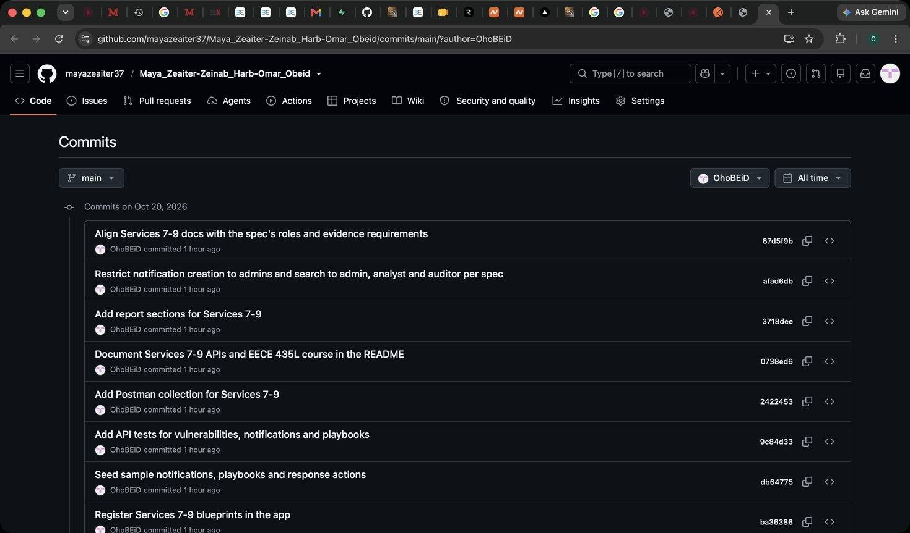
Figure 272: Omar Obeid – GitHub – commit history of the team repository filtered to my account (OhoBEiD)
Figure 273: Omar Obeid – GitHub – contributors graph showing the commits of all three team members

11. References and AI usage
- AI usage (whole team): all three team members used Claude (Anthropic), an AI assistant, as a research and support tool throughout Sprint I. The uses below are common to the whole team; the additional uses of each member are listed in 11.1–11.3.
- Where AI was used:
- Researching terminal commands needed during the project, such as creating and activating the Python virtual environment, installing the dependencies from requirements.txt, seeding the database, starting the Flask server, running the automated tests, and Git commands for committing and pushing to the team repository.
- Getting a step-by-step guide on how to approach the work: how to organise the nine services in a shared project structure, the order in which to build and test them, and how to verify each endpoint with Postman and DB Browser for SQLite.
- Checking our code for mistakes: when an endpoint returned an unexpected status code, a test failed, or a query did not behave as expected, we asked the AI to review the relevant code and explain what was wrong, then we applied and tested the fix ourselves.
- Purpose: to work more efficiently with tools we were less familiar with (the terminal, Git, Flask and SQLite), to follow a clear workflow that matches the Sprint I specification, and to find and understand errors in our code faster.
- What we did ourselves:
- Read the Sprint I specification, split the nine services between the three members and planned the work.
- Ran all the terminal commands on our own machines, set up the environment and ran the server and the test suite.
- Tested every API request in Postman against our running servers and checked the stored records in DB Browser for SQLite.
- Reviewed each suggestion from the AI before using it, and verified that every fix worked by re-running the tests and requests.
- Took all the screenshots for the evidence and pushed our commits to the team repository from our own GitHub accounts.
- Each member's own AI usage for their services is detailed in 11.1–11.3 below.

11.1 Services 1–3 (Maya Zeaiter)
- Flask documentation (flask.palletsprojects.com), Werkzeug security helpers, itsdangerous, SQLite docs.
- Newman (Postman CLI runner) and newman-reporter-htmlextra, used for the automated run report.
- AI usage: I used Claude (Anthropic), an AI assistant running in Claude Code on my laptop, for the following:
- Where: Assisted with generating the Python backend code and API endpoints.
- Helped design the database schema and generate sample data.
- Generated automated tests and assisted with debugging.
- Helped configure the server and resolve technical issues.
- Assisted with creating the Postman collection and Newman testing.
- Helped draft and format the README and project report.
- Assisted with organizing and captioning the evidence document.
- Purpose: to speed up implementation and documentation of my three services.
- What I did myself: Read and analyzed the assignment requirements.
- Planned and organized the project workflow.
- Reviewed the backend code and database structure.
- Tested and verified API functionality using Postman.
- Took screenshots of the API requests, responses, and database.
- Created and managed the GitHub repository, including commits and collaborator invitations.
- Took GitHub commit-history and contributor screenshots.
- Reviewed and edited the project documentation and report.
- Organized the testing evidence and prepared the final submission.

11.2 Services 4–6 (Zeinab Harb)
- Flask documentation (flask.palletsprojects.com), Python ipaddress and re modules, SQLite documentation (aggregate functions, date()), Postman documentation.
- AI usage: I used Claude (Anthropic), an AI assistant, as a helper while building and documenting Services 4–6. It did not do the whole task: I set up, ran, tested and verified the system myself and produced all the evidence from my own machine.
- Where AI was used:
- Generating the Python code for threats_service.py, logs_service.py and reports_service.py, the Threat/AuditLog models and repositories, the threat validators and the developer-name change in common.py, following the structure Maya had already built.
- Generating the seed data for threats and sample vulnerabilities, the automated tests (tests/test_services_4_6.py) and the Postman collection.
- Drafting the README API documentation and the text of my report sections.
- Guiding me step by step through running the Postman requests and DB Browser checks, and compiling my screenshots into the captioned evidence document.
- Purpose: to implement and document my three services within the sprint deadline while following the specification closely (roles, validation, error handling and evidence requirements), and to learn how a Flask REST backend is tested and verified with Postman and a database browser.
- What I did myself:
- Read the Sprint I specification, identified my services (4–6) and the parts of Maya's code to reuse, and wrote the task description I gave to the AI.
- Set up the project on my laptop (virtual environment, dependencies, database seeding), applied the changes and pushed all my commits to the team repository from my own GitHub account.
- Ran the automated test suite (32 tests passing) and ran every API request in Postman against my own running server, checking each status code and response.
- Took all the screenshots (73 figures) from my own system and checked the stored records, log entries and report numbers against the database in DB Browser for SQLite.
- Committed the evidence document and prepared my sections for the team report.

11.3 Services 7–9 (Omar Obeid)
- Flask documentation (flask.palletsprojects.com), SQLite documentation (foreign keys, ON DELETE CASCADE, CHECK constraints), the CVE ID syntax (cve.org), FIRST CVSS v3.1 specification (qualitative severity rating scale), Postman documentation.
- AI usage: see the team AI usage statement at the start of Section 11.

